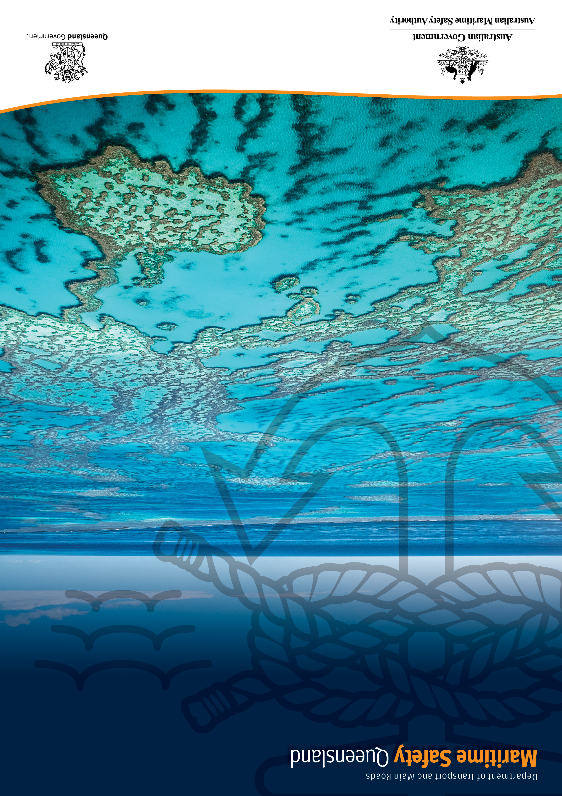
C
Great Barrier Reef and Torres Strait
Vessel Traffic Service
Reef VTS User Guide

Creative Commons information
© State of Queensland (Department of Transport and Main Roads) 2025
http://creativecommons.org.licences/by/4.0/
This work is licensed under a Creative Commons Attribution 4.0 Licence. You are free to copy, communicate and adapt the work, as long as you attribute the authors.
The Queensland Government supports and encourages the dissemination and exchange of information. However, copyright protects this publication. The State of Queensland has no objection to this material being reproduced, made available online or electronically but only if it's recognised as the owner of the copyright and this material remains unaltered.
 | The Queensland Government is committed to providing accessible services to Queenslanders of all cultural and linguistic backgrounds. If you have difficulty understanding this publication and need a translator, please call the Translating and Interpreting Service (TIS National) on 13 14 50 and ask them to telephone the Queensland Department of Transport and Main Roads on 13 74 68.
Disclaimer: While every care has been taken in preparing this publication, the State of Queensland accepts no responsibility for decisions or actions taken as a result of any data, information, statement, or advice, expressed or implied, contained within. To the best of our knowledge, the content was correct at the time of publishing.

Important
Reef Vessel Traffic Service (VTS) relies on the reports that it receives from ships. The information used by Reef VTS is only as accurate as the information that is given in these reports.
Reef VTS may not know about all the hazards in the region and ships may encounter unreported hazards at any time. Any hazards should be reported to Reef VTS immediately.
The master of a ship is responsible for the ship’s operation and is responsible for the safe navigation of the ship under all circumstances.
The information provided within this document is a guide only and does not replace any rules in the Navigation Act 2012 which apply to waters within the Reef VTS area. Any ship, owner, operator, charterer, master, or person directing the movement of a ship must follow all relevant laws or regulations and must take any precaution required by ordinary seamanship or the special circumstances of the case. Neither the Commonwealth of Australia nor the State of Queensland accept any responsibility for any decision made by any master or crew member.
If there is any difference between the information in this guide and the relevant laws, the relevant laws should be followed.

For more information
For any questions about this document or suggested improvements, please contact:
Maritime Safety Queensland
Email: REEFVTS.Management@msq.qld.gov.au
Address: PO Box 2595, Brisbane, Qld, 4001

Publishing details
First Edition – December 2004
Previous Edition – January 2022
Current Edition – January 2025

Contents

Creative Commons information 2
Important 3
For more information 3
Publishing details 3
Contents 4
Table of Tables 6
1. Definitions 7
2. Purpose 8
3. Introduction 8
4. Reef VTS 8
4.1 Authority 9
5. Reef VTS area 9
5.1 Reporting to Reef VTS 9
5.1.1 General obligation 9
5.1.2 Voluntary reporting 10
5.1.3 Warships, navy auxiliaries, and government ships 10
6. Master’s responsibilities 10
6.1 Failure to report to Reef VTS 10
7. Communication 11
7.1 VHF radio 11
7.2 Inmarsat-C 11
7.3 Other communications 11
8. Mandatory reporting requirements 12
8.1 Standard reporting codes reference table 13
8.2 Reef VTS reporting 14
8.2.1 Entry Report (ER) 14
8.2.2 Final Report (FR) 15
8.2.3 Route Deviation Report (DR) 15
8.2.4 Intermediate Position Report (IP) 16
8.2.5 Defect Report (IR) 16
8.2.6 Route Information 16
8.3 Passenger ship reporting requirements. 17
8.4 Outer ports and anchorages 17
9. Ship encounter information 18
9.1 Provision of SEI 18
9.1.1 SEI message 18
9.1.2 How to interpret SEI 19
9.1.3 New or changed information 20
9.1.4 SEI updates 20
9.2 Maritime safety information 21
9.3 Responding to developing unsafe situations 21
10. Other rules and regulations 22
10.1 Coastal Pilotage 22
10.2 Under Keel Clearance Management 22
10.3 Designated Shipping Areas 22
10.4 Standard route plans 22
10.5 Pollution Reporting 22
11. Chartlets 23
11.1 Reef VTS area 23
11.2 Reef VTS areas North and South 24
11.3 SEI North 25
11.4 SEI South 26
11.5 SEI Central 27
11.6 AMSA Coastal pilotage and designated shipping area 28
11.7 VHF coverage 29
11.8 VHF channel overview 30
11.9 VHF channel 14 – Torres Strait to Cape York 31
11.10 VHF channel 11 – Cape Flattery to Mourilyan 32
11.11 VHF channel 14 – Lucinda to Abbot Point 33
11.12 VHF channel 11 – Whitsundays and Hydrographers Passage 34
11.13 VHF channel 14 – Swain to Sandy Cape 35

Table of Tables
Table 1 - Reef VTS working channels 11
Table 2 - Standard reporting format 13
Table 3 - Example ER report 14
Table 4 - Example FR report 15
Table 5 - Example DR report 15
Table 6 - Example IP report 16
Table 7 - Example IR report 16
Table 8 - Outer ports and anchorages 17
Table 9 - Example SEI message 20
Table 10 - Example MSI message 21

- Definitions

AIS | Automatic Identification System
AMSA | Australian Maritime Safety Authority
APR | Automated Position Reporting
CPA | Compulsory Pilotage Area
GNEC | Great North East Channel
GBRMPA | Great Barrier Reef Marine Park Authority
IMO | International Maritime Organization
IMN | Inmarsat Mobile Number
JRCC | Joint Rescue Coordination Centre
Length of tow | The distance between the stern of the towing vessel and the after end of the tow
MASTREP | The Modernised Australian Ship Tracking and Reporting System
MSI | Maritime Safety Information
MSQ | Maritime Safety Queensland
Navigation Act | The Australian Government’s Navigation Act 2012
REEFREP | The Great Barrier Reef and Torres Strait Ship Reporting System
Reef VTS | The Great Barrier Reef and Torres Strait Vessel Traffic Service
SEI | Ship Encounter Information
TMR | Department of Transport and Main Roads
UKCM | Under Keel Clearance Management
VTS | Vessel Traffic Service

- Purpose
The purpose of this guide is to assist masters of ships transiting the Reef VTS area on the services provided by Reef VTS. The guide describes:
- The regulatory requirements for ships entering and transiting through the Reef VTS Area, including the mandatory reporting procedures, recommended shipping routes and compulsory pilotage areas;
- Contact and communication requirements; and
- The vessel traffic services provided by Reef VTS.
The master of a ship is responsible for the ship’s operation and is responsible for the safe navigation of the ship under all circumstances.
The information provided in the Reef VTS User Guide is a guide only. Any ship, owner, operator, charterer, master, or person directing the movement of a ship must still follow all relevant laws and regulations and must take any precautions required by ordinary seamanship or by the special circumstances of the case.
- Introduction
The environmental and cultural significance of the Great Barrier Reef and Torres Strait regions are internationally recognised. The Great Barrier Reef Marine Park was established in 1975 and was added to the World Heritage list in 1981. In 1990, the International Maritime Organization (IMO) named the Great Barrier Reef as the world’s first Particularly Sensitive Sea Area (PSSA). The IMO also named the Torres Strait as a PSSA in 2005.
- Reef VTS
Reef VTS is the Great Barrier Reef and Torres Strait Vessel Traffic Service and was established by the Queensland and Australian Governments in 2004.
Reef VTS operates 24 hours a day from the Townsville and Gladstone VTS centres. Reef VTS uses information from many sources to monitor the movements of participating vessels for example, Automatic Identification System (AIS), Radar, Automated Position Reports (APR) via Inmarsat C, VHF and the passage plans that vessels provide to Reef VTS.
The purpose of Reef VTS is to:
- Make navigation in Torres Strait and the inner route of the Great Barrier Reef safer by working with shipping to give the best possible information on potential traffic conflicts and other navigational information;
- Minimise the risk of maritime accidents, and therefore avoid the pollution and damage which such accidents can cause to the marine environment in the Great Barrier Reef and Torres Strait; and
- Assist with quick response if a safety or pollution incident does occur.
To assist with the safe navigation of ships, Reef VTS:
- Provides timely and relevant information on factors that may influence the ships movements and assist the onboard decision making;
- Monitors and manages ship traffic to ensure the safety and efficiency of ships transiting the Reef VTS area;
- Responds to requests for information, such as ship traffic and maritime safety information; and
- Responds to developing unsafe situations within the Reef VTS area.
Reef VTS is operated by Maritime Safety Queensland (MSQ) as the VTS Provider authorised by the Australian Maritime Safety Authority (AMSA) under Marine Order 64 (Vessel Traffic Services).
  - Authority
The Great Barrier Reef and Torres Strait Ship Reporting System (REEFREP) was established as a mandatory ship reporting system under the International Convention for the Safety of Life at Sea (SOLAS Regulation V/11). REEFREP was formally adopted by the IMO’s Maritime Safety Committee in Resolution MSC.52(66), and later amended by Resolutions MSC.161(78) and MSC.315(88).
The Navigation Act gives the general power to make regulations to implement SOLAS (s339) and the related power to make Australian Marine Orders (s342). The laws about mandatory ship reporting are based on these powers. Marine Order 63 (Vessel Reporting Systems) states that ships which are required to report to Reef VTS must do so whether they are voyaging overseas, between states or within one state. Reef VTS manages and operates REEFREP.
- Reef VTS area
The Reef VTS area is divided into two regions, Reef VTS North and Reef VTS South. The Reef VTS areas are separated at Latitude 18° 00.00' South (see section 11.2).
  - Reporting to Reef VTS
    - General obligation
The following categories of ships must report to Reef VTS:
- All ships with an overall length of 50 metres or more;
- All oil tankers, liquefied gas carriers, chemical tankers or ships coming within the Irradiated Nuclear Fuel Code, including those with an overall length of less than 50 metres; and
- Ships which are towing or pushing, or being towed or pushed, or where the overall length of the tow is 150 meters or more (the overall length of the tow is measured from the stern of the towing vessel to the after end of the tow).

For further information on reporting requirement to Reef VTS please see Division 1, Section 6 (Application), Sub Section 2 of Marine Order 63 (Vessel Reporting Systems).
    - Voluntary reporting
Other vessels transiting the Reef VTS area may report on a voluntary basis as defined in this user guide.
    - Warships, navy auxiliaries, and government ships
SOLAS Regulation V/11 does not apply to any warship, naval auxiliary, or any ship owned or operated by Government; however, SOLAS does state that “such ships are encouraged to participate in ship reporting systems”.
The Australian Government fully supports this approach, and all ships of the Royal Australian Navy are encouraged to participate in REEFREP on a voluntary basis, along with other ships owned or operated by the Australian Government.

- Master’s responsibilities
It is the responsibility of the ship’s master while in the Reef VTS area to:
- Follow all ship reporting requirements (as per section 8);
- Confirm that information from Reef VTS has been received when asked to do so;
- Respond appropriately to all information, warnings, and advice given by Reef VTS;
- Keep a listening watch on Reef VTS VHF working channels;
- Make sure that the Inmarsat C terminal is logged into the Pacific Ocean Region (POR) at all times;
- To ensure that the AIS is transmitting the correct data for the vessel; and
- As soon as possible, notify Reef VTS of any:
  - incident/accident affecting the ship’s safety;
  - incident/accident affecting safety of navigation;
  - defects affecting the ships safety or navigation
  - circumstances that may cause pollution;
  - pollutants/containers/packages drifting;
  - change to route plan.
Correct reporting is essential to enable Reef VTS to monitor the safe navigation of ships through the Reef VTS area. A full description of reporting requirements can be found in Marine Order 63 (Vessel Reporting Systems) and Marine Order 64 (Vessel Traffic Services).
  - Failure to report to Reef VTS
Any master, or officer of the watch at the time who fails to follow the required reporting procedures, or who deliberately transmits information, which is incorrect, false, or misleading, will have committed an offence and may be fined if convicted.
Section 215 and 216 of the Navigation Act 2012 makes it an offence for a person to fail to report the required information or provide false or misleading information. The penalty is up to 240 penalty units (presently A$53,280) or a civil penalty of 2,400 penalty units (presently A$532,800).

- Communication
Communication with Reef VTS is in English, using IMO’s Standard Marine Communication Phrases. The means of communication can be using VHF radio (voice), mobile satellite service (Inmarsat-C) or other communications (telephone or email).
  - VHF radio
Reef VTS can be contacted 24 hours a day on either VHF Channel 11 or 14 (radio call sign – Reef VTS). The VHF channel to be used will depend on the ship’s position as shown in the following table and in section 11.8.

Latitude From: | Latitude to: | VHF Channel
9° 00’ S | 13° 30’ S | 14
13° 30’ S | 18° 00’ S | 11
18° 00’ S | 20° 00’ S | 14
20° 00’ S | 21° 40’ S | 11
21° 30’ S | 24° 30’ S | 14
Table 1 - Reef VTS working channels
VHF coverage is limited in some areas. Please use Inmarsat-C messaging and email in the areas between:
- Inset (J) and Heath (K) – LADS Passage and Fairway Channel;
- Swain (Z1) and Archer (Z2) – Offshore from Gladstone in the SE area.
  - Inmarsat-C
Reef VTS will pay the cost of messages sent by Inmarsat-C if the ship uses a Special Access Code (SAC). Use SAC 862 for North entry exit points or SAC 863 for Southern entry/exit points via POR LES 212. Inmarsat-C terminals must be logged into the Pacific Ocean Region (POR).

  - Other communications
If for any reason a ship cannot communicate via Inmarsat-C or the VHF working channel, the ship must send the required information to Reef VTS in another way. The ship can use one of the following:
- Telephone number: +61 1300 721 293;
- By email: reefvtsnorth@msq.qld.gov.au or reefvtssouth@msq.qld.gov.au depending on location within the Reef VTS area (see section 11.2)
If a ship’s radio equipment fails and the ship cannot send the required reports to Reef VTS, the failure must be recorded in the ship’s radio logbook or the official logbook.
- Mandatory reporting requirements
A ship must provide the following reports to Reef VTS:
- Entry Report (ER); and
- Final Report (FR).
Reef VTS must receive an ER at least one (1) hour before a ship:
- Enters the REEFREP area; or
- Departs from a port within the REEFREP area.
When applicable, ships must also provide the following reports:
- Route Deviation Report (DR);
- Intermediate Position Report (IP); and
- Defect Report (IR).
Reporting ships are to submit their reports by VHF radio (voice), email or mobile satellite service (Inmarsat-C) using the following SAC for each region.
SAC 862 North region – All ports and entry/exit points north of Lat 18° 00.000S
Main Ports include – Thursday Island, Cook Town, Cape Flattery, Cairns, and Mourilyan. Main entry/exit points include - Booby, Endeavour, Bramble, and Grafton Passage.
SAC 863 South region – All ports and reporting points south of Lat 18° 00.000S
Main Ports include – Lucinda, Townsville, Abbot Point. Mackay, Hay Point, Port Alma, and Gladstone. Main entry/exit points include – Palm Passage Blossom, Swain, and Sandy Cape.

  - Standard reporting codes reference table
ID | Message Type (ER, FR, DR, IP, or IR)
A | Ship name, call sign and IMO number
B | Date and time (UTC)
C | Current Position – (Latitude and longitude in degrees and minutes)
E | Course – (True course)
F | Speed – (The planned speed of the ship in knots and tenths of a knot)
G | Last Port of Call / Port departing from  (If entering the Reef VTS area for the first time, state the last port of call. If departing from a port within the Reef VTS area, the name of that port)
H | Date, time (UTC) and point of entry to Reef VTS area  (Either the name of the entry point or the position (latitude and longitude) of entry of the Reef VTS area)
I | Next Port of Call – (Name of the next port of call date and time in UTC)
J | Pilot company details – (Provide the pilot company name)
K | Date, time (UTC) and point of exit from area  (Either the name of the point leaving the area, or the position (latitude and longitude) of exit)
L | Route information – (Recommended standard route plans, taking into account vessel draught)
M | Communication methods  (Primary Inmarsat C details: IMN, manufacturer and model, ship’s satellite phone number)
O | Draught – (Fore and aft and deepest draught, in meters and decimeters)
P | Cargo on-board  (Give the normal name of cargo and state whether it is classified as hazardous (yes or no).  Note: If required, this information may be given by non-voice means before the first Reef VTS report.
Q | Defects, damage, deficiencies, or other limitations  (Describe details of any damage, failure or breakdown, collision, grounding, fire, explosion, structural failure, flooding, cargo shifting; failure or breakdown of steering gear, propulsion plant, electrical generating system, essential shipboard navigational equipment)
R | Pollution/dangerous goods lost overboard  (Give brief details of the type of pollution (oil, chemicals and so on) or dangerous goods lost overboard and state the ship’s position)
U | Ship type, length (meters) and gross tonnage  (Give details of the ship, including ship type, length (meters) and gross tonnage)
X | Remarks  (Give any additional information which would help the navigational safety of shipping in the Reef VTS area, for example, abnormal weather; faulty navigational aid; or any Dangerous Goods (DG), Harmful Substances (HS) or Marine Pollution (MP) incident reports).
Table 2 - Standard reporting format

  - Reef VTS reporting
    - Entry Report (ER)
The following information must be provided to Reef VTS at least one hour before a vessel enters the Reef VTS area or departing from a port within the Reef VTS area (* denotes mandatory requirement for ER).
ID | Information Required | Example
ID | Message Type | ID/ER
A* | Ship name, call sign and IMO number | A/HAPPY SAILOR/ABCD/1234567
B* | Date and time (UTC) | B/010200UTC
C* | Current Position | C/1120S/14430E or Cairns
F* | Speed  Ships planned average speed | F/13.5
G* | Last Port of Call / Port Departing from within the Reef VTS area | G/Singapore, or, G/Hay Point
H* | Date, time (UTC) and point of entry to Reef VTS Area | H/010400UTC/BOOBY or H/1030S14120E
I* | Next Port of Call and ETA UTC | I/Gladstone/050500UTC NOV 16
J | Pilot Company Details  Give the pilot company name | J/Torres Pilots or J/Auriga
K* | Date, time (UTC) and point of exit from area | K/042100UTC/SANDY CAPE or K/042100UTC/2420S 15110E
L* | Route information  See section 11 of this guide for recommended route plans | L/INNER ROUTE DEEP DRAUGHT  or L/ALPHA NORTH VIA VARZIN PASSAGE/HANNIBAL
M* | Communication methods  Inmarsat C details, IMN, manufacturer, mode, and ship’s satellite phone number | M1/423456789/JRC/JUE- 85C or M2/870773123456
O* | Draught | O/Fore 11.6/Aft 11.8/Deepest 11.8
P* | Cargo on-board | P/BULK CHEMICALS/ DG YES
Q* | Defects, damage, deficiencies, or other limitations | Q/Include details as required
U* | Ship type, length (meters) and gross tonnage | U/TANKER/180/28000
X | Remarks | X/Include details as required
Table 3 - Example ER report

    - Final Report (FR)
The following information must be provided to Reef VTS immediately on exiting the Reef VTS area or arriving at a port in the Reef VTS area (* denotes a mandatory requirement for FR).
ID | Information Required | Example
ID | Message Type | ID/FR
A* | Ship name, call sign and IMO number | A/HAPPY SAILOR/ ABCD/1234567
K* | Date, time (UTC) and point of exit from  area | K/042100UTC/Hay Point, or  K/042100UTC/2420S 15110E
Table 4 - Example FR report
    - Route Deviation Report (DR)
If the ship needs to deviate from the Route Plan which was given to Reef VTS on entry to the Reef VTS area, this should be reported to Reef VTS before the deviation is made. In situations where a deviation is made without much warning, a DR report should be sent to Reef VTS within 15 minutes after the deviation made (* denotes mandatory requirement for DR).
ID | Information Required | Example
ID | Message Type | ID/FR
A* | Ship name, call sign and IMO number | A/HAPPY SAILOR/ ABCD/1234567
B* | Date, time (UTC) | B/010200UTC
I | Next Port of Call and ETA | I/Gladstone/050500UTC NOV 16
K* | Date, time (UTC) and point of exit from  area | K/042100UTC/Hay Point, or  K/042100UTC/2420S 15110E
L* | Route information  See section 11 of this guide for  recommended route plans | L/INNER ROUTE DEEP DRAUGHT  or  L/ALPHA NORTH VIA VARZIN PASSAGE/  HANNIBAL
O* | Draught | O/Fore 11.6/Aft 11.8/Deepest 11.8
Table 5 - Example DR report

    - Intermediate Position Report (IP)
Where Reef VTS advises that the ship’s position is being tracked by sensors then an IP is not required. If the ship’s position is not being tracked by sensors, then a brief position report must be provided to Reef VTS. Where required, provide the following information for an IP (* denotes mandatory requirement for IP).
ID | Information required | Example
ID | Message Type | ID/IP
A* | Ship name, call sign and IMO number | A/HAPPY SAILOR/ ABCD/1234567
B | Date and time (UTC) | B/010200UTC
C* | Current Position | C/1120S/14430E
F* | Speed – ships planned average speed | F/13.5
Table 6 - Example IP report
    - Defect Report (IR)
Provide the following information for an IR immediately if a ship suffers damage, failure or breakdown which affects the ship’s safety, or, immediately if there is pollution or cargo lost overboard, or, special reports as defined by the IMO for incidents involving dangerous goods, harmful substances or marine pollutants (* denotes mandatory requirement for IR).
ID | Information Required | Example
ID | Message Type | ID/FR
A* | Ship name, call sign and IMO number | A/HAPPY SAILOR/ ABCD/1234567
C* | Current Position | C/1120S/14430E
F* | Speed - Ships planned average speed | F/13.5
Q* | Defects, damage, deficiencies, or other limitations | Q/Include details as required
Table 7 - Example IR report
    - Route Information
Provide standard route plan details as set out in section 10.4. Any pre-planned variation from the standard route should be provided to Reef VTS when entering the Reef VTS area.

  - Passenger ship reporting requirements.
Passenger ships routinely depart the Reef VTS area into ports and anchorages. They also depart and enter the Reef VTS area via passages either to reach offshore destinations, or to access waters beyond the Territorial Sea for discharging black and grey water. Masters of passenger ships must comply with the below:
- Ships entering the Reef VTS area from a port or anchorage are to provide an ER on each occasion. Similarly ships departing the Reef VTS area are to provide a FR.
- Ships anchored within the Reef VTS area and outside of port limits will be considered to be still on a reef voyage. The ship will not receive Ship Encounter Information (SEI) whilst at anchor and will be required to notify Reef VTS when underway,
- Ships entering the Reef VTS area on a northerly or southerly track between Swains Reef and Sandy Cape will be exempt from providing an Entry Report and Final Report providing their intention is not to re-enter the Reef VTS area, such ships will not be provided with SEI.
- Multiple legs or advice of voyage intentions may be provided to Reef VTS in a separate email.
  - Outer ports and anchorages
Vessels that depart and arrive at ports and anchorages outside of the main Ports Cairns, Townsville, Hay Point and Gladstone which sit within the Reef VTS area must provide an ER and FR to Reef VTS and call the following VTS centres on arrival and departure.
All reports are to be sent to Reef VTS by Inmarsat-C, email or on the VHF working channels.

Port | Channel | VTS centre
Port Alma | 13 | Gladstone VTS
Mackay | 10 | Hay Point VTS
Whitsundays | 10 | Hay Point VTS
Abbot Point | 12 | Townsville VTS
Lucinda | 13 | Townsville VTS
Mourilyan | 13 | Cairns VTS
Cape Flattery | 13 | Cairns VTS
Table 8 - Outer ports and anchorages

- Ship encounter information
Reef VTS predicts ship encounters and sends this information to individual ships as Ship Encounter Information (SEI), usually through Inmarsat C messaging. The SEI provided is specific for each individual ship. There are no general broadcasts for SEI.
Reef VTS advises individual ships of SEI:
- When the ship enters the Reef VTS area;
- When a ship enters an SEI calculation area; and,
- At any other time when requested by a vessel.
Reef VTS can provide SEI in different ways:
- Inmarsat-C;
  - The ship must give Reef VTS the make, model and IMN of the ship’s Inmarsat C terminal,
  - Please make sure messages from Reef VTS are read when they are received. If a problem exists in receiving electronic messages, then contact Reef VTS to arrange for SEI to be provided by VHF communications,
- VHF communications;
  - Ships must keep a listening watch on the Reef VTS VHF working channels. Reef VTS uses VHF channels 11 and 14, and
- Email.
  - Provision of SEI
SEI is calculated throughout the Reef VTS area for all participating vessels that have been placed on an active voyage in our VTS systems. The SEI is calculated from the time a vessel enters the Reef VTS area from sea or from an adjacent port within the Reef VTS area for the next nominated hours of the ships transit. Further SEI updates are provided to a vessel when the vessel crosses one of the predefined SEI lines marked (see sections 11.3, 11.4 and 11.5). Additionally, SEI can be provided at any time on request to Reef VTS.
VTS systems use the data from a ships AIS to calculate the encounter information within an SEI message. The system cannot present SEI for vessels that are:
- Not a participating vessel (for example, warships);
- Not required to have an AIS (for example, a recreational vessel);
- Sailing with a defective AIS (must be declared to Reef VTS); and
- Vessels with a Class B AIS (these are presented in the SEI message as 'vessels in area').
    - SEI message
A ship will receive SEI about predicted ship encounters for the next nominated hours of its transit depending on the SEI calculation area. SEI messages are separated into two sections:
- Ship Encounter – the situation that two participating vessels on a route are (predicted) to pass each other as they transit the Reef VTS area. For these vessels, the SEI message will present a distance to and the approximate time that they will encounter the vessel.
- Ships in the Area – includes any vessels being tracked by AIS with no route that are in the predicted area around a participating vessel for which an SEI message is calculated. The predicted area is a 3nm radius around the SEI ship along the path the vessel will travel for the next configurable hours (default set at 6hrs).
    - How to interpret SEI
Upon entry into the Reef VTS area, the VTSO will assign a route to a vessel according to their ER. Once the vessel is assigned, it is deemed as a participating vessel. It is important that Reef VTS are advised of any changes to routes in line with this guide for any route deviations. If the ship does not advise Reef VTS of a change of route, it will impact the accuracy of SEI calculations.
The SEI message is to be read as follows.
Ship details:
- Name of the ship for which SEI calculated for;
- Speed of the ship at time of calculation; and
- Time of calculation.
Encounter information:
- Name of ship to be encountered;
- Location of the predicted encounter (latitude / longitude);
- Date and approximate time of encounter;
- Course and speed (at time of the calculation) of the ship to encounter; and
- Distance to CPA / TCPA (distance to encounter / time to encounter).
Within the message, letter indicators will be displayed to provide additional information such as:
- (P) – ship is piloted;
- (NP) – ship has no pilot;
- (DD) – deep draught >= 10 metres; and
- (T) – towing vessel.
Ships in the area:
- Lists the vessel name;
- Vessel location (latitude / longitude) at the time of the calculation; and
- Vessel course and speed (at the time of the calculation).

Generated at 05:48, 19:06:2024 (AEST)
Encounters:
RAINBOW WARRIOR (NP) in the vicinity of 13 31S 143 59E at 19 0553 (Course 152 Speed 7.0 Dist to CPA/TCPA 1.3/00:05:18)
HANYANG (P)(DD) in the vicinity of 13 00S 143 44E at 19 0817 (Course 152 Speed 10.9 Dist to CPA/TCPA 35.6/02:29:25)
GOLDEN DEB (P)(DD) in the vicinity of 12 28S 143 23E at 19 1057 (Course 141 Speed 12.2 Dist to CPA/TCPA 73.8/05:09:31)
Vessels in the Area:
STORM BAY at 13 23S 143 55E (Course 286 Speed 12.1)
STELLA RANE at 12 54S 143 40E (Course 286 Speed 0.5)
FV KW at 12 28S 143 23E (Course 115 Speed 7.0)
Additional information:

Table 9 - Example SEI message
    - New or changed information
Reef VTS monitors the transit of a ship to identify any significant changes to the traffic information which Reef VTS has previously provided. This could be when a new ship is identified or there is a change in the estimated time of arrival (ETA) because of an increase or decrease in speed. If deemed necessary, Reef VTS may recalculate SEI for a vessel.
    - SEI updates
During a ships transit through the Reef VTS area the ship may receive multiple SEI messages depending on the size of the SEI calculation area or if the ship is transiting through multiple SEI calculation areas. A ship may contact Reef VTS at any time to ask for an SEI update.
For areas where SEI is calculated and provided to ships see sections 11.3, 11.4 and 11.5.

  - Maritime safety information
Reef VTS provides ships Maritime Safety Information (MSI) that is relevant to their location and intended movement. If a ship encounters any hazards that may affect the safe navigation of other ships, it should contact and report to Reef VTS. MSI is also provided in broadcasts from JRCC in the form of navigational warnings (AusCoast Warnings).
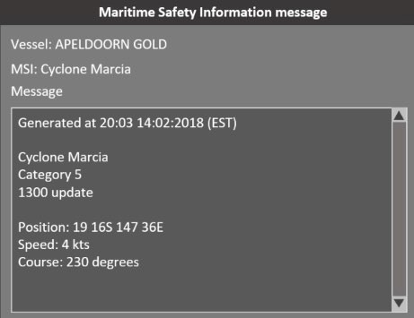
Reef VTS may not be aware of all the hazards in the Reef VTS area. If a ship encounters any hazard which is not already included in an MSI message (for example, a faulty navigational aid), it should advise Reef VTS immediately.
Table 10 - Example MSI message
  - Responding to developing unsafe situations
Responding to developing unsafe situations involves support to the navigational safety of the ship through the provision of essential navigational information to assist on board decision-making. It may also involve the provision of navigational advice and/or instruction. If Reef VTS has information which may help decision-making on-board a ship, Reef VTS may contact that ship.
If Reef VTS believes that the ship is heading into an unsafe situation (entering shallow water or deviating from a planned route), Reef VTS may contact a ship in response to a developing unsafe situation.
The master remains responsible for the safe navigation of the ship at all times and should not rely on the availability of navigational support from Reef VTS.

- Other rules and regulations
  - Coastal Pilotage
Under Australian law all ‘regulated ships’ must carry a licensed coastal pilot when transiting through:
- The Inner Route (from Cape York to Cairns);
- The Great North East Channel;
- Hydrographers Passage;
- Whitsundays (Whitsunday Passage, Whitsunday Group and Lindeman Group); and
- The Torres Strait.
The Queensland Coastal Passage Plan (QCPP) has been developed as a guide for the conduct of coastal pilotage in these areas. More information on coastal pilotage and QCPP is available on the AMSA website – www.amsa.gov.au
  - Under Keel Clearance Management
The Under Keel Clearance Management (UKCM) system helps large ships navigate through the Torres Strait. AMSA has implemented the UKCM system to assist in the planning and safe conduct of ships transiting through the Torres Strait. More information on the UKCM system is available on the AMSA website – www.amsa.gov.au
  - Designated Shipping Areas
The Great Barrier Reef Marine Park Authority (GBRMPA) has put in place a Designated Shipping Area (DSA) and General Use Zones (GUZ) within the Great Barrier Reef Marine Park as part of the Great Barrier Reef Marine Park Zoning Plan. More information is available from GBRMPA by phoning +61 7 4750 0700, emailing info@gbrmpa.gov.au or on the GBRMPA website www.gbrmpa.gov.au
  - Standard route plans
The Queensland Coastal Passage Plan (QCPP) provides details on routes, waypoints, and navigation aids in the pilotage areas (outlined in section 11.1 of the QCPP). The QCPP can be accessed from the AMSA website www.amsa.gov.au
  - Pollution Reporting
The MARPOL 73/78 definition of “nearest land” prohibits operational discharges in the Great Barrier Reef and Torres Strait regions. The following should be reported to Reef VTS:
- any quantity of oil (including diesel fuel, petrol, and oil products);
- any discharge from a ship of chemicals or chemical residues; or
- garbage (food waste, glass, plastic etc.).
More information on reporting ship sourced pollution is available on the MSQ website www.msq.qld.gov.au/Marine-pollution and the AMSA website www.amsa.gov.au
- Chartlets
  - Reef VTS area
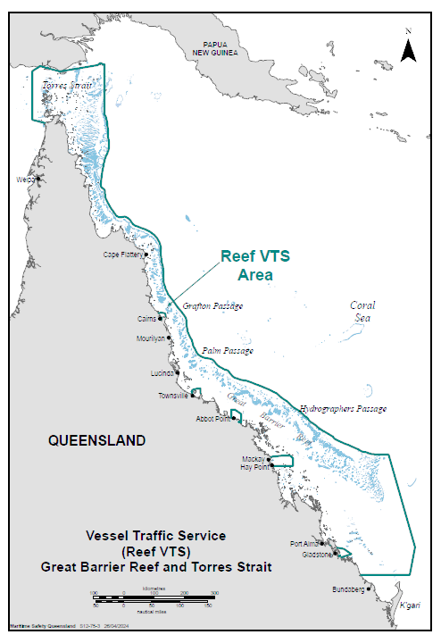
  - Reef VTS areas North and South
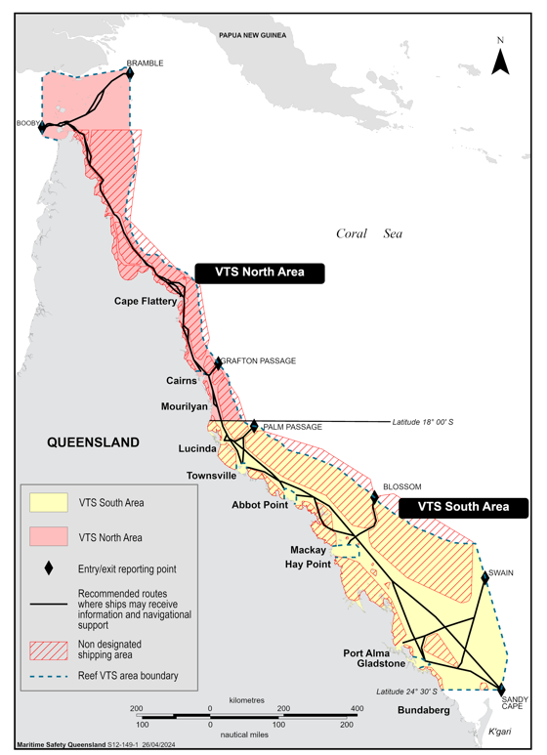

  - SEI North
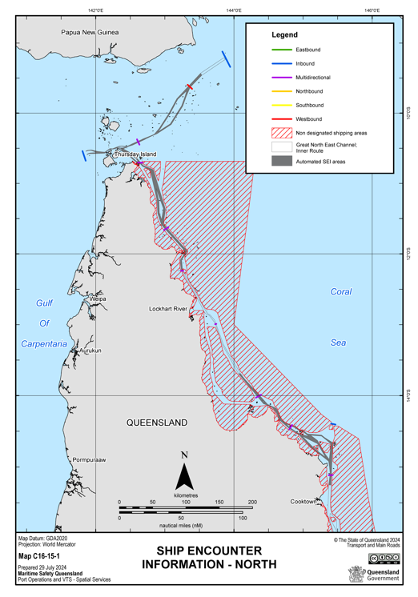

  - SEI South
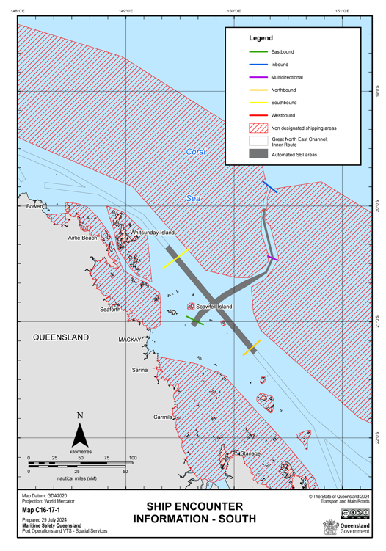

  - SEI Central
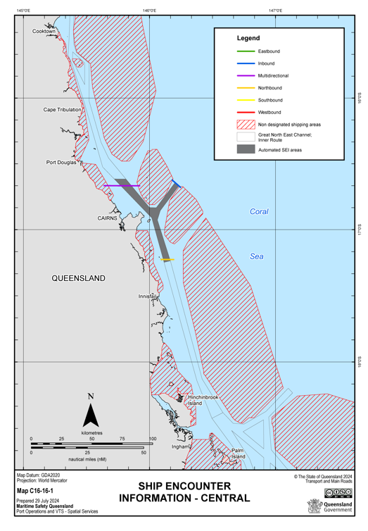

  - AMSA Coastal pilotage and designated shipping area
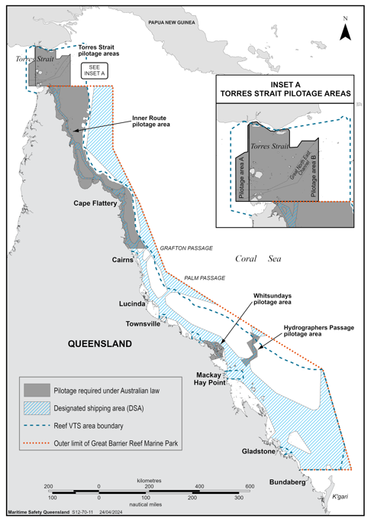
  - VHF coverage
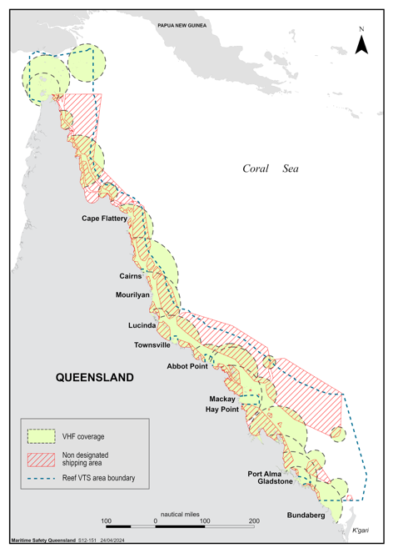

  - VHF channel overview
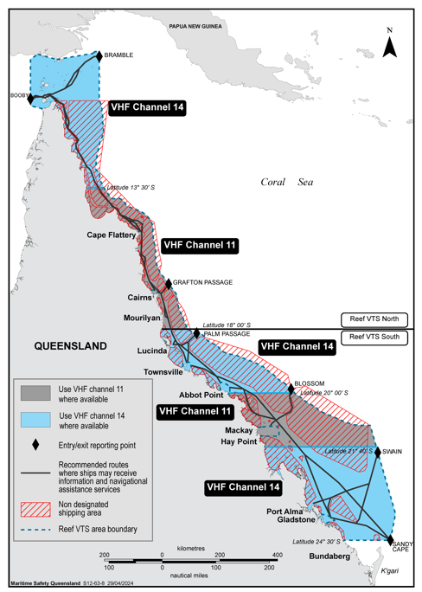

  - VHF channel 14 – Torres Strait to Cape York
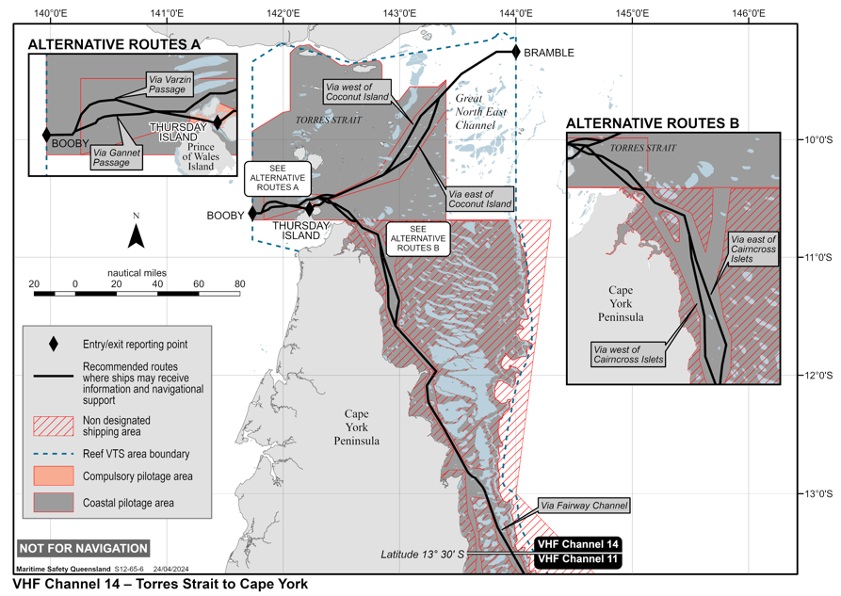
  - VHF channel 11 – Cape Flattery to Mourilyan
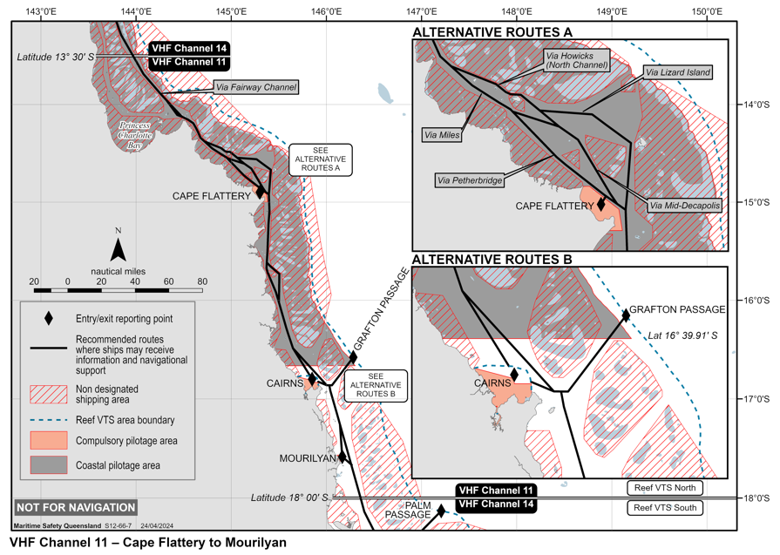

  - VHF channel 14 – Lucinda to Abbot Point
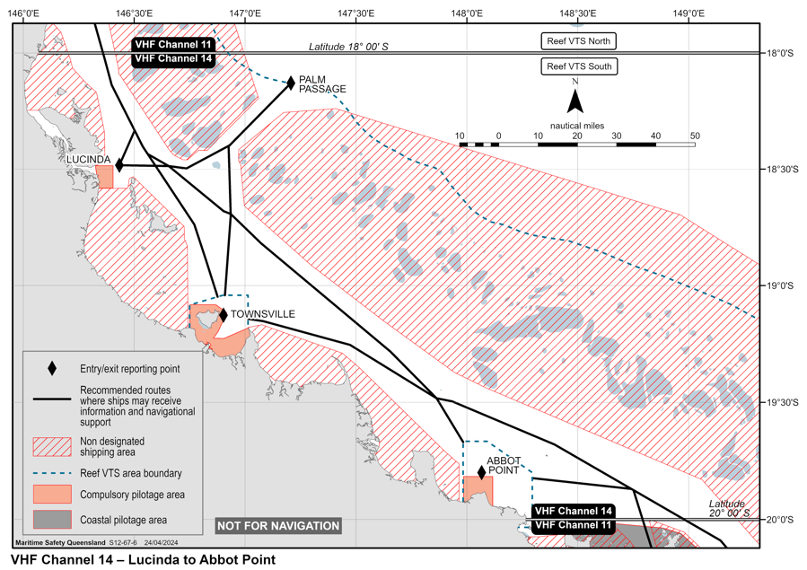
  - VHF channel 11 – Whitsundays and Hydrographers Passage
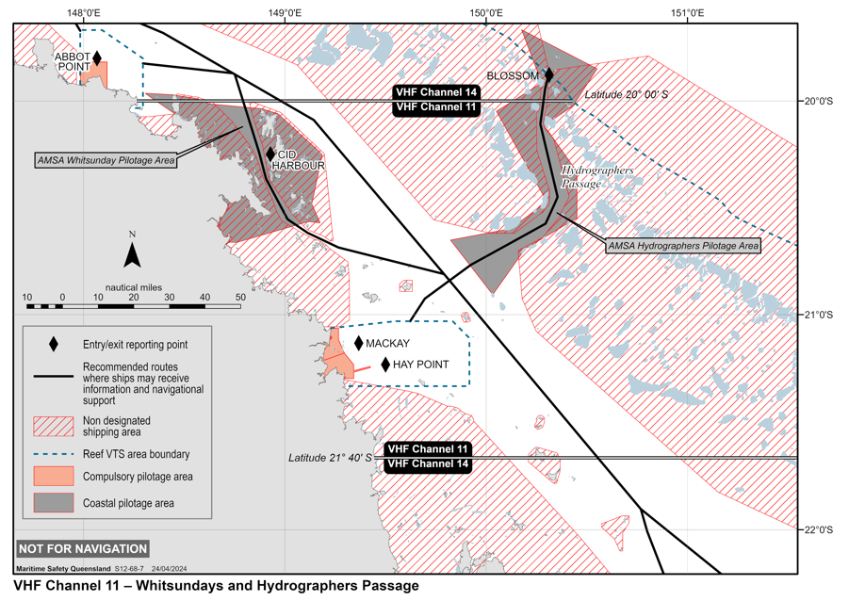
  - VHF channel 14 – Swain to Sandy Cape
