
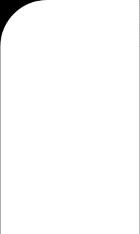



MOOLOOLABA BOAT HARBOUR ENTRANCE INDEPENDENT REVIEW
Draft Final Report

MOOLOOLABA BOAT HARBOUR ENTRANCE INDEPENDENT REVIEW
Final Interim Report

MOOLOOLABA BOAT HARBOUR ENTRANCE INDEPENDENT REVIEW
Draft Final Report

MOOLOOLABA BOAT HARBOUR ENTRANCE INDEPENDENT REVIEW
Draft Final Report

MOOLOOLABA BOAT HARBOUR ENTRANCE INDEPENDENT REVIEW
Draft Final Report

604-OEENVBNE-420124
15 December 2025
v 1.0

Document status
Version | Purpose of document | Authored by | Reviewed by | Approved by | Review date
A | Interim draft for MSQ review | Aaron Sayler  Sam King  George Freeman  Marty Mulcahy  Kat Thorne  Nicole Romano  Kiah Hume  Nuala Page  Devin Finn | Brad Williams  Aaron Sayler | Mick Le Riche | 13 Oct 2025
B | Revised draft for MSQ review | ‘as above’ | Brad Williams Aaron Sayler | Mick Le Riche | 24 Oct 2025
C | Draft Final for MSQ review | ‘as above’ | Brad Williams Aaron Sayler | Mick Le Riche | 21 Nov 2025
D | Draft Final for Minister review | ‘as above’ | Brad Williams Aaron Sayler | Mick Le Riche | 08 Dec 2025
1.0 | Final Interim Report | ‘as above’ | Brad Williams Aaron Sayler | Mick Le Riche | 15 Dec 2025

Approval for issue
Mick Le Riche |  | 15 December 2025

This report was prepared by RPS within the terms of RPS’ engagement with its client and in direct response to a scope of services. This report is supplied for the sole and specific purpose for use by RPS’ client. The report does not account for any changes relating the subject matter of the report, or any legislative or regulatory changes that have occurred since the report was produced and that may affect the report. RPS does not accept any responsibility or liability for loss whatsoever to any third party caused by, related to or arising out of any use or reliance on the report.

Prepared by: | Prepared for:
RPS AAP Consulting Pty Ltd (RPS) | Maritime Safety Queensland
Mick Le Riche  Technical Director | Maritime Assets & Infrastructure
1 Innovation Parkway  Birtinya QLD 4575 | Floor 4, 61 Mary Street  Brisbane, QLD 4000
T +61 7 5436 7888  E mick.leriche@rpsconsulting.com | T 13 74 68  E BoatingInfrastructure@msq.qld.gov.au

Contents
Executive Summary 10
Purpose 10
Context 10
Objective 10
Approach, findings & recommendations 10
Part 1 – Short term actions 10
Part 2 – Long term comprehensive planning 12
1 INTRODUCTION 15
1.1 Background 15
1.2 Current situation 15
1.3 Objective 15
1.4 Scope of work 15
PART 1 17
2 LEGISLATIVE AND POLICY FRAMEWORKS 18
3 INFORMATION SOURCES 19
4 COASTAL PROCESSES 20
4.1 Causes of shoaling events 20
4.1.1 Sand shoal numerical model 22
5 EXISTING ENVIRONMENT 25
5.1 Physical environment 25
5.1.1 Hydrodynamics 25
5.1.2 Climate 25
5.1.3 Water quality 25
5.1.4 Sediment quality 25
5.2 Biological environment 26
5.2.1 Environment Protection and Biodiversity Conservation Act 1999 26
5.2.2 Nature Conservation Act 1992 Threatened Species 26
5.2.3 Marine fauna and flora 27
5.2.4 Terrestrial fauna and flora 34
6 SOCIAL IMPACT EVALUATION 37
6.1 Stakeholder reference group 37
Long-term, proactive solutions are preferred over reactive approaches. 39
6.1.1 Social impacts of long-term options 39
6.1.2 Social values 40
6.2 Environmental values 40
6.3 Economic values 41
6.3.1 Demographic profile 41
6.3.2 Use profile 43
7 CURRENT DREDGING MANAGEMENT PRACTICES 46
7.1 Dredging activities 46
7.1.1 Current operational workflow 46
7.1.2 Existing constraints 47
7.2 Notices to mariners 47

Identifying the need for an NtM 47

Requesting a hydrographic survey 48

Conducting the survey 48

Reviewing the survey data 48

Preparing the NtM 48

Publishing and disseminating the NtM 48

Ongoing monitoring and updates 49
7.3 Crossing designated coastal bars 49
8 MSQ DREDGING OPTIONS – SHORT-TERM 50
9 MSQ DREDGING OPTIONS – LONG-TERM 51
10 ASSESSMENT OF SHORT-TERM DREDGING OPTIONS 52
10.1 Modifications to dredging strategy 52
10.1.1 Existing dredge strategy 52
10.1.2 Contract Dredge on Standby (356 days per year) 53
10.1.3 Trailer Suction Hopper Dredger (TSHD) 53
10.1.4 Jack-up barge option 54
10.1.5 Bed-levelling 54
10.1.6 Submarine Dredge (remotely piloted) 54
10.1.7 Summary of Dredging Strategy 55
10.1.8 Improvements to monitoring 56
10.1.9 Navigational warnings and guidance 59
10.1.10 Western Channel Trial 60
10.1.11 Condition assessment of eastern breakwater 61
11 PART 1 – CONCLUSIONS AND RECOMMENDATIONS 62
11.1.1 Recommendations 62
PART 2 64
12 THE NEED FOR LONG TERM SOLUTIONS 65
12.1 The goals of the long-term solution 65
12.1.1 High level goal list 66
12.2 Objectives and limitations of this expert review 67
12.3 Our approach to the long-term solutions 67
12.4 How we considered social impacts 68
12.5 How we reviewed options in this report 68
12.6 Long term options reviewed 70
12.6.1 Options with operational variations 70
12.7 Key assumptions 71
12.7.1 Sand transport rate (Area A) 71
12.7.2 Sand placement (Area B) 72
12.7.3 The existing pipe network 72
12.7.4 Common option elements 73
13 OPTION 1 – BUDDINA BEACH SAND TRAP 78
13.1 Description of Option 1 78
13.1.1 Effectiveness of Option 1 79
13.2 Variations of Option 1 80
13.3 Option 1A – Buddina Beach sand trap with TSHD transport 80
13.3.1 Description of Option 1A 80
13.3.2 Design and approvals 81
13.3.3 Capital works 82
13.3.4 Operational works 82
13.3.5 Coastal process considerations 83
13.3.6 Environmental constraints 87
13.3.7 Social impacts 92
13.3.8 Economic impacts 92
13.3.9 Future adaptability 92
13.3.10 Safety of Option 1A 92
13.3.11 Cost and feasibility 93
13.3.12 Option 1A summary 93
13.4 Option 1B – Buddina Beach Sand Trap utilising a pump system and pipeline across the entrance 93
13.4.1 Description of Option 1B 93
13.4.2 Design and approvals 95
13.4.3 Capital works 95
13.4.4 Operational works 96
13.4.5 Coastal processes considerations 97
13.4.6 Environmental constraints 98
13.4.7 Social impacts 105
13.4.8 Economic impacts 105
13.4.9 Future adaptability 105
13.4.10 Safety of Option 1B 106
13.4.11 Cost and feasibility 106
13.4.12 Option summary 106
13.5 Option 1 variations comparison 107
13.6 Multi-criteria analysis for Option 1A & 1B 109
14 OPTION 2 – INCREASED DREDGE CHANNEL DEPTH WITH ROCK EXCAVATION 112
14.1 Option description 112
14.1.1 How does it work to address shoaling? 112
14.1.2 What does this option involve? 112
14.1.3 Impacts on coastal processes 113
14.2 Effectiveness of Option 2 114
14.3 Variations of Option 2 114
14.4 Option 2A – Excavated sand trap with existing CSD operations 115
14.4.1 Design and approvals 116
14.4.2 Capital works 116
14.4.3 Operational works 116
14.4.4 Environmental constraints 118
14.4.5 Social impacts 125
14.4.6 Economic impacts 125
14.4.7 Future adaption 125
14.4.8 Safety of Option 2A 126
14.4.9 Cost 126
14.5 Option 2B – Excavated sand trap with TSHD campaigns 127
14.5.1 Option description 127
14.5.2 Design and approvals 127
14.5.3 Capital works 128
14.5.4 Operational works 128
14.5.5 Environmental constraints 130
14.5.6 Social impacts 136
14.5.7 Economic impacts 136
14.5.8 Future adaption 136
14.5.9 Safety of Option 2B 137
14.5.10 Cost 137
14.6 Option 2C – Excavated sand trap with semi-permanent pump system 137
14.6.1 Option description 137
14.6.2 Design and approvals 140
14.6.3 Capital works 140
14.6.4 Operational works 140
14.6.5 Environmental constraints 142
14.6.6 Social impacts 150
14.6.7 Economic impacts 150
14.6.8 Future adaption 151
14.6.9 Safety of Option 2C 151
14.6.10 Cost 151
14.7 Option 2 sub-options compared 152
14.8 Multi-criteria analysis for Options 2A, 2B & 2C 155
15 OPTION 3 – EASTERN BREAKWATER EXTENSION 160
15.1 Option description 160
15.1.1 Impact on Coastal Processes 160
15.2 Effectiveness of option 160
15.3 Variations of Option 3 161
15.4 Option 3A – Breakwater extensions with dredging and placement 163
15.4.1 Option descriptions 163
15.4.2 Design and approvals 163
15.4.3 Capital works 163
15.4.4 Operational works 164
15.4.5 Environmental constraints 165
15.4.6 Social impacts 173
15.4.7 Economic impacts 173
15.4.8 Future adaptation 173
15.4.9 Safety of Option 3A 174
15.4.10 Cost 174
15.5 Option 3B – Breakwater extension with sand shifter bypass system 175
15.5.1 Option description 175
15.5.2 Design and approvals 175
15.5.3 Capital works 175
15.5.4 Operational works 176
15.5.5 Environmental constraints 177
15.5.6 Social impacts 185
15.5.7 Economic impacts 185
15.5.8 Future adaptation 185
15.5.9 Safety of Option 3B 186
15.5.10 Cost 186
15.6 Option 3C – Breakwater extension with crane-operated mobile jet pump system 187
15.6.1 Option description 187
15.6.2 Design and approvals 187
15.6.3 Capital works 188
15.6.4 Operational works 188
15.6.5 Environmental constraints 189
15.6.6 Social impacts 199
15.6.7 Economic impacts 199
15.6.8 Future adaptation 199
15.6.9 Safety of Option 3C 200
15.6.10 Cost 200
15.7 Option 3 sub-options compared 201
15.8 Multi-criteria analysis for Options 3A, 3B & 3C 204
16 OPTION 4 – PERMANENT AUTOMATED SAND BYPASSING SYSTEM AT HEADLAND SAND TRAP 209
16.1 Option description 209
16.2 Effectiveness of option 210
16.3 Coastal processes impacts 211
16.4 Design and approvals 211
16.5 Capital works 212
16.6 Operational works 213
16.7 Environmental constraints 214
16.8 Social impacts 221
16.9 Economic impacts 221
16.10 Future adaption 221
16.11 Safety of Option 4 222
16.12 Cost 222
16.13 Option summary 223
16.14 Multi-criteria analysis for Option 4 224
17 OPTION 5 – WESTERN CHANNEL CONCEPT PLAN 226
17.1 Option description 226
17.1.1 How Does It Work to Address Shoaling? 226
17.1.2 What Does This Option Involve? 226
17.2 Coastal processes impacts 228
17.3 Effectiveness of Option 5 228
17.4 Variations of Option 5 228
17.5 Option 5A – Formalise Western Channel (No Structural Modification) 229
17.5.1 Design and approvals 229
17.5.2 Capital works 230
17.5.3 Operational works 230
17.5.4 Environmental constraints 231
17.5.5 Social impacts 236
17.5.6 Economic impacts 236
17.5.7 Future adaption 236
17.5.8 Safety of Option 5A 236
17.5.9 Cost 237
17.6 Option 5B – Shorten Western Entrance Wall + Formalise Western Channel (Structural Modification): 237
17.6.1 Design and approvals 238
17.6.2 Capital works 238
17.6.3 Operational works 238
17.6.4 Environmental constraints 240
17.6.5 Social impacts 249
17.6.6 Economic impacts 249
17.6.7 Future adaption 249
17.6.8 Safety of Option 5B 250
17.6.9 Cost 250
17.7 Multi-criteria analysis for Option 5 252
18 OPTIONS EVALUATION COMPARISON 255
18.1 Evaluation Summary 255
18.2 Evaluation Discussion 256
19 LONG TERM RECOMMENDATIONS 257
20 SUGGESTED NEXT STEPS 258
1. Implement Short Term Recommendations 258
2. Regulatory and Approvals Engagement 258
3. Planning the Trial for Option 1A 258
4. Parallel Development of Option 2 258
5. Prepare a cost benefit/detailed plan for formalising the Western Channel (5A) for the 2-year trial period 259
21 REFERENCES 260

Tables
Table 5-1: Summary of marine benthic habitats mapped in Figure 5-2 (Source: KBR, 2023) 31
Table 5-2: Summary of terrestrial fauna habitats mapped in Figure 5-6 (Source: KBR, 2023) 34
Table 6-1: Options presented to SRG and feedback received 38
Table 6-2: Demographic profile, 2021 census 42
Table 6-3: Value of recreational beach activities (2025 dollars) 45
Table 7-1: Current operational workflow 46
Table 10-1: Existing dredging strategy 52
Table 10-2: Contract Dredge on Standy (365 days per year) 53
Table 10-3: Use of Trailer Suction Hopper Dredger (TSHD) 53
Table 10-4: Use of jack-up barge option 54
Table 10-5: Use of bed-levelling option 54
Table 12-1: MCA scoring criteria 69
Table 12-2: MCA scoring 69
Table 12-3: Impacts description 70
Table 13-1: Constraints analysis criteria 87
Table 13-2: Environmental constraints for Buddina Beach Sand Trap (Option 1A) 87
Table 13-3: Overview of Option 1A – Advantages and Disadvantages 93
Table 13-4: Constraints analysis criteria 98
Table 13-5: Environmental constraints for Buddina Sand Trap with pump station and permanent pipe (Option 1B) 98
Table 13-6: Overview of Option 1B – Advantages and Disadvantages 107
Table 13-7: Variation Comparison of Option 1A and 1B 107
Table 13-8: Overview of capital and operational works for Option 1A and 1B 108
Table 13-9: Option 1A – MCA scoring 109
Table 13-10: Option 1B MCA scoring 110
Table 14-1: Constraints analysis criteria 118
Table 14-2: Environmental constraints for excavated sand trap with existing CSD operations (Option 2A) 118
Table 14-3: Constraints analysis criteria 130
Table 14-4: Environmental constraints for excavated sand trap with TSHD campaigns (Option 2B) 130
Table 14-5: Constraints analysis criteria 142
Table 14-6: Environmental constraints for excavated sand trap with semi-permanent pump system (Option 2C) 142
Table 14-7: Comparing of Option 2 variations 152
Table 14-8: Comparison of CAPEX vs OPEX for Option 2 variations 153
Table 14-9: Option 2A MCA scoring 155
Table 14-10: Option 2B MCA scoring 156
Table 14-11: Option 2C MCA scoring 158
Table 15-1: Constraints analysis criteria 165
Table 15-2: Environmental constraints for breakwater extensions with dredging and placement (Option 3A) 165
Table 15-3: Constraints analysis criteria 177
Table 15-4: Environmental constraints for breakwater extension with sand shifter bypass system (Option 3B) 177
Table 15-5: Constraints analysis criteria 189
Table 15-6: Environmental constraints for breakwater extension with crane-operated mobile jet (Option 3C) 189
Table 15-7: Comparison of Option 3 variations 201
Table 15-8: Comparison of CAPEX vs OPEX for Option 3 variations 202
Table 15-9: Option 3A MCA scoring 204
Table 15-10: Option 3B MCA scoring 205
Table 15-11: Option 3C MCA scoring 207
Table 16-1: Constraints analysis criteria 214
Table 16-2: Environmental constraints for permanent automated sand bypassing system at headland sand trap (Option 4) 214
Table 16-3: Overview of Option 4 – Advantages and Disadvantages 223
Table 16-4: Option 4 MCA Scoring 224
Table 17-1: Constraints analysis criteria 231
Table 17-2: Environmental constraints for Formalise Western Channel (No Structural Modification) (Option 5A) 231
Table 17-3: Constraints analysis criteria 240
Table 17-4: Environmental constraints for Shorten Western Entrance Wall + Formalise Western Channel (Structural Modification) (Option 5B) 240
Table 17-5: Option 5A MCA Scoring 252
Table 17-6: Option 5B MCA Scoring 253
Table 18-1: MCA evaluation of long-term options 255

Figures
Figure 4-1: Conceptual model of natural bypassing of Point Cartwright (BMT, 2014) 21
Figure 4-2: Consistent location and shape of sand shoal events at the entrance (i.e., form from the end of the eastern breakwater and extended to the west to Mooloolaba Beach) 22
Figure 4-3: Historical sand shoaling indicator results between 1997 and 2025 24
Figure 4-4: Example of waves shoaling and breaking during a sand shoal event at the entrance 24
Figure 5-1: Marine turtle nesting areas identified in 2020 – 2021 (Source: FPE, 2022) 28
Figure 5-2: Benthic habitat map (Source: KBR, 2023) 32
Figure 5-3: Bare mobile sand within subtidal waters (Source: KBR, 2023) 32
Figure 5-4: Bare mobile sand with exposed subtidal rocky reef within the offshore area (Source: KBR, 2023) 33
Figure 5-5: Lower intertidal rocky reef with macroalgae (Source: KBR, 2023) 33
Figure 5-6: Terrestrial vegetation map (Source: KBR, 2023) 35
Figure 6-1: SA2 areas considered for the baseline demographics 41
Figure 7-1: Example of Mooloolaba dredging windows compared to wave conditions 47
Figure 10-1: Example of SCI inferred bathymetry and shoreline change at Snapper Rocks following TC-Alfred 57
Figure 10-2: Example of cloud-based dashboard that provides live video feed, data visualisations and reporting 58
Figure 10-3: Example of Tweed River Entrance conditions webpage 59
Figure 10-4: Progression of sand shoal event across Mooloolaba Bay in 2025 60
Figure 10-5: Potential contribution of sediments to sand shoal from leakage through the eastern breakwater 61
Figure 12-1: Long term goal/objective (Note that ￼area boxes are shown indicatively and are not representative of any restrictive limits) 66
Figure 12-2: Mooloolah River entrance shoaling indicator prognostic shoal volume output (peak volume events circled) 71
Figure 12-3: Existing pipeline network 73
Figure 12-4: Cutter Suction Dredge – Navua Jade Platypus removing shoal build up in Mooloolaba channel entrance (Halls, 2025) 74
Figure 12-5: Left McQuade Marine TSHD Bottom Dumping (Mcquade Marine, 2024). Right: Rhode Nielsen Rainbowing TSHD onto the Gold Coast Nearshore (RN, 2025) 75
Figure 12-6: Schematic showing Indicative Dredge Accessibility [Distorted Scale 1V:20H] for a typical Gold Coast beach profile (ICM, 2017) 75
Figure 12-7: Slurry Systems Marine – 5 Jet Pumps utilised in Coffs Harbour channel entrance (Sand Slurry Systems, 2025) 76
Figure 12-8: Sand pipe with multiple outlets for beach deposition (ICM, 2024) 77
Figure 13-1: Conceptual plan view of Option 1 – Sand trap on northern Buddina Beach (ICM, 2025) 78
Figure 13-2: Longshore sand transport conceptual model for north Buddina Beach and Point Cartwright (BMT, 2024) 79
Figure 13-3: Option 1A – Buddina Sand Trap via a hopper dredge (ICM, 2025) 81
Figure 13-4: Cross-shore distribution of longshore transport at proposed north Buddina extraction 84
Figure 13-5: SBEACH simulated cross-shore profile response to Ex-TC Oswald (BMT,2024) 85
Figure 13-6: SBEACH simulated cross-shore profile response to the “design event” (BMT,2024) 86
Figure 13-7: Option 1B – Buddina Sand Trap with pump station and permanent pipe (ICM, 2025) 94
Figure 13-8: Option 1B – Buddina Sand Trap with pump station and permanent pipe (ICM, 2025) 95
Figure 14-1: Option 2 summary 112
Figure 14-2: Example of backhoe dredge capable of deepening entrance rock – Hall ‘Woomera’ Backhoe Dredge (Hall, 2025) 113
Figure 14-3: Option 2A schematic layout 115
Figure 14-4: Option 2B Schematic Plan 127
Figure 14-5: Option 2C schematic layout 139
Figure 15-1: Option 3 schematics 162
Figure 16-1: Option 4 – Permanent Automated Sand Bypassing System at Headland Sand Trap Conceptual Plan View (ICM, 2025) 209
Figure 16-2: Option 4 – Permanent Automated Sand Bypassing System at Headland Sand Trap Conceptual Plan View (ICM, 2025) 211
Figure 17-1: Option 5 – Shorten Western Entrance wall and Western Channel 227
Appendices
Appendix A EPBC Act Protected Matters Search Tool, WildNet search results and ATLAS of Living Australia search results 263
Appendix B Social Impact Evaluation 264
Appendix C Other relevant project examples 265

Executive Summary

Purpose
This document has been prepared by RPS AAP Consulting Pty Ltd (RPS), in partnership with International Coastal Management (ICM), to conduct an expert, independent review to investigate ongoing shoaling events at the Mooloolaba Boat Harbour Entrance, and the impacts the proposed management measures may have had on coastal process at the site. Short- and long-term recommendations are to be developed and shared with the Stakeholder Reference Group taking account of various stakeholder views.

Context
Sand shoaling events have occurred periodically in the entrance channel causing marine safety and accessibility issues. Maintaining a safe navigable entrance to the Mooloolaba Boat Harbour at all times is critical for all boaties. Shoaling events have become more frequent and major shoaling events have required continuous dredging for long periods and have a significant impact on navigational access.
Due to unpredictable weather and swell conditions, dredging activities to clear sand shoals from the navigational entrance channel are not always immediately possible and a long-term solution is required to minimise the impact of these shoaling events.

Objective
The primary objective is to maintain a safe and reliable navigation channel for all vessels. While short-term solutions focus on reactive maintenance, a comprehensive long-term plan is critical for a sustainable and cost-effective management approach.

Approach, findings & recommendations
To address the objective components of short-term solutions and long-term compressive plan, the review has occurred in two parts.

Part 1 – Short term actions
Approach
To inform coastal processes engineering solutions, a desktop review was undertaken of existing documentation relating to the cause and impacts of shoaling events and potential solutions to mitigate impacts.
Review of Commonwealth and State environmental database identified the key environmental characteristics (terrestrial and marine) of the area surrounding the Mooloolaba Boat Harbour entrance channel potentially impacted by the current and proposed short- or long-term shoaling management options. This area includes Point Cartwright and La Balsa Park, the Mooloolaba foreshore and shoreline from the southern end of Buddina beach to the north end of Mooloolaba beach.
In determining the best solution for the Mooloolaba Harbour Entrance, the economic, environmental and social impacts of any option was done through the development of a Social Impact Evaluation (SIE) in accordance with the Social Impact Evaluation Guide, Business Case Development Framework, Release 3 (2021) developed by the Queensland Government.
Findings
An initial desktop review of previous reports and studies relating to the cause and impacts of shoaling events has been undertaken that has:
- Confirmed the causes for the shoaling events
  - The exact location and shape of the sand shoal events is a complex result of the interaction between a range of dynamic coastal processes that occur at the entrance including but not necessarily limited to the incident wave conditions, reflected and refracted waves within Mooloolaba Bay, tidal current flow from the entrance, longshore currents at the breakwaters, net sediment supply to the shoal etc.
  - Despite this complexity, available survey data indicates that the sand shoal events occur in a relatively consistent pattern at the entrance, forming from the east and migrating towards the west.
- Identified high-level coastal impacts of the shoaling events
  - Increased wave height and steepness over the accumulation of sand, due to wave shoaling. This effect results in more hazardous marine conditions at the entrance.
  - Wave refraction and impacts to the wave field caused by wave breaking and shoaling can also contribute to more challenging navigation conditions at the entrance.
  - Evidence of redirection of tidal ebb and flood flows at the entrance as the shoal forms from the east towards the west, typically directing the tidal channel to a more westward direction.
The following long-term options were identified for assessment and evaluation in Part 2:
- Permanent Automated Sand Bypassing System
- Increased Dredge Channel Depth with Rock Excavation
- Excavated Headland Sand Trap
- Eastern Breakwater Extension
- Buddina Beach sand trap
- Western Channel Concept Plan – shorten western wall
Recommendations
- Continue with the existing maintenance and targeted dredging strategy in the short-term, with the use of cutter suction dredgers. This strategy is approved and the current most effective option to react to shoaling events and maintain safe channel depths in the entrance.
- Any improvements to site monitoring and the numerical modelling tool should be brought in to improve the timeliness of maintenance dredging and reactive targeted dredged as much as possible. In regard to the Shoal Sand Numerical Model, the following should be considered to improve the use of the existing model or the overall monitoring and prediction of sand shoals:
  - Continue to incorporate use of drone monitoring data and available survey data to confirm reliability or re-calibrate the model over time.
  - Automate the model as a real-time service.
  - Use forecasted wave data (1 – 2 weeks) and typical seasonal conditions.
  - Consider upgrading model to (or use in conjunction with) a calibrated numerical model which can provide not only a more reliable indicator of sand shoal events but a greater understanding of the extent and location of the sand shoal.
  - Integrate the SurflineAI camera technology for improved real time monitoring.
- Continue with the Western Channel Trial to provide interim improvements to navigation and inform longer-term strategies that incorporate the western channel. That this area is regularly monitored or surveyed, such as with up-to-date satellite deriver bathymetry, to always provide mariners with the indicative location of the sand shoal and safe navigation pathway.
- Maritime Safety Queensland (MSQ), continue to issue regular and detailed Notices to Mariners. These notices inform vessel masters of current shoaling, reduced depths, and provide guidance on safe navigation, including alternative routes where possible.
- The use of TSHD dredgers could be considered as an alternative to the cutter suction dredgers but is not expected to greatly improve the suitable dredge window due to constraints at the site (i.e., shallow depths, rocky layer, wave exposure). Use of the submarine dredger and jack-up barge options are not recommended due significant visual and amenity impact and increase risks public safety (e.g. recreational ocean users) risks, costs and uncertainty of benefits.
- Use of the bed-levelling option is not recommended for addressing the sand shoal due to the sites wave climate and associated risks to bed-levelling operations.
- Contracting a dredger to be available for 365 days per year does have the potential to maximise flexible dredging operations at the site and minimise mobilisation times. However, further analysis of potential annual average utilisation rates is required to determine overall cost-benefit of this option. This option would also not address inclement weather delays to dredging and at best requires frequent dredging of the channel to occur.
- Conduct an integrity assessment of the eastern breakwater to identify potential pathways for sand leakage.
- Further investigation and feasibility analysis are undertaken to better inform Buddina Beach Sand Trap long term option.

Part 2 – Long term comprehensive planning

Approach
The long-term options assessed in this review were identified through a combination of sources, including concepts previously developed and provided by MSQ, ideas and feedback arising from the Stakeholder Reference Group (SRG) and broader community engagement, and the professional judgement and experience of the review team as coastal engineers familiar with sediment dynamics and harbour management along the Queensland coast. This collective input has ensured that the range of options considered reflects both local knowledge and technical feasibility, providing a balanced foundation for further investigation.
Building up on the Social Impact Evaluation (SIE) started in Part 1, the SIE considered both the positive and negative impacts for each option. The impacts have been assessed against the social baseline, which is the current state of the harbour including the ongoing management activities. Impacts are considered in terms of the change between the baseline and the anticipated stakeholder experience following mitigation. Each impact is categorised according to the 11 impact categories identified in the guidance: Community, Culture, Health, Intergenerational, Lifestyle, Personal and Property Rights, Institutional, Legal, Political systems and equity, Quality of Life, Economic, Environmental and Gender relations.
Environmental constraints assessment was undertaken for each option that assessed impacts upon marine water quality, marine habitat and protected species, and terrestrial habitats and protected species.
Each option has been assessed in relation to:
- Effectiveness of the coastal engineering solutions to achieve the long-term goal.
- Potential for social and economic impacts
- Potential for environmental impacts
To integrate the outcomes of the coastal engineering, socio-economic and environmental assessments and conduct an evaluation of the long-term options, a multi-criteria analysis (MCA) was undertaken to determine preferred options that meet the long-term goal. The assessment blends coastal engineering analysis with environmental, social, operational, and economic considerations, informed by our experience delivering similar projects in comparable coastal settings.
The MCA scoring was undertaken by the ICM and RPS technical leads from the project team. No weighting or sensitivity has been applied to the scoring. The following options were evaluated:
- The Option 1A; Buddina Sand Trap via a Hopper Dredge
- Option 1A; Buddina Sand Trap with pump station and permanent pipeline
- Option 2A; Increased Dredge Channel Depth with Rock Excavation – Excavated sand trap with existing CSD operations
- Option 2B; Increased Dredge Channel Depth with Rock Excavation - Excavated sand trap with TSHD campaigns
- Option 2C; Increased Dredge Channel Depth with Rock Excavation - Excavated sand trap with semi-permanent pump system
- Option 3A; Eastern Breakwater Extension - Cutter suction dredge and pipeline transfer
- Option 3B; Eastern Breakwater Extension - Buried slurry pump (Sand Shifter) system
- Option 3C; Eastern Breakwater Extension - Crane-operated jet pump
- Option 4; Permanent Automated Sand Bypassing System
- Option 5A; Formalise Western Channel (no structural modification)
- Option 5B; Shorten Westen Entrance Wall + Formalise Western Channel (structural modification)

Findings
The following is a summary of the MCA scoring of the Long-term options:
Options | Coastal Engineering | Safety | Social & Economic | Environmental | Financial | Total Score
1A | 19 | 9 | 32 | 9 | 6 | 75
1B | 16 | 9 | 21 | 6 | 5 | 57
2A | 17 | 11 | 30 | 5 | 7 | 70
2B | 17 | 11 | 31 | 5 | 5 | 69
2C | 17 | 11 | 25 | 5 | 4 | 62
3A | 25 | 14 | 27 | 7 | 5 | 78
3B | 16 | 14 | 24 | 4 | 6 | 64
3C | 23 | 14 | 26 | 7 | 4 | 74
4 | 16 | 9 | 22 | 4 | 5 | 56
5A | 22 | 4 | 33 | 10 | 8 | 77
5B | 13 | 4 | 21 | 6 | 5 | 49
Across all options assessed, Option 3A (Breakwater Extension - Rock Armour) achieved the highest overall score. This option performed well because it offers improved control over sediment transport, reduced frequency of shoaling, and enhanced reliability of entrance access. It also demonstrates stronger alignment with long-term management goals, particularly those aiming to improve navigability at all times.
Option 5A, which formalises the existing Western Channel without structural change, ranked well due to its extremely low environmental and social impact and modest cost. However, its high score reflects its suitability as an operational enhancement, not as a comprehensive sediment management solution. It does not reduce shoaling frequency, improve bypassing efficiency, or address the root causes of entrance instability. Its value lies in improving clarity, user confidence, and safety messaging during early shoal formation, rather than resolving the underlying problem.
Option 2 shows promise as a softer alternative and is expected to improve entrance conditions in many scenarios by providing a sand trap and creating more operational flexibility around when material is removed. However, it also carries potential negative effects, including local changes in wave transformation and the risk of creating new or modified shoaling patterns. Because Option 2 remains at a conceptual stage, with no detailed design or numerical modelling completed, it is difficult to quantify these effects or directly compare its reliability against Option 3A. There is merit in progressing Option 2 into more detailed design and modelling, but in its current early form it cannot be ranked higher than an option with fully established performance.
Overall, the spread of rankings highlights that each option carries different strengths, with technical performance, community impacts, and environmental outcomes influencing the variation in scores.
Based on the current level of development across the options, Option 3A ranked the highest due to its established design work and proven performance at comparable sites. At the same time, we recognise that there has been community hesitation toward more structural approaches, with a preference expressed for softer measures where feasible.

Recommendations
The objective of this Long-Term review was to assess the available options and determine which solutions best address the navigational and coastal management challenges at the entrance. After considering technical performance, constructability, and community impacts, it is recommended that:
- Option 1A be progressed as the next stage of works. Option 1A presents a low-impact and low-risk opportunity to address entrance shoaling. It is expected to provide measurable improvements while introducing limited disturbance to existing beach conditions. While Option 1A is being trialled, further development of Option 2 can continue, noting that Option 2 scored well but remains at an early, schematic stage. Advancing its design in parallel would ensure that a more refined version is ready should the trial indicate the need for additional measures
- Long-term plan follows:
  - Proceed with Buddina Beach Sand Trap (Option 1A) with ongoing monitoring as the next step.
  - Further develop and detail the Rock excavation of the entrance (Option 2) then re-assess against Option 3.
  - Use 1A monitoring results to validate performance and inform future refinement, including potential combinations of measures if required.
  - Continue the use of the Western Channel during the 2-year trial period. This will give additional safety measures by providing a known navigational route and reduce the time constraint of addressing the entrance shoal during limited working weather windows.
  - Re-evaluate options 3 vs. 2 once further detailed.
This staged approach enables early action through a soft solution, supports data-driven decision making, and maintains flexibility for future upgrades if needed.

.

INTRODUCTION

Background
The Mooloolaba harbour and entrance training walls were built in the late 1960's. Since that time, sand shoaling events have occurred periodically in the entrance channel causing marine safety and accessibility issues. Maintaining a safe navigable entrance to the Mooloolaba Boat Harbour at all times is crucial for all boaties. The Queensland Government, through Maritime Safety Queensland (MSQ) aims to maintain the boat harbour entrance clear to a design depth of at least -2.5 m Lowest Astronomical Tide (LAT) at all times.
In the past, shoaling events were infrequent, occurring every few years, with intervals of 3 – 5 years or longer. However, in the last 15 years shoaling events have become more frequent and major shoaling events in 2011–12 and 2022 have required continuous dredging for long periods and had a significant impact on navigational access.
MSQ has undertaken a range of activities to address the shoaling, including the formation of a Stakeholder Reference Group, a maintenance trial, a rock-level mapping survey and a range of investigations.
Due to unpredictable weather and swell conditions, dredging activities to clear sand shoals from the navigational entrance channel are not always immediately possible and a long-term solution is required to minimise the impact of these shoaling events.

Current situation
The Mooloolaba entrance eastern channel has been affected by a recent shoal patch, which extends from the end of the eastern breakwater across the channel, reducing depths to as little as 1.9 to 2.3 m LAT as of September 2025.
Mariners have been advised they must exercise extreme caution and consult MSQ for updated Notices to Mariners.
The Queensland Government has engaged RPS AAP Consulting Pty Ltd (RPS), in partnership with International Coastal Management (ICM), to conduct an expert, independent review to investigate ongoing shoaling events, and the impacts the proposed management measures may have had on coastal process at the site. Short- and long-term recommendations will be developed and shared with the Stakeholder Reference Group taking account of various stakeholder views.

Objective
The primary objective is to maintain a safe and reliable navigation channel for all vessels. While short-term solutions focus on reactive maintenance, a comprehensive long-term plan is critical for a sustainable and cost-effective management approach.

Scope of work
The scope of work for this review includes:
- Developing short-term recommendations for consideration by Government that maximise navigational safety at the entrance until longer-term solutions can be implemented.
- Undertaking a desktop review of previous reports and studies relating to the cause and impacts of shoaling events.
- Confirming causes for the shoaling events.
- Identifying impacts of the shoaling events.
- Assessing the effectiveness and impact of options to prevent and/or mitigate shoaling events as they relate to a wide range of stakeholders.
- Developing longer-term recommendations to reduce the likelihood of shoaling events occurring and the navigational risk should a shoaling event occur. Undertaking consultation with the Stakeholder Reference Group regarding causes, impacts and short-and longer-term recommendations.
- Consideration of the impact arising from any proposed intervention on the community, tourism operators, maritime and recreational users.
- Any other relevant matters the independent reviewer considers appropriate to the review.
- The scope of work does not include a full impact assessment of options as this would require detailed project design and footprint information.
The deliverables are:
- Interim report (Part 1) with recommendations for short-term actions that can be made prior to the completion of the final report.
- Final report (Part 2) that includes review of existing analysis, outcomes of consultation, and short- and long-term recommendations.

PART 1
The objectives of Part 1 of the Report are:
- Undertake a desktop review of previous reports and studies relating to the cause and impacts of shoaling events
- Confirm causes for the shoaling events
- Identify impacts of the shoaling events
- Establish the coastal engineering, socio-economic and environmental context for evaluation of options to remedy shoaling events
- Understand SRG views for actions to remedy the shoaling events.
- Develop short-term recommendations for consideration by Government that maximise navigational safety at the entrance until longer-term solutions can be implemented.

LEGISLATIVE AND POLICY FRAMEWORKS
The current dredging operations and beach nourishment activities are conducted under the following relevant laws and policies:
- Sustainable Planning Act 2009
- Environmental Protection Act 1994 and subordinate legislation
- Coastal Protection and Management Act 1995
- DERM Permit No SPDE00269110 issued 4 June 2010, allows TMR and any subsequent authority to conduct dredging operations up to 100,000 tonnes of material per year for the Mooloolaba Boat Harbour and Coral Sea offshore.
- DERM Permit No: SPDC00269010 issued 4 June 2010 allows TMR and any subsequent authority disposal of dredge spoil and tidal works for Mooloolaba Boat Harbour and Coral Sea offshore.
Noted, that the above approvals do not remove the need to obtain any further approval for this development, which may be required pursuant to this legislation or other legislation, both State and Commonwealth.
MSQ understands any new/change in activity will require assessment against all state and federal legislation.
Following are relevant Sunshine Coast Council’s policy frameworks:
- Placemaking Mooloolaba master plan
- Point Cartwright Reserve La Balsa Park master plan (Sunshine Coast Council, 2023a)
- Legislative Framework and Generic Shoreline Management Options (2013)
- Coastal Processes Study for the Sunshine Coast (BMT, 2013)
- Shoreline erosion management plan.
The above frameworks will be considered when assessing the long-term options in the final report.

INFORMATION SOURCES
MSQ has provided the following information in relation to.
- Dredging approvals and management plan for Mooloolaba harbour entrance maintenance dredging
- Breakwater extension reports and modelling investigation options.
- Buddina beach sand trap technical note [BMT Pty Ltd, 19/2/2024]
- Dredge data logs Feb 2022 – June 2025
- Entrance monitoring improvements
- Historical coastal processes
- Hydro survey data
- Rock level investigations
- Sand Shifter Trial
- Mooloolaba harbour sediment sampling
- SRG meeting records.
- Wave buoy – sediment transport model
- Web cam links
- Relevant MSQ webpages.

COASTAL PROCESSES
Several previous studies have been undertaken to understand the cause of the sand shoal events at the entrance. These studies include:
- Mooloolah River Entrance Shoaling (Department of Harbours and Marine, 1987)
- Mooloolah River Entrance Shoal Management (WBM, 2004)
- Mooloolah River Entrance Shoal Development Indicator (WBM, 2005)
- Investigation of Capital Works Options for the Management of Shoaling at the Mooloolah River Entrance.
A high-level review of these studies and other available data relating to the site has been undertaken for this interim report, with additional considerations and more detailed analysis to follow in the final report.

Causes of shoaling events
An assessment of the site conditions, available historical data and previous studies indicates that the coastal processes operating around Point Cartwright, and the mechanisms driving sand shoal events at the entrance, are reasonably well understood at a conceptual level. The following statements are supported by our experience and the available site data and are considered to represent the current understanding of coastal processes at the entrance.
- Sediment supply. Supply of sediments during sand shoal events is predominantly marine sands that bypass Point Cartwright (from Buddina Beach).
- Bypassing of Point Cartwright. Natural bypassing of Point Cartwright is conceptually illustrated in Figure 4-1, which includes the following sequence. This high-level conceptual process is supported by historical aerial imagery and hydrographic survey:
  - Net northerly longshore transport of sediment at Buddina Beach, which supplies sediment to the eastern side of Point Cartwright.
  - Infrequent (weather dependent i.e., wave height and direction) sand bypassing of the eastern side of Point Cartwright and often the accumulation of sediment or ‘storage’ of sand north of Point Cartwright.
  - Westward transport of sediments along the northern rocky shelf of Point Cartwright across the eastern breakwater, including mobilisation of deeper accumulated sands during periods of higher wave conditions.
  - Bypassing of the eastern rock breakwater where sediment enters and ‘crosses’ the Mooloolah River channel.
  - During this sequence, it should be noted that sediment bypassing of the breakwater and migration across the entrance can occur without the occurrence of sand shoal event, usually during periods of calmer wave conditions.
  - Minor sand shoals have naturally dispersed in the past without the need for dredging or forming a hazardous shoal.
  - Eventual westward migration of sediment towards Mooloolaba Beach.
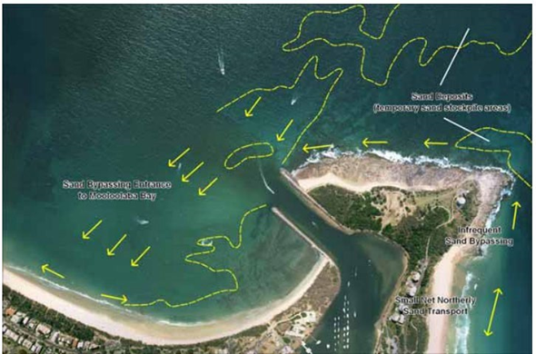
Figure 4-1: Conceptual model of natural bypassing of Point Cartwright (BMT, 2014)

- Cause of sand shoal events. The cause of sand shoal events at the entrance is well understood at a conceptual level and has been replicated using numerical modelling to a reasonable degree.
  - At a high-level, the sand shoal events appear to be the result of a net difference in longshore transport rates across the entrance i.e., the rate at which sediment is arriving from the rocky shelf along the northern coastline of Point Cartwright is significantly greater than the rate at which sediment can migrate across the entrance.
  - This is supported by the consistent formation of the sand shoal events that extend from the end of the eastern breakwater and to the west across to Mooloolaba Beach.
  - The occurrence of sand shoal events is heavily dependent on weather conditions (i.e., wave energy and direction) and the availability of sand to be mobilised that can be transported into the entrance to supply the formation of the shoal.
  - Periods of higher wave energy from the east and north-easterly directions mobilise large volumes of sediments along the northern coast of Point Cartwright supplying sediments into the entrance.
Indicatively, this appears to be wave conditions that are about greater than 2.5m to 3.0m but is more accurately estimated by the numerical model tool.
- Consistent shoal location and shape. The exact location and shape of the sand shoal events is a complex result of the interaction between a range of dynamic coastal processes that occur at the entrance including but not necessarily limited to the incident wave conditions, reflected and refracted waves within Mooloolaba Bay, tidal current flow from the entrance, longshore currents at the breakwaters, net sediment supply to the shoal etc. Despite this complexity, available survey data indicates that the sand shoal events occur in a relatively consistent pattern at the entrance, forming from the east and migrating towards the west (Figure 4-2).
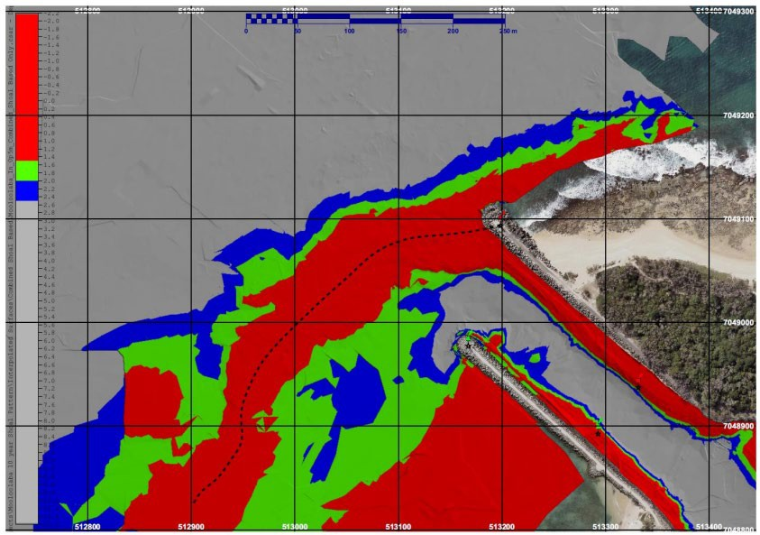
Figure 4-2: Consistent location and shape of sand shoal events at the entrance (i.e., form from the end of the eastern breakwater and extended to the west to Mooloolaba Beach)

Sand shoal numerical model
Several sand shoal models have been developed to help indicate the occurrence of sand shoals at the entrance, including a numerical modelling tool developed by BMT in 2014 as part of the investigation of potential capital works options to manage the shoaling events.
Sand Shoal Indicator
An empirical sand shoal prediction model is currently used to indicate the potential occurrence of sand shoal events using real time wave data from local wave buoy data (magnitude, direction and period). The model was developed in 2005 and uses a conceptual bucket model with empirical sediment transport calculations to infer sediment transport towards the entrance:
- Real time wave conditions are used to empirically calculate sediment transport at both Buddina Beach (i.e. input of sand to Point Cartwright headland bucket) and across the northern coastline of Point Cartwright (towards the entrance).
- Net volume of sediment ‘stored’ in the conceptual headland ‘bucket’ is calculated. When at least 100,000 m³ of sand is ‘stored’ within the headland bucket, sediment transport towards the entrance is calculated.
- Model is manually run periodically.
The model was developed and calibrated on a large series of wave model runs and previous shoaling events. While the model is empirical in nature and relatively simple, it has performed reliably well at generally indicating sand shoaling events and appears to be a practical and cost-effective tool to monitor sand shoaling. However, there remain several limitations, including:
- Calibration is based on early wave model runs and shoaling events. Model could be reviewed with more recent survey data and against a numerical model.
- Only calculates inferred sediment transport and assumes sediment is always available to be transported. This limitation is likely to over-estimate the occurrence of sand shoal events rather than underestimate. Recent survey data or drone monitoring data should be used to confirm actual sediment transport volumes.
- Model relies on empirical sediment transport calculations to infer sand transport volumes into the shoal and net volume stored within the bucket, and a simplistic approach to headland bypassing. Therefore, the actual stored volumes of sediment that could be mobilised to form a sand shoal may differ from what is modelled. Recent survey data or drone monitoring data should be used to confirm stored sand volumes.
- Uses real-time wave data only. Options to improve longer term predictability of the model should be considered.
- Model is manually run periodically.
Recommendations: The following should be considered in to improve the use of the existing model or the overall monitoring and prediction of sand shoals:
- Continue to incorporate use of drone monitoring data and available survey data to confirm reliability or re-calibrate the model over time.
- Automate the model as a real-time service.
- Use forecasted wave data (1 – 2 weeks) and typical seasonal conditions.
- Consider upgrading model to (or use in conjunction with) a calibrated numerical model which can provide not only a more reliable indicator of sand shoal events but a greater understanding of the extent and location of the sand shoal.

Prediction of shoaling events
Prediction of sand shoaling events at the entrance is currently limited to the use of the empirical sand shoal indicator model with real time wave data to infer a sand shoal trend. Options to improve the prediction timeframe should be considered to allow for earlier survey and contact with local dredge contractors.
The use of forecasted weather conditions could be trialled either with the existing tool or an upgraded numerical modelling tool to predict sand shoal likelihood in the near-term.
However, accurate weather forecasts are limited to 1 – 2 weeks which does not provide much time to mobilise a hydrographic surveyor to confirm depths and a dredger in advanced of the event (unless one was available on standby), with reactive dredging likely undertaken following the event.
Alternatively, assumed seasonal weather conditions could be used to check the likelihood of sand shoals over the next several months.
While short-term shoal prediction may be possible with modelled weather forecasts and accurate site data, there remains longer-term uncertainty with predictions of shoaling events. Influence of decadal weather cycles or global weather patterns (e.g., El Nino/La Nina) is not known. Longer term predictive indicators may not be available. Therefore, proactive options to mitigating shoal events are recommended to account for this uncertainty.
The following are high-level coastal, social, environmental and economic impacts caused by the presence of sand shoal events.
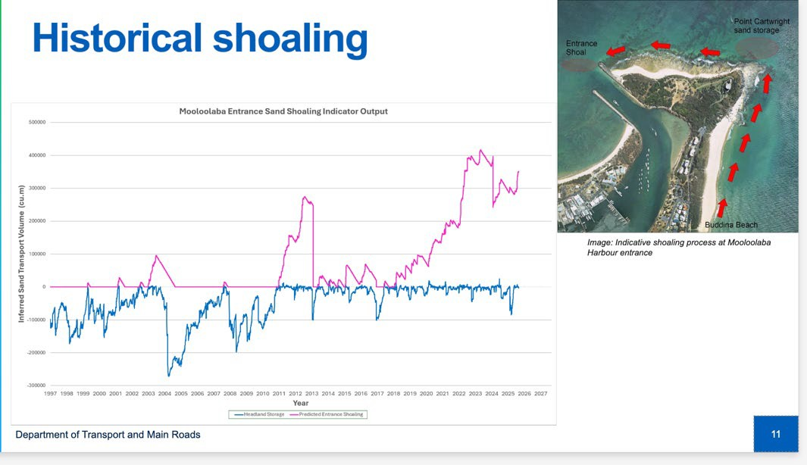
Figure 4-3: Historical sand shoaling indicator results between 1997 and 2025

Coastal impacts
Coastal processes at the entrance and around the shoaling events is complex and affected by a range of dynamic weather and site conditions. However, the following high-level coastal impacts appear to be occurring:
- Increased wave height and steepness over the accumulation of sand, due to wave shoaling, as shown in Figure 4-4. This effect results in more hazardous marine conditions at the entrance.
- Wave refraction and impacts to the wave field caused by wave breaking and shoaling can also contribute to more challenging navigation conditions at the entrance.
- Evidence of redirection of tidal ebb and flood flows at the entrance as the shoal forms from the east towards the west, typically directing the tidal channel to a more westward direction.

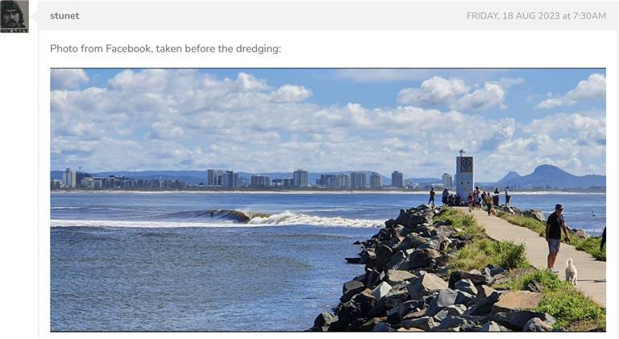
Figure 4-4: Example of waves shoaling and breaking during a sand shoal event at the entrance

EXISTING ENVIRONMENT
This section describes the key environmental characteristics (terrestrial and marine) of the area surrounding the Mooloolaba Boat Harbour entrance channel potentially impacted by the current and proposed short- or long-term shoaling management options. This area includes Point Cartwright and La Balsa Park, the Mooloolaba foreshore and shoreline from the southern end of Buddina beach to the north end of Mooloolaba beach.

Physical environment

Hydrodynamics
The Mooloolaba shoreline is shaped by waves, tides and long-shore sand movement, its beaches and dunes form a dynamic system that both absorbs energy from storms and nourishes surf-quality sands. The Mooloolah River system drains a relatively small catchment with an area of 196 square kilometres that extends 25 kilometres inland from the coast. It flows east-northeast from the Blackall Range, discharging to the sea between Mooloolaba and Point Cartwright (Sunshine Coast Council, 2023a). The net sediment transport is northward; sand is transported around Point Cartwright from Buddina Beach when there is sufficient accumulation at the northern end of Buddina Beach and favourable wave conditions occur (BMT, 2013).

Climate
The Sunshine Coast experiences a sub-tropical climate with long summers that are warm and wet and mild winters that are short, cool, and relatively dry. Mean minimum and maximum temperatures vary between 20 and 29.1 °C in summer and 9.7 and 22.3 °C in winter (BOM, 2025). Annual rainfall is approximately 1500 mm, with an average of 600 mm falling over 48 days. The Sunshine Coast experiences a seasonal wind climate. Winds are predominantly from the south-east; east to south-easterly trade winds dominate between April and September (BMT, 2013). During the summer months lighter east to north-easterly sea breezes occur. Generally, November to April is the tropical cyclone season. Tropical cyclones and east coast low pressure systems often bring destructive wind to the region, generating storm surges and extreme waves (BMT, 2013).

Water quality
Maintaining water quality in the Maroochy estuary and nearby coastal waters is fundamental to preserving these interconnected habitats. The Maroochy River Environmental Values and Water Quality Objectives report (DESI, 2022) recognises protection of aquatic ecosystems as its primary goal and requires that developments avoid increases in turbidity, suspended solids or nutrient loads that could smother seagrass or disrupt food webs. The estuarine water quality in the Mooloolaba Boat Harbour was described as excellent in the 2021 catchment summary by HLW (2021) despite a slight decrease in dissolved oxygen in the mid-estuary. Where there are seagrass meadows, good local water clarity for light penetration is required to safeguard their extent, species diversity and depth limits (Sunshine Coast Council, 2023a).

Sediment quality
The physical and chemical properties of sediments at and adjacent to the Mooloolaba Harbour Entrance and the existing disposal area offshore of Mooloolaba Main Beach in 2009 (FRC, 2009). The results indicated that the settling rates of these sediments were relatively quick with 90% of particles setting within 18 seconds. Organic carbon and nutrients levels were found to be relatively low, and all tested metals/metalloids and organic compounds were either below the limit of reporting or below the relevant NAGD (DEWHA, 2009) guidelines.
Further, the sediments in the Mooloolaba Harbour were assessed by BMT (2018) ahead of maintenance dredging works in the harbour. The results of the sediment sampling showed that concentrations of all tested metals/metalloids and organic compounds were below the relevant NAGD (DEWHA, 2009) and NEPM (NEPC, 2013) guidelines. These results indicate the sediment within the Harbour was free of contaminants and can be considered clean and suitable for ocean disposal or beach nourishment.
It is noted that MSQ is in the process of obtaining recent data that will be reviewed when available.

Biological environment
Over 60 percent of the Sunshine Coast’s foreshores remain in a natural or near-natural state, sustaining iconic species such as marine turtles, dugong, migratory birds and whales (Sunshine Coast Council, 2023a). Specifically, La Balsa Park and Point Cartwright Reserve provides habitat for several of these species.
Further, the coast off Mooloolaba supports a range of intertidal and marine communities whose health underpins both ecological resilience and the recreational character of the region. Extending from nearshore seagrass meadows through to mangrove fringes and saltmarsh to offshore reef systems, these habitats provide critical nursery and feeding grounds for turtles, fish, crustaceans and shorebirds, while stabilising sediments and cycling nutrients essential to coastal waters. The Point Cartwright and La Balsa Park Master Plan highlight the importance of maintaining nearshore hard-coral assemblages beyond the surf zone and protecting fish habitat areas under the Fisheries Act 1994 (Sunshine Coast Council 2023a and DESI 2022). Riparian corridors and adjacent wetlands further enhance this diversity, offering refuge for waterbirds, turtles and aquatic mammals.

Environment Protection and Biodiversity Conservation Act 1999
A review of the Environment Protection and Biodiversity Conservation Act 1999 (EPBC) Protected Matters Search Tool (PMST) results (DCCEEW, 2025) was undertaken to determine if any species listed under Matters of National Environmental Significance (MNES) occur within or in the vicinity of the potential areas of disturbance. The search was undertaken over an area centred on the current dredge and dredge disposal areas with a 2 km radius and the full PMST results are detailed in Appendix A.
While no critical habitats are listed as present in the search area, one habitat critical to the survival of marine turtles which is known to occur in the study area: Loggerhead turtle nesting between November and February (DCCEEW, 2025). The PMST results lists the following biologically important areas (BIAs) known to occur in the search area:
- Breeding BIA for Indo-Pacific Humpback Dolphin (Sousa chinensis)
- Breeding BIA for Indo-Pacific/Spotted Bottlenose Dolphin (Tursiops aduncus)
- Nesting BIA for Loggerhead Turtles (Caretta caretta)
- Foraging BIA for Grey Nurse Shark (Carcharias taurus)
- Migration BIA for Humpback Whales (Megaptera novaeangliae)
Five threatened ecological communities (TEC) are listed as present in the PMST search area. The PMST results lists the following TECs that are likely to or may occur in the search area:
- Subtropical eucalypt floodplain forest and woodland of the New South Wales North Coast and South East Queensland bioregions endangered TEC likely to occur.
- Coastal Swamp Sclerophyll Forest of New South Wales and South East Queensland endangered TEC likely to occur.
- Coastal Swamp Oak (Casuarina glauca) Forest of New South Wales and South East Queensland endangered TEC likely to occur.
- Subtropical and Temperate Coastal Saltmarsh vulnerable TEC likely to occur.
- Lowland Rainforest of Subtropical Australia critically endangered TEC may occur.

Nature Conservation Act 1992 Threatened Species
A review of the Wildnet database (DETSI, 2025) managed by the Department of Environment and Science, was undertaken to determine if any species of conservation significance under the Queensland Nature Conservation Act 1992 (NC Act) occur within or in the vicinity of the potential areas of disturbance. The search was undertaken over an area centred on the entrance to the Mooloolaba Boat Harbour with a 2 km search radius and the full Wildnet results are detailed in Appendix A. A total of 136 species of fauna were recorded on the Wildnet database within or in the vicinity of the study area, comprising two amphibia, 120 aves, five insecta, three mammalia and six reptilia (DETSI, 2025). The majority of the species listed as conservation significant species under the NC Act and were recorded in the La Balsa Park and Point Cartwright Reserve.
Additionally, a search of the ATLAS of living Australia database (ALA, 2025) was undertaken to compare and verify the species of conservation significance under the NC Act returned from the Wildnet database. The search was undertaken over the same area as the Wildnet search. These results are detailed in the following sections.

Marine fauna and flora

Turtles
Turtle species listed under the EPBC Act identified in the PMST search (DCCEEW, 2025) that may be impacted by activities at the Mooloolaba Boat Harbour include the leatherback turtle, loggerhead turtle, olive ridley turtle, green turtle, flatback turtle and hawksbill turtle. The ATLAS of Living Australia contains records of the green turtles in the area, which is listed as vulnerable under the NC Act, although the Wildnet search of this area did not identify this species (ALA, 2025).
The EPBC Act PMST search listed a loggerhead turtle (endangered) nesting BIA in the area as well as a habitat critical to the survival of loggerhead turtles.
Loggerhead turtles, (listed as endangered under the EPBC Act) and Geen turtles and Flatback turtles (listed as vulnerable under the EPBC Act) are known to breed in the dunes and beaches around Mooloolaba Boat Harbour, with a Loggerhead turtle nesting BIA in a habitat critical to the survival of Loggerhead turtles listed in the PMST search. Surveys and turtle monitoring conducted by TurtleCare Sunshine Coast have found the predominant species of nesting turtles in the area are Loggerhead and Green turtles, and monitoring has found Buddina Beach, specifically the northern part closest to Point Cartwright, contains one of the highest numbers of nest sites on the Sunshine Coast, due to the landform including a high dune system that creates a dark land silhouette (Figure 5-1).
Turtles nest on the Sunshine Coast in Summer, typically from October to December, with peak nesting occurring over the first two weeks of November (Hofmeister et al. 2019). Specifically, loggerhead turtle nesting occurs between November and February. Turtle nest data in the Sunshine Coast Turtle Nesting Technical Report 2005 – 2016 (Hofmeister et al. 2019) indicates loggerhead and green turtle nests were on average 31.5 cm and 30 cm deep (to the top of the eggs), respectively.
Artificial light is one of the main threats to nesting turtles, leading to deterrence of nesting behaviour and disorientation of hatchlings leading to exhaustion, dehydration and predation.

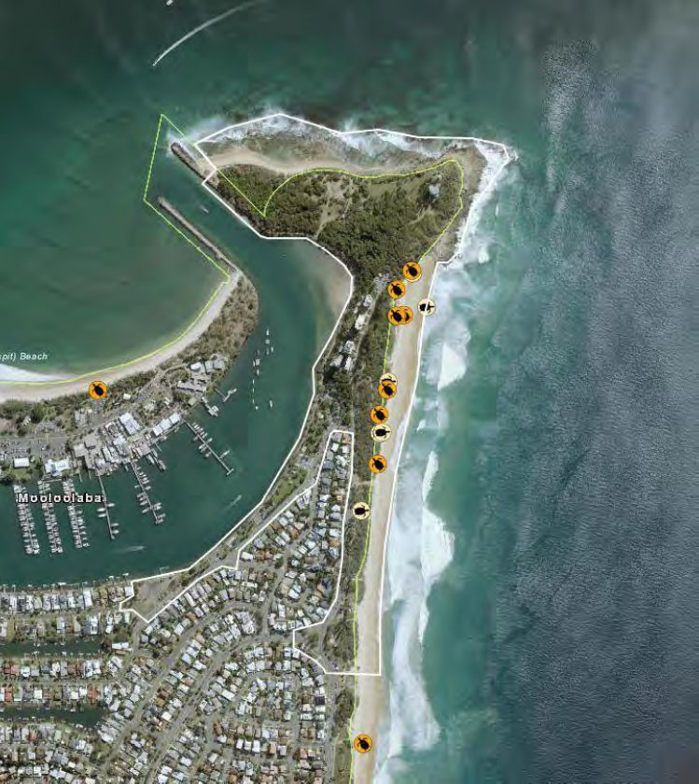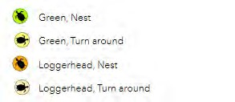
Figure 5-1: Marine turtle nesting areas identified in 2020 – 2021 (Source: FPE, 2022)

Marine mammals
Eight marine mammal species listed as threatened and/or migratory under the EPBC Act were identified through a PMST search for the area and all have a migratory status. Two are classified as endangered (blue whale and southern right whale) and two as vulnerable (Australian snubfin dolphin and Australian humpback dolphin). ATLAS of Living Australia returned some records of Sousa sahulensis (Australian humpbacked dolphin) and Orcaella heinsohni (Australian snubfin dolphin), listed as vulnerable NC Act (ALA, 2025).
Further, multiple marine mammal species have BIAs in waters near to the Mooloolaba Boat Harbour. Megaptera novaeangliae (humpback whale) have a migration BIA through the region and their seasonal migration runs from June to early October. In 2020 local groups reported a total of 23 whale sighting events around Point Cartwright (FPE, 2022). There is potential for humpback whales with calves to use the Mooloolaba beach area as resting place during their migration, however there is currently no data supporting this.
The waters surrounding Point Cartwright are also breeding BIAs for Australian humpback dolphin (Sousa sahulensis) and Indo-Pacific/spotted bottlenose dolphin (Tursiops aduncus). However, the Indo-Pacific/spotted bottlenose dolphin breeding BIA encompasses all coastal waters in Queensland and NSW (DoE, 2025a) and the Australian humpback dolphin breeding BIA covers most coastal waters of south-east Queensland, including all of the Sunshine coast (DoE, 2025b), indicating these BIAs are unlikely to be significantly impacted by the proposed activities near the Mooloolaba Boat Harbour. There is little available data about the presence of these species in the area.
In addition, Wildnet and ATLAS of Living Australia have records for the area that include Arctocephalus tropicalis (Subantarctic fur seal), which is listed under the NC Act as vulnerable (DETSI 2025 and ALA 2025). Further, there have been observations of Arctocephalus forsteri (New Zealand fur seal) and Dugong dugon (dugong) within the waters surrounding Point Cartwright (FPE, 2022).

Seabirds, Shorebirds and Raptors
Note, while shorebirds and raptors are not marine fauna, they are discussed in this section so that all bird-related topics are kept together.
Point Cartwright Reserve is considered to hold value as a roosting and feeding location for resident and migratory seabirds and shorebirds, including conservation significant species (Sunshine Coast Council, 2023a). As such, the Commonwealth Shorebird Conservation Action Plan (2020), which provides a framework to guide the conservation of migratory shorebirds and their habitat in Australia, includes the Point Cartwright Reserve. The Sunshine Coast in general is an important nesting habitat for resident and migratory shorebirds and is an important habitat in the East Asian-Australasian Flyway, which is one of only eight international routes taken by migratory birds (Sunshine Coast Council, 2023a). Seabirds and shorebirds most likely to be impacted by the Mooloolaba Boat Harbour current and proposed activities are those that roost and forage in the Point Cartwright and La Balsa Park area or on the Mooloolaba or Buddina beaches.
Surveys conducted by the Queensland Wader Study group in the Point Cartwright and La Balsa Park area have recorded several species of birds, including conservation significant species, within the area, such as the eastern osprey (Pandion cristatus) and wandering tattler (Tringa incana) (FPE, 2022). The PMST search returned 39 bird species that are classified as threatened under the EPBC Act: 5 critically endangered, 7 endangered and 27 vulnerable. Further, 13 bird species classified as migratory but not threatened under the EPBC Act were listed to potentially occur in the area.
Birds contribute the majority of the conservation significant species under the NC Act that potentially occur in the area, based on searches of the Wildnet and ATLAS of Living Australia databases (DETSI 2025 and ALA 2025). Based on the Wildnet database,14 bird species listed as conservation significant under the NC Act may occur in areas (or in the vicinity of areas) potentially impacted by the short and/or long-term solutions, these are listed in Appendix A. Of the 14 conservation significant bird species under the NC Act, two species, the Western Alaskan bar-tailed godwit and eastern curlew, also have national conservation significance under the EPBC Act. The birdlife database contains close to 6000 records of conservation significant bird species under the EPBC Act and/or NC Act, and/or migratory bird species for the Point Cartwright area and close to 2000 of the records are seabird records, based on a review of the Birdlife database (Birdlife Australia, 2025). The majority of the records in the Wildnet search were located in the La Balsa Park and Point Cartwright Reserve, which was reported as an area of high ecological value in the Point Cartwright Reserve and La Balsa Park Master Plan by the Sunshine Coast Council (2023a), based on the following site-based assessment:
- identified high tide roost site
- presence of nesting species (Sooty Oystercatcher; listed species in NSW and Victoria, but not in Queensland)
- presence of conservation significant species under the NC Act (terns, wandering tattler and eastern ospreys)
- distance to other suitable roost areas.
Further, the conservation significant Eastern osprey is known to reside in Point Cartwright reserve; they are considered important and iconic raptors and often gain a large amount of public interest due to their hunting prowess, and reuse of nesting sites over many years (Sunshine Coast Council, 2023a). Artificial nesting platforms have been installed at many sites across the east coast due to a historical reduction in natural nesting sites, including the Mooloolaba Spit which has been successful in attracting revisiting mating pairs of ospreys (Sunshine Coast Council, 2023a).
Therefore, ongoing management of the Mooloolaba area to retain value for seabird and shorebird populations is an important consideration for shoaling management activities (FPE, 2022).
Habitat use, roosting, foraging and potentially nesting activities differ between seabirds and shorebirds. Seabirds are aerial feeders and are more susceptible to impacts to water clarity whereas shorebirds forage for food in soft sediments, often in the intertidal zone. Point Cartwright and Buddina beach are secondary shorebird habitats as a primary shorebird habitat exists to the north, around the lower Maroochy River (Sunshine Coat Council, 2020).
Generally, primary habitats are more critical to shorebirds than secondary habitats because shorebirds prefer to forage and roost closer to these. Migratory shorebirds are most likely to occur at Point Cartwright and surrounding beaches in the summer because they spend their summers in Australia before migrating north (Sunshine Coast Council, 2023a). Point Cartwright contains habitat for a range of seabirds, which are likely to congregate in the area for roosting, feeding and potentially nesting.
Little terns are one of the threatened seabirds that occur at Point Cartwright, with 332 records from around Point Cartwright in the birdlife database (Birdlife Australia, 2025) and are more susceptible to impacts to water clarity due to their small (50 m) foraging range from shore (DoE, 2025c) compared to other threatened seabirds that potentially occur in the area based on the PMST search. Further assessment of bird occurrence and habitat use in the project area is required to fully assess the potential impact of the proposed shoaling management activities on the seabirds and shorebirds in this area.

Other significant marine fauna

Site attached marine fauna
Two site-attached species of marine fauna, the White’s seahorse (Hippocampus whitei) and sand yabby (Cherax robustus), are classified as conservation significant under the EPBC Act and were listed to potentially occur in the area from the PMST search. The ATLAS of Living Australia contains records of White’s seahorses in the area, which are classified as endangered under both the EPBC Act and NC Act.
Although they aren’t listed as conservation significant species, Nudibranchs commonly occur in lower reaches of the Mooloolah River (FPE, 2022). In total, 610 species of nudibranch have been documented by local dive groups over 7 years along the shores of La Balsa Park (FPE, 2022) and The Nudibranchs of the Sunshine Coast Queensland Australia and Indo-Pacific database (Cobb G, 2025) contains 749 records of Nudibranch in the Mooloolah River and La Balsa Park region. Nudibranchs short life span causes them to be susceptible to environmental disturbances.

Mobile marine fauna
Grey nurse sharks (Carcharias taurus) have a known foraging BIA in the vicinity of the project area (DCCEEW, 2025). Grey nurse sharks (east coast population) are listed as critically endangered under the EPBC Act and are protected under the Fisheries Act 1994 and the east coast population of these sharks aren’t classified as migratory. The scalloped hammerhead (Sphyrna lewini) is listed as conservation dependent under the EPBC Act may occur in the coastal waters near to the Mooloolaba Boat Harbour. There are six other species of sharks and rays that are listed as conservation significant under the EPBC Act that may occur in waters near the Mooloolaba Boat Harbour based on the PMST search but are unlikely to be impacted by the activities being proposed at the Mooloolaba Boat Harbour due to their presence (“may” occur) or the large-size of their habitat, such as the White shark (Carcharodon carcharias). One freshwater species was returned in the PMST search that will not be impacted by the proposed activities because it only inhabits freshwaters, which won’t be impacted by the activities based on the current stage of design. The ATLAS of Living Australia contains records of the Australian lungfish (Neoceratodus forsteri) in the area, which is listed as vulnerable under the NC Act, although the Wildnet search of this area did not identify this species. Also, the PMST search listed four species of sharks and rays, which are not threatened, may migrate through the area but there is limited data available on these.

Benthic habitats
The most recent benthic surveys within and near to the Mooloolaba Boat Harbour entrance indicates the benthic habitat in the area is comprised of predominantly bare sand with rocky rubble and minimal benthos (KBR, 2023; Table 5-1; Figure 5-2). The majority of the subtidal seabed in the area is characterised by bare mobile sand (Figure 5-3). Small patches of exposed rocky reef with minimal benthos occur further offshore and is interspersed with bare mobile sands with minimal benthos (Figure 5-4). Further inshore as water depth decreases marine benthos increases with the lower intertidal rocky reef system, supporting a diverse range of marine life, including red and green macroalgae species and Cunjevoi (Pyura stolonifera), Figure 5-5 (KBR, 2023).
The entrance channel to the Mooloolaba Boat Harbour is influenced by strong tidal and catchment flows within the Mooloolah River. The channel bed primarily consists of bare mobile sands with patches of rocky rubble observed along the south-western boundary of the survey area and running parallel to the eastern breakwater structure (KBR, 2023).
Further assessment, potentially including surveys, is required to identify all benthic habitats over the current dredge and dredge disposal areas and proposed long term options disturbance footprints, specifically those habitats where conservation significant marine fauna reside.

Table 5-1: Summary of marine benthic habitats mapped in Figure 5-2 (Source: KBR, 2023)
Mapped area | Description of marine plant and benthic habitat characteristics
Bare mobile sand | - Seabed dominated by bare mobile sand (100% bare sand)
Rocky rubble on sand | - Bare mobile sand with exposed patches of rocky rubble within subtidal and intertidal portions of the entrance channel.  - Minimal benthos present with small amounts (<5% cover) of green algal turf observed on the intertidal rocky rubble.
Breakwater rock subtidal zone | - Subtidal breakwater rock with minimal (5% cover) of benthos and barnacles
Breakwater rock intertidal zone | - Lower intertidal breakwater rock dominated by Cunjevoi, Coralline algae and Red algae (30% cover)  - Upper intertidal breakwater rock dominated by molluscs (10% cover)
Breakwater rock intertidal zone entrance channel | - Rock along toe of breakwater with occasional green algal turf (<1% cover)
Subtidal rocky reef | - Subtidal exposed rocky reef with minimal (10% cover) marine benthos interspersed with mobile bare sands
Intertidal rocky reef | - Intertidal rocky reef which supports a diverse range of marine species including macroalgae and seaweeds (30% cover)  - Green and red macroalgae most prevalent, with Cunjevoi and red macroalgae increasing in density towards the lower intertidal zone  - Other species observed include soft coral, anemones, sea cucumbers, chitons, whelks, periwinkles and sea hares.
Upper intertidal rocky reef | - Upper intertidal rocky reef characterised by exposed rock with green algal turf (10% cover of exposed rock)
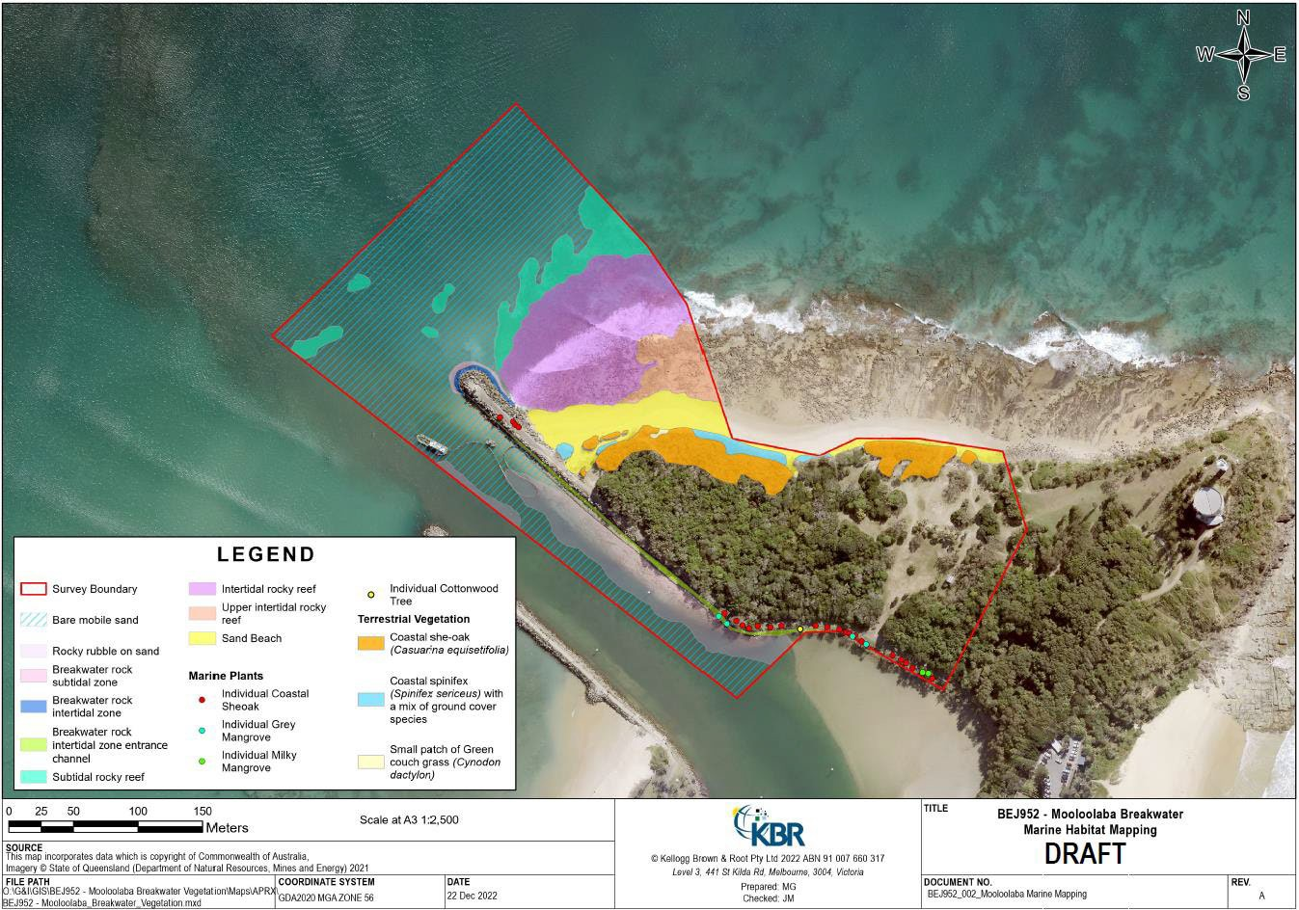
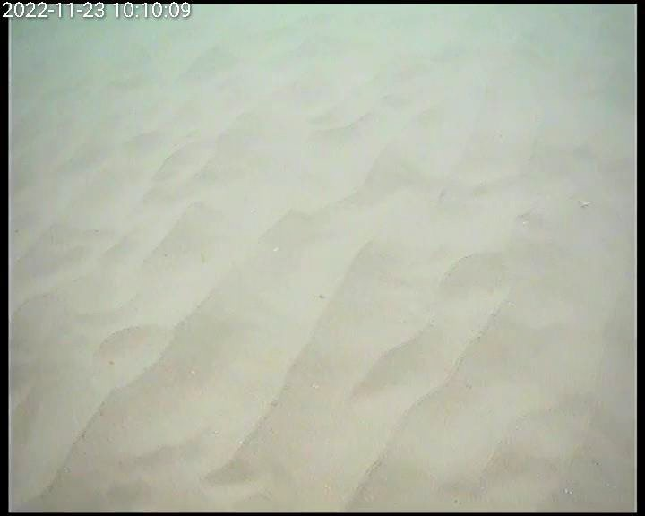
Figure 5-2: Benthic habitat map (Source: KBR, 2023)
Figure 5-3: Bare mobile sand within subtidal waters (Source: KBR, 2023)
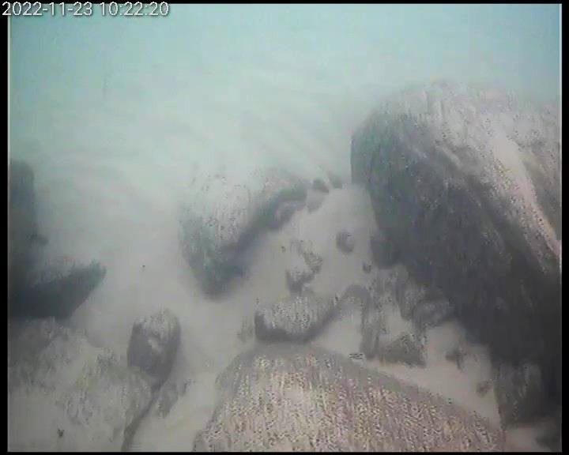
Figure 5-4: Bare mobile sand with exposed subtidal rocky reef within the offshore area (Source: KBR, 2023)
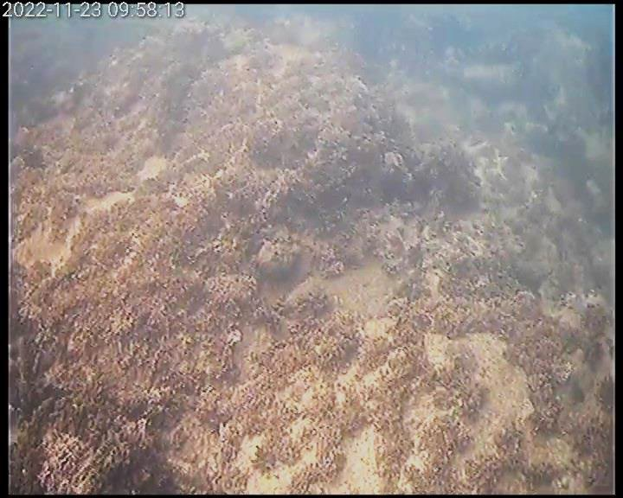
Figure 5-5: Lower intertidal rocky reef with macroalgae (Source: KBR, 2023)

Terrestrial fauna and flora
The Point Cartwright Reserve and its immediate surrounds comprise vegetation communities that provide habitat to a range of flora and fauna, some of which is critically endangered and nationally significant (Sunshine Coast Council, 2023a). The terrestrial habitats adjacent to the Mooloolaba Boat Harbour were mapped in 2023 (Table 5-2; Figure 5-6; KBR, 2023). The main target species of the KBR (2023) terrestrial vegetation survey was Acronychia littoralis, however the Acronychia species observed on site was Acronychia imperforata (listed by Department of the Environment, Tourism, Science and Innovation as Common).

Table 5-2: Summary of terrestrial fauna habitats mapped in Figure 5-6 (Source: KBR, 2023)
Mapped area | Description of terrestrial plant characteristics
Coastal spinifex (Spinifex sericeus) with a mix of ground cover species | Small patches of Coastal Spinifex (Spinifex sericeus) within close proximity to the breakwater. Made up of approx. 90% Coastal Spinifex, 5% Dune Bean (Vigna marina), 2% American sea-rocket (Cakile edentula). with the remainder as disturbance and Cobblers Pegs (Bidens Pilosa).  Approximately 3 m strip of 100% Coastal Spinifex (Spinifex sericeus), extending to 6 m width further east.
Coastal she-oak (Casuarina equisetifolia) | Four individual Coastal she-oaks (Casuarina equisetifolia) with patches of Coastal spinifex (Spinifex sericeus) east of the breakwater structure  Two stands of Coastal She-oaks (Casuarina equisetifolia) with a ground cover of Dune bean (Vigna Marina) and Cobblers Pegs (Bidens Pilosa), with scattered Sea purslane (Sesuvium portulacastrum) extending to the east around the headland of Point Cartwright
Small patch of Green couch grass (Cynodon dactylon) | Small patches of vegetation consisting of 95% green couch gras (Cynodon dactylon) and approx. 5% of combined Warrigal greens (Tetragonia tetragonioides) and Blue Flax Lily (Dianella sp.)
Coastal foreshore along breakwater structure and rock revetment | Individual marine plants located on either side of the pathway on top of the breakwater structure:  - 4 Coastal she-oaks (Casuarina equisetifolia)  - Small patch of Boobialla (Myoporum acuminatum)  - Individual plants located on the seaward side of the existing pathway which follows the rock revetment include:  - 19 Coastal she-oaks (Casuarina equisetifolia) (adjacent to path amongst maintained lawn)  - 1 mature Grey mangrove (Avicennia marina) (on rock revetment)  - 2 juvenile Grey mangroves (Avicennia marina) (amongst rock revetement)  - 1 regrowth Grey mangrove (juvenile) on trimmed mangrove roots (Avicennia marina) (on rock revetment)  - 2 mature Milky mangroves (Excoecaria agallocha) (on rock revetment)  - 1 mature Cottonwood tree (Hibiscus tilliaceus) (on top of rock revetment)  - Revetment is free of plants except 10 cm diameter of  - Seablite (Suaeda australis) (north of Cottonwood tree)
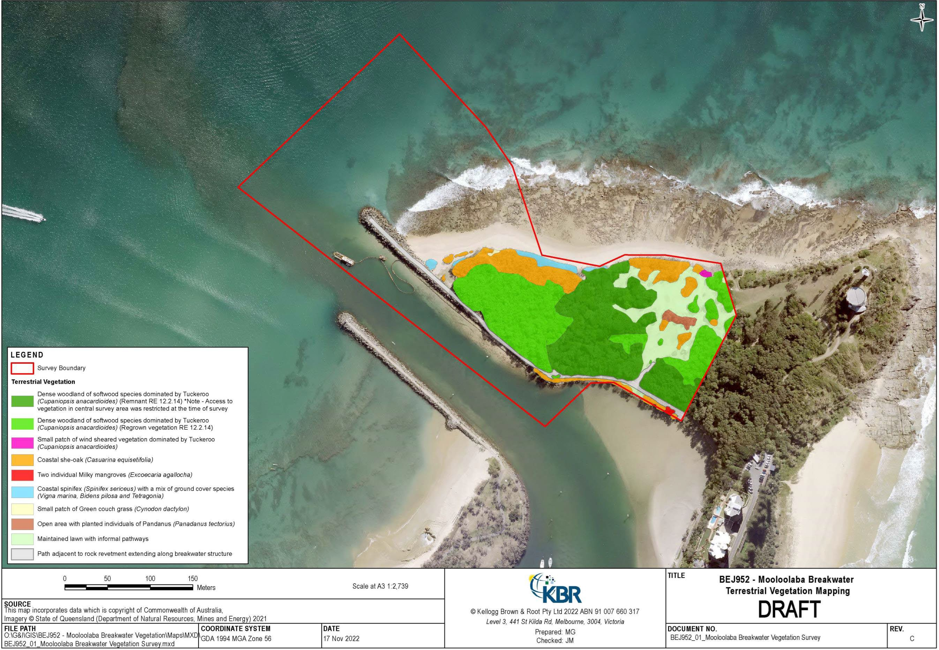
Figure 5-6: Terrestrial vegetation map (Source: KBR, 2023)

State significant habitats and flora
The Point Cartwright Reserve and Buddina Beach dune habitat include areas mapped by Queensland Government as Matters of State environmental significance (MSES), including:
- MSES high ecological significance wetlands – the entire rocky foreshore area
- MSES wildlife habitat (endangered or vulnerable) – Buddina beach dunal habitat
- MSES wildlife habitat (special least concern animal) – all naturally vegetated parts of the site
- MSES wildlife habitat (sea turtle nesting areas) – all ocean facing parts of the site
- MSES regulated vegetation (category B – endangered or of concern)
- MSES regulated vegetation (essential habitat) – Buddina Beach dune vegetation.
Further, the area contains two regional ecosystems (RE) mapped by Department of the Environment, Tourism, Science and Innovation (DESI) and listed under the Vegetation Management Act 1999: (Queensland Herbarium, 2024):
- Category B ‘of concern’ (RE 12.12.19) – A vegetation complex of exposed headlands of remnant Tertiary surfaces. Typically, this vegetation type includes species such as Themeda triandra grassland and wind-sheared shrubland and woodland
- Category B ‘least concern’ (RE 12.2.14) – A strand and foredune complex. This vegetation type tends to include species such as Spinifex sericeus grassland as well as Casuarina equisetifolia subsp. incana low woodland/open forest with Acacia sp., Banksia integrifolia and Corymbia tessellaris.
Two flora species listed as threatened under the NC Act have been reported in Point Cartwright Reserve: Pararistolochia praevenosa (Richmond birdwing butterfly vine) – ‘near threatened’ and Murraya crenulata (Smyrell's clausena) – ‘endangered’.

Commonwealth significant habitats, flora and fauna
The Point Cartwright Reserve and nearby vegetated areas include areas of MNES, including five TECs listed under the EPBC Act PMST search (DCCEEW, 2025). The PMST search covered the current dredging and disposal areas with a 2 km buffer, which may have captured TECs that are inland of the area of interest and are unlikely to be impacted by the Mooloolaba Boat Harbour activities. Additionally, one study of the Point Cartwright and La Balsa Park area identified one TEC was present, the Littoral rainforest and coastal vine thickets of eastern Australia TEC (FPE, 2022), which was not listed in the PMST search. The investigation also determined the TEC Coastal Swamp Oak (Casuarina glauca) Forest of New South Wales and South East Queensland were not present in the Point Carwright and La Balsa Park area. Further, no threatened plant species have been reported immediately adjacent to the Mooloolaba Boat Harbour (KBR, 2023).
There are 13 terrestrial fauna species listed under a threatened category of the EPBC Act that were identified in the PMST search as potentially occurring in the area, including mammals, insects and reptiles (Appendix A). Further assessment will be required to determine if these occur in the immediate vicinity of the Mooloolaba Boat Harbour.

SOCIAL IMPACT EVALUATION
In determining the best solution for the Mooloolaba Harbour Entrance, it is important to consider the long-term and short-term economic, environmental and social impacts of any option. This has been done through the development of a Social Impact Evaluation (SIE) in accordance with the Social Impact Evaluation Guide, Business Case Development Framework, Release 3 (2021) developed by the Queensland Government.
An SIE is included in Appendix B and aims to identify the stakeholders and impacts (positive and negative) of the options under consideration and determine mitigation or enhancement measures that can be implemented to ensure lasting social and economic benefit.
The SIE has been informed through desktop research to establish a social baseline for the area along with valuable feedback provided by the Stakeholder Reference Group (SRG).

Stakeholder reference group
In 2022, a Stakeholder Reference Group (SRG) was formed with local representatives from the Coast Guard, commercial and recreational fishers, harbour business owners, and residents and community groups. The role of the SRG has been to enable community input into the long-term solution for the Mooloolaba Boat Harbour entrance project and provide an opportunity for community issues to be addressed by
the project team. The SRG has been presented with data and modelling of shoaling events as well as a range of options, with benefits and constraints, to reduce the impacts of shoaling for consideration and discussion amongst the group. Through the SRG the current mitigation strategy was determined being the Western Channel Trail – to maintain a safe, navigable channel to the west of the harbour entrance.
The SRG has met on four occasions as follows:
- Wednesday 28 September 2022 – 24 attendees, 3 apologies
- Wednesday 12 October 2022 – 19 attendees, 9 apologies
- Tuesday 30 April 2024 – 11 attendees, 6 apologies, 10 absent
- Thursday 2 October 2025 – 16 attendees, 31 apologies
SRG members were provided with the history of the Mooloolaba Boat Harbour Entrance which included:
- Training walls built in late 1960s; eastern breakwater shorter than planned
- Shoaling has increased in duration over the last 10 years, with significant sand movement during 2011-2013 event
- Shoaling influenced by wave conditions, sand transport from Buddina Beach, and natural coastal processes
- Questions addressed about wave directions, historical shoaling, dredging productivity, and sand impact inside harbour.
At the SRG meetings, a number of options have been discussed and considered including:
- Option 1: Permanent Automatic Sand Bypassing System
- Option 2: Increased dredge channel depth with rock excavation
- Option 3: Excavated sand trap on headland
- Option 4: Breakwater extension
- Option 5: Buddina Beach sand trap.
The feedback from the SRG on these options is detailed in Table 6-1.
Table 6-1: Options presented to SRG and feedback received
Option | SRG feedback/questions
Option 1 – Permanent Automatic Sand Bypassing System | A number of questions were raised by the SRG including option to reduce visual impact of the system, the costs for construction and operation and if it could be operated by solar power.  MSQ confirmed that the system would need to be high enough to be out of storm water levels, that costs were estimated to be $120m to construct and $2m per year to operate and that solar was not a suitable option due to the energy required to run the pumps.
Option 2 – Increased dredge channel depth with rock excavation | The SRG raised a number of questions including how much time a deeper dredge channel would provide benefit for during a shoaling event; the costs of the works; the integration of an automatic pump with this option; potential impacts to beaches to the north; the operation times of the dredge and where excavated material would be located.  MSQ confirmed that the trench could maintain a months’ worth of shoaling; there are two benefits of the option, both maintaining a deeper channel to buffer shoaling events and to provide deeper margin for generating a buffer – the option still requires ongoing dredging; an automated pump requires removal for servicing and on-land support infrastructure, placing it in a channel presents logistical and navigational constraints; under the Coastal Protection and Management Act 2003, any final option that is chosen will have to ensure sand flow to the beach is maintained in perpetuity; the dredge occasionally works on weekends, however, this is discouraged as this is when the main recreational activity happens in the harbour; excavated material would need to be shipped or trucked out and may be problematic finding a location.
Option 3 – Excavated sand trap – without breakwater extension | The SRG raised a number of questions including: the required size of the hole, why it can be bigger than the entrance channel, if it can be located further east, if a longer channel could feed sand offshore, potential impacts to the surf break and if a crane can go out onto the current breakwater to reach the whole.  MSQ confirmed that further investigations would need to occur to understand the size needed, the location can be flexible so long as it catches the sand before entering the entrance, it cannot be further offshore as it will just fill with sand without any wave energy, a large excavation on the head is likely to impact the headland waves, and a crane cannot use the current breakwater, it would need other transport options.
Option 4 – Extension to the eastern breakwater | The SRG enquired as to the cost of the option and if a hole would still be needed.  MSQ confirmed the cost estimate at $22m and maintenance of around $1m per year and no hole would be necessary but would improve the collection of sand.  The majority of SRG members advised they believed the extension of the breakwater was a last resort option and requested all other alternatives be extensively exhausted before further considering this option. At meeting 3 it was agreed to continue to hold off work on the breakwater extension for now until the feasibility of the Western Channel Trial can be determined.
Option 5 – Buddina Beach Sand Trap | The SRG shared feedback and questions including: what further studies are required, what impact the infrastructure would have, the challenges of the area, the impact on the surf break and beach nourishment, cost benefit analysis, monitoring of drift patterns, Buddina Beach erosion and wildlife impacts.  There was limited support from the SRG for this option and no further investigations proceeded after meeting 3.
Other options | Other options raised by the SRG for investigation have included:  - Option for MSQ to own and operate its own dredge  - Alternative dredge options such as a jack up barge  - Large scale dredging of the sand banks within and to the west of the entrance channel to be placed into the northern beach system  - Viability of capturing sand off Point Cartwright before it moves west into the entrance channel  - Shortening of the western breakwater wall.
At the most recent meeting of the SRG on 2 October 2025, the following feedback was provided by and discussed with the SRG:
- Dredging has not been continuous; the SRG expects it to be carried out more responsively and continuously.
- Clearing shoals is essential for navigation safety and beach sand nourishment.
- The Western Channel Trial has maintained access; however, the SRG questions the safety of that access, and there has not been a significant event to fully test it.
- Options need to consider natural sand transport to the northern beaches.
- Monitoring improvements and virtual buoy updates have been requested to enhance navigation safety.
- Consideration is needed for where dredged sand is deposited – MSQ works with Council on this.
- More virtual markers are needed to guide channel access.
- Positive feedback was given on the drone pilot, with interest in outcomes and sharing information.
- Stakeholders, including Council, MSQ, Coast Guard, and local operators, should collaborate on management and data sharing.
- Waterways Authority establishment is underway; legislation is in progress.
- Communication to mariners about bar safety (Notice to Mariners) needs improvement for accuracy and timeliness.

Long-term, proactive solutions are preferred over reactive approaches.
In developing the draft SIE, consideration was given to the impacts associated with each stakeholder group. A high-level list of impacts is included below which have been identified by stakeholder group and option in the interim SIE.
- Environmental compliance and regulatory responsibilities
- Financial and economic considerations
- Safety and access
- Environmental and ecological impacts
- Community and stakeholder considerations
- Visual and amenity impacts
- Harbour access and operational disruptions
- Long-term planning and solutions
- Visitor experience.

Social impacts of long-term options
The social impacts of the long-term options have been considered in the SIE in Appendix B and detail the mitigation and enhancement measures that are recommended for each impact. The impacts are assessed against the baseline which is the current state which includes the ongoing management measures being implemented. The outcome of this SIE assessment has informed the social and economic rankings for each of the long-term options.

Social values
To inform the development of the SIE, social values have been primarily shaped by the contributions of the SRG. Providing a safe, navigable channel is a top priority, with a strong desire to identify a long-term, proactive solution. Based on a recent survey, the prevention of shoaling and the management of safe access are considered equally important by the SRG. In the same survey, 72 percent of respondents expressed support for a capital works solution; however, the SRG has previously emphasised that the Breakwater Extension option should be regarded as a last resort, to be considered only after all other alternatives have been thoroughly explored. The SRG also highlighted that solutions should respect natural coastal processes and showed a clear preference for options with minimal visual impact.
Regarding short-term options, there was general acceptance that the Western Channel Trial would continue, supported by reactive dredging as needed. The SRG welcomed enhancements to the Pilot Entrance Monitoring System, particularly the improved drone monitoring model. There is a strong desire to improve access to timely, up-to-date information for channel users as a key measure to enhance safe navigation.
More broadly, the Sunshine Coast community places high value on its connection to nature, embracing the region’s beaches, forests, rivers, and subtropical climate as central to its identity and lifestyle. Residents consistently emphasise liveability as a defining feature, appreciating the balance of indoor-outdoor living, safety, green spaces, and affordability. Water and marine environments hold particular importance, not only for recreation but also for their ecological significance. Cultural identity values are also significant with a strong recognition of Indigenous heritage—especially that of the Kabi Kabi and Jinbara peoples—alongside a vibrant mix of artists, retirees, and innovators who contribute to the region’s character.

Environmental values
The coast off Mooloolaba supports a range of intertidal and marine communities whose health underpins both ecological resilience and the recreational character of the region. Extending from the seagrass of the estuary through to mangrove fringes and saltmarsh to the offshore reef systems described in the Point Cartwright and La Balsa Park Master Plan (Sunshine Coast Council, 2023a), these habitats provide critical nursery and feeding grounds for fish, crustaceans and shorebirds, while stabilising sediments and cycling nutrients essential to coastal waters. The master plan also highlights the importance of maintaining nearshore hard-coral assemblages beyond the surf zone and protecting fish habitat areas under the Fisheries Act 1994 (DESI, 2022). Riparian corridors and adjacent wetlands further enhance this diversity, offering refuge for waterbirds, turtles and aquatic mammals. Today, over 60 percent of the Sunshine Coast’s foreshores remain in a natural or near-natural state, sustaining iconic species such as marine turtles, dugong, migratory birds and whales (Sunshine Coast Council, 2023a).
Maintaining water quality in the Maroochy estuary and nearby coastal waters is fundamental to preserving these interconnected habitats. The Maroochy River Environmental Values and Water Quality Objectives report (DESI, 2022) recognises protection of aquatic ecosystems as its primary goal and requires that developments avoid increases in turbidity, suspended solids or nutrient loads that could smother seagrass or disrupt food webs. Where seagrass meadows remain intact, local water clarity and light penetration must be upheld to safeguard their extent, species diversity and depth limits.
Because the Mooloolaba shoreline is shaped by waves, tides and long-shore sand movement, its beaches and dunes form a dynamic system that both absorbs energy from storms and nourishes surf-quality sands. The Point Cartwright and La Balsa Park Master Plan (Sunshine Coast Council, 2023a) calls for dune revegetation using native grasses and shrubs to enhance sand-trapping capacity, while the broader Environment and Liveability Strategy advocates integrating nature-based solutions—such as bio reefs and living shorelines—alongside engineered structures to bolster resilience against sea-level rise and storm-tide inundation (Sunshine Coast Council, 2023b).

Economic values

Demographic profile
To establish a demographic profile of the local area, 2021 ABS Census data has been analysed for the following SA2s:
- Mooloolaba – Alexandra Headland
- Buddina – Minyama
The area is highlighted in Figure 6-1.

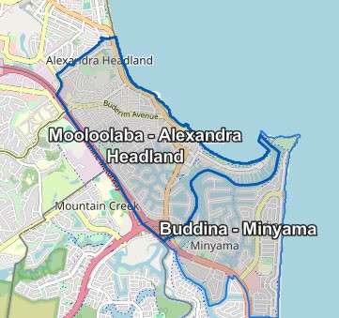
Figure 6-1: SA2 areas considered for the baseline demographics

Table 6-2: Demographic profile, 2021 census
Indicator | Mooloolaba - Alexandra Headland SA2 | Buddina – Minyama SA2 | Sunshine Coast | Queensland
Population | 12,443 | 6,956 | 342,541 | 5,156,138
Males | 49% | 48.9% | 48.1% | 49.3%
Females | 51% | 51.1% | 51.9% | 50.7%
Median age | 45 | 47 | 43 | 38
Families | 3,220 | 1,900 | 95,412 | 1,366,657
Dwellings | 7,180 | 3,271 | 148,638 | 2,190,424
Average no. of people per household | 2.1 | 2.4 | 2.5 | 2.5
Median weekly household income | $1,559 | $1,719 | $1,595 | $1,675
Median monthly mortgage repayments | $1,800 | $2,167 | $1,915 | $1,733
Median weekly rent | $400 | $450 | $440 | $365
Average no. motor vehicles per dwelling | 1.7 | 1.9 | 2 | 1.9

The two SA2 areas—Mooloolaba–Alexandra Headland and Buddina–Minyama—are substantially smaller in population than the broader Sunshine Coast or Queensland, yet they display distinctive household and housing characteristics. Mooloolaba–Alexandra Headland’s 12,443 residents occupy 7,180 dwellings at an average of just 2.1 people per household, while Buddina–Minyama’s 6,956 residents live in 3,271 dwellings with 2.4 persons on average. By contrast, households across the Sunshine Coast and Queensland average
2.5 occupants. The relatively high dwelling-to-person ratios in these coastal suburbs suggest a prevalence of smaller household units—such as retirees or one- to two-person households—and possibly a mix of permanent and short-stay accommodation.
Both SA2s are noticeably older than the region as a whole. Buddina–Minyama has a median age of 47 and Mooloolaba–Alexandra Headland 45, compared with 43 on the Sunshine Coast and 38 for Queensland. This age skew points to a larger retiree or empty-nester population and a smaller proportion of young families with children relative to the wider region.
Income and housing costs in the two SA2s reflect their demographic profiles and housing markets. Buddina–Minyama households report the highest median weekly income at $1,719—surpassing both the Sunshine Coast’s $1,595 and Queensland’s $1,675—while Mooloolaba–Alexandra Headland sits slightly below the coast average at $1,559. Correspondingly, Buddina–Minyama commands the steepest housing outgoings, with median monthly mortgage repayments of $2,167 and weekly rents of $450. Mooloolaba–Alexandra Headland is somewhat more affordable (mortgages at $1,800 per month; rents at $400 per week), though still above Queensland’s medians.
Vehicle ownership patterns echo these living arrangements. Sunshine Coast households average two vehicles each, and Queensland as a whole averages 1.9. Buddina–Minyama aligns with the state norm at
1.9 vehicles per dwelling, while Mooloolaba–Alexandra Headland households average just 1.7 vehicles. This lower car ownership intensity may reflect higher-density living, a stronger local amenity that reduces car reliance, or a significant holiday-accommodation sector where residents and visitors own fewer vehicles.
Gender balance is consistent across all geographies—roughly 49 percent male and 51 percent female—and families make up around 26–28 percent of households in each area. Both SA2s sit just below the Sunshine Coast average for family households, reinforcing the pattern of smaller or couple-only households dominating these suburbs.
In summary, Mooloolaba–Alexandra Headland and Buddina–Minyama stand out as older, smaller-household communities with relatively high housing costs. Buddina–Minyama is the more affluent of the two, with higher incomes and rental and mortgage levels. Mooloolaba–Alexandra Headland offers somewhat greater affordability but still exceeds Queensland averages. Together, these characteristics underscore the two SA2s’ appeal to retirees, downsizers, and those seeking a coastal lifestyle in smaller household arrangements rather than traditional family settings.

Use profile

Commercial uses
Mooloolaba Harbour serves as a vital commercial and maritime hub on the Sunshine Coast, supporting a diverse range of industries and users. The harbour is regularly used by dozens of commercial vessels, particularly those involved in the seafood and agrifood sectors. Mooloolaba Fisheries, for example, relies heavily on the harbour for its operations, with the seafood industry contributing significantly to the local economy.
Beyond fisheries, the harbour accommodates maritime-related government services, sustainable boating activities, and tourism operators. It offers all-tide deep-water access, making it suitable for both recreational and commercial vessels (Sunshine Coast News, 2025). Charter boats in Mooloolaba offer diverse water-based experiences, including luxury river cruises, private event charters, deep-sea fishing expeditions, and activities like jet boat rides, with most operators depart from The Wharf Mooloolaba.
Adjacent to the harbour, The Wharf Mooloolaba serves as a vibrant lifestyle precinct with waterfront dining, boutique shopping, and attractions like SEA LIFE Sunshine Coast, making it a popular destination for both locals and tourists (The Wharf Mooloolaba, 2025). The precinct adds a strong commercial dimension with over 30 tenanted retail and hospitality businesses, a 57-berth marina, and tourism-oriented enterprises that attract more than 2.2 million visitors annually (The Wharf Mooloolaba, 2025).

Recreational boat users
Within the Sunshine Coast LGA the high demand for recreational boating and associated facilities are driven in part by the size of the population within the area and neighbouring LGAs, the large local recreational boating fleet, as well as several canal estates that include private pontoons with waterside residential properties. As of July 2022, there was a total of 22,256 vessels with a home registration within the Sunshine Coast LGA, with 96% being ‘trailable’ – and therefore requiring boat launching facilities – with vessels primarily used within the LGA and demand added to by vessels registered in surrounding LGAs such as Brisbane, Moreton Bay, Noosa and Toowoomba (BMT, 2023).
The Mooloolah River including the Mooloolaba Boat Harbour is a major recreational destination on the Sunshine Coast, supporting recreational boaters through offering safe, all-tide access for a variety of leisure activities including boating, fishing and sailing. Recreational users benefit from well-maintained facilities such as the Mooloolaba Boat Ramp on Parkyn Parade, which features multiple lanes, floating pontoons, and trailer parking to support ease of access for private vessels (BMT, 2023). The harbour also includes the Mooloolaba Marina, which provides short- and long-term berthing options for recreational boaters.0F Each year the Marina hosts fishing competitions and waterfront festivals. For day-trippers, river cruises and whale-watching tours depart regularly in winter, while anglers launch small boats from public ramps.
A recent demand study undertaken by BMT found that across the Sunshine Coast LGA, users accessing offshore destinations gave heavy preference to the facilities in the Mooloolah River, with the Parkyn Parade facility (Mooloolaba state boat harbour) preferred because of its better facilities, parking capacity and access to key open water destinations, as well as proximity to food and retail outlets.1F The areas popularity with recreational boaters has resulted in high usage and congestion during peak periods.
Boat users seeking access to open water launching from facilities in the Mooloolah River have to traverse coastal bars that are subject to changes that can change regularly and impede safe navigation for recreational boats.

Recreational fishing
Recreational fishing is an important aspect of social, cultural, and economic life on the Sunshine Coast with recreational fishing being one of Australia’s most important leisure activities by participation, with nearly one in five people fishing in 2023. Many Queensland fishers focus on saltwater fishing, with 86.8% reporting they fished in saltwater areas within the last year with over 70% of all recreational fishing being boat based.2F In the Sunshine Coast, recreational fishing by both residents and visitors resulted in $24 million expenditure in 2019–20, with trip costs which includes items such as bait, boat fuel and hire, charter/guide fees, car fuel and accommodation accounting for approximately $3.4 million (DPI, 2019-20). With an approximate 75,000 fishers estimated, this amounts to a current average annual spend of $57 per person ($45 in 2019 dollars).

Tourism
In 2023/24, tourism on the Sunshine Coast made a significant contribution to the region’s economy and employment. In 2024, over 6.1 million tourists visited the Sunshine Coast of which a majority (98%) were from within Australia, with top international markets being New Zealand, the United Kingdom and America.3F However, international visitors remained for significantly more nights on average compared to domestic visitors (16 and 3 nights respectively) and spent on average $1,386 per trip.4F
The tourism sector supported a total of 18,544 jobs, with 10,498 in direct employment and 8,046 in indirect roles (NIEIR, 2025). This represented 10.2% of the region’s total industry employment and 6.4% of Queensland’s tourism-related employment (NIEIR, 2025). In terms of economic output, tourism generated $4 billion in total sales, comprising $1.6 billion in direct output and $2.4 billion in indirect output (NIEIR, 2025).
These figures accounted for 9.2% of the Sunshine Coast’s total industry output and 5.5% of Queensland’s tourism output (NIEIR, 2025). The value added by tourism—reflecting its net economic contribution—was $2 billion, split between $817.56 million directly and $1.182 billion indirectly (NIEIR, 2025). This made up 9.6% of the Sunshine Coast’s total industry value added and 5.7% of Queensland’s tourism value added (NIEIR, 2025). Overall, the data highlights tourism’s vital role in the Sunshine Coast’s economy, both as a major employer and as a driver of regional output and value creation (NIEIR, 2025).
Mooloolaba plays a central and dynamic role in the Sunshine Coast’s tourism industry, serving as one of the region’s most popular and vibrant coastal destinations. Its strategic location—just 15 minutes from Sunshine Coast Airport and one hour from Brisbane—makes it a convenient gateway for domestic and international visitors. Its north-facing beach is consistently ranked among Australia’s best, including a recent accolade as 6th in TripAdvisor’s Travellers’ Choice Best of the Beaches 2024.5F
The area attracts visitors with its safe swimming conditions, scenic waterfront, and bustling esplanade lined with cafés, restaurants, and boutique shops.6F Mooloolaba is also home to key attractions like SEA LIFE Sunshine Coast, a multi-award-winning marine park that draws families and tourists year-round.
The suburb is undergoing a major transformation through the Mooloolaba Foreshore Revitalisation Project, which includes expanded beachfront parklands, improved accessibility, and new public spaces designed to enhance visitor experience and support local tourism operators.7F This multimillion-dollar investment underscores Mooloolaba’s importance as a tourism hub and its role in shaping the future of the Sunshine Coast’s visitor economy.

Recreational beach users and visual amenity
Reputation of the beaches is part of what makes the Sunshine Coast an attractive tourist destination, bringing people from across Australia and internationally to holiday in the area. The north-facing Mooloolaba Beach is a patrolled swimming beach popular for body boarding, paddleboarding and surfing. It is protected by the Point Cartwright Headland to the South enabling gentle waves reduced in height, making it safe for families with children. The beach’s curved shoreline is backed by a continuous foreshore reserve with green areas, picnic and barbecue facilities, playgrounds with active transport paths along the esplanade. Cycle-paths and pedestrian bridges crisscross the riverbanks, knitting the harbour, beach and town centre into a compact and highly walkable community.
As recreational beach use is free for anyone to do, there is no market price able to be placed on undertaking this activity. To assign value to a non-market good a non-market valuation is applied by either surveying beneficiaries about how much they value certain outcomes (i.e., ‘stated preference’) or deriving an estimate for that value based on the behaviour of beneficiaries (i.e., ‘revealed preference’). The value of Mooloolaba beach to recreational users can be understood through other academic studies of similar beach assets.
Based on a 2019 study by Pascoe (Pascoe S, 2019), estimates of the non-market consumer surplus values of beach recreation at Sunshine Coast beaches indicate that beach recreation is worth between $9-24 per trip, with variation derived based on the activity being undertaken and whether the users are a resident or non-residents as shown in the table below.

Table 6-3: Value of recreational beach activities (2025 dollars)
Activity | Resident | Non-resident
Swimming | $22.31 | $21.90
Surfing | $24.18 | $23.48
Passive (viewing the beach) | $12.59 | $9.37

Whilst Mooloolaba Beach and surrounds is not within the bounds of the harbour entrance project boundaries, any option taken forward must consider the potential impacts to users of the beach as well as those deriving visual amenity from the beach via the surrounding parklands, playgrounds and restaurants.

CURRENT DREDGING MANAGEMENT PRACTICES

Dredging activities
The current approach to address the sand shoal at the entrance is reactive with the following management strategy:
- Monitor for shoaling events – using the existing wave buoy model and hydrographic survey.
- Mobilise local dredge contractor.
- Undertake re-active dredging and placement at Mooloolaba Beach as required. A detailed operational ‘workflow’ has been provided by MSQ below.

Current operational workflow
The following workflow is based on the direction of conversations with MSQ.

Table 7-1: Current operational workflow
Step | Workflow action | Independent query | Potential actions
 | MSQ check weather forecasts
 | Use BMT shoal indicator model from 2005 with real time wave data to check shoaling trend. | Present reliability of the model.  Uses real time wave data only with limited shoal prediction with forecasted weather. | Consider options to apply forecasted weather conditions in short-term and future season to predict risk of shoaling events.
Order a hydrographic survey to confirm and check web cameras and local user feedback to confirm shoal trend and intensity.
If shoal confirmed. Notice to
Mariners issued.
 | Contact local dredge contractor to mobilise. | Community concern with delays in mobilisation of crew – dependant on  availability.
 | Undertake Dredge maintenance.  Hydrograph surveys repeated during shoaling event and NTM updated as needing until shoal cleared. | Works only within safe weather window
 | Sand placed at discretion on SCRC | Potential of sand placed close to entrance – potential circulation pattern reinterring system? | Further investigation of currents along western breakwater, via hydrodynamic model and/or site-specific measurements.
 | Hydrographic survey done during works and on completion
 | Dredge crew demobilised | Dredge moored inside the channel (unless used on another project)

Existing constraints
There are several critical constraints to the current operational workflow for managing shoaling events. These include:
- Rapid shoaling: Shoaling events can occur rapidly, leaving limited time for MSQ to simulate the shoaling event model, survey the site, mobilise a dredge contractor and undertake the dredge works.
- Mobilisation: Mobilisation of suitable dredging equipment can take considerable time as it is not on standby locally and dependent on staff availability and weather.
- Weather: Dredging operations may only be undertaken when safe to do so, which requires a favourable sea state, as shown in Figure 7-1. For the existing cutter suction dredger, this is limited to about Hs of 1.0m. As sand shoal events are contingent on high wave conditions, dredging may be delayed until a substant volume as accumulated.
- Dredge depths: Sand thickness above the underlying rock shelf is relatively thin, even when significant sand shoal events have occurred. If dredging is undertaken to remove a sand shoal, the site may rapidly infill if shoaling event conditions persist. Weather conditions favourable for sand shoal events can continue for on-going periods of time.
- Approvals: Current dredging approvals are for ongoing maintenance works only and relate to sand extraction only. No capital works are permitted.

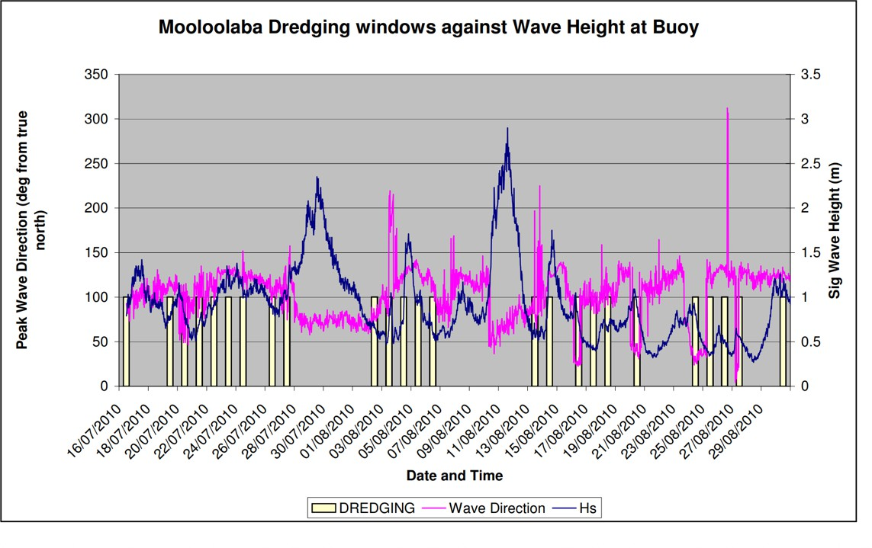
Figure 7-1: Example of Mooloolaba dredging windows compared to wave conditions

Notices to mariners
The following outlines the process undertaken by MSQ to issue a Notice to Mariners (NtM).

Identifying the need for an NtM
The process starts with identifying whether there’s a need for an NtM. This can happen in several ways:
- Monitoring shoaling events: Regular checks of the bar, especially after weather events, to detect shoaling or other changes.
- Reports from stakeholders: Information from the Coast Guard, commercial operators, Water Police, Pilot vessels, or Marine Officers about changes in the bar’s condition.
- Predictions: Anticipating issues based on weather forecasts or other data provided by Maritime Asset Infrastructure (MAI).
At this stage, we’re looking for anything that could make the bar unsafe or difficult to navigate.

Requesting a hydrographic survey
If MSQ suspect there’s an issue, MSQ or MAI request a hydrographic survey to confirm the bar’s condition. This involves:
- Consulting with the MAI team, who manage the bar.
- Scheduling the survey based on weather conditions to ensure it’s safe and accurate.
- Providing a vessel and master from the MSQ Sunshine Coast team to take the surveyor out to the bar. The survey is the preferred method in order to provide precise data on the bar’s depth and condition.

Conducting the survey
On the scheduled day, the Hydrographic Services team conducts the survey. They collect data on:
- The bar’s depth
- Any changes since the last survey.
This step provides the basis for deciding whether an NtM is needed.

Reviewing the survey data
Once the survey is complete, the preliminary data is sent to the MSQ Area Manager, the Regional Harbour Master (RHM), and the GIS Spatial Services team amongst others. Together, the team review the data to determine if a NtM is required.
The decision is based on:
- Whether the bar is below the designed depth of 2.5 metres.
- Whether there have been significant changes since the last survey that could impact navigation. If either of these conditions is met, MSQ move forward with issuing an NtM.

Preparing the NtM
If an NtM is needed, the following steps are taken:
- The GIS team prepares a survey map based on the data. If virtual navigation aids (navaids) are required to guide vessels through the deepest part of the channel, they are activated and included on the map.
- MSQ draft the NtM, which includes:
  - The survey findings, such as depth and any identified hazards.
  - Additional considerations, like dredging operations or other activities in the area.
  - Warnings about the dynamic nature of the bar and the need for caution when crossing.
  - Safety information, including life jacket laws.
The aim is to ensure the NtM is clear, accurate, and provides all the necessary information for mariners.

Publishing and disseminating the NtM
Once the NtM is finalised:
- It is emailed, along with the survey map, to the NtM Publishing team by 3:00 PM on the business day before publication.
- The NtM is published on the Queensland Government website, where it is available for other organisations such as Coast Guard to share on their social media pages.
In addition to sharing the NtM, MSQ encourage the Coast Guard to share local advice if conditions change as shoal movement can be rapid. MSQ also encourages mariners to seek local knowledge prior to crossing the coastal bar.

Ongoing monitoring and updates
The bar is continuously monitored, and new surveys are conducted as needed. If conditions change, updated NtMs are issued upon receiving accurate data to ensure mariners have the most current information.
This process remains responsive to changing conditions to enhance navigational safety.

Crossing designated coastal bars
It’s important to note that most designated coastal bars in Queensland do not have NtMs issued when conditions change. This is because coastal bars are dynamic in nature, meaning their conditions are constantly shifting due to tides, weather, and other environmental factors.
Crossing a coastal bar is inherently dangerous, and the responsibility for ensuring a safe crossing lies entirely with the vessel’s master. While NtMs provide valuable information about conditions at specific times, they are not a substitute for the Master’s own preparation and judgement. Masters should:
- Seek out the latest information: Always check the most recent NtMs and other updates before attempting a crossing. For the Mooloolah River bar, this includes reviewing survey data and any warnings issued.
- Gain experience: If unfamiliar with bar crossings, consider seeking advice or training to build confidence and skills. Experienced mariners can provide valuable insights into how to handle challenging conditions.
- Conduct a risk assessment: Assess the conditions on the day, including tide, swell, and weather, and decide whether it is safe to proceed. Even with favourable conditions, crossing a bar requires caution and skill.
Mariners should also be aware of the legal requirements for wearing life jackets when crossing a designated coastal bar. These laws are in place to reduce the risk of fatalities in the event of an incident. Information and guidance can be found on the Maritime Safety Queensland website. By understanding the risks and taking appropriate precautions, vessel masters can significantly reduce the dangers associated with crossing coastal bars.

MSQ DREDGING OPTIONS – SHORT-TERM
Short-term solutions are focused on immediate, reactive measures to ensure navigational safety and mitigate current shoaling hazards. For the purpose of this review, we consider ‘interim’ or ‘short-term’ works to include those that can be done within a relatively short timeframe (i.e., within 1 year).
The following options have been reviewed for interim solutions to address or improve the current situation at the entrance:
- Maintenance dredging: This is the current and most critical short-term solution. Regular dredging using a cutter suction dredge is essential to remove sand from the entrance channel and restore safe depths. The dredged sand is typically pumped onto Mooloolaba Beach for beach nourishment and to combat coastal erosion.
- Targeted dredging: In response to significant shoaling events, targeted and sometimes continuous dredging is required. For example, recent targeted dredging was undertaken recently as part of the Western Channel Trial.
- Hydrographic surveys and monitoring: Frequent and high-frequency hydrographic surveys are necessary to monitor the shoaling process and identify changes in the channel depth. This data is crucial for:
  - Improve prediction tools for potential shoaling events.
  - Determining the need and timing for dredging operations.
  - Providing the Harbour Master with up to date and accurate data to make informed decisions about navigational hazards.
  - Issuing timely and accurate Notices to Mariners to warn of changing bar conditions.
  - Mooloolaba Drone Imagery Capture Project.
- Shoal sand numerical model: The following should be considered in to improve the use of the existing model or the overall monitoring and prediction of sand shoals:
  - Continue to incorporate use of drone monitoring data and available survey data to confirm reliability or re-calibrate the model over time.
  - Automate the model as a real-time service.
  - Use forecasted wave data (1 – 2 weeks) and typical seasonal conditions.
  - Consider upgrading model to (or use in conjunction with) a calibrated numerical model which can provide not only a more reliable indicator of sand shoal events but a greater understanding of the extent and location of the sand shoal.
- Navigational warnings and guidance: TMR, through Maritime Safety Queensland (MSQ), must continue to issue regular and detailed Notices to Mariners. These notices inform vessel masters of current shoaling, reduced depths, and provide guidance on safe navigation, including alternative routes where possible.
- Western Channel Trial: This initiative, commenced in 2022, involves targeted dredging to maintain a basin area west of the entrance. This is an ongoing trial to assess its effectiveness in mitigating sand accumulation in the main channel.
- Condition Assessment of Eastern Breakwater.

MSQ DREDGING OPTIONS – LONG-TERM
Long-term solutions are aimed at addressing the root cause of the shoaling to reduce the frequency and cost of maintenance dredging.
- Option 1 – Permanent Automated Sand Bypassing System: This option involves a permanent system to mechanically transport sand from the updrift side of the bar (Point Cartwright) to the downdrift side (Mooloolaba Beach). While technically feasible, the capital and operational costs, as well as the environmental impact and visual amenity, require detailed consideration.
- Option 2 – Increased Dredge Channel Depth with Rock Excavation: This involves deepening the channel beyond the current -2.5m LAT design depth. This would likely require the excavation of underlying rock. While it would provide a greater buffer against shoaling, it is a significant and costly undertaking with potential environmental and engineering challenges.
- Option 3 – Eastern Breakwater Extension: A 60-meter extension to the existing eastern breakwater is the preferred engineering solution. The objective is to intercept the majority of the northward sand drift before it can enter the navigation channel. A design report for this project has been completed, and it is considered the most effective long-term solution to reduce channel sedimentation.
- Option 4 – Buddina Beach sand trap: Trailing suction hopper dredge, about 100,000 m³ from trap to Sunshine Coast beaches. It was noted that this option was considered at the recent SRG as a viable opportunity but had not been fully considered at this stage.
- Option 5 – Western Channel Concept Plan – shorten western wall: Removal of a section of western breakwater wall to create a wider western channel for safe access during adverse shoaling conditions.
- Recommendation: As part of the short-term actions before completion of the final report, further investigation and feasibility analysis are undertaken to better inform the Buddina Beach Sand Trap option.
The assessment of long-term options against social, economic and environmental considerations will occur in Part 2 of this report.

ASSESSMENT OF SHORT-TERM DREDGING OPTIONS
A range of short-term option have been considered in this section against the following assessment criteria:
- Ensures navigational safety
- Mitigates current shoaling hazards.
- Impacts upon the values of the place that includes impacts upon the community, tourism operators, maritime and recreational users.

Modifications to dredging strategy
The existing dredging strategy at the entrance is to undertake both:
- Maintenance Dredging: This is the current and most critical short-term solution to regularly remove sand from the entrance channel and restore safe depths. The dredged sand is typically pumped onto Mooloolaba Beach for beach nourishment and to combat coastal erosion.
- Targeted Dredging: In response to significant shoaling events, targeted and sometimes continuous dredging is required.
A range of potential alternative dredging strategies have been proposed by MSQ and community stakeholders as interim solutions to addressing sand shoal events in the entrance. The intent of this assessment is to identify whether modifications to the current dredging strategy could deliver improved outcomes to safe navigation of the entrance in the short-term, or whether continuation of the existing strategy remains the most appropriate option until the longer-term solutions can be implemented.
The dredging options considered included:
- Existing Dredge Strategy (Status Quo)
- Contract Dredge on Standby (365 days per year)
- Use of Trailer Suction Hopper Dredge (TSHD)
- Use of Jack-up Barge
- Bed Levelling
- Submarine Dredge (remotely piloted)

Existing dredge strategy
Table 10-1: Existing dredging strategy
Advantages | - No additional studies or modelling costs.  - No new documentation, impact assessments or designs required.  - No re-approval delays.  - Contractor familiarity and established logistics.
Disadvantages | - Remains a reactive dredge strategy only. Does not prevent sand shoal events from occurring.  - Remains limited to favourable weather conditions for dredging  - Perception of no action on improved management of sand shoals
Cost | - No change to existing entrance management costs

Contract Dredge on Standby (356 days per year)
This option involves having a suitable dredger maintained on continuous standby throughout the year to enable immediate response to sand shoaling events within the entrance.
Requires a more detailed review of potential current and future annual average dredging requirements, particularly in response to climate change, to determine utilisation rate and overall cost-benefit.

Table 10-2: Contract Dredge on Standy (365 days per year)
Advantages | - Provides maximum flexibility to undertake maintenance dredging immediately in response to sand shoaling events AND any additional dredging should sand shoaling conditions remain persistent.  - No additional study or modelling costs.  - Adopts existing dredge response plan. No re-approval delays.  - Contractor familiarity and established logistics.  - Perception of action to improve management of shoals and safety of channel
Disadvantages | - Remains a reactive dredge strategy only.  - Remains limited to favourable weather conditions for dredging.  - High standby costs for dredge down time, which is subject to weather conditions and may be for extended periods of time.
Cost | - Very high cost

Trailer Suction Hopper Dredger (TSHD)
This option involves the use of a trailing suction hopper dredger (TSHD) to undertake the dredging works instead of the existing cutter suction dredger. Dredged sediments would be placed offshore of Mooloolaba Beach or suitable alternate location.
Expectation is that the TSHD could operate in a wider range of marine conditions, improving the ability to address a sand shoal event. However, while TSHD dredgers may be able to dredge in wave conditions
>2.0m, this is likely of minimal benefit given the high risk at the site due to:
- The inherently shallow depth of the dredge area being the sand shoal.
- Likelihood of wave shoaling or wave breaking over the sand shoal.
- Shallow depth of the underlying rock layer.
- Despite this, the use of TSHDs at the site remains an effective alternative option to cutter suction dredgers.

Table 10-3: Use of Trailer Suction Hopper Dredger (TSHD)
Advantages | - Additional dredging option in the event local cutter suction dredger not available.  - No pipeline mobilisation required.  - Small improvement to potential marine conditions to operate in.
Disadvantages | - Dredger remains constrained to suitable weather conditions.  - High risk due to site constraints (shallow depth, rocky shelf, wave exposure)  - Dredger may not be readily available.  - Mobilisation  - Sediment placement would be limited to the deeper nearshore section of the beach profile.
Cost | - High mobilisation costs.

Jack-up barge option
This option involves the use of a ‘Jack-up’ barge or spudded barge to allow for dredging of the entrance during marine conditions typically unsuitable for dredging by cutter suction or TSHD dredgers.

Table 10-4: Use of jack-up barge option
Advantages | - Potential to operate during larger wave conditions than other dredgers.  - Could remain deployed to manage sand shoals over time, removing mobilisation time (subject to standby costs).
Disadvantages | - Cannot be relocated during high wave conditions.  - While barge may be stable under wave conditions that would typically be unsuitable for other dredgers, operating the dredger during such conditions may still be a high-risk operation due to wave loading on the dredge equipment.  - Lower productivity compared to existing cutter suction dredger or TSHD.  - Requires support vessels to reposition.  - Stability concerns with limited penetration depth to rocky shelf.  - Visual and aesthetic impacts. Safety impacts to marine recreational users.
Cost | - High

Bed-levelling
This option involves bed-levelling activities to manage sand shoals at the entrance. Due to challenges and risks associated with bed-levelling activities exposed to wave conditions at the entrance, this option is not recommended to be applied as an interim solution.

Table 10-5: Use of bed-levelling option
Advantages | - Low cost (under ideal weather circumstances and Contractor availability i.e., no standby)  - Could potentially be rapidly deployed (provided weather conditions are suitable).  - Often lower crew requirements compared to other dredging strategies.
Disadvantages | - Constrained to calm marine conditions. Levelling not possible with wave conditions.  - Expected to be challenging to undertake at the site given exposure to ocean waves and wave shoaling.  - Levelling activities likely not possible during marine conditions that typically form sand shoals
Cost | - Low

Submarine Dredge (remotely piloted)
This option involves the use of remotely piloted submarine dredge equipment to dredge the sand shoal during marine conditions that would typically be unsuitable for other dredge options.
Requires the use of specialist equipment that is typically utilised for deeper water operations and not shallow water areas exposed to wave breaking.
Due to the high costs, low contractor familiarity and relatively unproven performance of such equipment for addressing the sand shoal, this option is not recommended as a potential interim solution.

Summary of Dredging Strategy
Based on our assessment and understanding of the coastal setting and available data, the following recommendations can be made for the dredging strategy:
- Recommendation: Continue with the existing maintenance and targeted dredging strategy in the short-term, with the use of cutter suction dredgers. This strategy is approved and the current most effective option to react to shoaling events and maintain safe channel depths in the entrance.
- Recommendation: Any improvements to site monitoring and the numerical modelling tool should be brought in to improve the timeliness of maintenance dredging and reactive targeted dredged as much as possible.
- Recommendation: The use of TSHD dredgers could be considered as an alternative to the cutter suction dredgers but is not expected to greatly improve the suitable dredge window due to constraints at the site (i.e., shallow depths, rocky layer, wave exposure).
- Recommendation: Use of the submarine dredger and jack-up barge options are not recommended due to the increased risks, costs and uncertainty of benefits.
- Recommendation: Use of the bed-levelling option is not recommended for addressing the sand shoal due to the sites wave climate and associated risks to bed-levelling operations.
- Recommendation: Contracting a dredger to be available for 365 days per year does have the potential to maximise flexible dredging operations at the site and minimise mobilisation times. However, further analysis of potential annual average utilisation rates is required to determine overall cost-benefit of this option. This option would also not address inclement weather delays to dredging and at best requires frequent dredging of the channel to occur.

Potential environmental impacts of dredging strategy
The potential environmental impacts resulting from the continuation of dredging at the Mooloolaba Boat Harbour entrance would need to be fully assessed to determine the appropriate environmental management requirements during works. However given the anticipated low risk of the works, the high-level potential impacts are as follows.
- Dependant on the location and timing of dredge disposal works, there may be changes to the beach profile where sediment is disposed to Mooloolaba Beach resulting in impacts to turtle nesting, bird roosting and visual amenity of the immediate area (refer to Section 5.2.3.1, 5.2.3.3,). Additionally, downstream this could cause an increase sediment load at Maroochy River mouth. Further information regarding the dredging and disposal design, including footprints, methods and timings will inform a more detailed assessment.
- Dependant on the location and timing of dredge disposal works, there may be impacts to marine and terrestrial fauna, including nesting and foraging birds and turtles, due to noise generation from dredging plant and any required land-based plant, physical disturbance via direct contact with dredging or land-based plant or indirectly via the disturbance of habitat, light impacts if works are completed outside of daylight hours. Further information regarding the dredging and disposal design, including footprints, methods and timings will inform a more detailed assessment.
- Given the benthic habitat in the vicinity of the dredge area comprises bare sand with some subtidal rocky reef with minimal marine benthos (refer to Section 5.2.3.5) and the previous dredging disturbance in the area, direct disturbance of benthic habitats is unlikely to be of environmental concern. However, a more detailed assessment of the benthic habitats within the dredge and disposal footprints will confirm this.
- The generation of turbid plumes at the dredge and dredge disposal site could impact foraging seabirds as they require water clarity for aerial feeding. The impact of turbidity on benthic habitats is unlikely to be of environmental concern, however, a more detailed assessment of the benthic habitats within and directly adjacent to the dredge and disposal footprints will be required to confirm that any reduction in water quality will not potentially impact benthic habitats (specifically, seagrass meadows and corals) at and adjacent to these sites.
- Based on the existing sediment quality data (refer to Section 5.1.4), there is unlikely to be any release of contaminants or hypoxia impacting the marine environmental quality. However, recent sediment quality data from the entrance channel will confirm this.
- Other potential impacts from the presence and operation of dredging plant include: hydrocarbon spills and waste generation, introduced marine species from the dredging plant and introduction of navigational hazards due to presence of dredging plant.
- If any land-based work is required, i.e. for the placement and contouring of dredged material on the beach, there may be disturbance of dune vegetation or generation of wind-blown sand impacting terrestrial habitats. Impacts to public safety, visual amenity, beach access by presence of dredging and any land-based plant

Improvements to monitoring
Monitoring of the shoaling processes and entrance conditions is crucial for safe and effective management of the entrance, including:
- Improving prediction of potential shoaling events.
- Determining the need and timing for dredging operations.
- Providing the Harbour Master with up to date and accurate data to make informed decisions about navigational hazards and entrance management.
- Issuing timely and accurate Notices to Mariners to warn of changing bar conditions.
It is essential that frequent, reliable and high-resolution monitoring data is both collected, assessed and provided to relevant stakeholders. This includes:
- Continue undertaking frequent high-resolution survey of the entrance, shoaling area and known sand stockpile areas around Point Cartwright.
  - This data is essential for both calibrating the shoal indicator model, detailed assessment of sediment transport volumes, bed level changes, maintenance and targeting dredging works and calibrating satellite derived bathymetry.
- Use of satellite derived bathymetry (SDB), calibrated against most recent hydrographic survey to provide additional seabed data and shoal locations.
  - Without calibration with real world depths, this data tends to be accurate to about 1 m.
  - Limited by waves and cloud conditions.
  - MSQ have advised that processing and delivery times for SDB may be too long to be effective for improving shoal monitoring. Therefore, SDB may be more practical to use if hydrographic survey cannot be undertaken.
- Continue with Drone Monitoring pilot program to visually track sand movement.
  - Provides frequent and high-resolution imagery to visually track sand shoal locations and entrance conditions.
- Consider installation of Surfline Coastal Intelligence system to provide real-time analysis of shoal location, wave breaking and safety at the entrance.
  - Rapid coastal monitoring option using CCTV feeds. 24 Hz video capture, which is a significant improvement in data capture compared to the existing 15-minute interval snapshot.
  - Cloud-based dashboard that provides live video, data visualisation and historical data for analysis.
  - Operates during high wave energy conditions to provide inferred bathymetric data when traditional survey methods aren’t possible.
  - Implemented in conjunction with existing monitoring methods to improve tracking and understanding of shoaling events and provide practical data to entrance users.

Surfline coastal intelligence
The Surfline Coastal Intelligence system uses standard CCTV camera feeds to provide detailed and near real-time data on shoaling at the entrance, wave breaking conditions and safety at the entrance. The services are provided through a cloud-based dashboard that provides live video, inferred bathymetry, data visualisations and historical information for analysis and reporting.
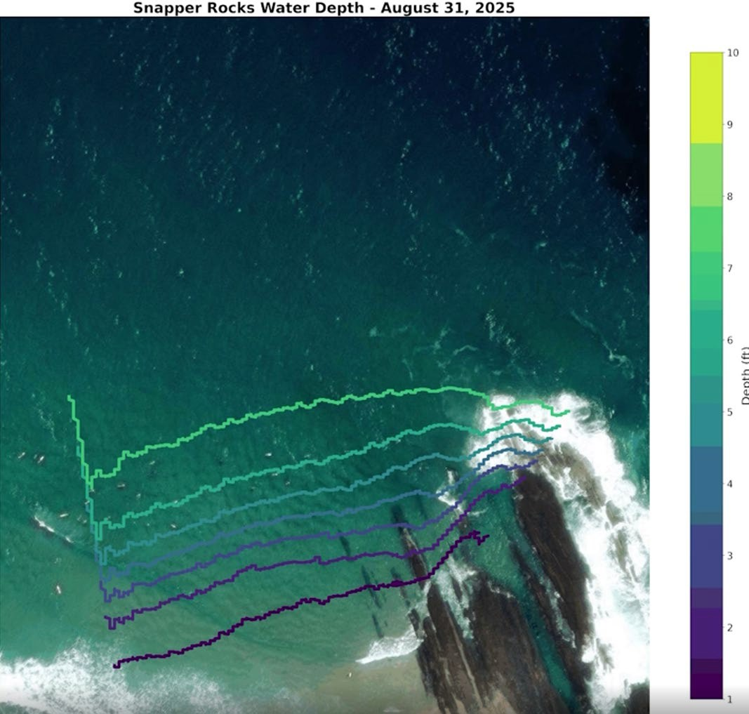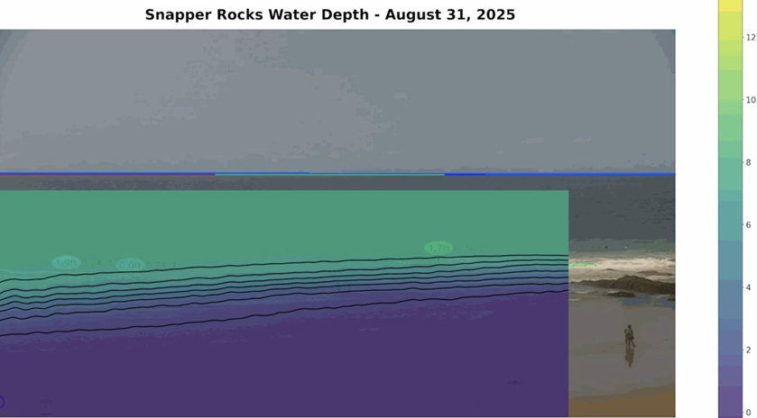
Figure 10-1: Example of SCI inferred bathymetry and shoreline change at Snapper Rocks following TC-Alfred

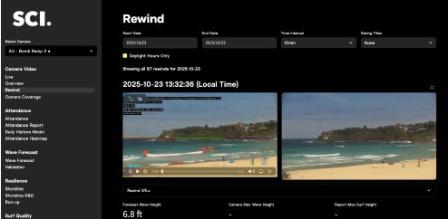
Figure 10-2: Example of cloud-based dashboard that provides live video feed, data visualisations and reporting

An indicative setup (subject to further investigation) would include the following:
- Camera installation: NDAA compliant PTZ camera focused on the Mooloolaba Harbour entrance (typical shoaling area) capturing video at 24 Hz.
- Live video feed: Publicly available through MSQ website for the entrance and archived on a rolling basis for 12 months.
- Computer vision and detection: Use of proprietary Surfline Coastal Intelligence technology to detect the following:
- Wave activity at the entrance as a near-real-time indicator of shoaling events, including quantification of wave breaking frequency, breaking wave heights, direction etc.
- Presence of swimmers/surfers at entrance (if any).
- Bathymetry and seabed change based on wave breaking.
- Automatic stakeholder alerts: Detected wave and people activity data flagged to MSQ to identify potential shoaling risks. Potential to apply forecasted wave conditions with latest inferred bathymetry to provide indication of shoal hazard.
- Public-facing information: Processed data and video outputs provided to keep entrance users and local community informed of real-time entrance conditions.
- Reporting and analysis: Automatic generation of reports and visual outputs, including heat maps or event frequency charts of wave conditions to help quantify shoaling conditions, shoaling frequency etc.

Indicative pricing:
- Typical term: 1 year.
- Annual licensing and data access: Estimated AUD $20,000 (including video access and SCI data services), subject to further investigation and detailed quote.
- Hardware and installation: Provided by Surfline at no cost, including hardware supply, installation, maintenance and connection. Surfline only require local power supply to be provided. All installation provided by the Surfline operations team.

Navigational warnings and guidance
To ensure navigational safety in the event hazardous sand shoaling events occur, effective warnings and guidance must be communicated to entrance users and relevant stakeholders.
Recommendation: Maritime Safety Queensland (MSQ), continue to issue regular and detailed Notices to Mariners. These notices inform vessel masters of current shoaling, reduced depths, and provide guidance on safe navigation, including alternative routes where possible.
In addition to this, the following improvements to communication and guidance should be considered in the interim:
- Ensure warning and notices are physically present at local boat ramps and harbour notice boards.
- Provide a platform for up-to-date aerial images from the Drone Monitoring program to be communicated to entrance users.
- Consider the development of a Mooloolaba Entrance App, similar to the Tweed Entrance app that provides:
  - Up to date entrance conditions.
  - Weather observations and forecasts (wind, wave and tide etc)
  - Latest accurate entrance bathymetry.
  - Notices to Mariners, warnings and advice.
  - Access to webcams of entrance conditions.

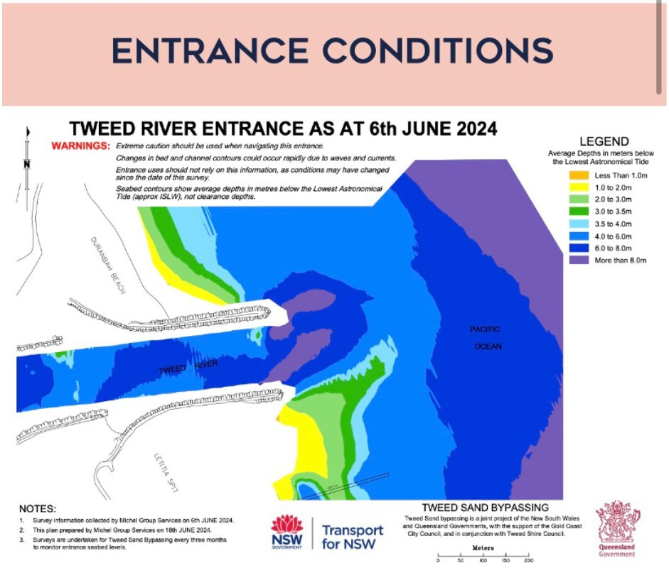
Figure 10-3: Example of Tweed River Entrance conditions webpage

Western Channel Trial
The Western Channel Trial was implemented in late 2022 with the intention to maintain an access channel to the west of the entrance. Dredging of a basin to the west of the entrance was completed in March 2023. It has subsequently been maintained in conjunction with regular dredging of the entrance.
- The latest outcomes of the trial indicate that the channel has improved safe access.
- A high-level review of survey data suggests that during sand shoaling events:
  - Sand shoals tend to occur and be the largest (and most hazardous) seaward of the entrance where there is the greatest net difference in sediment transport across the bay, as well as interactions with ebb/flood tidal flows from the river.
  - As the sand shoal gradually migrates westwards, the shoal tends to naturally disperse across Mooloolaba Bay and ‘weld’ into the nearshore system at Mooloolaba Beach.
  - During such shoaling events, safe navigation of the entrance through the western channel is more likely to be available (subject to safe marine conditions) and provide a viable alternative until the main entrance channel can be re-dredged.
- While the Western Channel has been shown to improve safe access, the following safety issues remain:
  - The channel alignment may require mariners to travel more parallel to incident wave fronts, increasing navigational risks.
  - The western channel is a longer pathway for mariners to reach deeper water.
  - Sand shoal location is dynamic, requiring mariners to navigate safely around it.
Recommendation: Continue with the Western Channel Trial to provide interim improvements to navigation and inform longer-term strategies that incorporate the western channel. That this area is regularly monitored or surveyed, such as with up-to-date satellite deriver bathymetry, to always provide mariners with the indicative location of the sand shoal and safe navigation pathway.

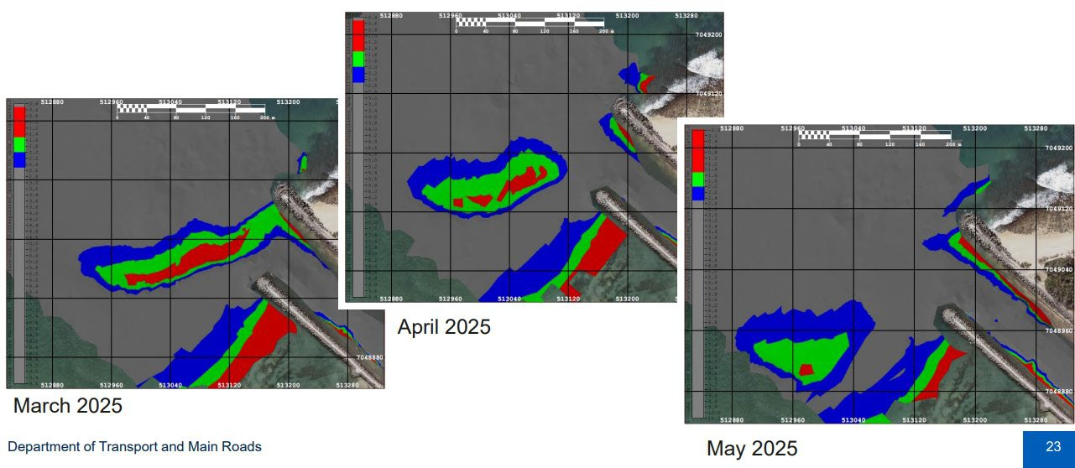
Figure 10-4: Progression of sand shoal event across Mooloolaba Bay in 2025

Potential environmental impacts of maintaining the western channel
The potential environmental impacts resulting from the maintenance of the western channel will be similar to those of the dredging strategy (refer to Section 10.1.7) and can be refined via further assessment.

Condition assessment of eastern breakwater
A review of aerial images of the site indicated potential sand leakage through the eastern breakwater, as shown in Figure 10-5 below. While it is most likely that this sand was deposited from seaward of the entrance, having bypassed the breakwater, a condition assessment of the eastern breakwater is recommended in the interim to identify potential pathways for sand leakage through the armour rock.
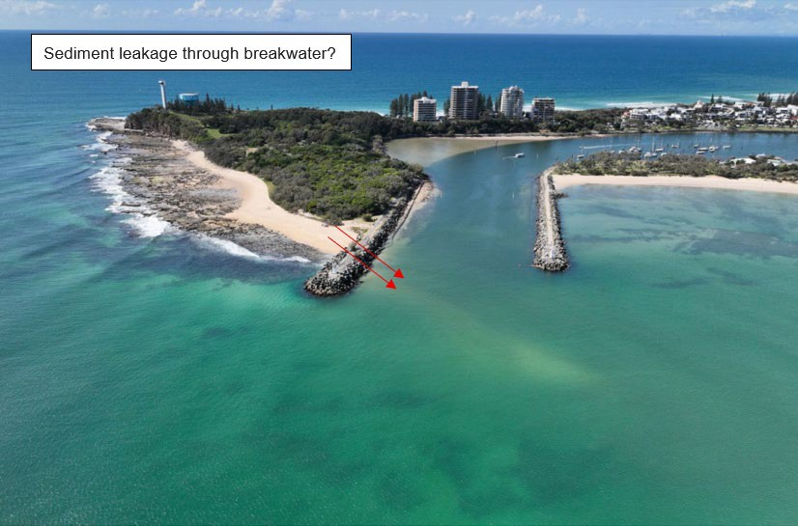
Figure 10-5: Potential contribution of sediments to sand shoal from leakage through the eastern breakwater

Recommendation: Conduct an integrity assessment of the eastern breakwater to identify potential pathways for sand leakage.

PART 1 – CONCLUSIONS AND RECOMMENDATIONS
An initial desktop review of previous reports and studies relating to the cause and impacts of shoaling events has been undertaken that has:
- Confirmed the causes for the shoaling events
  - The exact location and shape of the sand shoal events is a complex result of the interaction between a range of dynamic coastal processes that occur at the entrance including but not necessarily limited to the incident wave conditions, reflected and refracted waves within Mooloolaba Bay, tidal current flow from the entrance, longshore currents at the breakwaters, net sediment supply to the shoal etc.
  - Despite this complexity, available survey data indicates that the sand shoal events occur in a relatively consistent pattern at the entrance, forming from the east and migrating towards the west.
- Identified high-level coastal impacts of the shoaling events
  - Increased wave height and steepness over the accumulation of sand, due to wave shoaling. This effect results in more hazardous marine conditions at the entrance.
  - Wave refraction and impacts to the wave field caused by wave breaking and shoaling can also contribute to more challenging navigation conditions at the entrance.
  - Evidence of redirection of tidal ebb and flood flows at the entrance as the shoal forms from the east towards the west, typically directing the tidal channel to a more westward direction.
- Assessed the effectiveness and impact of options to prevent and/or mitigate shoaling events as they relate to a wide range of stakeholders through the completion of a social impact evaluation.
- Identified short-term recommendations to stabilise the situation for consideration by Government.

Recommendations
Following are recommendations for short-term actions.
- Continue with the existing maintenance and targeted dredging strategy in the short-term, with the use of cutter suction dredgers. This strategy is approved and the current most effective option to react to shoaling events and maintain safe channel depths in the entrance.
- Any improvements to site monitoring and the numerical modelling tool should be brought in to improve the timeliness of maintenance dredging and reactive targeted dredged as much as possible. In regard to the Shoal Sand Numerical Model, the following should be considered to improve the use of the existing model or the overall monitoring and prediction of sand shoals:
  - Continue to incorporate use of drone monitoring data and available survey data to confirm reliability or re-calibrate the model over time.
  - Automate the model as a real-time service.
  - Use forecasted wave data (1 – 2 weeks) and typical seasonal conditions.
  - Consider upgrading model to (or use in conjunction with) a calibrated numerical model which can provide not only a more reliable indicator of sand shoal events but a greater understanding of the extent and location of the sand shoal.
  - Integrate the SurflineAI camera technology for improved real time monitoring
- Continue with the Western Channel Trial to provide interim improvements to navigation and inform longer-term strategies that incorporate the western channel. That this area is regularly monitored or surveyed, such as with up-to-date satellite deriver bathymetry, to always provide mariners with the indicative location of the sand shoal and safe navigation pathway.
- Maritime Safety Queensland (MSQ), continue to issue regular and detailed Notices to Mariners. These notices inform vessel masters of current shoaling, reduced depths, and provide guidance on safe navigation, including alternative routes where possible.
- The use of TSHD dredgers could be considered as an alternative to the cutter suction dredgers but is not expected to greatly improve the suitable dredge window due to constraints at the site (i.e., shallow depths, rocky layer, wave exposure).
- Use of the submarine dredger and jack-up barge options are not recommended due significant visual and amenity impact and increase risks public safety (e.g. recreational ocean users) risks, costs and uncertainty of benefits.
- Use of the bed-levelling option is not recommended for addressing the sand shoal due to the sites wave climate and associated risks to bed-levelling operations.
- Contracting a dredger to be available for 365 days per year does have the potential to maximise flexible dredging operations at the site and minimise mobilisation times. However, further analysis of potential annual average utilisation rates is required to determine overall cost-benefit of this option. This option would also not address inclement weather delays to dredging and at best requires frequent dredging of the channel to occur.
- Conduct an integrity assessment of the eastern breakwater to identify potential pathways for sand leakage.
- Further investigation and feasibility analysis are undertaken to better inform Buddina Beach Sand Trap long term option.

PART 2
The objectives of Part 2 of the Report are:
- Assessing the effectiveness and impact of options to prevent and/or mitigate shoaling events as they relate to a wide range of stakeholders
- Developing longer-term recommendations to reduce the likelihood of shoaling events occurring and the navigational risk should a shoaling event occur.
- Undertaking consultation with the Stakeholder Reference Group regarding causes, impacts and short-and longer-term recommendations
- Consideration of the impact arising from any proposed intervention on the community, tourism operators, maritime and recreational users.
- Assessment of existing analysis, outcomes of consultation, and short- and long-term recommendations.

THE NEED FOR LONG TERM SOLUTIONS
While the short-term measures identified Part 1 of this Report are expected to improve day-to-day usability of the Mooloolaba Boat Harbour, particularly through enhanced communication, data sharing, and coordinated dredging management, they do not fundamentally alter the underlying coastal processes operating at the site. Sand transport and subsequent shoaling within the entrance channel are natural and ongoing phenomena driven by wave climate, littoral drift, and storm activity.
Without intervention at a broader, system level, shoaling will continue to occur, requiring ongoing dredging to maintain navigable depths. Moreover, these challenges are anticipated to intensify in the future as a result of increased storm frequency and intensity, sea level rise, and potential shifts in sediment supply and coastal morphology. These factors may amplify the rate and extent of sediment deposition at the entrance, further constraining navigational safety and access reliability.
Accordingly, it is essential that long-term engineering and management solutions be considered to achieve a more sustainable balance between maintaining safe navigation, reducing maintenance requirements, and protecting coastal and community values. The pursuit of such solutions offers the potential for enhanced safety, improved usability, and broader social and economic benefits for all harbour users and the surrounding community.

The goals of the long-term solution
The overarching goal of the long-term solution for the Mooloolaba Boat Harbour entrance is to maintain safe and reliable all-tide access for mariners at all times. Achieving this requires effectively managing the movement of sand within the coastal system, specifically, to transfer sand from the updrift area east of the entrance (Area A) to the downdrift area west of the entrance (Area B) in a manner that replicates the natural coastal sediment bypassing process. Note that Area A and Area B have been shown indicatively for discussion purposes and are not real boundaries.
Under natural conditions, wave action and longshore drift would transport sand westward across the entrance. However, the presence of the training walls and the altered shoreline geometry prevent this process from occurring naturally. As a result, sand accumulates within the entrance channel, constricting navigation and creating ongoing safety and access challenges. Historically, this sediment transfer has been artificially maintained through maintenance dredging, with material periodically removed from Area A and placed in or near Area B. While this approach provides short-term relief, it is costly, disruptive, and increasingly unsustainable, particularly given the growing frequency of shoaling events.
Therefore, the goal of the long-term solution is to establish a sustainable mechanism to bypass sand from Area A to Area B while maintaining a clear, safe navigation channel under all tidal and weather conditions. In pursuing this goal, solutions should aim to minimise environmental impacts, be cost-effective to operate and maintain, and achieve broad social acceptance. These principles underpin the evaluation criteria and option development discussed in the following sections of this report.

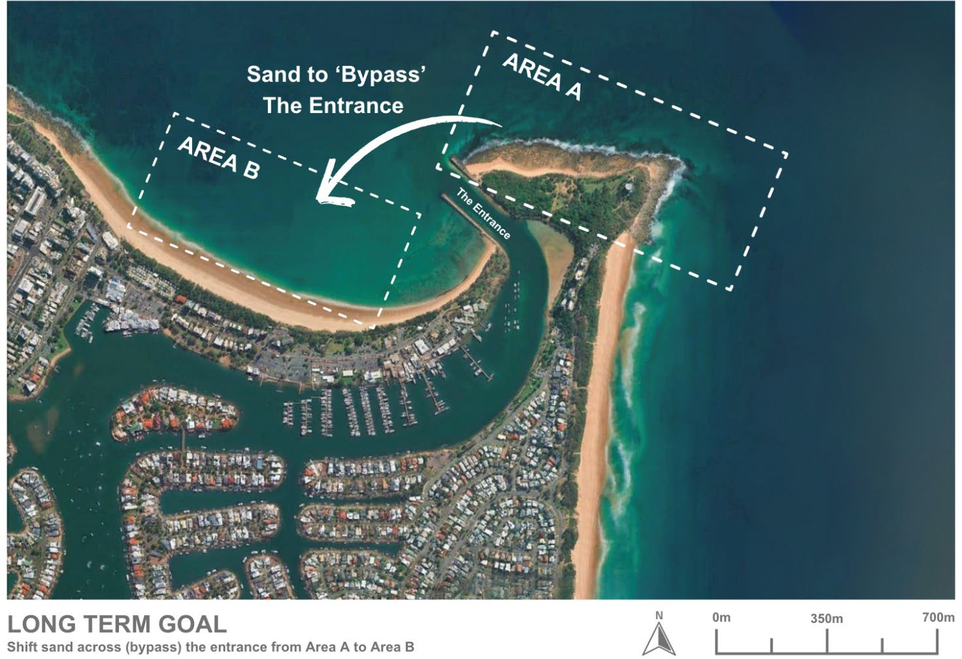
Figure 12-1: Long term goal/objective (Note that ￼area boxes are shown indicatively and are not representative of any restrictive limits)

High level goal list
- Maintain safe, reliable all-tide access for mariners through the Mooloolaba Boat Harbour entrance at all times.
- Facilitate the natural movement of sand by transferring material from the updrift area east of the entrance (Area A) to the downdrift area west of the entrance (Area B).
- Replicate natural coastal bypassing processes to maintain sediment balance while preventing sand accumulation within the entrance channel.
- Reduce reliance on the current ongoing maintenance dredging, which is disruptive to navigation, and operationally constrained by weather and sea conditions.
- Develop a sustainable, long-term sediment management mechanism that maintains a clear navigational channel under all tidal and seasonal conditions.
- Minimise environmental impacts on coastal and marine habitats.
- Ensure cost-effectiveness in both capital investment and ongoing operation and maintenance.
- Achieve social acceptance by supporting harbour usability, recreational values, and community expectations.

Objectives and limitations of this expert review
This expert review has been undertaken to provide a high-level, conceptual assessment of potential long-term solutions for managing sediment accumulation at the Mooloolaba Boat Harbour entrance. As noted, there are two primary areas of consideration in the coastal system:
- Area A – located to the east of the entrance, where sand naturally accumulates due to littoral transport and wave-driven processes.
- Area B – located to the west of the entrance, where sand would naturally deposit if uninterrupted by the existing entrance and training wall structures.
The focus of this review is primarily on Area A, investigating how and where accumulated sand can be collected and moved to maintain navigable depths. Area B remains under the management of the Sunshine Coast Regional Council (SCRC), which oversees the maintenance of the adjacent beaches and coordinates with Maritime Safety Queensland (MSQ) regarding suitable placement locations for dredged material from Area A at the time of works.
In the short term, continued coordination between SCRC and MSQ will be essential to ensure the effective placement of dredged material and maintenance of coastal amenity. However, as detailed design and longer-term strategies are developed, closer collaboration will be required to explore opportunities for a mutually beneficial and more consistent sediment management framework, potentially replacing the current relatively ad-hoc approach.
For the purposes of this review, it has been assumed that sand from Area A may be placed within a defined “placement box” in Area B (note again that this box is not limiting and only shown as an indicative east of the entrance). Within this placement box, two general options are recognised:
- Beach nourishment, involving direct placement of material on the upper (dry) beach area.
- Nearshore placement, where material is deposited offshore to allow natural coastal processes to gradually return sand to the beach system.
Other limitations of this review include the scope and level of detail. Due to the urgent nature of the request and the requirement for timely delivery, this assessment is provided at a conceptual level for comparative and discussion purposes only. No new site data has been collected, and the review relies solely on existing information provided by relevant agencies and publicly available sources. Further investigations, detailed modelling, and design development will be required prior to implementation of any preferred long-term solution.
The options assessed in this review were identified through a combination of sources, including concepts previously developed and provided by MSQ, ideas and feedback arising from the Stakeholder Reference Group (SRG) and broader community engagement, and the professional judgement and experience of the review team as coastal engineers familiar with sediment dynamics and harbour management along the Queensland coast. This collective input has ensured that the range of options considered reflects both local knowledge and technical feasibility, providing a balanced foundation for further investigation.

Our approach to the long-term solutions
Our approach is to begin with softer, lower-risk interventions and only escalate to more engineered (“hard”) options if monitoring shows they’re needed. This aligns with MSQ’s current management direction, including its implementation of the Western Channel Trial, a softer, adaptive change to entrance management intended to maintain access while minimising structural impacts.
In practice, we prioritise incremental, reversible measures that can be trialled and monitored (e.g., targeted sediment management and operational refinements) before considering capital works. This staged methodology responds to the SRG and broader community preference to trial less intrusive solutions first, while keeping proven hard-engineering options in reserve. By doing so, we aim to balance navigation safety and reliability with environmental sensitivity, social acceptance, and cost-effectiveness, and to build an evidence base that de-risks any future escalation to more permanent works.

How we considered social impacts
A Social Impact Evaluation (SIE) was developed providing a streamlined assessment considerate of the Social Impact Evaluation Guide, Business Case Development Framework, Release 3 (2021) developed by the Queensland Government. The SIE considered both the positive and negative impacts for each option. The impacts have been assessed against the social baseline, which is the current state of the harbour including the ongoing management activities. Impacts are considered in terms of the change between the baseline and the anticipated stakeholder experience following mitigation. Each impact is categorised according to the 11 impact categories identified in the guidance: Community, Culture, Health, Intergenerational, Lifestyle, Personal and Property Rights, Institutional, legal, political systems and equity, Quality of Life, Economic, Environmental and Gender relations. The SIE is included in Appendix B. The findings of the SIE have informed the social and economic rankings provided for each option.

How we reviewed options in this report
Our review considers both options already advanced to varying stages of concept/design and ideas emerging from community and SRG input to achieve the long-term goal: moving sufficient sand from Area A (east) to Area B (west) to maintain a clear, safe entrance at all times.
Each option has been assessed in relation to:
- Effectiveness of the coastal engineering solutions to achieve the long-term goal.
- Potential for social and economic impacts
- Potential for environmental impacts
Evaluation of long-term options uses a multi-criteria analysis (MCA) process to determine preferred options that meet the long-term goal. The assessment blends coastal engineering analysis with environmental, social, operational, and economic considerations, informed by our experience delivering similar projects in comparable coastal settings.
The MCA scoring was undertaken by the ICM and RPS technical leads from the project team. No weighting or sensitivity has been applied to the scoring.
The key steps undertaken by the project team in the MCA process include:
- Develop and agree on the list of MCA categories and criteria
- Score each option with respect to each criterion
- Combine the scores for each MCA category to provide a total score for the option
- Select the preferred option(s) with highest score(s).
Note, no weighting of scoring for MCA criteria or sensitivity analysis applied to MCA categories.

Table 12-1: MCA scoring criteria
MCA category | MCA criteria
Coastal engineering | - Effectiveness: Likely ability to shift enough sand past the entrance (bypassing efficiency, trap capture rate, reduction in shoal frequency/magnitude, entrance depth reliability).  - Impacts on coastal processes: the level in which it changes or has negative impacts on existing coastal processes  - Design and approvals: how far is the option progressed with design and approvals and how much would be required  - Capital works: how significant the capital works would be and their impacts during the process  - Operational works: how significant the operational works would be and their impacts during the process  - Future adaption: how well the option be adapted to future conditions
Safety | - Mariner safety and reliability of all-tide access; clarity of navigation
Social and economic | - Achieves SRG preference for lower impact, “softer” measures where practicable  - Traditional Owners do not experience disturbance to cultural values  - Visual amenity  - Community amenity (including noise from pumps)  - Beach users experience (including impacts to demand)  - Safe access for business and recreational users  - Reliable access for business and recreational users  - Broader economic considerations during construction and operation  - Environmental impact perceptions  - Reliable access for business and recreational users
Environmental | - Marine water quality impacts  - Marine habitats and protected species impacts  - Terrestrial habitats and protected species impacts
Financial | - CAPEX costs  - OPEX costs – operations, maintenance, monitoring and contingency

Table 12-2: MCA scoring
Score | Description of scores
1 | Worst performance or Significant impacts
2 | Poor performance or Major impacts
3 | Average performance or Moderate impacts Average performance or Moderate impacts
4 | Good performance or Minor impacts
5 | Excellent performance or Insignificant impacts

Table 12-3: Impacts description
Impact | Description of impact
Significant | - Long-term, high-magnitude and far-reaching impacts  - Positive impacts will provide enormous value both locally and regionally  - Society has no capacity to cope with significant negative impacts
Major | - Long-term and potentially far-reaching impacts  - Positive impacts will provide substantial value to society  - Society has limited capacity to adapt and cope with the negative impacts
Moderate | - Medium-term impacts  - Positive impacts can be enhanced to provide substantial value to society  - Society has the capacity to adapt and cope with the negative impacts
Minor | - Short-term and mostly local impacts  - Positive impacts provide some value to society  - Negative impacts can be easily adapted to by society
Insignificant | - Small-scale impacts. These impacts provide limited value or costs to society. These impacts may require future consideration if there is change to the option reference design

Long term options reviewed
Long-term solutions are aimed at addressing the root cause of the shoaling to reduce the frequency and cost of maintenance dredging.
- Option 1 – Buddina Beach Sand Trap: Trailing suction hopper dredge, about 100,000 m³ from trap to Sunshine Coast beaches. It was noted that this option was considered at the recent SRG as a viable opportunity but had not been fully considered at this stage.
- Option 2 – Increased Dredge Channel Depth with Rock Excavation: This involves deepening the channel beyond the current -2.5 m LAT design depth. This would likely require the excavation of underlying rock. While it would provide a greater buffer against shoaling, it is a significant and costly undertaking with potential environmental and engineering challenges.
- Option 3 – Eastern Breakwater Extension: A 60-meter extension to the existing eastern breakwater is the preferred engineering solution. The objective is to intercept the majority of the northward sand drift before it can enter the navigation channel. A design report for this project has been completed, and it is considered the most effective long-term solution to reduce channel sedimentation.
- Option 4 – Permanent Automated Sand Bypassing System: This option involves a permanent system to mechanically transport sand from the updrift side of the bar (Point Cartwright) to the downdrift side (Mooloolaba Beach). While technically feasible, the capital and operational costs, as well as the environmental impact and visual amenity, require detailed consideration.
- Option 5 – Western Channel Concept Plan – Shorten Western Wall: Removal of a section of western breakwater wall to create a wider western channel for safe access during adverse shoaling conditions.

Options with operational variations
It is also important to note that some of the five primary options include sub-options or operational variations. For each option, there are typically two key components that influence performance:
- How sand is collected in Area A (the updrift accumulation zone); and
- How sand is distributed to Area B (the downdrift deposition area).
Different combinations of collection and placement methods may be possible within a single option, for example, using alternate dredging techniques or varying between direct beach placement and nearshore disposal. These sub-options represent different operational modes rather than distinct strategies and are considered in the review to highlight the flexibility, adaptability, and potential staging opportunities available within each broader long-term solution.

Key assumptions

Sand transport rate (Area A)
A key assumption underpinning all sand management options is the depth-dependent and episodic nature of sediment transport around Point Cartwright. Long-term monitoring and modelling (BMT, 2018; BMT, 2024) show that:
- Only 5,000–10,000 m³/year of sand typically accumulates in the shallow shoal zones above -3 m LAT, which is the portion most relevant to navigation and maintenance dredging.
- In contrast, modelling during a persistent shoaling episode in late 2011 to mid-2012 estimated that approximately 96,500 m³ of sand bypassed into Mooloolaba Bay in a single event, almost entirely within the -3 m to -10 m LAT depth band (BMT, 2018).
This behaviour supports a two-stage bypassing model previously described in where sand first accumulates offshore of Point Cartwright under net northerly transport, then moves westward into the entrance zone during subsequent high-energy events.
This pulse-driven dynamic is fundamental to the observed shoaling cycles and directly informs the inconsistency and variability in annual peak and average bypassing rates. While the long-term average net transport is estimated at 75,000 m³/year, the actual delivery of shoaling-prone material into the entrance occurs in irregular, event-driven pulses. As such, bypassing rates vary dramatically from year to year depending on the timing, intensity, and sequencing of storm events and prior accumulation (as shown in Figure 12-2). This variability reinforces the need for management options that are not only sized for long-term averages but are also resilient and responsive to short-duration, high-volume transport pulses.
The occurrence and magnitude of entrance shoaling depend on the joint probability and sequencing of these phases i.e., the timing between sand accumulation events and the arrival of wave conditions strong enough to trigger bypassing. Without both phases occurring in the right sequence, sand may remain offshore or bypass the entrance altogether.

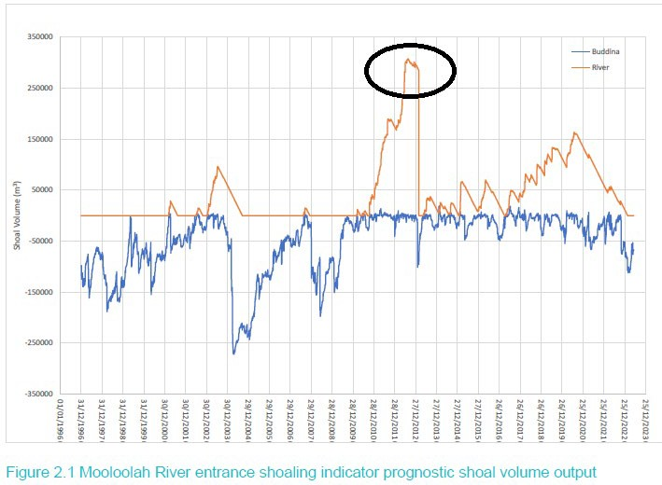
Figure 12-2: Mooloolah River entrance shoaling indicator prognostic shoal volume output (peak volume events circled)

Sand placement (Area B)
In reviewing and comparing the long-term options, a number of operational assumptions have been made regarding the placement of material in Area B. These assumptions are necessary to enable consistent comparison between options and reflect typical practical and economic considerations for the site.
For options that rely on trailing suction hopper dredge (TSHD) operations, it has been assumed that sand placement would occur in the nearshore (offshore) zone. This approach is generally more cost-effective (then onshore placement), as it avoids the additional expense of pumping material ashore through pipelines. It also minimises disturbance to beach users, as works are undertaken offshore rather than within the active beach area. While sand placed in the nearshore will typically move onshore over time through natural coastal processes, providing a beneficial buffer against storm erosion, it does not provide immediate dry beach nourishment or visible widening. The placement is also not limited to within Area B, as the TSHD could ship to wherever the sand may be needed at the time.
Conversely, for options involving pipeline-based sand transfer systems (e.g. fixed or temporary sand pumping), it has been assumed that sand would be placed directly onto the dry beach. If sand is being actively pumped, it is more beneficial to deliver it directly to the beach to achieve immediate beach nourishment outcomes and enhanced recreational and aesthetic benefits. However, this method requires on-beach machinery (typically an excavator and loader) to distribute and level the placed material, which would result in short-term disruption to beach users during placement operations. These assumptions are applied consistently throughout the option assessments to allow meaningful comparison of costs, environmental effects, and social considerations between dredging-based and pipeline-based systems.

The existing pipe network
A permanent pipeline system is already in place within and around the Mooloolah River entrance, providing established infrastructure for sediment transfer and beach nourishment activities. On both the eastern and western training walls, permanent pipelines are installed internally, including a fixed under-channel section that connects beneath the entrance and enables sand transfer between sides.
Along the western side, a buried pipeline runs behind the dunes along Mooloolaba Beach, extending to the area known as the “cheese wedge.” This line features multiple outlets points to allow flexible sand placement along the beach. During recent dredging campaigns, this system has been extended temporarily, using a booster pump in collaboration with Sunshine Coast Council, to deliver sand further east toward the surf club for direct beach nourishment.
Historically, dredged sand was placed in the western corner of the entrance; however, this is now only used when significant erosion occurs, as the default sand placement area is along Mooloolaba Beach via the established dune-backed pipeline network.
This existing infrastructure provides a strong foundation for integration with future long-term sediment management options, particularly those that utilise on-demand pumping or bypass systems to improve efficiency and flexibility.
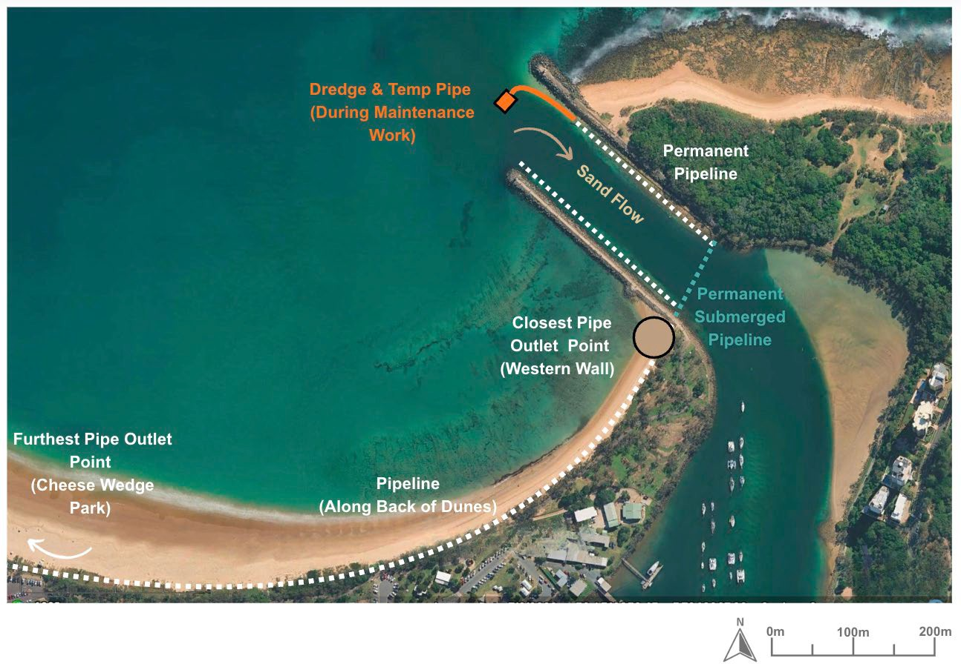
Figure 12-3: Existing pipeline network

Common option elements
A number of core components are common to several of the long-term management options reviewed in this report. These include the use of Cutter Suction Dredges (CSDs) and Trailer Suction Hopper Dredges (TSHDs) for sand collection, as well as shore-based pump stations and slurry-pumping systems for sediment transfer. Supporting infrastructure such as buried or floating pipeline networks and beach outlet structures (or diffusers) are also recurring elements.

Cutter suction dredge
The Navua Jade Platypus 300 HDDSX Series Cutter Suction Dredge is currently employed at the Mooloolaba Entrance as part of maintenance dredging operations. This dredge plays a critical role in maintaining safe navigation by removing sand shoals that accumulate in the entrance channel. The dredged material is pumped onto Mooloolaba Beach for beach nourishment, helping to counteract coastal erosion and support shoreline stability.

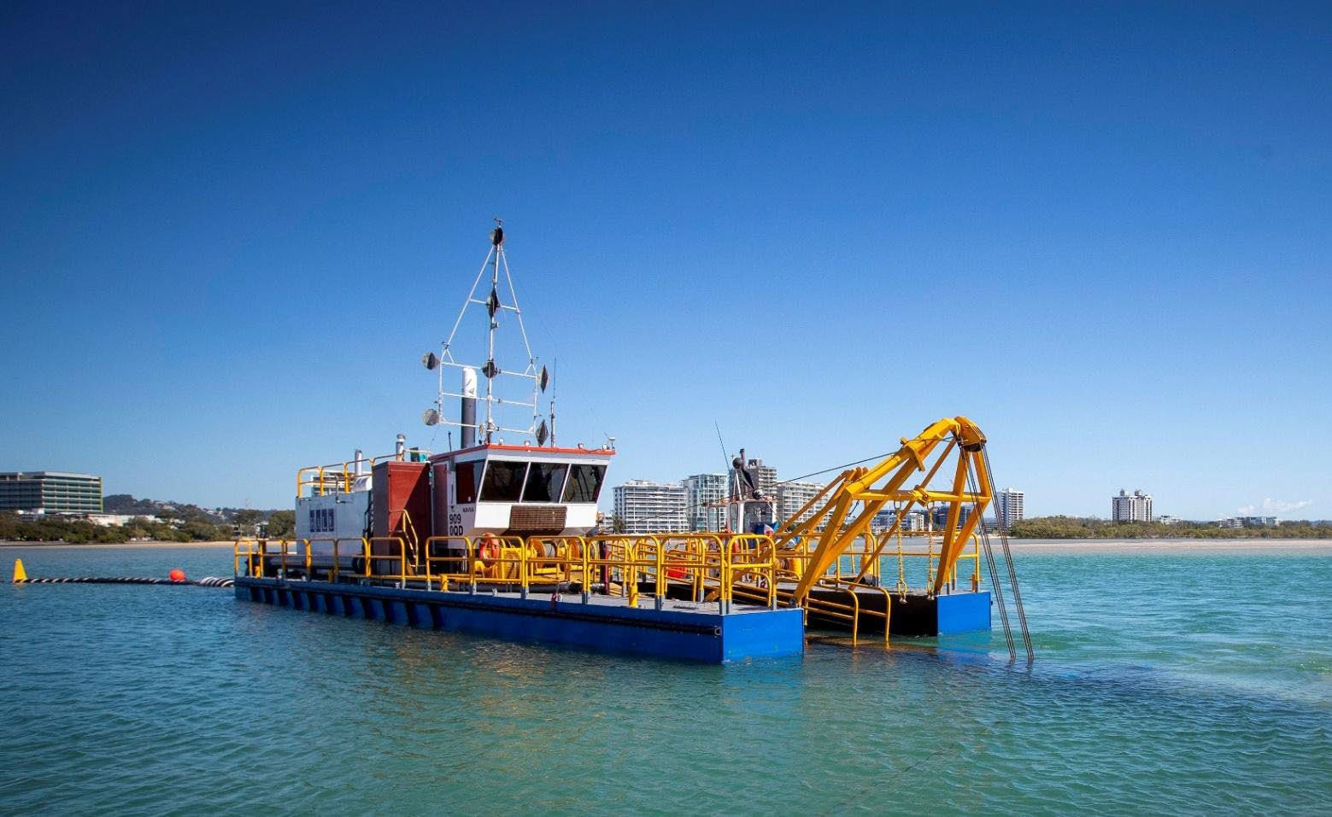
Figure 12-4: Cutter Suction Dredge – Navua Jade Platypus removing shoal build up in Mooloolaba channel entrance (Halls, 2025)

The cutter suction dredge (CSD) is a floating mechanical dredge designed to excavate compacted sand and pump it via the existing pipeline at the entrance to the designated placement areas. It is currently used for:
- Maintenance dredging following significant shoaling events, such as those observed during the Western Channel Trial.
Mobilisation of the dredge is managed through local contractors (Hall Contracting) and is dependent on equipment and crew availability. The CSD has proven effective for shallow sand removal, but operational constraints limit its efficiency (weather dependency, rapid shoaling, mobilisation delays depth limitations and regulatory limits).

Trailing Suction Hopper Dredge
A Trailing Suction Hopper Dredge (TSHD) is a self-propelled dredging vessel that collects sediment through trailing suction pipes equipped with drag heads. The dredged material is stored in an onboard hopper and later discharged either offshore or through controlled placement methods such as pumping or rainbowing. TSHDs are designed for efficient large-scale dredging and can operate in moderate sea conditions, making them suitable for broader coastal and channel maintenance works.

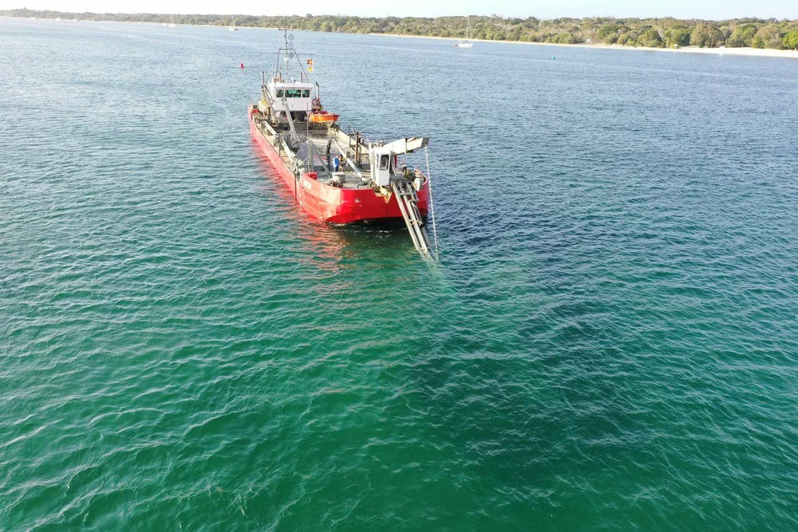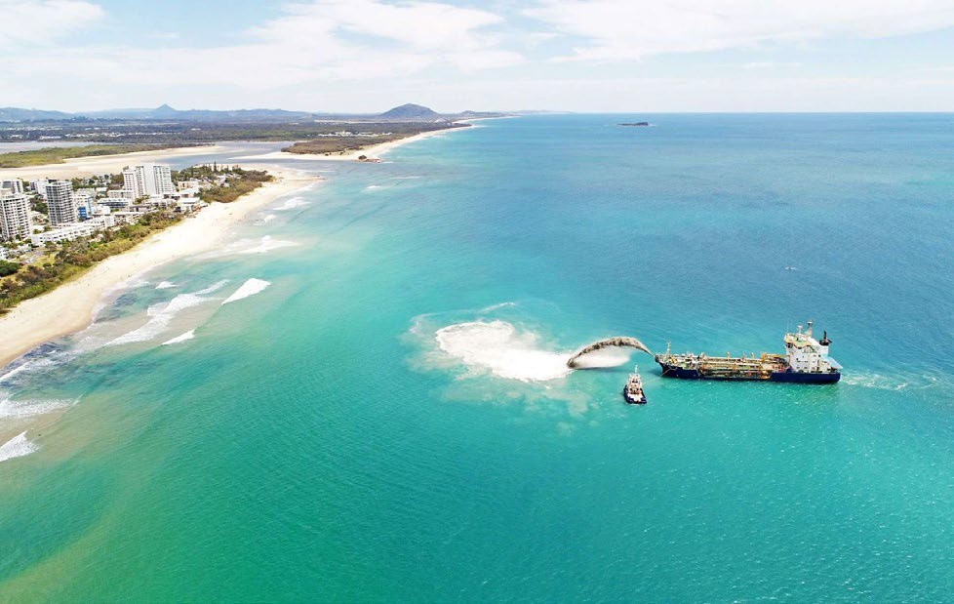
Figure 12-5: Left McQuade Marine TSHD Bottom Dumping (Mcquade Marine, 2024). Right: Rhode Nielsen Rainbowing TSHD onto the Gold Coast Nearshore (RN, 2025)

Within the local region, two primary operators provide TSHD services — McQuade Marine and RN Dredging.
- McQuade Marine operates a Trailing Suction Hopper Dredge, which is well-suited for maintenance dredging and offshore sand relocation. Their vessels are capable of operating in more energetic sea states than smaller dredging units and can remove and transport large volumes of sediment efficiently over longer distances.
- RN Dredging offers specialised rainbowing capabilities, which allow dredged sand to be directly discharged to the nearshore via rainbowing of material. This technique is particularly useful for beach nourishment and coastal protection projects, enabling precise placement of sand along the foreshore to naturally drift onshore.

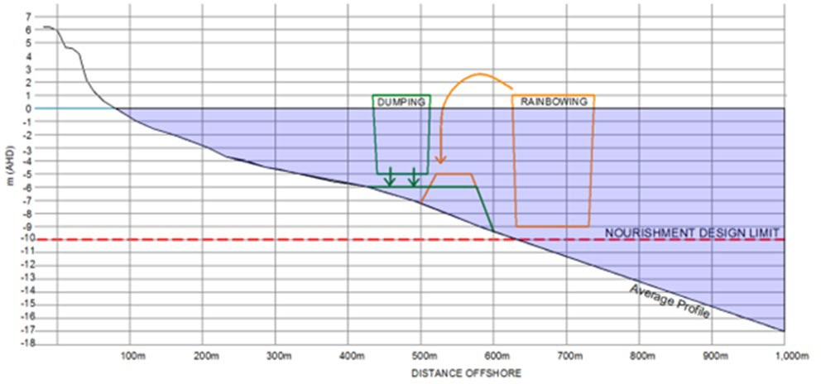
Figure 12-6: Schematic showing Indicative Dredge Accessibility [Distorted Scale 1V:20H] for a typical Gold Coast beach profile (ICM, 2017)

Together, these contractors provide flexibility for a range of dredging tasks, from channel deepening and sand removal to beach replenishment and coastal restoration.
While TSHDs offer significant dredging capacity and efficiency, mobilisation delays remain a key limitation. Both McQuade and RN’s dredges are not permanently stationed at Mooloolaba, meaning mobilisation depends on vessel scheduling, crew availability, and weather conditions. This typically results in longer lead times and higher mobilisation costs compared to the local cutter suction dredge (CSD), which can be deployed more quickly for small-scale or urgent maintenance works.
TSHDs operated by McQuade Marine and RN Dredging provide valuable large-scale dredging and sand transport capabilities, enhancing regional sediment management options. They are particularly effective for bulk sand removal, offshore disposal, and beach nourishment, especially where wave conditions are too challenging for a CSD.

Submarine sand shifter
A sand slurry system is an engineered solution designed to manage sediment movement and maintain navigable channels in coastal and riverine environments. It works by capturing accumulated sand and transporting it—via a slurry pipeline—to a designated disposal or replenishment area. The system prevents excessive sand build-up and reduces the need for large-scale dredging operations.
The system typically consists of several submerged jet pumps or intake units located strategically along a channel or near structures such as breakwaters or boat ramps. These pumps are positioned to intercept sand moving alongshore or into navigation areas.

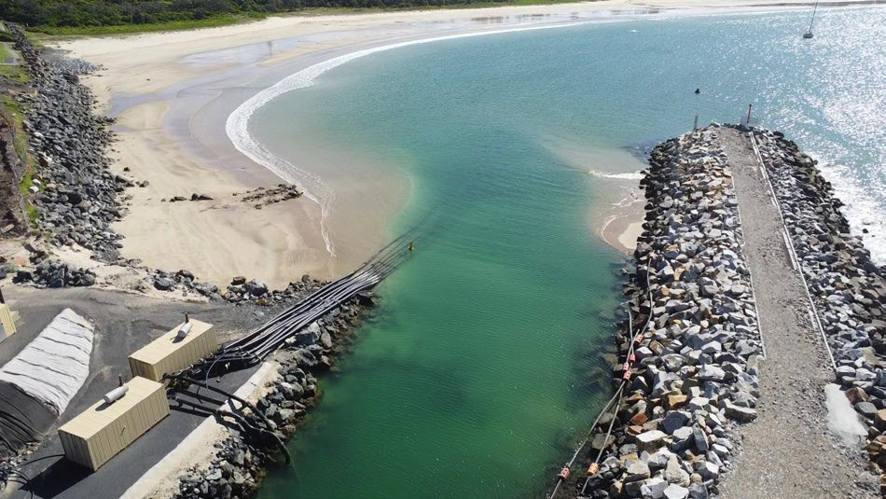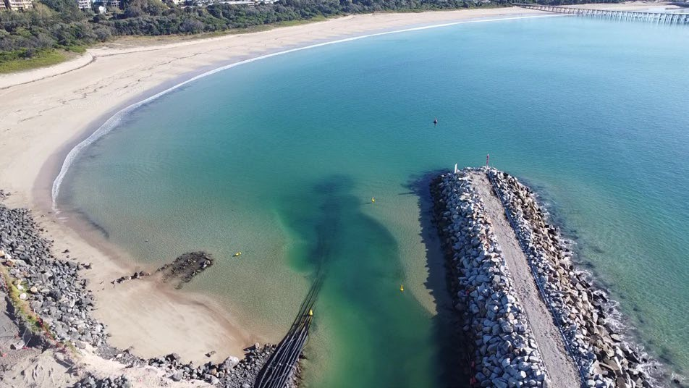
Figure 12-7: Slurry Systems Marine – 5 Jet Pumps utilised in Coffs Harbour channel entrance (Sand Slurry Systems, 2025)

Locating the pumps within the channel ensures:
- Sand cannot migrate past the intake zone.
- Only sand that naturally accumulates in the channel is bypassed.
- Sand entering from any direction is trapped and redirected.
- Operation immediately clears the channel of obstructions.
- Pump capacity does not need to match peak sand movement, allowing flexible and efficient operation. A standard sand slurry system includes:
- Jet pumps or intake units – Buried within the seabed, these create localised depressions that draw in sand and water to form the slurry.
- Water supply pump – Provides high-pressure water to power the jet pumps.
- Dredge booster pump – Located onshore to increase pressure and move the slurry through the discharge pipeline.
- Discharge pipeline – Transfers the sand slurry to the disposal area, which may be several hundred metres away.
- Control units and power source – Diesel or electric-powered, typically housed in containerised units for ease of relocation.
Typical systems can handle sand volumes in the range of 50–200 cubic metres per hour, depending on pump size, sediment type, and pipeline length. The installation layout and spacing of pumps depend on local seabed conditions and sand movement patterns. The system can be operated continuously or intermittently, based on monitoring of sand accumulation.
Maintenance requirements are generally low compared to mechanical dredging. Systems can often pump hundreds of thousands of cubic metres of sand before major servicing is required. The main maintenance tasks include checking pipelines for blockages, inspecting pump internals for wear, and ensuring efficient slurry flow. Electric operation is increasingly favoured due to lower running costs and the ability to use off-peak energy rates, though diesel systems remain common for remote or temporary setups.

Pump outfall onto beach
The following is an example of temporary pipe with multiple pipe outlets shown on the Gold Coast. Refer to Appendix C for other examples of sand bypass and operating systems.
The existing pipe network along Mooloolaba Beach has been in use and it is assumed that the setup for this will remain the same (considered as the same for our options comparison). This image below is only used for refence when more distribution of material is required on the beach through ‘splitter values’ to direct sand to multiple outlets at one time.

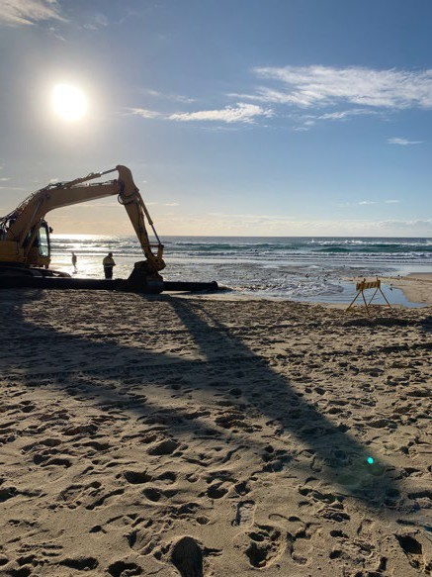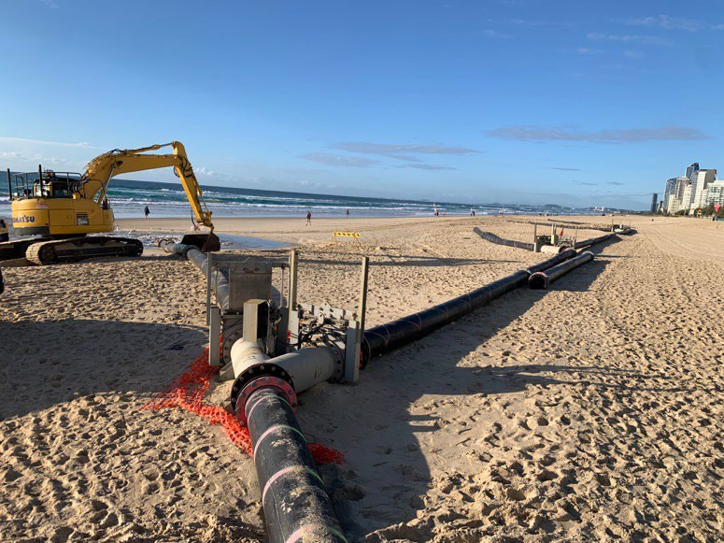
Figure 12-8: Sand pipe with multiple outlets for beach deposition (ICM, 2024)

OPTION 1 – BUDDINA BEACH SAND TRAP

Description of Option 1
Option 1 investigates a long-term sediment-management measure aimed at slowing the rate of sand shoaling at the Mooloolaba Harbour entrance. Shoaling occurs as sand naturally bypasses Point Cartwright and accumulates within the entrance channel, reducing navigable depths and requiring frequent maintenance dredging.
This option seeks to interrupt and temporarily store part of the northward-moving littoral sand transport before it enters the Mooloolah River entrance. The overall objective is to reduce the rate and frequency of shoaling, improving navigation safety and reducing long-term dredging demand, while maintaining natural sediment processes as far as practicable.
The concept involves establishing a defined nearshore sand trap at northern Buddina Beach (Area A) where a persistent sand deposit exists. Sand accumulating within the trap would be periodically removed and transferred to a down-drift beach nourishment area (Area B) such as Mooloolaba Bay, Alexandra Headland, or Maroochydore. This approach functions as a controlled, repeatable sediment management system that manages sand before it reaches the entrance - slowing shoaling without completely halting the natural bypass cycle (BMT, 2024).
Option 1 schematic:
- Location: Offshore of northern Buddina Beach, adjacent to the eastern slope of Point Cartwright (see Figure 13-1)
- Dimensions: Approximately 100 m × 280 m.
- Depth: Existing seabed levels -8 m AHD to -12 m AHD; dredging depth 2.5 – 3.5 m.
- Expected yield: 70,000 – 98,000 m³ per campaign (BMT, 2024).
- Potential modification: Extraction area may be extended or repositioned westward into shallower water to improve trapping efficiency, subject to operability and safety constraints (BMT, 2024).
The sand trap is expected to refill over time, primarily under storm conditions, requiring periodic re-extraction every few years as part of a sustainable, long-term sediment management cycle.

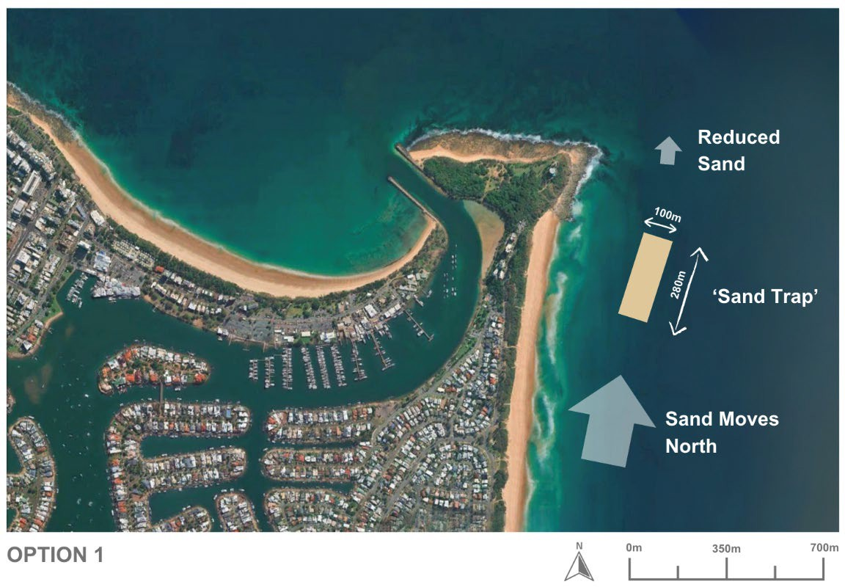
Figure 13-1: Conceptual plan view of Option 1 – Sand trap on northern Buddina Beach (ICM, 2025)
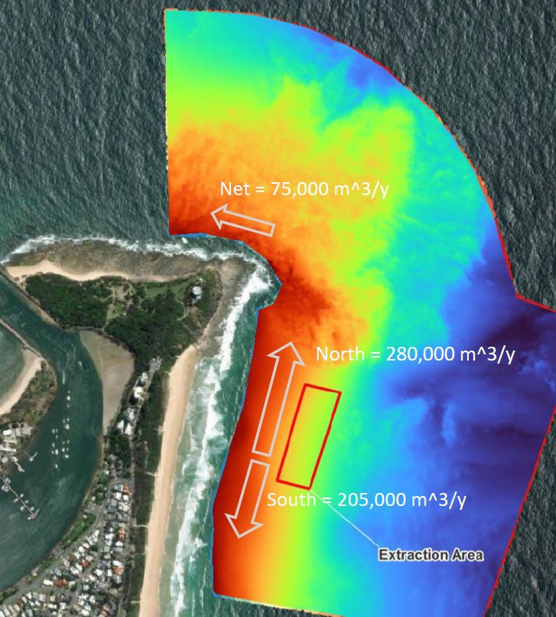
Figure 13-2: Longshore sand transport conceptual model for north Buddina Beach and Point Cartwright (BMT, 2024)

Effectiveness of Option 1
The Buddina Beach Sand Trap is designed to reduce, not eliminate, sand shoaling at the Mooloolaba Harbour entrance. By trapping a portion of the northward-moving sand before it rounds Point Cartwright, the option would slow the rate of shoal formation and extend the duration between maintenance dredging campaigns.
Modelling derived from the sand shoal indicator (BMT,2024) estimates a net northward longshore transport around Point Cartwright of approximately 75,000 m³ per year (), while the gross annual transport along Buddina beach is approximately 485,000 m³ per year (280,000 m³ northward and 205,000 m³ southward). The proposed trap could intercept 28,000 – 95,000 m³ per year, equating to 37 – 126 % of the net average northward sand flux, depending on storm conditions (BMT, 2024).
This means the trap could temporarily capture a significant proportion of the sand that would otherwise reach the entrance, thereby slowing the accumulation rate within the shoal zone. Infilling is expected to occur mainly during high-energy storm events when waves mobilise sediment beyond the -7 m contour, while moderate conditions would result in minimal trapping activity.
- Primary function: Reduce (not prevent) shoaling by slowing sand delivery to the entrance.
- Bypassing efficiency: 40% of the net longshore sand supply (BMT, 2024).
- Trap capture rate: 28,000 – 95,000 m³/year, dependent on storm frequency.
- Impact on shoaling frequency: Fewer and less severe shoaling events expected.
- Entrance depth reliability: Improved through slower sediment accumulation and reduced dredging frequency.
Overall, the Buddina Sand Trap is assessed as having moderate potential effectiveness in slowing shoal formation and supporting long-term navigation management. Its success will rely on storm occurrence patterns, ongoing monitoring, and periodic maintenance dredging to maintain trap functionality.

Variations of Option 1
Two practical variations of option 1 are proposed, which differ primarily in how sand is collected and transferred between Areas A and B. Option 1A represents a low-risk, passive approach suitable for pilot or trial implementation, while Option 1B introduces a more engineered, active system capable of delivering controlled, ongoing sand bypassing. Both are examined in the following subsections in terms of capital and operational works, physical processes, environmental and social implications, cost, and overall feasibility.
Two potential variations have been identified within Option 1, reflecting alternative ways to achieve the same sediment-management objective:
- Option 1A – Buddina Beach sand trap with TSHD transport: Establishment of a defined nearshore trap area to capture and periodically dredge accumulated sand for beneficial reuse.
- Option 1B – Buddina Beach sand trap with pump system and pipeline across the entrance: Installation of a shore-based pump and buried pipeline network to directly transfer sand across the entrance to Mooloolaba Beach.
These variations are described further in the following sections.

Option 1A – Buddina Beach sand trap with TSHD transport

Description of Option 1A
Option 1A proposes the construction of a controlled nearshore sand-trap area offshore of northern Buddina Beach, immediately south of Point Cartwright. The purpose of this option is to intercept and temporarily store a portion of the northward-moving littoral sand transport before it enters the Mooloolaba River entrance, thereby slowing the rate of shoaling within the navigation channel.
Under Option 1A, sand collection is achieved using a Trailer Suction Hopper Dredge (TSHD). The dredge would periodically remove material that has naturally accumulated in the trap and transport it for beneficial reuse at nearby beaches such as Mooloolaba Bay, Alexandra Headland, and Maroochydore.
This contrasts with Option 1B, which employs a fixed pump and pipeline transfer system across the entrance. Accordingly, the key difference between the two sub-options lies in the deposition method, not the trap location or its sand-capture function.
The trap would occupy an area of approximately 100 m × 280 m in water depths of –8 m to –12 m AHD and provide a total capacity of 70 000 – 98 000 m³ per campaign. An initial capital dredging campaign of about 90 000 m³ (including over-dredge allowances) would establish the design depth. Captured material would then be periodically removed by the TSHD as part of an ongoing sediment-management cycle. The concept and indicative parameters are consistent with the investigations undertaken by BMT (2024) and earlier MSQ sediment-management studies, which confirmed both the presence of an accessible nearshore sand source and its potential role in reducing entrance shoaling.

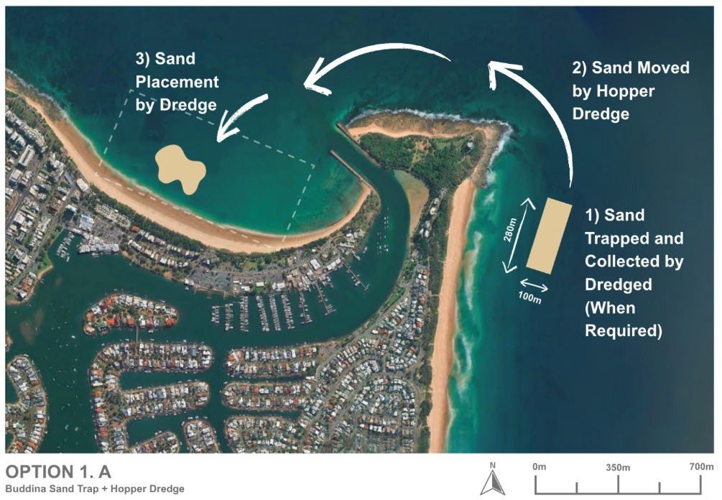
Figure 13-3: Option 1A – Buddina Sand Trap via a hopper dredge (ICM, 2025)

Design and approvals
The Buddina Beach concept has been progressed through several technical studies, including work by BMT (2024) and earlier investigations undertaken for MSQ. These studies have confirmed the presence of a significant nearshore sand deposit suitable for managed extraction and have provided a preliminary understanding of local sediment dynamics, potential dredge footprints, and indicative volumes.
At this stage, the concept remains at a high-level or conceptual design phase and is intended to guide further feasibility and detailed-design assessments rather than represent a final engineered solution.
To advance option 1A, the following studies are recommended:
- Detailed 2D/3D coastal process modelling to validate trap efficiency and local hydrodynamics.
- Environmental Impact Assessment (EIA) addressing turbidity, benthic-habitat effects, impacts to marine fauna and shoreline response.
- Operational safety assessment for dredging near the -8 m contour.
- Pilot dredging program with targeted monitoring to evaluate trap infilling rates and post-dredge recovery.
- Review of engineering design parameters (trap dimensions, slope stability, and maintenance frequency).
The concept has progressed to schematic design, supported by recent technical studies confirming feasibility and outlining key design parameters. While further modelling, environmental assessment, and validation are needed, the current definition provides a reasonable foundation for approvals.

Capital works
Implementation of Option 1A would involve:
- Excavation of a defined sand trap area (approximately 100 m x 280 m) in the nearshore zone (between
-8 m to -12 m AHD) adjacent to Northern Buddina Beach.
- Initial capital dredging campaign of 90,000 m³ (including over-dredge allowances) to achieve design depth and trap capacity.
- Establishment of temporary access or offshore mooring locations for dredge mobilisation and material transfer operations.
- No permanent onshore infrastructure is anticipated.
This option represents a substantial volume of dredging using standard dredging plant and techniques. The use of a Trailer Suction Hopper Dredge (TSHD) for both sand collection and nearshore nourishment is a well-proven and highly reliable method of sediment management along the Australian coastline. Similar operations are routinely undertaken at major ports and coastal locations such as Moreton Bay, Gold Coast, Tweed River, and Newcastle, where TSHDs are used to relocate sand for beach nourishment and entrance maintenance.
With minimal onshore impacts and no permanent infrastructure requirements, the works are considered highly feasible with low environmental and operational risk.

Operational works
Ongoing operation of Option 1A would involve the periodic removal of accumulated sand from the Buddina Beach sand trap using a Trailer Suction Hopper Dredge (TSHD), with subsequent placement at identified nourishment sites along the Sunshine Coast (Mooloolaba, Alexandra Headland or Maroochydore). This cyclical approach maintains the trap’s effectiveness while delivering regional coastal benefits through strategic sand recycling.
- Sand collection
  - Sediment will accumulate naturally within the sand trap through longshore transport processes, particularly following moderate to high-energy storm events that mobilise the nearshore profile.
  - Once monitoring data indicate (sand shoal indicator and hydrographic surveys) that the trap is nearing its design capacity, a TSHD will mobilise to the site to undertake controlled dredging operations.
  - Dredging would typically occur within the existing trap footprint, following pre-approved bathymetric and environmental constraints.
  - The TSHD is capable of operating efficiently at depths between -8 m AHD and -12 m AHD, making it well suited to the local seabed conditions and wave climate.
  - Each dredging cycle is expected to recover 60,000 – 90,000 m³ of material, depending on the degree of natural infill since the previous campaign.
- Sand placement
  - Collected material will be beneficially reused to nourish nearby beaches within the regional sediment cell, maintaining a balanced littoral system.
  - Preferred placement sites include Mooloolaba Bay, Alexandra Headland, and Maroochydore, selected for their ongoing erosion management needs and compatibility with the dredged material characteristics.
  - Sand placement may be carried out by direct pump-out to the nearshore zone, rainbow discharge, or bottom-dumping within approved nourishment polygons, depending on site conditions and permit requirements.
  - This methodology mirrors proven beach-nourishment practices employed at other Queensland and New South Wales locations such as the Gold Coast, Moreton Bay, and Tweed River Entrance Sand Bypassing Project, where TSHD-based recycling has been demonstrated to be effective, repeatable, and environmentally sustainable.
- Frequency of operations
  - The re-dredging interval is expected to be approximately every 2–3 years, contingent on storm frequency and observed infill rates.
  - Monitoring of bathymetry, sediment characteristics, and shoreline response will guide the timing of each maintenance cycle to ensure optimal trap performance while minimising environmental disturbance.
- Coordination and management
  - Operational works will be jointly planned and coordinated between Maritime Safety Queensland (MSQ), the Sunshine Coast Regional Council (SCRC), and other relevant state agencies.
  - Campaigns will be scheduled to align with existing regional coastal-management and nourishment programs, ensuring efficient resource use and consistent sediment-budget outcomes.
  - All dredging and placement activities will be undertaken under approved environmental management plans, incorporating turbidity controls, exclusion zones, and post-dredge monitoring to confirm compliance.
Operation of Option 1A involves periodic TSHD dredging and sand recycling to nearby beaches, maintaining trap efficiency and regional sediment balance. The approach is proven, low-impact, and well-integrated with existing coastal programs. However, this approach does require substantial dredge volume and the efficiency of removal of materials is likely much lower, than dredging undertaken directly at or adjacent to the entrance.

Coastal process considerations

Longshore sediment transport
The Mooloolaba–Buddina coastal cell is characterised by a highly dynamic littoral transport system, with sand moving both northward and southward under varying wave conditions. Modelling conducted by BMT (2024) indicates a net northward longshore transport rate around Point Cartwright of approximately 75,000 m³ per year, which represents the volume of sediment typically bypassing the headland and contributing to shoaling at the Mooloolaba Harbour entrance.
In contrast, the gross annual transport along Buddina Beach is significantly higher — around 485,000 m³ per year, comprising 280,000 m³ northward and 205,000 m³ southward. This highlights the bidirectional nature and high mobility of sand within this section of the coastline, where short-term reversals in transport direction occur frequently in response to seasonal and storm-driven wave conditions (BMT, 2024).
The proposed Buddina Beach Sand Trap is designed to intercept a portion of this northward-moving sediment before it rounds Point Cartwright. Modelled estimates suggest the trap could capture between 28,000 and 95,000 m³ per year, equating to approximately 37–126 % of the net northward sand flux, depending on storm frequency and wave climate (BMT, 2024).
This reduction in volume of sand naturally bypassing Point Cartwright, will result in a modest decrease in the sediment supply available to the northern beaches. This reduction will likely slow the natural replenishment of these beaches; however, the impact is expected to be minor because the trapped material will be periodically re-dredged and reintroduced to the system through targeted nourishment campaigns. This managed sand recycling approach will maintain the overall sediment balance of the coastal cell, ensuring that while shoaling at the Mooloolaba entrance is reduced, the northern beaches continue to receive sufficient sand to sustain their natural dynamic equilibrium.
The longshore transport analysis (Figure 13-4) also highlights that trap performance will be episodic, with the greatest capture efficiency occurring during large wave events when sand is mobilised in deeper water.
Under typical calm conditions, most sediment transport remains landward of the -7 m AHD contour, resulting in minimal ongoing infill. This behaviour ensures that the sand trap fills gradually rather than continuously, allowing manageable re-dredging intervals.
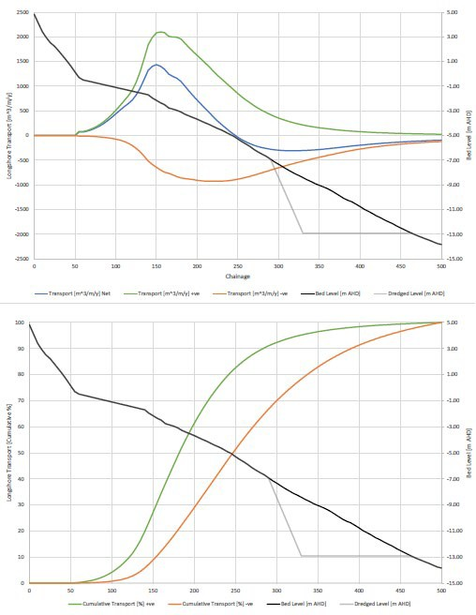
Figure 13-4: Cross-shore distribution of longshore transport at proposed north Buddina extraction

Cross-shore dynamics
Cross-shore sediment exchange plays a significant role in determining both the rate of sand trap infill and the response of the adjacent shoreline. Modelling using the SBEACH numerical model was applied to assess potential cross-shore sediment movement during both historical and design storm events.
Two storm scenarios were modelled:
- Ex-Tropical Cyclone Oswald (2013) – representative of a 1-in-20-year event.
  - A synthetic “design” storm with a significant wave height of 8.1 m and water level of 1.6 m AHD, representing a 1-in-100-year extreme event.
- Results indicated:
  - The borrow area would experience partial infilling of up to 30% of the dredged volume during major storm events due to offshore sand bar migration.
  - There would be a slight increase (4–7%) in upper-beach storm-bite erosion under these extreme conditions, attributed to reduced wave breaking and energy dissipation over the deeper bathymetry of the sand trap (BMT, 2024).
  - For the vast majority of conditions (99 % of the time), the active surf zone remains landward of -7 m AHD, meaning sand transport into the trap is primarily episodic and storm-driven rather than continuous.
- This modelling confirms (Figure 13-5 and Figure 13-6) that the sand trap will operate effectively as an intermittent sediment sink, filling progressively during high-energy events while exerting only a minor and manageable influence on the upper beach profile. The limited increase in storm-bite erosion (4–7%) is considered within the bounds of natural variability and would not significantly alter the overall beach alignment or amenity at northern Buddina.

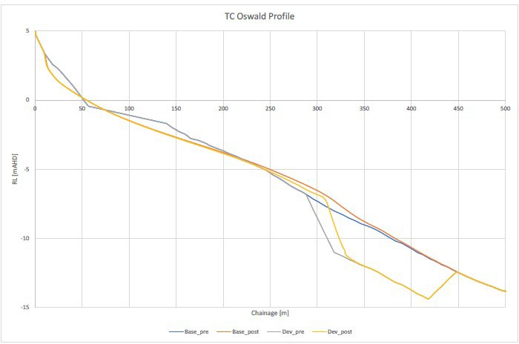
Figure 13-5: SBEACH simulated cross-shore profile response to Ex-TC Oswald (BMT,2024)

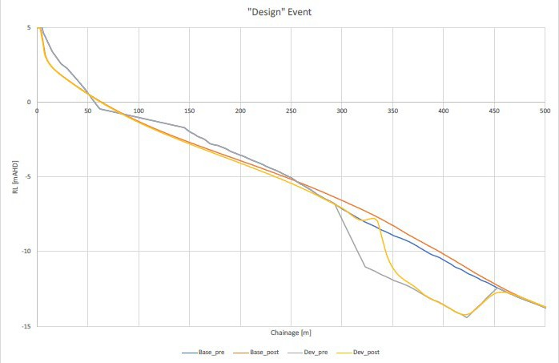
Figure 13-6: SBEACH simulated cross-shore profile response to the “design event” (BMT,2024)

Summary of coastal process response
In summary, the Buddina Beach Sand Trap (Option 1A) interacts with local coastal processes in a predictable and manageable manner:
- It targets the dominant northward longshore transport that drives shoaling at the entrance.
- Episodic infill during storm events ensures sustainable trap operation with manageable maintenance intervals.
- Minor localised erosion effects are expected but remain within the natural dynamic range of Buddina Beach.
- The concept aligns with established sediment-management practices used successfully at similar dynamic coastal inlets along the Queensland and New South Wales coasts, such as the Tweed River Entrance Sand Bypassing Project and the Gold Coast Seaway.
Overall, coastal process modelling supports the conclusion that Option 1A would effectively slow sand shoaling at the Mooloolaba Harbour entrance while maintaining acceptable and predictable coastal behaviour along Buddina Beach.

Environmental constraints
A preliminary assessment of environmental constraints for the Buddina Beach Sand Trap (Option 1A), based on the constraints analysis criteria in Table 13-1, is detailed in Table 13-2.
Table 13-1: Constraints analysis criteria
Constraint level | Description
No impact | There is no impact pathway for the sensitive receptor. No further assessment is required.
Low | There is low potential for impact to the sensitive receptor. No further assessment is required. No or standard management likely.
Moderate | There is a moderate potential for impact to the sensitive receptor which will require further assessment to determine the significance of impact. Likely to be manageable or engineered to minimise potential impacts on the receiving environment.
High | There is a high potential for impact to the sensitive receptor. Further assessment is required to determine the significance of impact and mitigation strategy. Consideration for regulatory approvals.

Table 13-2: Environmental constraints for Buddina Beach Sand Trap (Option 1A)
Category | Receptor | Impact pathway | Constraint level | Justification | Further assessment recommendations | Potential monitoring and management requirements
Marine environmental quality | Water quality | - Generation of turbidity | Moderate | - This is a dynamic, open ocean environment, any plume will likely dissipate quickly. | - Turbidity modelling | - Turbidity monitoring during works
Marine environmental quality | Water quality | - Release of contaminants/hypoxia | Low | - Dredge sediments likely comprise clean marine sand free of contaminants with low organic matter content | - Assumption that suitable data exists to inform this risk | - None
Marine environmental quality | Water quality | - Hydrocarbon spills/waste | Low | - Compliance with standard procedures will minimise this risk | - None | - Standard oil spill and waste procedures
Marine environmental quality | Water quality | - Introduced marine species | Low | - Compliance with standard procedures will minimise this risk | - None | - Compliance with standard state and commonwealth procedures regarding IMS
Marine fauna | Turtles | - Behavioural response and interruption of nesting behaviour due to light  - Mortality/injury due to vessel collision, entanglement, entrainment  - Change of beach profile at Buddina Beach due to nearshore dredging impacting nesting  - Change of beach profile at Mooloolaba Main Beach due to sediment disposal offshore of beach impacting nesting | Moderate | - Several turtle species listed as endangered or vulnerable under the EPBC were identified in the project area with Green (Vulnerable) and Loggerhead (Endangered) turtles known to nest on Buddina and Mooloolaba beaches. Therefore, potential impacts need to be managed accordingly.  - Assessment of shoreline response to works indicates low risk of Change of beach profile at Buddina Beach | - Light assessment if night works are proposed | - Timing of works outside of turtle nesting periods  - Limitation of works to daylight hours or if necessary, standard light mitigation procedures  - Standard marine fauna mitigation practices e.g. marine fauna observers and exclusion zones  - Turtle guards on dredger  - Dredging and disposal designed to maintain the beach profile  - Beach profile monitoring
Marine fauna | Marine mammals | - Mortality/injury/ behavioural response due to noise  - Vessel collision, entanglement, entrainment | Moderate | - Humpback whales may use the area for resting with calves during their migration period.  - While species of dolphins listed as vulnerable may also occur in the area, they tend to move away from noise sources and are at lower risk of injury.  - While species of dolphin have breeding BIA in area, there is a lower risk to breeding because of the wide distribution of the BIA | - Underwater noise assessment | - Timing of works outside of whale migration periods  - Standard marine fauna mitigation practices e.g. marine fauna observers and exclusion zones
Marine fauna | Roosting Seabirds | - Mortality/injury/ behavioural response due to noise  - Behavioural response and interruption of nesting behaviour due to light  - Mortality/injury/behavioural response due physical presence | Moderate | - Several species of migratory seabirds aggregate and may nest at Point Cartwright and could be impacted | - Noise assessment  - Light assessment if night works are proposed | - Timing of works outside of peak aggregation season (summer) for migratory terns
Marine fauna | Foraging Seabirds | - Generation of turbidity impacting foraging activities | Moderate | - Turbidity will impede the ability of aerial feeding birds to see prey underwater, which will impact the Little Terns aggregating in Point Cartwright reserve. Larger seabirds will travel outside of the turbid zone to forage.  - An assessment of the predicted plume extent will inform the extent of turbidity related impacts however as this is a dynamic, open ocean environment, any plume will likely dissipate quickly. | - Turbidity modelling | - Timing of works outside of peak aggregation season (summer) for migratory terns
Marine fauna | Site attached species | - Direct mortality/injury due to dredging  - Mortality/injury/ behavioural response due to physical effects of turbidity  - Mortality/injury/ behavioural response due to smothering at disposal site | Low | - These species are broadly distributed along the coastline  - The dredging area has a relatively small footprint and in an area of bare sand which is not the habitat for most of these species, including the endangered White’s Seahorse and sand yabby  - It is assumed that the disposal area is an already disturbed area from previous disposal  - works  - Dredging and disposal is in a dynamic, open ocean environment, any plume will likely dissipate quickly | - None | - None
Marine fauna | Site attached species | - Mortality/injury/ behavioural response due to toxic effects due to release of contaminants/hypoxia | Low | - Dredge sediments likely comprise clean marine sand free of contaminants with low organic matter content | - Assumption that suitable data exists to inform this risk | - None
Marine fauna | Mobile species | - Vessel collision  - Direct mortality/injury due to dredging  - Mortality/injury/ behavioural response due to physical effects of turbidity  - Mortality/injury/ behavioural response due to smothering at disposal site | Low | - Mobile species including the critically endangered Grey Nurse Shark and conservation dependant scalloped hammerhead will actively avoid areas of activity | - None | - None
Marine fauna | Mobile species | - Mortality/injury/behavioural response due to toxic effects due to release of contaminants/hypoxia | Low | - Dredge sediments likely comprise clean marine sand free of contaminants with low organic matter content | - Assumption that suitable data exists to inform this risk | - None
Benthic habitats | Rocky reef habitat, seagrass and coral | - Direct removal due to dredging  - Generation of turbidity  - Smothering | Moderate | - The dredge area comprises bare sand  - Further assessment is required to determine if the potential turbidity generated will impact sensitive marine habitats  - Dredging and disposal is in a dynamic, open ocean environment, any plume will likely dissipate quickly | - Benthic habitat assessment in and surrounding dredging and disposal areas  - Turbidity modelling | - Turbidity monitoring during works  - Benthic habitat monitoring
Benthic habitats | Rocky reef habitat, seagrass and coral | - Release of contaminants/hypoxia | Low | - Dredge sediments likely comprise clean marine sand free of contaminants with low organic matter content | - Assumption that suitable data exists to inform this risk | - None
Terrestrial fauna including shorebirds and raptors |  | - Mortality/injury/ behavioural response due to noise  - Behavioural response and interruption of nesting behaviour due to light  - Mortality/injury/ behavioural response due physical presence | Moderate | - Several species listed as vulnerable or endangered may occur in the project area  - Several species of shorebirds are listed as occurring at Point Cartwright and could be impacted; however, it is more likely they would occur at the lower Maroochy River | - Assessment of species occurrence at Point Cartwright  - Noise assessment  - Light assessment if night works are proposed | - Timing of works outside of peak aggregation periods for migratory shorebirds
Terrestrial flora |  | - No impact pathway to terrestrial environment | No impact | - NA | - None | - None
Assumptions:
- Dredge area is an area of bare sand
- Disposal area assumed to be within the nearshore area offshore of southern end of Mooloolaba Main Beach where sediment has been placed previously
- There is sediment contamination data to inform the risk of on release of contaminants via dredging and disposal
- No rock excavation is required for this option

In summary, there would be minimal permanent footprint, limited primarily to the seabed excavation area. There would be temporary impacts during dredging campaigns however, these would not be significant and would be broadly consistent with existing maintenance dredging operations and can be managed during works. There is also the opportunity for environmental benefit through beneficial reuse of sand for local beach nourishment and erosion mitigation.
Further assessment and/or environmental monitoring and management during works, above the standard dredging management procedures, would be required to minimise turbidity related impacts and impacts to marine fauna, shorebirds, benthic habitats and beach habitats.

Social impacts
Option 1A is expected to generate social value with four positive impacts ranked as high in the SIE assessment, including: safer channel access through reduced shoaling, improved economic outcomes through more reliable channel access, improved amenity through reduced frequency of dredging and potentially improved beach nourishment through nearshore sand placement. When compared to the baseline, there were five negative social impacts identified; however, after mitigation measures were considered, there were two which may be of high concern to the community and stakeholders, including: potential environmental impacts due to dredging and potential negative impacts on turtle species known to nest on Buddina Beach. Further mitigations must be undertaken to reduce negative social impacts including environmental assessments, management plans and broader community and stakeholder engagement.

Economic impacts
Compared with the current approach, the economic impact of Option 1A is expected to be minimal, with no significant adverse effects. The project will reduce shoaling at the harbour entrance improving channel access and reliability for users in the long-term. This enhancement will allow both commercial and recreational vessels to navigate the channel without interruption, reducing delays and minimising reliance on emergency maintenance dredging. This option would require less frequent maintenance dredging than the current operations and allows for variable placement of sand as needs require. By ensuring consistent access, the project supports safer operations and greater confidence for businesses and the boating community. The reduced dredging frequency would improve reliability and minimise disruptions to harbour access, as dredging activities would primarily occur at Buddina Beach rather than at the harbour entrance. Moderate, short-term impacts on beach demand/use at Buddina Beach are anticipated, including temporary changes to beach conditions and possible closure of sections of the beach. These impacts would occur only during construction and at intervals of several years when maintenance dredging is required. No broader economic impacts are expected as a result of this option.

Future adaptability
Option 1A offers a high degree of future adaptability and represents a low-risk pilot measure. If monitoring demonstrates limited effectiveness, the trap can be readily decommissioned with minimal intervention, if left untouched, the excavation would naturally infill over time through ongoing sand transport, returning the seabed to pre-existing conditions. This makes it an easily reversible and low-impact trial.
Positively, the trap configuration can be readily modified as new data become available. For instance, its footprint or depth could be expanded to increase capture efficiency if monitoring indicates underperformance. This flexibility supports an adaptive management framework and enables incremental refinement without major new infrastructure.
However, the concept remains dependent on dredge availability, and future access to suitable dredging plant may become constrained as other coastal sites compete for limited resources. Increases in demand or weather-related downtime could also reduce responsiveness, potentially limiting the long-term practicality of this approach.

Safety of Option 1A
Option 1A improves safety at the entrance by slowing the rate of shoaling through periodic removal of sand from the Buddina Beach Sand Trap, improving the likelihood of more reliable all-tide access between dredging campaigns. Although the effectiveness is cyclical rather than continuous, maintaining the trap and
transferring material offshore helps extend the duration between rapid shoal formations that typically restrict access at low tide. This contributes to improved clarity of navigation, as channel depths remain stable for longer periods and navigational aids require fewer emergency adjustments. For mariner safety, Option 1A reduces the occurrence of wave-induced hazards associated with shallow shoal crests, including wave breaking and sudden depth changes that can impact small craft. The primary safety drawback for Option 1A occurs during dredging operations, when the presence of a TSHD introduces temporary navigation constraints near the entrance; however, these risks are well managed through established maritime protocols and exclusion zones. Overall, Option 1A delivers a moderate safety benefit, improving predictability of conditions while relying on periodic intervention.

Cost and feasibility
The proposed option entails a moderate capital expenditure, primarily associated with one-off dredging works, as well as recurring operational costs for maintenance dredging every two to three years, subject to shoaling rates. The technical feasibility is considered high, as the approach employs established dredging techniques and equipment that are readily available within Queensland. Notwithstanding these advantages, there are inherent risks, including dependency on favourable weather conditions, uncertainty regarding sediment replenishment rates, and the ongoing financial burden of operational maintenance.

Option 1A summary
Option 1A represents a low-risk, soft-engineering solution that aligns with community and SRG preferences for non-structural interventions. It provides a practical starting point for improving entrance management and can serve as a pilot or transitional measure toward more permanent bypassing systems. While it cannot eliminate shoaling entirely, it offers an effective way to reduce sediment input and build operational experience at modest cost and environmental impact. The below table outlines the advantages and disadvantages that have been recognised with this options approach (Table 13-3)

Table 13-3: Overview of Option 1A – Advantages and Disadvantages
Advantages | Disadvantages
- Simple, proven dredging method.  - Works with natural coastal processes (soft approach).  - Reduces shoaling at the entrance, improving safety.  - Enables beneficial sand reuse for local nourishment.  - Minimal new infrastructure or visual impact. | - Requires ongoing dredging campaigns.  - Dependent on calm sea conditions for dredging.  - Provides less direct control over sediment movement.  - May not fully prevent shoaling during extreme events.  - Long-term cost of repeated dredging remains.

Option 1B – Buddina Beach Sand Trap utilising a pump system and pipeline across the entrance

Description of Option 1B
Option 1B builds upon the Buddina Beach Sand Trap concept by incorporating a shore-based pump and pipeline system to actively transfer sand across the Mooloolaba River entrance (Figure 13-7 and Figure 13-8). The objective is to establish a controlled sediment-bypassing system that directly replicates the natural longshore transport process while mitigating sand accumulation at the entrance. Under this option, sand would be collected from the Buddina nearshore sand trap (Area A) via a dredge and pumped through a buried pipeline beneath the entrance channel to designated discharge points along Mooloolaba Main Beach (Area B). This system would function as a mechanical sand bypass, transferring material on a more regular basis compared with the periodic dredging campaigns proposed under Option 1A.
The design concept includes the establishment of a shore-based pump station located near the northern end of Buddina Beach, positioned landward of the proposed sand trap. A dredge (CSD or TSHD) would collect the sand deposited in the trap and pump it to the landward pump station connecting to a submerged pipeline extending beneath the Mooloolaba River entrance to a range of outlets or diffuser heads along Mooloolaba Beach. These outlets would allow for controlled sand placement, supporting targeted beach nourishment while simultaneously reducing the volume of sand available to form shoals within the entrance channel.
This configuration effectively replicates natural littoral drift by mechanically moving sand from east to west around Point Cartwright, restoring sediment continuity while reducing entrance shoaling and improving navigation reliability. The system represents a more active and engineered solution than Option 1A, offering greater operational control and continuous management of sediment transfer within the coastal cell.

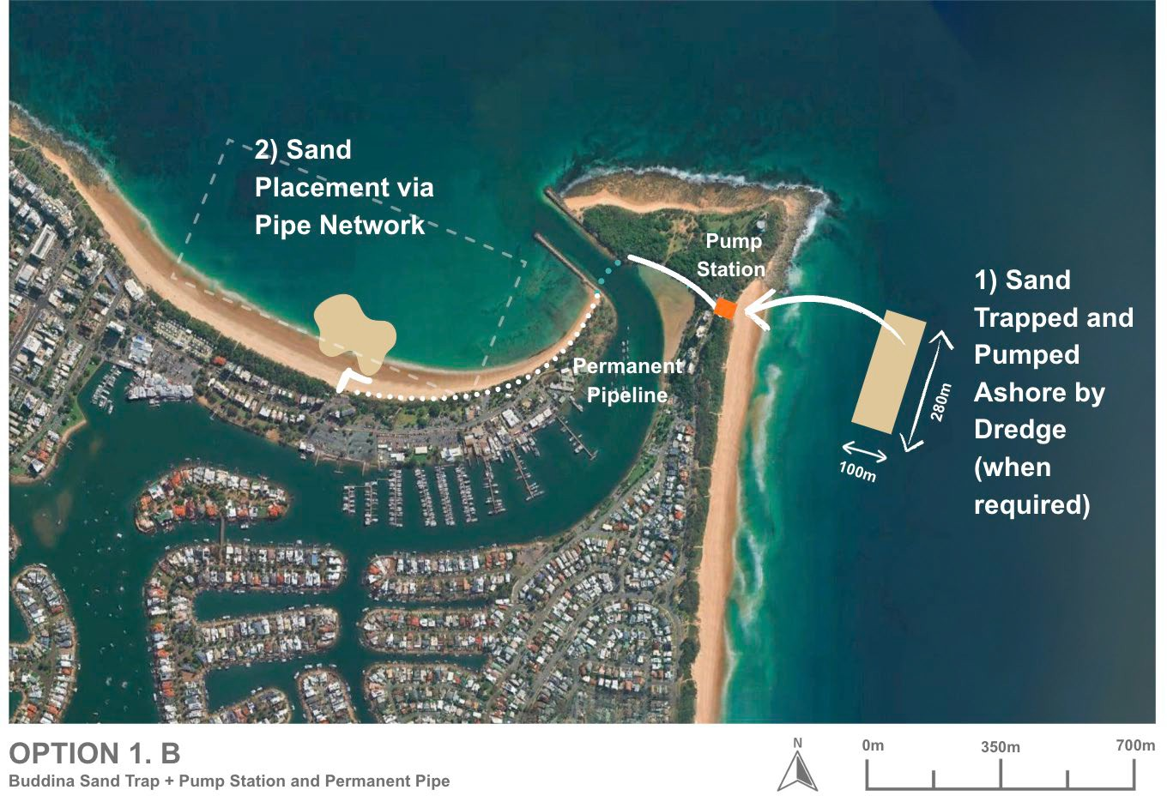
Figure 13-7: Option 1B – Buddina Sand Trap with pump station and permanent pipe (ICM, 2025)
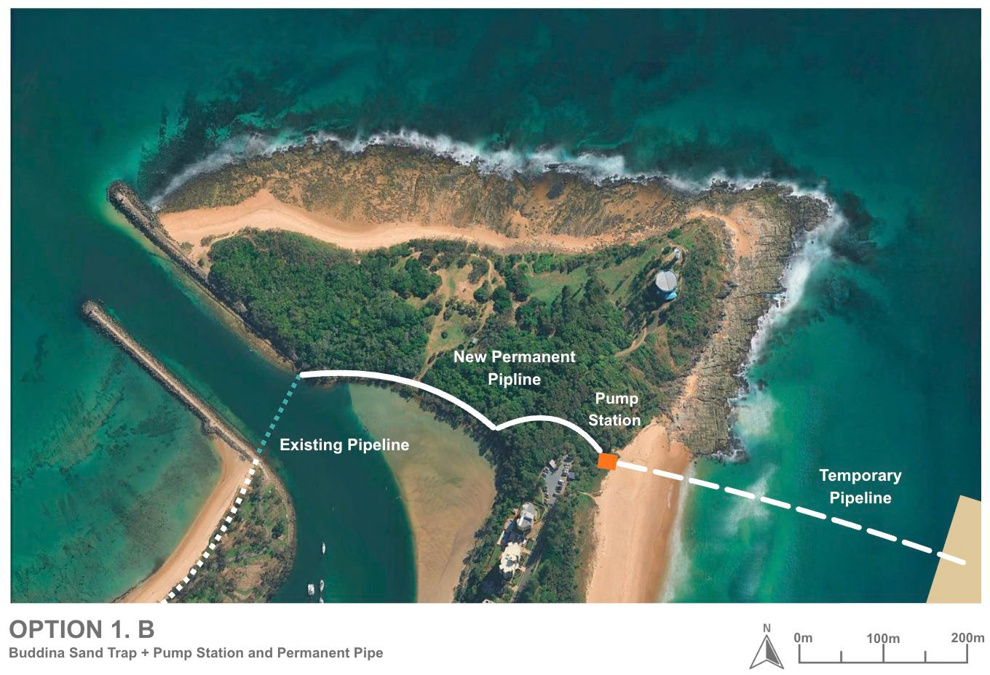
Figure 13-8: Option 1B – Buddina Sand Trap with pump station and permanent pipe (ICM, 2025)

Design and approvals
As per Section 13.3.2.
To advance Option 1B, the following additional studies and approvals are recommended:
- Comprehensive 2D/3D coastal process modelling to assess hydrodynamic and sediment transport interactions with the submerged pipeline, pump outlets, and nearshore morphology.
- Detailed engineering design for the pump station, submerged and onshore pipeline system, and associated land-based infrastructure, supported by geotechnical and constructability investigations.
- A full Environmental Impact Assessment (EIA) addressing potential turbidity, shoreline habitat disturbance, vegetation clearing, noise, and visual impacts.
- Operational and navigational safety assessments for dredging, pumping operations, and offshore discharge points.
- Land tenure, coastal development, and environmental approvals under state and Commonwealth legislation, including marine park and coastal works permits.
Option 1B represents a more advanced and infrastructure-intensive design than Option 1A, introducing permanent onshore and offshore components such as a pump house, submerged pipeline, and nourishment outlets. While this provides increased operational reliability and flexibility for sand placement, it also brings greater engineering complexity and environmental approval requirements.

Capital works
Implementation of Option 1B would require the construction of a shore-based pump and buried pipeline system to actively transfer sand from the Buddina Beach sand trap (Area A) across the Mooloolaba River entrance to Mooloolaba Beach (Area B). Unlike Option 1A, which relies on periodic removal and transport using a Trailer Suction Hopper Dredge (TSHD), Option 1B provides a fixed, onshore mechanical system capable of transferring sand on a more frequent or continuous basis. This represents a significant increase in engineering complexity and capital investment but offers greater control over sand movement and improved predictability of entrance conditions.
Key components of the system would include:
- Shore-based pump station: A purpose-built facility located near the base of Point Cartwright, positioned to receive sand collected from the nearshore trap or dredged from adjacent areas. The station would house booster pumps, screening and control equipment, and connection points for dredge or shore feed lines.
- Pipeline network: A submerged pipeline crossing beneath the entrance channel, extending to distribution outlet along Mooloolaba Main Beach. The pipeline would be constructed using high-density polyethylene (HDPE) or steel sections, ballasted and buried to ensure stability under dynamic coastal conditions. Where available, existing pipeline will be used.
- Beach discharge infrastructure: A network of sand outlets designed for temporary pipework to be connected to evenly release sand along Mooloolaba Beach, providing targeted nourishment to the Mooloolaba cell.
- Electrical and control systems: Power supply infrastructure, control panels, and telemetry systems to manage pump operation, monitor pressures and flow rates, and coordinate with environmental and navigational conditions.
- Site preparation and access: Minor vegetation clearance, establishment of temporary construction compounds, and formation of access tracks for heavy plant and materials delivery. Works would be undertaken within a defined construction corridor to minimise environmental disturbance.
The system would be compatible with existing Cutter Suction Dredges (CSDs), such as those operated by Hall Contracting, which could periodically feed material from the nearshore sand trap into the shore-based pump station for transfer across the entrance.
Option 1B represents a more permanent and technically advanced solution than Option 1A, establishing dedicated infrastructure for ongoing sediment bypassing and long-term reduction of shoaling within the Mooloolaba entrance. While capital costs and approvals requirements would be higher, the investment would deliver a predictable, low-maintenance sand transfer system that provides year-round management of sediment continuity and enhances navigational safety within the harbour.
While technically feasible and based on proven methods, the scale and complexity of infrastructure increase construction risk, cost, and environmental disturbance.

Operational works
Operation of Option 1B would involve the active and ongoing transfer of sand from the Buddina Beach sand trap (Area A) to Mooloolaba Beach (Area B) through a fixed pipeline and pumping network.
- Sand collection
  - Sand would be collected from the Buddina nearshore sand-trap area using a Cutter Suction Dredge (CSD) or a TSHD capable of operating in shallow coastal conditions and feeding material directly to the shore-based booster pump station.
  - The dredge would periodically mobilise to remove accumulated sand from within the designated trap footprint or adjacent deposits, maintaining the required design depth and capacity.
  - Operations would typically target the post-storm period when sand availability in the nearshore zone is highest.
- Transfer system operation
  - The dredged sand slurry would be pumped ashore to the Buddina pump station, where booster pumps would pressurise the flow through the submerged pipeline crossing beneath the entrance channel.
  - Sand would then be conveyed across to Mooloolaba Main Beach, discharged through a range of sand outlets, and placed accordingly along the beach where required.
  - The pumping system could be operated in continuous or campaign modes, depending on environmental windows, sediment accumulation rates, and navigation priorities.
  - Flow rates and discharge volumes would be monitored in real time to optimise energy efficiency and ensure even sand distribution along the beach.
- Sand placement
  - Discharged material would be placed directly onto the dry upper beach or nearshore zone of Mooloolaba Main Beach, providing immediate nourishment benefits and improved beach amenity.
  - Placement patterns could be adjusted via multiple outlet valves to target areas requiring reinforcement or recovery after erosion events.
  - This controlled deposition method mimics natural longshore drift while avoiding excessive mounding or local scour.
- Maintenance and servicing
  - Routine inspection and maintenance of pumps, valves, electrical systems, and buried pipeline sections would be required to maintain operational reliability.
  - Periodic internal pipeline flushing and integrity testing would be undertaken to prevent sediment build-up.
  - The system design would allow for quick isolation of sections for maintenance without disrupting beach or navigation activities.
  - Occasional CSD mobilisation may be required to maintain optimal sand supply and connectivity with the nearshore trap.
- Operational frequency
  - Active pumping campaigns are anticipated every 12–24 months, adaptable to prevailing sediment-accumulation rates and environmental conditions.
  - The system could also be operated opportunistically following major storm events or during scheduled maintenance closures of the entrance, providing flexibility to manage shoaling risks proactively.
- Coordination and environmental management
  - All operational activities would be coordinated between Maritime Safety Queensland (MSQ), the Sunshine Coast Regional Council (SCRC), and dredging contractors to align with regional coastal-management and nourishment programs.
  - Operations would be governed by Environmental Management Plans (EMPs) detailing turbidity monitoring, discharge controls, and ecological safeguards.
  - Scheduling would take into account tidal windows, sea-state limitations, and marine-traffic safety requirements.
Operation of Option 1B would involve ongoing management of the fixed pump system, submerged pipeline, and offshore outlets to transfer sand from the trap to designated nourishment sites. While this approach enables more controlled and continuous sediment recycling, it introduces higher operational complexity, maintenance demands, and environmental monitoring requirements compared to Option 1A. Overall, it is assessed as having moderate operational feasibility.

Coastal processes considerations
As per Option 1A 13.3.5.

Environmental constraints
A preliminary assessment of environmental constraints for the Buddina Sand Trap with pump station and permanent pipe (Option 1B), based on the constraints analysis criteria in Table 13-4 and detailed in Table 13-5.
Table 13-4: Constraints analysis criteria
Constraint level | Description
No impact | There is no impact pathway for the sensitive receptor. No further assessment is required.
Low | There is low potential for impact to the sensitive receptor. No further assessment is required. No or standard management likely.
Moderate | There is a moderate potential for impact to the sensitive receptor which will require further assessment to determine the significance of impact. Likely to be manageable or engineered to minimise potential impacts on the receiving environment.
High | There is a high potential for impact to the sensitive receptor. Further assessment is required to determine the significance of impact and mitigation strategy. Consideration for regulatory approvals.

Table 13-5: Environmental constraints for Buddina Sand Trap with pump station and permanent pipe (Option 1B)
Category | Receptor | Impact pathway | Constraint level | Justification |  | Further assessment recommendations | Potential monitoring and management requirements
Marine environmental quality | Water quality | - Generation of turbidity | Moderate | - An assessment of the predicted plume extent will inform the extent of turbidity related impacts however as this is a dynamic, open ocean environment, any plume will likely dissipate quickly |  | - Turbidity modelling | - Turbidity monitoring during works
Marine environmental quality | Water quality | - Release of contaminants/hypoxia | Low | - Dredge sediments likely comprise clean marine sand free of contaminants with low organic matter content |  | - Assumption that suitable data exists to inform this risk | - None
Marine environmental quality | Water quality | - Hydrocarbon spills/waste | Low | - Compliance with standard procedures will minimise this risk |  | - None | - Standard oil spill and waste procedures
Marine environmental quality | Water quality | - Introduced marine species | Low | - Compliance with standard procedures will minimise this risk |  | - None | - Compliance with standard state and commonwealth procedures regarding IMS
Marine fauna | Turtles | - Mortality/injury/behavioural response due to noise of dredging and pumps  - Behavioural response and interruption of nesting behaviour due to light  - Mortality/injury due to vessel collision, entanglement, entrainment  - Mortality/injury due to onshore plant and vehicle movement  - Disturbance of habitat during sediment disposal and beach reprofiling  - Change of beach profile at Buddina Beach due to trenching of pipeline on beach and nearshore dredging and onshore construction of pipeline and pumping station, and at Mooloolaba Main Beach due to sediment disposal direct to beach impacting nesting  - Change of beach profile at Mooloolaba Main Beach due to sediment disposal offshore of beach impacting nesting | Moderate | - Several turtle species listed as endangered or vulnerable under the EPBC were identified in the project area with Green (Vulnerable) and Loggerhead (Endangered) turtles known to nest on Buddina and Mooloolaba beaches. Therefore, potential impacts need to be managed accordingly. |  | - Light assessment if night works are proposed  - Assessment of shoreline response to works | - Timing of works outside of turtle nesting periods  - Limitation of works to daylight hours or if necessary, standard light mitigation procedures  - Design to minimise disturbance of turtle habitat and to maintain the beach profile  - Standard marine fauna mitigation practices e.g. marine fauna observers and exclusion zones  - Turtle guards on dredger  - Appropriate management for onshore works e.g. onshore vehicles and plant to operate in designated tracks and areas  - Beach profile monitoring
Marine fauna | Marine mammals | - Mortality/injury/behavioural response due to noise of dredging and pumps  - Vessel collision, entanglement, entrainment | Moderate | - Humpback whales may use the area for resting with calves during their migration period  - While species of dolphins listed as vulnerable may also occur in the area, they tend to move away from noise sources and are at lower risk of injury  - While species of dolphin have breeding BIA in area, there is a lower risk to breeding because of the wide distribution of the BIAs |  | - Underwater noise assessment | - Timing of works outside of whale migration periods  - Standard marine fauna mitigation practices e.g. marine fauna observers and exclusion zone
Marine fauna | Roosting Seabirds | - Mortality/injury/behavioural response due to noise of dredging and pumps  - Behavioural response and interruption of nesting behaviour due to light  - Mortality/injury/behavioural response due physical presence  - Mortality/injury due to onshore plant and vehicle movement  - Loss/degradation/fragmentation of habitat due to onshore construction of pipeline and pumping station | High | - Several species of migratory seabirds aggregate and may nest at Point Cartwright and could be impacted  - Potential for loss/degradation/ fragmentation of habitat needs to be assessed |  | - Noise assessment  - Light assessment if night works are proposed  - Assessment of bird habitat with reference to proposed clearing and works areas | - Timing of works outside of peak aggregation season (summer) for migratory terns  - Design to minimise clearing required and avoid key habitat areas  - Appropriate management for onshore works e.g. onshore vehicles and plant to operate in designated tracks and areas, design to avoid key habitat areas
Marine fauna | Foraging Seabirds | - Generation of turbidity impacting foraging activities | Moderate | - Turbidity will impede the ability of aerial feeding birds to see prey underwater, which will impact the Little Terns aggregating in Point Cartwright reserve. Larger seabirds will travel outside of the turbid zone to forage.  - An assessment of the predicted plume extent will inform the extent of turbidity related impacts however as this is a dynamic, open ocean environment, any plume will likely dissipate quickly |  | - Turbidity modelling | - Timing of works outside of peak aggregation season (summer) for migratory terns
Marine fauna | Site attached species | - Direct mortality/injury due to dredging  - Mortality/injury/behavioural response due to physical effects of turbidity | Low | - These species are broadly distributed along  - the coastline The dredging area has a relatively small footprint and in an area of bare sand which is not the habitat for most of these species, including the endangered White’s Seahorse and sand yabby  - Dredging is in a dynamic, open ocean environment, any plume will likely dissipate quickly. |  | - None | - None
Marine fauna | Site attached species | - Mortality/injury/behavioural response due to toxic effects due to release of contaminants/hypoxia | Low | - Dredge sediments likely comprise clean marine sand free of contaminants with low organic matter content |  | - Assumption that suitable data exists to inform this risk | - None
Marine fauna | Mobile species | - Vessel collision  - Direct mortality/injury due to dredging  - Mortality/injury/behavioural response due to physical effects of turbidity | Low | - Mobile species including the critically endangered Grey Nurse Shark and conservation dependent scalloped hammerhead will actively avoid areas of activity. |  | - None | - None
Marine fauna | Mobile species | - Mortality/injury/behavioural response due to toxic effects due to release of contaminants/hypoxia | Low | - Dredge sediments likely comprise clean marine sand free of contaminants with low organic matter content |  | - Assumption that suitable data exists to inform this risk | - None
Benthic habitats | Rocky reef habitat, seagrass and corals | - Direct removal due to dredging  - Generation of turbidity  - Smothering | Moderate | - The dredge area comprises bare sand  - Further assessment is required to determine if the potential turbidity generated will impact sensitive marine habitats.  - Dredging and disposal is in a dynamic, open ocean environment, any plume will likely dissipate quickly. |  | - Benthic habitat assessment in and surrounding dredging area  - Dredge plume modelling | - Turbidity monitoring during works
Benthic habitats | Rocky reef habitat, seagrass and corals | - Release of contaminants/hypoxia | Low | - Dredge sediments likely comprise clean marine sand free of contaminants with low organic matter content |  | - Assumption that suitable data exists to inform this risk | - None
Terrestrial fauna including shorebirds and raptors |  | - Mortality/injury/behavioural response due to noise  - Mortality/injury/behavioural response due to dust  - Behavioural response and interruption of nesting behaviour due to light  - Mortality/injury/behavioural response due physical presence  - Mortality/injury due to onshore plant and vehicle movement  - Loss/degradation/fragmentation of habitat due to onshore construction of pipeline and pumping station | High | - Several species listed as vulnerable or endangered may occur in the project area  - Several species of shorebirds are listed as occurring at Point Cartwright and could be impacted; however, it is more likely they would occur at the lower Maroochy River | - Assessment of species occurrence at Point Cartwright  - Noise assessment  - Light assessment if night works are proposed |  | - Timing of works outside of peak aggregation periods for migratory shorebirds  - Standard noise management procedures  - Limitation of works to daylight hours or if necessary, standard light mitigation procedures  - Standard fauna mitigation practices including monitoring for conservation significant fauna, management of fauna entrapment in construction trenches, appropriate fencing of work area  - Fauna relocation procedures  - Waste management procedures  - Revegetation of cleared areas post-construction
Terrestrial flora |  | - Direct clearing of vegetation  - Smothering and degradation of habitat due to dust generation from works | High | - Several MSES and TECs occur in the project area | - Terrestrial flora assessment  - Extended vegetation mapping |  | - Design to minimise clearing required and avoid key habitat areas  - Appropriate management for onshore works e.g. onshore vehicles and plant to operate in designated tracks and areas  - Dust management procedures  - Weed control management procedures  - Waste management procedures  - Monitor conservation significant flora  - Post construction survey  - Topsoil stockpiling and revegetation of cleared areas post-construction
Assumptions:
- Dredge area is an area of bare sand
- There is sediment contamination data to inform the risk of on release of contaminants via dredging and disposal
- No rock excavation is required for this option

In summary, there are some key aspects that require further assessment regarding vegetation clearance and ground disturbance at the Buddina pump site, temporary works within coastal dunes and foreshore areas, and the associated potential significant impact on terrestrial fauna and flora of conservation significance. The marine impacts would be temporary during dredging campaigns and will require some further assessment; however, these would be broadly consistent with existing maintenance dredging operations and can be managed during works. There is also the opportunity for environmental benefit through beneficial reuse of sand for local beach nourishment and erosion mitigation with direct nourishment of Mooloolaba Beach.
It is likely that environmental monitoring and management during works, above the standard dredging management procedures, would be required to manage risks to terrestrial fauna and habitats and marine fauna and habitats, and shoreline habitats, including monitoring and management for turbidity related impacts.

Social impacts
Option 1B is expected to generate social value with four positive impacts ranked as high in the SIE assessment, including: safer channel access through reduced shoaling, improved economic outcomes through more reliable channel access, improved amenity through reduced frequency of dredging and potentially improved beach nourishment through nearshore sand placement. When compared to the baseline, there were 11 negative social impacts identified, however, after mitigation measures were considered there were six which may be of high concern to the community and stakeholders, including: change to visual amenity through the addition of the shore based pump station, potential negative impacts on turtle species know to nest on Buddina Beach, potential negative environmental impacts both off-shore and on-shore, potential noise from the pump operation, the potential that the pump may be impacted by severe weather when shoaling is more prevalent and possible beach access changes on Buddina Beach during pumping. Further mitigations must be undertaken to reduce potential negative social impacts including visual impact assessment, environmental assessments, management plans, noise monitoring, operational plans and broader community and stakeholder engagement.

Economic impacts
Option 1B is expected to have a low to moderate economic impact compared with the current approach. The project will reduce shoaling at the harbour entrance improving channel access and reliability for users in the long-term. This enhancement will allow both commercial and recreational vessels to navigate the channel without interruption, reducing delays and minimising reliance on emergency maintenance dredging. By ensuring consistent access, the project supports safer operations and greater confidence for businesses and the boating community. Reduced maintenance dredging frequency would improve reliability and reduce disruptions to harbour access, as most dredging would occur at Buddina Beach rather than at the harbour entrance.
During construction, there may be temporary impacts on beach amenity, including reduced access and possible closures of sections of Buddina Beach. During maintenance dredging, moderate impacts are anticipated due to the temporary pipeline and shore-based pump station at Point Cartwright, which will connect to the existing pumping system. These works will require closure of the northern section of the beach. Dredging in this area may also affect beach fishing, which is permitted at Buddina Beach. Depending on the footprint of the beach closed to the public and the duration it is closed for, this has the possibility to reduce visitors to the region, with some likely opting to visit/stay elsewhere on the Sunshine Coast or other coastal region instead. Reduced visitor numbers would impact local businesses within the area through reduced spending.

Future adaptability
The pump and pipeline system also provides scope for staged adaptation, though with a different risk profile. If the system proves unsuccessful or not well-received by the community, the infrastructure could be removed or decommissioned with moderate effort. While this would involve dismantling the pump station and excavating sections of the buried pipeline, the overall impact of removal would be manageable and reversible.
Conversely, if the system performs effectively and gains long-term support, there is significant opportunity for progressive enhancement. A logical future upgrade could involve the installation of a permanent sand-collection intake within the Buddina Beach sand trap area potentially incorporating a jetty-mounted pump system or smaller automated slurry-transfer setup. Such an enhancement would move the system closer to a fully integrated sand bypass facility, reducing reliance on periodic dredging and enabling continuous sediment transfer.
The primary constraint on future adaptability is the fixed nature of the installed infrastructure while scalable in concept, modifications or relocation of the pipeline alignment would require additional construction effort and environmental approvals. Nevertheless, Option 1B remains adaptable through incremental improvements as performance data and community feedback become available.

Safety of Option 1B
Option 1B provides a higher and more consistent level of safety benefit than Option 1A due to its ability to transfer sand more frequently and maintain the trap in a more effective state. By actively pumping accumulated sand from Area A to Area B, Option 1B offers improved reliability of all-tide access, with reduced variability in channel depth compared with intermittent dredging. The more regular bypassing action supports greater clarity of navigation, helping ensure that channel markers, hydrographic charts, and AtoNs remain accurate for longer periods without requiring frequent resurvey or adjustment.
In terms of mariner safety, Option 1B decreases the likelihood of shoal-related hazards such as breaking waves, surging conditions, and unpredictable crosscurrents at the entrance. While construction and installation of the pipeline introduce temporary works-related risks, once operational, the system reduces reliance on large dredging vessels, thereby minimising navigation conflicts and safety risks during maintenance cycles. Overall, Option 1B provides a strong safety improvement, offering more stable entrance conditions and fewer operational disruptions compared with Option 1A.

Cost and feasibility
- Capital Cost: High – associated with pump station, buried pipeline, and electrical/control systems.
- Operational Cost: Moderate – regular maintenance and intermittent dredging, but more efficient than repeated TSHD campaigns.
- Technical Feasibility: Moderate to high – requires careful design of buried infrastructure and ongoing system maintenance but uses proven technologies.
- Risks: Infrastructure exposure or damage from coastal storms; maintenance access challenges; environmental permitting for pipeline construction.

Option summary
Option 1B provides a more structured and controllable extension of the Buddina Beach Sand Trap concept, offering the potential to establish a semi-permanent artificial sand bypass system. By pumping material directly onto Mooloolaba Beach, it delivers immediate coastal protection and amenity benefits while maintaining navigational safety.
Although it involves higher upfront costs and infrastructure maintenance, it represents a practical, scalable long-term solution consistent with the community’s and MSQ’s preference for soft but proactive management of the entrance. This option could logically follow Option 1A as a second-phase implementation, building on lessons from the sand trap trial, with the potential to lead into an even more permanent setup, having a permanent sand intake pump in this location. An overview of this option has been broken down into the below table outlining the advantages and disadvantages recognised with this option (Table 13-6).

Table 13-6: Overview of Option 1B – Advantages and Disadvantages
Advantages | Disadvantages
- Provides direct, controlled sediment bypassing across the entrance.  - Enables immediate dry-beach nourishment and coastal protection benefits.  - Compatible with locally available CSD dredging equipment (e.g., Hall).  - Increases the efficiency of moving large volumes of sand (compared to shifting in a TSHD)  - Allows adaptive, responsive operation to match sediment dynamics and coastal processes.  - Aligns with SRG preference for a “soft” but active management approach. | - High initial capital cost for pump and pipeline infrastructure.  - Requires vegetation clearance and disturbance during installation.  - Ongoing maintenance of pumps and pipeline required.  - Short-term disruption to beach users during sand placement.  - Vulnerable to damage from storm events or erosion exposure.  - Requires consistent operational oversight and funding commitment

Option 1 variations comparison
Table 13-7: Variation Comparison of Option 1A and 1B
Criteria | Option 1A – Buddina Beach Sand Trap | Option 1B – Pump System and Pipeline
Description | Establish a nearshore sand trap to intercept littoral drift before it enters the Mooloolaba River entrance. | Establish a nearshore sand trap with the inclusion of a shore-based pump and buried pipeline to transfer sand across the entrance directly onto Mooloolaba Beach.
Capital works | Low – seabed excavation only, minimal onshore infrastructure. | Moderate / High – pump station, electrical supply, buried pipeline and discharge outlets.
Operational works | Periodic dredging (TSHD) every 2–3 years; offshore placement for regional nourishment. | Routine dredging (CSD) + active pumping every 1–2 years; on-beach placement and system maintenance.
Physical processes | Intercepts sand naturally moving around Point Cartwright; reduces but doesn’t eliminate shoaling. | Mechanically replicates natural bypassing; maintains direct sediment continuity between Area A and Area B.
Environmental impacts | Minimal permanent footprint with low risk of significant impacts on conservation significant species and communities. | Capital works to install pipeline and pumping station will potentially cause significant impacts to marine and terrestrial species and communities of conservation value.  Ongoing operations have low risk of significant impacts.
Social impact | Low visual impact but consideration needed around environment including potential turtle impacts. | Increased visual impact with consideration needed around environment, potential turtle impacts, Buddina Beach impacts and pump resilience and operations.
Cost profile | Lower CAPEX; recurring OPEX for dredging. | High CAPEX; moderate OPEX with ongoing maintenance.
Technical feasibility | High – proven, low-risk dredging method. | Moderate–high – proven technology but requires careful design and reliable maintenance.
Advantages | Simple, low-risk, environmentally soft; beneficial sand reuse. | Controlled sand placement in Area B, quicker sand transfer; supports future permanent bypass system, compatible with existing dredge (Hall’s CSD).
Disadvantages | Ongoing dredging; weather- dependent; partial reduction of shoaling only. | Additional high capital cost; vegetation disturbance; maintenance burden.
Overall assessment | Low-risk, short-term or pilot solution – improves understanding and reduces shoaling frequency. | Structured, long-term proactive solution – higher cost but greater control and effectiveness of sand distribution.

Table 13-8: Overview of capital and operational works for Option 1A and 1B
Capital works |  |  |  | Operational works
Option 1A |  |  | Option 1B | Option 1A |  | Option 1B
General | Dredge Sand Trap | Dredge Sand Trap +  Pump and Pipe Network |  |  | TSHD collects sand build up, shifts to main beach nearshore for placement |  | CSD use temporary pipe to pump into onshore booster pump. Pipe network to main beach distribution
Pros | Simple, low risk and will refill naturally if decide not to pursue the option any further | Pipe network in place for any future integration |  |  | Low impact, taking sand from offshore in Area A and placing offshore Area B |  | Compatible with local CSD for potential quick setup when required, accurate sand placement onshore in Area B
Cons | Disturbance to nearshore sand, potential for minimal beach erosion at Buddina Beach | Disturbance to nearshore sand, potential for minimal beach erosion at Buddina beach – level of complication with pump and pipe network though national park. |  |  | Sand likely placed offshore in Area B |  | Noise of pump system on shore, disturbance to beach in Area B where sand is placed

Multi-criteria analysis for Option 1A & 1B
To enable the integration and evaluation of the preceding assessments on coastal engineering, socio-economic and environmental, a multi-criteria analysis (MCA) has been undertaken to evaluate the options.
The MCA scoring legend follows:
Score | Description of scores
1 | Worst performance or Significant impacts
2 | Poor performance or Major impacts
3 | Average performance or Moderate impacts Average performance or Moderate impacts
4 | Good performance or Minor impacts
5 | Excellent performance or Insignificant impacts

Table 13-9: Option 1A – MCA scoring
MCA Category | MCA criteria | Score
Coastal engineering | Effectiveness: Likely ability to shift enough sand past the entrance (bypassing efficiency, trap capture rate, reduction in shoal frequency/magnitude, entrance depth reliability). | 2
Coastal engineering | Impacts on coastal processes: the level in which it changes or has negative impacts on existing coastal processes | 2
Coastal engineering | Design and approvals: how far is the option progressed with design and approvals and how much would be required | 3
Coastal engineering | Capital works: how significant the capital works would be and their impacts during the process | 4
Coastal engineering | Operational works: how significant the operational works would be and their impacts during the process | 3
Coastal engineering | Future adaption: how well the option be adapted to future conditions | 5
Coastal engineering | Sub-total | 19
Safety | Reliability of all-tide access | 3
Safety | Clarity of navigation | 3
Safety | Mariner safety | 3
Safety | Sub-total | 9
Social and economic | Consistency with SRG preference for lower impact, “softer” measures where practicable. | 5
Social and economic | Traditional Owners do not experience disturbance to cultural values | 3
Social and economic | Visual amenity | 4
Social and economic | Community amenity (inc. noise from pumps) | 3
Social and economic | Beach users experience | 3
Social and economic | Safe access for business and recreational users | 3
Social and economic | Reliable access for business and recreational users | 3
Social and economic | Broader economic considerations during construction and operation | 5
Social and economic | Environmental impact perceptions | 3
Social and economic | Sub-total | 32
Environmental | Marine water quality impacts | 3
Environmental | Marine habitats & protected species impacts | 3
Environmental | Terrestrial habitats & protected species impacts | 3
Environmental | Sub-total | 9
Financial | Capital (CAPEX), | 4
Financial | Operations and maintenance (OPEX), contingency, monitoring. | 2
Financial | Sub-total | 6
Total Score |  | 75

Table 13-10: Option 1B MCA scoring
MCA Category | MCA criteria | Score
Coastal engineering | Effectiveness: Likely ability to shift enough sand past the entrance (bypassing efficiency, trap capture rate, reduction in shoal frequency/magnitude, entrance depth reliability). | 2
Coastal engineering | Impacts on coastal processes: the level in which it changes or has negative impacts on existing coastal processes | 3
Coastal engineering | Design and approvals: how far is the option progressed with design and approvals and how much would be required | 2
Coastal engineering | Capital works: how significant the capital works would be and their impacts during the process | 2
Coastal engineering | Operational works: how significant the operational works would be and their impacts during the process | 3
Coastal engineering | Future adaption: how well the option be adapted to future conditions | 4
Coastal engineering | Sub-total | 16
Safety | Reliability of all-tide access | 3
Safety | Clarity of navigation | 3
Safety | Mariner safety | 3
Safety | Sub-total | 9
Social and economic | Consistency with SRG preference for lower impact, “softer” measures where practicable. | 1
Social and economic | Traditional Owners do not experience disturbance to cultural values | 3
Social and economic | Visual amenity | 2
Social and economic | Community amenity (inc. noise from pumps) | 2
Social and economic | Beach users experience | 2
Social and economic | Safe access for business and recreational users | 3
Social and economic | Reliable access for business and recreational users | 3
Social and economic | Broader economic considerations during construction and operation | 4
Social and economic | Environmental impact perceptions | 1
Social and economic | Sub-total | 21
Environmental | Marine water quality impacts | 3
Environmental | Marine habitats & protected species impacts | 2
Environmental | Terrestrial habitats & protected species impacts | 1
Environmental | Sub-total | 6
Financial | Capital (CAPEX), | 3
Financial | Operations and maintenance (OPEX), contingency, monitoring. | 2
Financial | Sub-total | 5
Total Score |  | 75

OPTION 2 – INCREASED DREDGE CHANNEL DEPTH WITH ROCK EXCAVATION

Option description
This option explores the potential to excavate a deeper basin within the existing Mooloolah River entrance channel, effectively creating a sand sink that captures sediment before it builds up in the main navigational zone. By modifying the bedrock profile, this approach aims to manage shoaling through natural sediment trapping rather than ongoing reactive dredging.

How does it work to address shoaling?
The deepened channel would disrupt the sand supply moving into the entrance by providing a low-energy deposition zone where sand can accumulate before reaching critical navigational areas. This acts as a controlled sediment trap, reducing shoal formation in the main channel and extending the time between maintenance dredging campaigns.

What does this option involve?
The concept involves excavating approximately 100m by 150m (approx. 90,000 m³ of rock, sand, clay) of the existing channel down into the underlying rock substrate, forming a stable, deeper basin. Over time, sand from Area A would naturally settle within this zone. Once the trap nears capacity, accumulated material would be dredged and transferred to Area B, ensuring beneficial reuse of the sand for beach nourishment while maintaining safe channel depths.

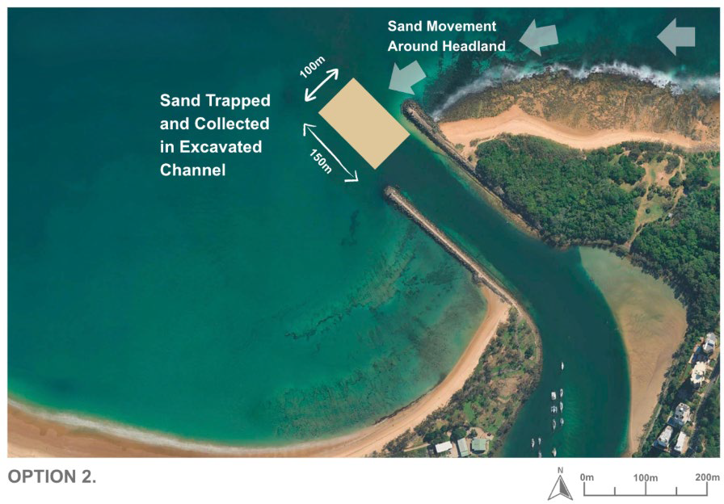
Figure 14-1: Option 2 summary

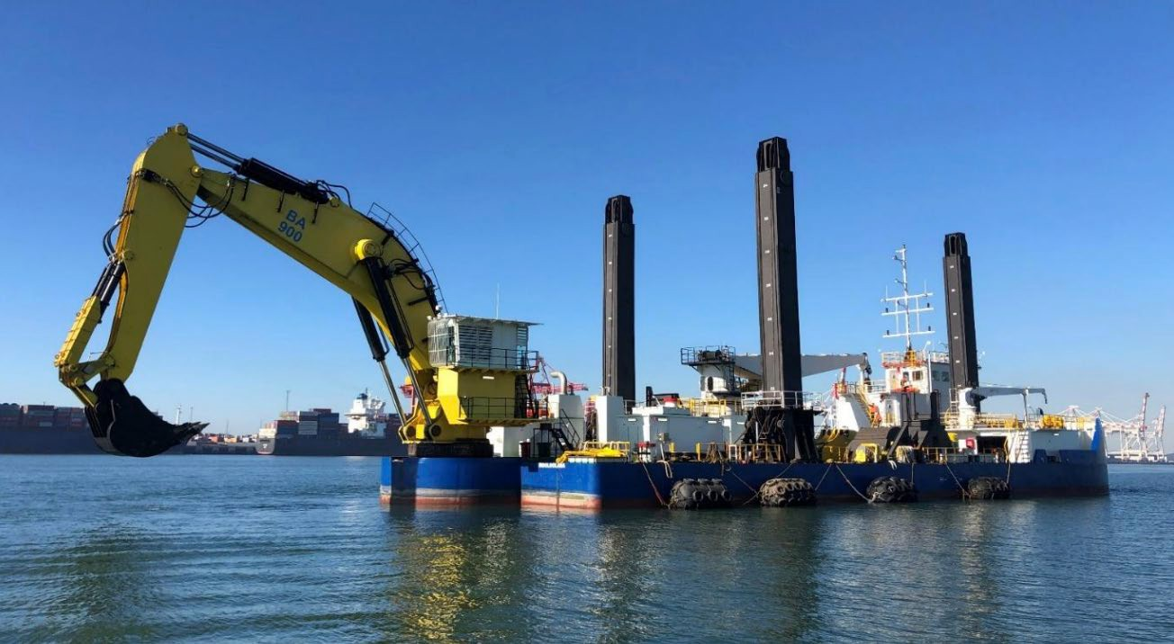
Figure 14-2: Example of backhoe dredge capable of deepening entrance rock – Hall ‘Woomera’ Backhoe Dredge (Hall, 2025)

Impacts on coastal processes
Excavating a deeper channel section within the Mooloolah River entrance will modify local coastal and sediment dynamics by introducing a new, semi-permanent sand sink within the system. In general, dredged channels act as sediment traps, capturing sand that would otherwise continue along the natural littoral drift pathway. This process is deliberate in the context of Option 2, as the deepened area is intended to intercept and store sand moving around Point Cartwright before it contributes to shoaling in the main navigation channel.
From a coastal processes perspective, the introduction of a deepened basin may result in changes to wave transformation across the entrance. Deeper seabed generally results in larger depth limited waves across a given profile, and therefore under certain wave direction, a larger wave could propagate into the entrance. Hydrodynamic modelling would be required during detailed design to validate the concept and refine geometry to ensure no adverse wave or current effects within the harbour or adjacent beaches.
Given the dominant easterly wave climate, offshore waves will have already refracted and shoaled around Point Cartwright before reaching the entrance and are therefore expected to approach the dredged channel under mostly non-breaking conditions. This assumption will be refined and confirmed through detailed wave and hydrodynamic modelling.
The creation of a larger sand trap will also influence the timing and balance of sediment exchange between Buddina and Mooloolaba. Unlike the current maintenance regime, which continually transfers smaller volumes of sand to Mooloolaba Beach, the new system would retain sand within the entrance for longer periods, allowing larger volumes to accumulate before being removed. This change in sediment timing may cause temporary sand deficits on Mooloolaba Beach, potentially leading to short-term erosion until the next dredging campaign occurs and material is redistributed.
Overall, while the primary physical impact of the option would be increased sediment retention at the entrance, the expected coastal impacts are manageable with appropriate monitoring and adaptive management. With coordinated dredging and placement scheduling, sediment continuity along the coast can be maintained, ensuring the approach remains consistent with long-term coastal stability objectives.

Effectiveness of Option 2
Modelling undertaken by BMT (2024) indicates a net northward longshore transport rate around Point Cartwright of approximately 75,000 m³ per year, representing the typical annual volume of sand that bypasses the headland and contributes to shoaling within the Mooloolaba entrance. The sand trap should be designed to accommodate approximately one year’s worth of sediment transport, allowing for effective capture and storage before maintenance is required.
The trap should be sized to accommodate at least one year’s worth of transport (~75,000 m³), providing a buffer that enables scheduled removal through maintenance dredging. This transport volume extends seaward to approximately RL -10 m LAT. Further modelling will be required to refine the optimal geometry and volume of the trap to ensure it effectively captures mobile sediment while minimising overfill and bypass.
This design would therefore reduce the frequency of dredging campaigns, providing longer intervals between maintenance events and enabling dredging to occur under safer and more predictable weather conditions.
By concentrating sand accumulation in one defined area, the approach simplifies dredging logistics and enhances the ability to maintain navigable depths throughout the entrance.
The effectiveness of this option is expected to be high in terms of improving channel stability and reducing shoaling impacts. The sand trap provides a passive, natural mechanism for sediment capture without requiring continuous mechanical intervention. While some ongoing dredging will still be necessary to remove trapped material, the frequency, duration, and urgency of maintenance activities are likely to be significantly reduced.
This approach would provide greater operational flexibility, improved navigational reliability, and a more manageable long-term maintenance regime, aligning well with the objective of maintaining clear and safe access for all marine users.

Variations of Option 2
Three sub-options have been identified for on-going maintenance operations, after the rock substrate has been removed. implementing this option, each differing primarily in how accumulated sand within the excavated trap would be removed and transferred to the receiving area (Area B). These sub-options reflect varying levels of capital investment, dredging efficiency, and operational flexibility.
- Option 2A – Excavated sand trap with existing CSD operations: This variation proposes excavating the rock trap as described, with ongoing maintenance dredging conducted by the existing Cutter Suction Dredge (CSD). The dredge would operate as required, similar to the current maintenance regime, and discharge material through the existing pipeline network to Mooloolaba Beach (Area B). This represents a comparatively low-capital, adaptive approach that leverages existing plant and infrastructure.
- Option 2B – Excavated sand trap with TSHD campaigns: Under this variation, dredging would be less frequent but involve larger-volume campaigns using a Trailer Suction Hopper Dredge (TSHD). The TSHD would remove accumulated sand once the trap reaches capacity, potentially every 12 months, and place material in the nearshore zone of Area B for natural onshore migration. This approach would allow greater dredging efficiency and flexibility in timing, though it depends on the availability of suitable dredge plant and suitable sea-state conditions for a TSHD to access the entrance – an operational constraint given the shallow, occasionally breaking bar.
- Option 2C – Excavated sand trap with semi-permanent pump system: This variation introduces a semi-permanent pump and pipeline system designed to periodically transfer sand directly from the trap across the entrance to Area B. The system could be activated as needed, providing a more automated sediment-bypassing function while retaining the benefits of the deepened sand trap. This approach involves higher upfront costs but offers improved control and responsiveness, potentially evolving into a more continuous or on-demand bypass system in the longer term.
Each of these variations seeks to achieve the same fundamental goal, reducing shoaling frequency and maintaining safe navigational depths, but does so through different operational mechanisms and levels of engineering intervention. The following sections evaluate their relative performance, costs, and feasibility.

Option 2A – Excavated sand trap with existing CSD operations
Option 2A involves the excavation of a rock-based sand trap within the entrance channel, with ongoing maintenance dredging undertaken by the existing Cutter Suction Dredge (CSD) as required. The dredge would remove accumulated sand from the trap and discharge it through the existing pipeline network to Mooloolaba Beach (Area B). This approach represents a low-cost, low-risk adaptation of the current maintenance regime, utilising existing equipment and infrastructure while benefiting from the improved efficiency provided by the deeper, purpose-built sand trap.
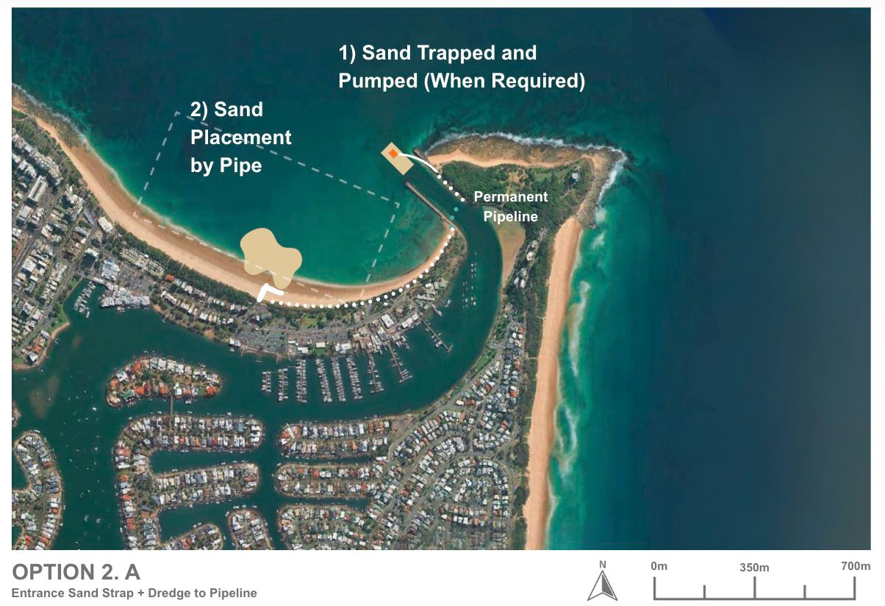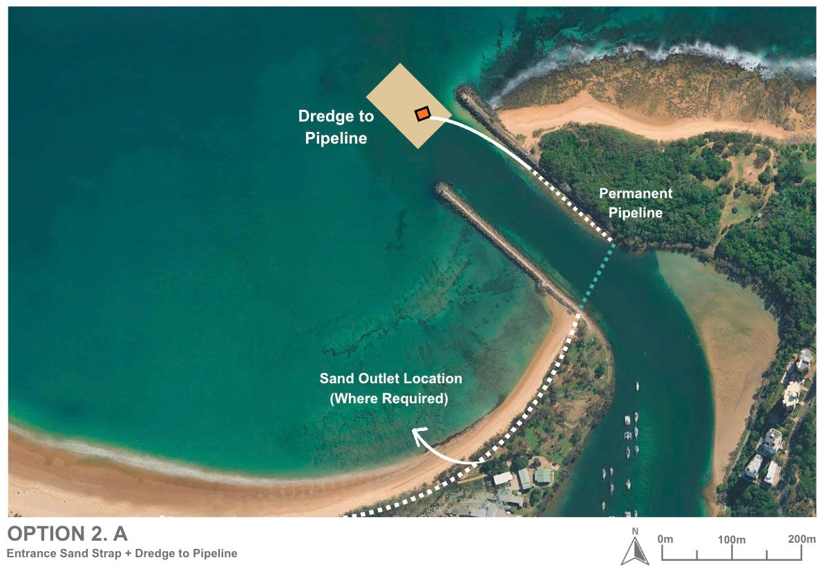
Figure 14-3: Option 2A schematic layout

Design and approvals
At this stage, no detailed design work has been completed for the rock excavation sand trap, and the concept remains at a high-level feasibility stage. Progression of this option would require numerical hydrodynamic and wave modelling to assess how the deepened basin might influence local currents, wave propagation, and sediment transport. From preliminary high-level review, the intervention is not expected to significantly have significant negative impacts coastal processes, though this assumption will need to be validated through detailed modelling.
Previous geotechnical investigations undertaken in 2012 identified the approximate depth of bedrock at the entrance, providing an initial understanding of excavation requirements. However, material composition and strength characteristics of the rock remain uncertain and would require further sampling and testing to inform constructability, equipment selection, and cost estimates.
Assessment on whether a deeper channel would impact the slope stability of the existing breakwater would need to be undertaken. Also, whether a batter design is required and what impact this would have to the sand traps geometry.
From an approval's perspective, the concept would trigger the need for environmental and coastal development approvals, particularly under state and Commonwealth legislation, given its location within the coastal zone and potential for seabed disturbance. These aspects would be further defined during detailed design and environmental assessment stages.

Capital works
The capital works for Option 2A would involve excavating a defined sand trap basin within the existing Mooloolah River entrance channel, extending approximately 100m by 150 m into the underlying rock. This excavation would require specialised rock-cutting or dredging equipment, supported by marine-based plant such as barges, excavators, or drilling and blasting systems depending on material hardness.
Preliminary assessments indicate that the concept is technically feasible within the existing site conditions. The area is moderately sheltered from wave exposure, and water depths are suitable for marine construction. Key technical challenges include excavating into unknown rock types and ensuring that the trap geometry maintains stability under tidal currents. Additional geotechnical investigations would be required to confirm the strength and composition of bedrock, as well as to determine optimal excavation methods.
Construction in a tidally influenced, high-traffic marine environment presents logistical challenges, including vessel access, environmental controls, and sediment management during excavation. The rock excavation process may also generate turbidity and noise requiring mitigation. However, once established, the system is simple to maintain, with most risks associated only with the initial construction phase.

Operational works
Operational works for Option 2A would utilise the existing Cutter Suction Dredge (CSD) to remove sand that naturally accumulates within the newly excavated rock sand trap. Dredging would occur on an as-needed basis, likely at less frequent intervals than under the current maintenance regime, depending on sedimentation rates. The dredged sand would be pumped through the existing pipeline network to Area B (Mooloolaba Beach), where it would be placed for beneficial reuse as beach nourishment. Operational activities would include mobilising the dredge, monitoring sediment levels within the trap, and coordinating sand placement operations in accordance with environmental and navigational requirements.
The operation is expected to be highly effective in maintaining navigable depths at the entrance. The deepened sand trap would serve as a controlled deposition area, allowing sediment to build up predictably before removal. This approach would reduce the frequency and urgency of maintenance dredging, as the trap’s capacity is likely sufficient to capture up to a year’s worth of sediment inflow (approximately
75,000 m³/year). As a result, dredging could be scheduled under favourable sea and weather conditions, improving operational safety and efficiency.
The use of the existing CSD system makes this option technically straightforward and operationally proven. The dredge is already well-suited to the entrance conditions and can be easily deployed to remove material from the designated trap area. Key operational considerations include ensuring adequate dredge reach and suction performance to access the full trap depth and maintaining navigational access during works.
Sediment monitoring (e.g., via hydrographic surveys) will be required to confirm infill rates and trigger dredging activities.
Maintenance under Option 2 is expected to involve larger sediment volumes than the current regime, as deeper trap areas tend to accumulate sand more rapidly. However, by maintaining greater channel depth, the operational and navigational hazards associated with shoaling are significantly reduced. Maintenance would include episodic dredging to remove accumulated material, inspection and upkeep of associated pipeline infrastructure, and post-dredging hydrographic surveys to assess trap performance and guide future interventions.

Environmental constraints
A preliminary assessment of environmental constraints for the excavated sand trap with existing CSD operations (Option 2A), based on the constraints analysis criteria in Table 14-1, detailed in Table 14-2.
Table 14-1: Constraints analysis criteria
Constraint level | Description
No impact | There is no impact pathway for the sensitive receptor. No further assessment is required.
Low | There is low potential for impact to the sensitive receptor. No further assessment is required. No or standard management likely.
Moderate | There is a moderate potential for impact to the sensitive receptor which will require further assessment to determine the significance of impact. Likely to be manageable or engineered to minimise potential impacts on the receiving environment.
High | There is a high potential for impact to the sensitive receptor. Further assessment is required to determine the significance of impact and mitigation strategy. Consideration for regulatory approvals.

Table 14-2: Environmental constraints for excavated sand trap with existing CSD operations (Option 2A)
Category | Receptor | Impact pathway | Constraint level | Justification | Further assessment recommendations | Potential monitoring and management requirements
Marine environmental quality | Water quality | - Generation of turbidity | High (for rock cutting) | - An assessment of the predicted plume extent will inform the extent of turbidity related impacts however as this is a dynamic, open ocean environment, any plume will likely dissipate quickly  - Turbidity is likely to be more extensive and persistent during rock cutting works | - Turbidity modelling | - Turbidity monitoring during works  - Standard turbidity mitigation procedures  - e.g. silt curtains, staging of works
Marine environmental quality | Water quality | - Release of contaminants/hypoxia | Low | - Dredge sediments likely comprise clean marine sand free of contaminants with low organic matter content  - Rock is likely to be uncontaminated | - Assumption that suitable data exists to inform this risk | - None
Marine environmental quality | Water quality | - Hydrocarbon spills/waste | Low | - Compliance with standard procedures will minimise this risk | - None | - Standard oil spill and waste procedures
Marine environmental quality | Water quality | - Introduced marine species | Low | - Compliance with standard procedures will minimise this risk | - None | - Compliance with standard state and commonwealth procedures regarding IMS
Marine fauna | Turtles | - Behavioural response and interruption of nesting behaviour due to light  - Mortality/injury due to vessel collision, entanglement, entrainment  - Mortality/injury due to onshore plant and vehicle movement during beach profiling  - Disturbance of habitat during sediment disposal and beach reprofiling  - Change of beach profile at Mooloolaba Main Beach due to sediment disposal direct to beach impacting nesting | Moderate | - Several turtle species listed as endangered or vulnerable under the EPBC were identified in the project area with Green (Vulnerable) and Loggerhead (Endangered) turtles known to nest on Buddina and Mooloolaba beaches. Therefore, potential impacts need to be managed accordingly. | - Light assessment if night works are proposed  - Assessment of shoreline response to works | - Timing of works outside of turtle nesting periods  - Limitation of works to daylight hours or if necessary, standard light mitigation procedures  - Design to minimise disturbance of turtle habitat and maintain the beach profile  - Standard marine fauna mitigation practices e.g. marine fauna observers and exclusion zones  - Turtle guards on dredger  - Appropriate management for onshore works e.g. onshore vehicles and plant to operate in designated tracks and areas  - Beach profile monitoring
Marine fauna | Marine mammals | - Mortality/injury/behavioural response due to noise of rock cutting and dredging  - Vessel collision, entanglement, entrainment | High (for rock cutting) | - Humpback whales may use the area for resting with calves during their migration period  - Species of dolphins listed as vulnerable may also occur in the area and while they tend to move away from noise sources and are at lower risk of injury, the greater level of noise generated from rock cutting requires further assessment | - Underwater noise assessment including modelling | - Timing of works outside of whale migration periods  - Standard marine fauna mitigation practices e.g. marine fauna observers and exclusion zone
Marine fauna | Roosting Seabirds | - Mortality/injury/behavioural response due to noise of rock cutting and dredging  - Behavioural response and interruption of nesting behaviour due to light  - Mortality/injury/behavioural response due physical presence  - Mortality/injury due to onshore plant and vehicle movement during beach reprofiling required | Moderate | - Several species of migratory seabirds aggregate and may nest at Point Cartwright and could be impacted | - Noise assessment including modelling  - Light assessment if night works are proposed | - Timing of works outside of peak aggregation season (summer) for migratory terns  - Design to minimise clearing required and avoid key habitat areas  - Appropriate management for onshore works e.g. onshore vehicles and plant to operate in designated tracks and areas, design to avoid key habitat areas.
Marine fauna | Foraging Seabirds | - Generation of turbidity impacting foraging activities | Moderate | - Turbidity will impede the ability of aerial feeding birds to see prey underwater, which will impact the Little Terns aggregating in Point Cartwright reserve. Larger seabirds will travel outside of the turbid zone to forage.  - An assessment of the predicted plume extent will inform the extent of turbidity related impacts however as this is a dynamic, open ocean environment, any plume will likely dissipate quickly  - Turbidity is likely to be more extensive and persistent during rock cutting works | - Turbidity modelling | - Timing of works outside of peak aggregation season (summer) for migratory terns  - Turbidity monitoring during works  - Standard turbidity mitigation procedures  - e.g. silt curtains, staging of works
Marine fauna | Site attached species | - Direct mortality/injury due to dredging and disposal  - Mortality/injury/behavioural response due to physical effects of turbidity  - Mortality/injury/behavioural response due to smothering at disposal site | High (for rock cutting) | - These species are broadly distributed along the coastline  - The dredging area has a relatively small footprint and in an area of bare sand which is not the habitat for most of these species, including the endangered White’s Seahorse and sand yabby  - It is assumed that the disposal area is an already disturbed area from previous disposal works  - Dredging and disposal is in a dynamic, open ocean environment, any plume will likely dissipate quickly  - Turbidity is likely to be more extensive and persistent during rock cutting works and could impact endangered species habitat | - Turbidity modelling  - Fauna / benthic habitat assessment | - Turbidity monitoring during works  - Standard turbidity mitigation procedures  - e.g. silt curtains, staging of works
Marine fauna | Site attached species | - Mortality/injury/behavioural response due to toxic effects due to release of contaminants/hypoxia | Low | - Dredge sediments likely comprise clean marine sand free of contaminants with low organic matter content  - Rock is likely to be uncontaminated | - Assumption that suitable data exists to inform this risk | - None
Marine fauna | Mobile species | - Vessel collision  - Direct mortality/injury due to dredging  - Mortality/injury/behavioural response due to physical effects of turbidity | Low | - Mobile species including the critically endangered Grey Nurse Shark and the conservation dependent scalloped hammerhead will actively avoid areas of activity. | - None | - None
Marine fauna | Mobile species | - Mortality/injury/behavioural response due to toxic effects due to release of contaminants/hypoxia | Low | - Dredge sediments likely comprise clean marine sand free of contaminants with low organic matter content | - Assumption that suitable data exists to inform this risk | - None
Benthic habitats | Rocky reef habitat, seagrass and corals | - Direct removal due to dredging  - Generation of turbidity  - Smothering | High (for rock cutting) | - The dredge area has been previously dredged and comprises bare sand  - Further assessment is required to determine if the potential turbidity generated will impact sensitive marine habitats  - Dredging is in a dynamic, open ocean environment, any plume will likely dissipate quickly  - Turbidity is likely to be more extensive and persistent during rock cutting works | - Benthic habitat assessment in and surrounding dredging area  - Turbidity modelling | - Turbidity monitoring during works  - Standard turbidity mitigation procedures  - e.g. silt curtains, staging of works  - Benthic habitat monitoring
Benthic habitats | Rocky reef habitat, seagrass and corals | - Release of contaminants/hypoxia | Low | - Dredge sediments likely comprise clean marine sand free of contaminants with low organic matter content  - Rock is likely to be uncontaminated | - Assumption that suitable data exists to inform this risk | - None
Terrestrial fauna including shorebirds and raptors |  | - Mortality/injury/behavioural response due to noise  - Mortality/injury/behavioural response due to dust from beach disposal  - Behavioural response and interruption of nesting due to light  - Mortality/injury/behavioural response due physical presence during beach reprofiling  - Mortality/injury due to onshore plant and vehicle movement during beach reprofiling | High (for rock cutting) | - Several species listed as vulnerable or endangered may occur in the project area  - Several species of shorebirds are listed as occurring at Point Cartwright and could be impacted; however, it is more likely they would occur at the lower Maroochy River | - Noise assessment including modelling  - Terrestrial fauna assessment | - Timing of works outside of peak aggregation periods for migratory shorebirds  - Standard noise management procedures  - Limitation of works to daylight hours or if necessary, standard light mitigation procedures  - Standard fauna mitigation practices including monitoring for conservation significant fauna, appropriate fencing of work area
Terrestrial flora |  | - Disturbance or degradation of dune vegetation behind Mooloolaba Main Beach onshore plant and vehicle movement during beach reprofiling required  - Smothering and degradation of habitat due to dust generation from beach disposal | Moderate | - Several MSES and TECs occur in the project area | - None | - Terrestrial flora
Assumptions:
- Dredge area is an area of bare sand
- There is sediment contamination data to inform the risk of on release of contaminants via dredging and disposal
- No vegetation clearing is required for this option
- Excavated rock will be disposed of offsite if not appropriate for offshore disposal

In summary, the rock cutting capital works for Option 2A will potentially result in a more extensive and persistent turbid plume and greater noise impacts potentially resulting in significant impacts to marine environmental quality, marine and terrestrial fauna and benthic habitats of conservation significance. This will require further assessment and monitoring/management during works, including timing the works to avoid key seasons for conservation significant fauna.
Once established, the ongoing environmental impact would be broadly consistent with existing maintenance dredging operations and potential impacts to benthic habitats, marine fauna and beach habitat can be managed during works. The beneficial reuse of dredged sand at Mooloolaba Beach would support natural coastal nourishment and maintain sediment balance along the shoreline.

Social impacts
Option 2A is expected to generate social value with two positive impacts ranked as high in the SIE assessment, including: safer channel access through reduced shoaling and improved economic outcomes through more reliable channel access.
When compared to the baseline, there were five negative social impacts identified, however, after mitigation measures were considered, there was one which may be of high concern to the community and stakeholders, being potential negative impact on the environment. Further mitigations must be undertaken to reduce potential negative social impacts including environmental assessments, management plans, silt curtains and broader community and stakeholder engagement.

Economic impacts
Option 2A is expected to have a low to moderate economic impact compared with the current approach.
The project will reduce shoaling at the harbour entrance improving channel access and reliability for users in the long-term. This enhancement will allow both commercial and recreational vessels to navigate the channel without interruption, reducing delays and minimising reliance on emergency maintenance dredging. By ensuring consistent access, the project supports safer operations and greater confidence for businesses and the boating community. Maintenance dredging would remain consistent with current practices, however shoaling frequency across the entrance would be decreased due to the sand trap making dredging frequency less in future.
During construction, temporary changes to channel access may occur, affecting recreational boaters and commercial operators who use the harbour entrance. Onshore rock fishing at the breakwater and Point Cartwright may also be impacted due to reduced fishing locations and safety requirements during works. These disruptions could lead to fewer visitors during the construction period, with some choosing alternative destinations on the Sunshine Coast or other coastal areas. This may result in short-term reductions in local spending, affecting nearby businesses; however, these impacts are expected to be temporary and managed to minimise disruption.
In the longer term, Option 2A may result in changes to tidal patterns that influence wave conditions at Mooloolaba Beach. These changes could lead to a decline in surf quality, particularly to the north of the harbour, where wave energy may be reduced. A reduction in surf conditions could affect the area’s reputation as a popular surfing destination, potentially decreasing visitation over time. This decline in visitor numbers may have flow-on effects for local businesses that rely on tourism and recreational activity, including accommodation providers, cafes, and surf-related enterprises. While these impacts are uncertain and dependent on the extent of tidal changes, they represent a potential long-term consideration for the local economy and community.

Future adaption
The excavated rock trap would form a permanent physical feature that can be expanded, deepened, or integrated with additional sediment-transfer infrastructure over time. This allows the system to evolve alongside future management needs, transitioning from a simple dredge-maintained trap to more engineered approaches such as periodic TSHD campaigns (Option 2B) or a semi-permanent pump and pipeline transfer system (Option 2C). This staged adaptability aligns with the broader principle of starting “soft” and progressing toward “harder” interventions as performance data and confidence increase.
Structurally, the excavated trap is highly resilient to environmental change. Its rock foundation ensures stability under storm conditions, extreme wave events, and future sea-level rise. The system can also adapt operationally, dredging frequency, timing, and placement strategy can be refined over time as sediment behaviour and climate conditions evolve. Importantly, if the system were ever deemed no longer necessary or cost-effective, it could be decommissioned passively; the trap would naturally infill with sand through ongoing coastal processes, gradually restoring the seabed to its pre-construction condition without requiring active intervention.
Option 2A is fully compatible with future upgrades and hybrid approaches. It could serve as the initial stage of a phased implementation pathway, with potential transition to Option 2B or 2C as operational needs and available funding evolve. This flexibility allows the approach to remain responsive to both environmental performance and community expectations, supporting an adaptive, long-term sediment management strategy for the Mooloolah River entrance.

Safety of Option 2A
Option 2A provides a modest improvement in safety, primarily through the deepened sand trap’s ability to intercept sediment before it reaches the entrance. This assists in reducing shoaling rates, thereby improving the reliability of all-tide access. Because the CSD would continue to operate in a manner similar to the current maintenance regime, the clarity of navigation is improved gradually rather than continuously, and temporary depth variability may still occur between dredging cycles. Mariner safety is enhanced relative to current conditions through more predictable shoaling behaviour, but CSD operations near the entrance introduce short-term hazards, including plant movement, pipework, and exclusion zones. These risks are manageable and well understood, but Option 2A does not eliminate the need for active navigation alerts or marine safety controls during dredging. There is limited design or modelling for all option 2 scenarios. It’s noted that there may be potential risk during larger wave events that the sudden drop in the seabed at the entrance hole may trigger some wave shoaling.

Cost
Capital Works Costs
The primary cost driver for this option is the excavation of the nearshore rock shelf to form the sand trap. Based on the indicative concept design, a substantial volume of rock would require mechanical or cutterhead removal and offsite disposal. Mobilisation of suitable marine plant, excavation, and construction of associated access works is expected to result in a moderate–high capital cost. This figure should be treated as indicative only, pending detailed geotechnical investigations and constructability assessment.
Operational Costs
Ongoing operational costs are governed by trap infill rates, which remain uncertain due to the episodic, storm-driven nature of sediment supply.
Current evidence indicates:
- 5,000–10,000 m³/year typically infills the shallow shoal zone above –3 m LAT,
- deeper bypassing between –3 m LAT and –10 m LAT can reach ~70,000 m³/year on average and substantially more during major events.
Because the proposed trap extends into deeper water (but not to depth of closure), annual infill volumes are expected to fall between these two limits and may vary significantly year to year depending on storm sequencing. Targeted sediment-transport modelling is recommended to refine expected infill rates and improve operational cost forecasting.
Once capital excavation is complete, operational dredging costs will be significantly lower than initial works, as maintenance removal will involve clean sand rather than hard rock. Although annual maintenance volumes are expected to be higher than the current status quo (5,000–10,000 m³/year), the system is intended to reduce navigation hazards associated with shallow entrance depths, providing a more reliable and predictable maintenance regime.

Option 2B – Excavated sand trap with TSHD campaigns

Option description
Option 2B builds upon the concept of the deepened rock sand trap within the Mooloolah River entrance channel but introduces a different operational method for sediment removal and management. In this variation, sand would be excavated into the underlying bedrock to create a defined sediment trap approximately 100 m by 150 m in area, functioning as a permanent sand sink that intercepts material moving around Point Cartwright before it accumulates within the main navigation channel.
Rather than relying on the existing Cutter Suction Dredge (CSD), this option would use a Trailer Suction Hopper Dredge (TSHD) to remove accumulated sand at less frequent intervals, for example, every 12 months. The TSHD, capable of handling larger dredge volumes, would extract material once the trap nears capacity and place it within the nearshore zone of Area B (off Mooloolaba Beach). The nearshore placement would allow natural coastal processes, wave action and longshore drift, to move the sand onshore over time, replenishing the beach system with minimal disturbance to beach users.
While efficient for large-volume removal, the viability of this method depends on the TSHD being able to safely access the entrance, a significant constraint given the shallow, occasionally breaking bar at the river mouth.
This option may be more suitable if the entrance design allowed for increased dredge depths, even if the full storage capacity of the trap is not utilised. Maintenance dredging would need to be triggered earlier, while depths remain sufficient for TSHD access, meaning the trap would be dredged deeper than required solely for sand-sink functionality.

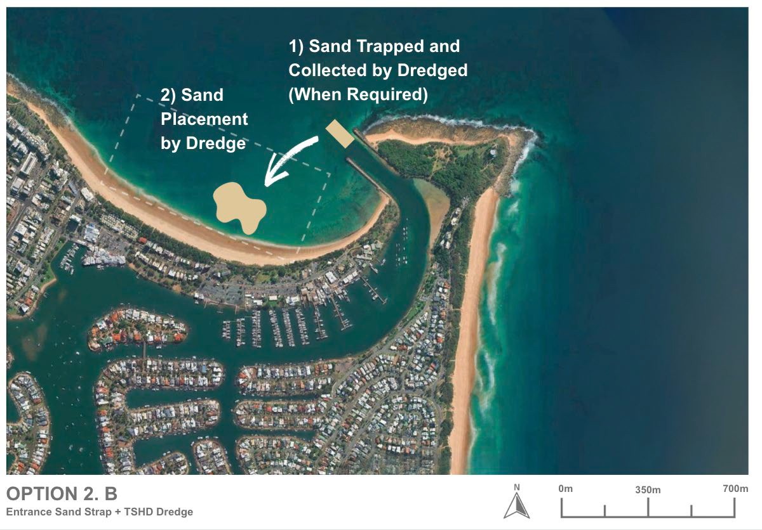
Figure 14-4: Option 2B Schematic Plan

Design and approvals
As per 2A for the extraction of material to create the sand trap.
For deposition the sand placement would in the nearshore and would need to have and approved deposition area which would require an environmental impact assessment as nourishment impacts study.

Capital works
Capital Works Costs
Capital works for Option 2B are identical to Option 2A, as the excavation of the nearshore rock shelf must still be undertaken using mechanical or cutterhead methods. A Trailing Suction Hopper Dredger (TSHD) cannot excavate rock, so it provides no capital-phase efficiencies.
Operational Costs
The key difference between Options 2A and 2B lies in the maintenance dredging approach. Once the rock trap is formed, ongoing removal involves clean sand, enabling the use of a TSHD if access and draft allow.
As per sediment transport evidence:
- Shoaling above –3 m LAT typically contributes 5,000–10,000 m³/year.
- Bypassing between –3 m and –10 m LAT averages around 70,000 m³/year, with significantly larger storm-driven pulses.
Because the trap extends into deeper water, annual infill volumes are expected to fall between these limits, with large year-to-year variability. A TSHD is generally more efficient for higher-volume, less frequent campaigns, making it well-suited to removing sand pulses following major storm sequences. If safe access across the entrance can be confirmed, TSHD campaigns may offer lower unit rates and faster clearance than CSD-based operations.
Further sediment-transport modelling is recommended to refine expected maintenance volumes, event frequency, and optimal campaign sizing.
Although operational volumes are expected to exceed the current 5,000–10,000 m³/year baseline, maintenance dredging will be significantly cheaper than the capital stage, and the system will help reduce navigation hazards associated with unpredictable shoaling.

Operational works
Under Option 2B, operational works would involve periodic large-scale dredging campaigns using a Trailer Suction Hopper Dredge (TSHD) to remove accumulated sediment from the excavated sand trap. Once the trap reaches its design storage capacity, anticipated to occur approximately every 12 to 18 months, the TSHD would mobilise to the site, extract the material, and transport it for nearshore placement within Area B (off Mooloolaba Beach).
This method is expected to be highly effective in maintaining entrance navigability while allowing for natural sediment bypassing to the downdrift beaches. The excavated trap provides predictable storage for approximately one year’s worth of sand transport (~75,000 m³, to be confirmed with numerical modelling) and the TSHD can remove this volume efficiently in a single campaign. This reduces the need for frequent dredging and allows works to be timed under favourable sea and weather conditions, improving operational safety and cost-effectiveness.
The use of a TSHD is technically feasible for the site, provided adequate depth and manoeuvring space are available. The TSHD is well-suited to handling unconsolidated sand deposits and transporting material to the nearshore placement area. Some coordination will be required with vessel traffic and tidal windows, as operations are conducted in an active navigation channel. The interface between the rock excavation and sand accumulation zones will need careful monitoring to ensure efficient sediment capture and dredge access.
However, the feasibility of this option is constrained by several operational concerns. TSHDs cannot reliably or safely work across a shallow, breaking entrance bar, as dragheads require stable seabed contact and the vessel requires sufficient under-keel clearance. As a result, dredging would only be possible during extended low-wave windows, which may be infrequent depending on seasonal swell conditions. This creates uncertainty in maintenance timing and increases the risk of prolonged shoaling events if suitable weather conditions do not align with dredging needs. Additionally, plant availability is highly variable, with many TSHDs committed to larger national or international projects, potentially limiting responsiveness.
Overall, while this option may deliver efficient large-volume dredging when conditions allow, its suitability is heavily dependent on favourable sea states, dredge availability, and the frequency of safe operational windows. These factors introduce significant variability into long-term maintenance planning and may reduce the reliability of keeping the entrance navigable.

Environmental constraints
A preliminary assessment of environmental constraints for the excavated sand trap with TSHD campaigns (Option 2B), based on the constraints analysis criteria in Table 14-3, detailed in Table 14-4.
Table 14-3: Constraints analysis criteria
Constraint level | Description
No impact | There is no impact pathway for the sensitive receptor. No further assessment is required.
Low | There is low potential for impact to the sensitive receptor. No further assessment is required. No or standard management likely.
Moderate | There is a moderate potential for impact to the sensitive receptor which will require further assessment to determine the significance of impact. Likely to be manageable or engineered to minimise potential impacts on the receiving environment.
High | There is a high potential for impact to the sensitive receptor. Further assessment is required to determine the significance of impact and mitigation strategy. Consideration for regulatory approvals.

Table 14-4: Environmental constraints for excavated sand trap with TSHD campaigns (Option 2B)
Category | Receptor | Impact pathway | Constraint level | Justification | Further assessment recommendations | Potential monitoring and management requirements
Marine environmental quality | Water quality | - Generation of turbidity | High (for rock cutting) | - An assessment of the predicted plume extent will inform the extent of turbidity related impacts however as this is a dynamic, open ocean environment, any plume will likely dissipate quickly  - Turbidity is likely to be more extensive and persistent during rock cutting works | - Turbidity modelling | - Turbidity monitoring during works  - Standard turbidity mitigation procedures e.g. silt curtains, staging of works
Marine environmental quality | Water quality | - Release of contaminants/hypoxia | Low | - Dredge sediments likely comprise clean marine sand free of contaminants with low organic matter content  - Rock is likely to be uncontaminated | - Assumption that suitable data exists to inform this risk | - None
Marine environmental quality | Water quality | - Hydrocarbon spills/waste | Low | - Compliance with standard procedures will minimise this risk | - None | - Standard oil spill and waste procedures
Marine environmental quality | Water quality | - Introduced marine species | Low | - Compliance with standard procedures will minimise this risk | - None | - Compliance with standard state and commonwealth procedures regarding IMS
Marine fauna | Turtles | - Behavioural response and interruption of nesting behaviour due to light  - Mortality/injury due to vessel collision, entanglement, entrainment  - Change of beach profile at Mooloolaba Main Beach due to sediment disposal offshore of beach impacting nesting | Moderate | - Several turtle species listed as endangered or vulnerable under the EPBC were identified in the project area with Green (Vulnerable) and Loggerhead (Endangered) turtles known to nest on Buddina and Mooloolaba beaches. Therefore, potential impacts need to be managed accordingly. | - Assessment of shoreline response to works  - Light assessment if night works are proposed | - Timing of works outside of turtle nesting periods  - Limitation of works to daylight hours or if necessary, standard light mitigation procedures  - Standard marine fauna mitigation practices e.g. marine fauna observers and exclusion zones  - Turtle guards on dredger  - Beach profile monitoring
Marine fauna | Marine mammals | - Mortality/injury/behavioural response due to noise of rock cutting and dredging  - Vessel collision, entanglement, entrainment | High (for rock cutting) | - Humpback whales may use the area for resting with calves during their migration period  - Species of dolphins listed as vulnerable may also occur in the area and while they tend to move away from noise sources and are at lower risk of injury, the greater level of noise generated from rock cutting requires further assessment | - Underwater noise assessment including modelling | - Timing of works outside of whale migration periods  - Standard marine fauna mitigation practices e.g. marine fauna observers and exclusion zone
Marine fauna | Roosting Seabirds | - Mortality/injury/behavioural response due to noise of rock cutting and dredging  - Behavioural response and interruption of nesting behaviour due to light  - Mortality/injury/behavioural response due physical presence | Moderate | - Several species of migratory seabirds aggregate and may nest at Point Cartwright and could be impacted | - Noise assessment  - Light assessment if night works are proposed | - Timing of works outside of peak aggregation season (summer) for migratory terns
Marine fauna | Foraging Seabirds | - Generation of turbidity impacting foraging activities | Moderate | - Turbidity will impede the ability of aerial feeding birds to see prey underwater, which will impact the Little Terns aggregating in Point Cartwright reserve. Larger seabirds will travel outside of the turbid zone to forage.  - An assessment of the predicted plume extent will inform the extent of turbidity related impacts however as this is a dynamic, open ocean environment, any plume will likely dissipate quickly  - Turbidity is likely to be more extensive and persistent during rock cutting works | - Turbidity modelling | - Timing of works outside of peak aggregation season (summer) for migratory terns  - Turbidity monitoring during works  - Standard turbidity mitigation procedures e.g. silt curtains, staging of works
Marine fauna | Site attached species | - Direct mortality/injury due to dredging and disposal  - Mortality/injury/behavioural response due to physical effects of turbidity  - Mortality/injury/behavioural response due to smothering at disposal site | High (for rock cutting) | - These species are broadly distributed along the coastline  - The dredging area has a relatively small footprint and in an area of bare sand which is not the habitat for most of these species, including the endangered White’s Seahorse and sand yabby  - It is assumed that the disposal area is an already disturbed area from previous disposal works  - Dredging and disposal is in a dynamic, open ocean environment, any plume will likely dissipate quickly  - Turbidity is likely to be more extensive and persistent during rock cutting works and could impact endangered species habitat | - Turbidity modelling  - Fauna / benthic habitat assessment | - Turbidity monitoring during works  - Standard turbidity mitigation procedures e.g. silt curtains, staging of works
Marine fauna | Site attached species | - Mortality/injury/behavioural response due to toxic effects due to release of contaminants/hypoxia | Low | - Dredge sediments likely comprise clean marine sand free of contaminants with low organic matter content  - Rock is likely to be uncontaminated | - Assumption that suitable data exists to inform this risk | - None
Marine fauna | Mobile species | - Vessel collision  - Direct mortality/injury due to dredging  - Mortality/injury/behavioural response due to physical effects of turbidity  - Mortality/injury/behavioural response due to smothering at disposal site | Low | - Mobile species including the critically endangered Grey Nurse Shark and conservation dependant scalloped hammerhead will actively avoid areas of activity | - None | - None
Marine fauna | Mobile species | - Mortality/injury/behavioural response due to toxic effects due to release of contaminants/hypoxia | Low | - Dredge sediments likely comprise clean marine sand free of contaminants with low organic matter content  - Rock is likely to be uncontaminated | - Assumption that suitable data exists to inform this risk | - None
Benthic habitats | Rocky reef habitat, seagrass and corals | - Direct removal due to dredging  - Generation of turbidity  - Smothering | High (for rock cutting) | - The dredge area has been previously dredged and comprises bare sand  - Further assessment is required to determine if the potential turbidity generated will impact sensitive marine habitats  - Dredging is in a dynamic, open ocean environment, any plume will likely dissipate quickly  - Turbidity is likely to be more extensive and persistent during rock cutting works | - Benthic habitat assessment in and surrounding dredging area  - Turbidity modelling | - Turbidity monitoring during works  - Standard turbidity mitigation procedures e.g. silt curtains, staging of works  - Benthic habitat monitoring
Benthic habitats | Rocky reef habitat, seagrass and corals | - Release of contaminants/hypoxia | Low | - Dredge sediments likely comprise clean marine sand free of contaminants with low organic matter content  - Rock is likely to be uncontaminated | - Assumption that suitable data exists to inform this risk | - None
Terrestrial fauna including shorebirds and raptors |  | - Mortality/injury/ behavioural response due to noise  - Behavioural response and interruption of nesting behaviour due to light  - Mortality/injury/ behavioural response due physical presence | High (for rock cutting) | - Several species listed as vulnerable or endangered may occur in the project area  - Several species of shorebirds are listed as occurring at Point Cartwright and could be impacted; however, it is more likely they would occur at the lower Maroochy River | - Assessment of species occurrence at Point Cartwright  - Noise assessment  - Light assessment if night works are proposed | - Timing of works outside of peak aggregation periods for migratory shorebirds  - Standard noise management procedures  - Limitation of works to daylight hours or if necessary, standard light mitigation procedures  - Standard fauna mitigation practices including monitoring for conservation significant fauna
Terrestrial flora |  | - None | No impact | - No impact pathway to terrestrial environment | - None | - None
Assumptions:
- Dredge area is an area of bare sand
- Disposal area assumed to be within the nearshore area offshore of southern end of Mooloolaba Main Beach where sediment has been placed previously
- There is sediment contamination data to inform the risk of on release of contaminants via dredging and disposal
- Excavated rock will be disposed of offsite if not appropriate for offshore disposal

Similar to Option 2A, capital rock cutting will potentially result in a more extensive and persistent turbid plume and greater noise impacts potentially resulting in significant impacts to marine environmental quality, marine and terrestrial fauna and benthic habitats. This will require further assessment and monitoring/management during works, including timing the works to avoid key seasons for conservation significant fauna.
Once established, the ongoing maintenance dredging and nearshore disposal presents a larger footprint compared to Option 2A, which will cause temporary turbidity plumes in the placement area and minor short-term disturbance to benthic habitats. It is expected these effects will be localised and dissipate rapidly under coastal wave action and potential impacts to benthic habitats and marine fauna can be managed during works. Benthic habitat monitoring is also recommended to confirm that placed sand behaves as intended and does not smother sensitive nearshore habitats. However, the nearshore placement of sand provides environmental and coastal protection benefits by reinforcing the natural sediment budget and maintaining beach resilience against erosion.

Social impacts
Option 2B is expected to generate social value with two positive impacts ranked as high in the SIE assessment, including: safer channel access through reduced shoaling and improved economic outcomes through more reliable channel access.
When compared to the baseline, there were five negative social impacts identified, however, after mitigation measures were considered, there was one which may be of high concern to the community and stakeholders, being potential negative environmental impacts. Further mitigations must be undertaken to reduce potential negative social impacts including environmental assessments, management plans, silt curtains and broader community and stakeholder engagement.

Economic impacts
Option 2B is expected to have a low to moderate economic impact compared with the current approach. The project will reduce shoaling at the harbour entrance improving channel access and reliability for users in the long-term. This enhancement will allow both commercial and recreational vessels to navigate the channel without interruption, reducing delays and minimising reliance on emergency maintenance dredging. By ensuring consistent access, the project supports safer operations and greater confidence for businesses and the boating community.
This option would require less frequent maintenance dredging than the current operations and allows for variable placement of sand as needs require. The nearshore placement would allow natural coastal processes, wave action and longshore drift, to move the sand onshore over time, replenishing the beach system with minimal disturbance to beach users.
During construction, temporary changes to channel access may occur, affecting recreational boaters and commercial operators who use the harbour entrance. Onshore rock fishing at the breakwater and Point Cartwright may also be impacted due to reduced fishing locations and safety requirements during works. These disruptions could lead to fewer visitors during the construction period, with some choosing alternative destinations on the Sunshine Coast or other coastal areas. This may result in short-term reductions in local spending, affecting nearby businesses; however, these impacts are expected to be temporary and managed to minimise disruption.
In the longer term, Option 2B may result in changes to tidal patterns that influence wave conditions at Mooloolaba Beach. These changes could lead to a decline in surf quality, particularly to the north of the harbour, where wave energy may be reduced. A reduction in surf conditions could affect the area’s reputation as a popular surfing destination, potentially decreasing visitation over time. This decline in visitor numbers may have flow-on effects for local businesses that rely on tourism and recreational activity, including accommodation providers, cafes, and surf-related enterprises. While these impacts are uncertain and dependent on the extent of tidal changes, they represent a potential long-term consideration for the local economy and community.

Future adaption
The excavated rock trap serves as permanent infrastructure, while the TSHD-based operational model offers the capacity to handle progressively larger dredging volumes or longer intervals between campaigns as understanding of sediment behaviour improves. Over time, the approach could transition to include mechanical or pump-assisted sediment transfer systems (similar to Option 2C), providing a clear pathway for staged enhancement if warranted by future conditions or performance outcomes.
The main challenges for this option relate to dredge availability and operational logistics. As regional demand for large dredging vessels increases, securing a TSHD for periodic campaigns may become more difficult or costly. Mobilisation and demobilisation costs can also be significant for relatively modest dredge volumes, which could limit cost efficiency if the trap fills slower than expected. Additionally, the timing of dredge campaigns must align with safe operating conditions and minimal disruption to navigation and recreation, requiring careful scheduling and coordination with other coastal users.
The system is inherently resilient to coastal and climatic variability. The rock-based sand trap will remain structurally stable under extreme storm events, sea-level rise, and altered sediment regimes, continuing to function as a passive capture zone. The use of mobile dredging plant enhances adaptability, allowing operational responses to be tailored to changing conditions, infill rates, or management priorities.
Option 2B can seamlessly integrate with other long-term management pathways. The rock trap itself forms a common foundation that could support more continuous bypassing solutions such as the semi-permanent pump and pipeline system proposed in Option 2C. Alternatively, it could revert to a simpler CSD-based operation (Option 2A) if dredge access or funding becomes constrained.

Safety of Option 2B
Option 2B provides a greater potential improvement in navigation safety because TSHD campaigns can remove larger sand volumes at once, restoring deeper entrance conditions and thus improving all-tide access for longer periods between dredging events. This results in improved clarity of navigation, as dredging occurs in well-defined campaigns with predictable outcomes. However, mariner safety is constrained by the operational limitations of TSHDs. The vessel must cross the shallow, occasionally breaking bar at the entrance, which may restrict mobilisation windows and create short-term safety hazards during entry and exit. In adverse sea states, dredging may be delayed, allowing shoaling to continue unchecked and reducing safety margins. While the TSHD improves dredging efficiency, its reliance on favourable conditions introduces variability in safety performance. There is limited design or modelling for all option 2 scenarios. It’s noted that there may be potential risk during larger wave events that the sudden drop in the seabed at the entrance hole may trigger some wave shoaling.

Cost
Capital Works Cost
As per 2A.
Operational Costs
Would be similar to Option 2B. The additional mobilisation cost of the TSHD would likely increase the operational costs (depending on frequency of dredging annually/seasonal variation).

Option 2C – Excavated sand trap with semi-permanent pump system

Option description
Option 2C builds upon the excavated entrance sand trap concept but introduces a semi-permanent sand slurry pump system to enable on-demand sediment transfer between the sand trap (Area A) and Mooloolaba Beach (Area B). This system would allow controlled, flexible, and lower-risk sand bypassing without relying on large dredging campaigns.
The proposed setup includes an onshore pump station positioned behind the dunes near the eastern breakwater, occupying an area of approximately 30m × 20m. From this location, a sand suction intake, likely with multiple collection heads, would extend into the excavated trap to collect accumulated sand. A water intake pipe would draw seawater from the entrance channel to create the slurry mixture required for pumping. The slurry would then be transferred through the existing pipeline network across the entrance to the placement area on Mooloolaba Beach, where the sand would be discharged and shaped to match natural beach profiles.
The system is intended to operate intermittently rather than continuously, activated only when sand accumulation in the trap reaches a pre-defined level or when beach nourishment is required. This operational flexibility reduces energy demand and maintenance while still achieving consistent sediment bypassing, aligning with community and stakeholder preferences for a softer, more adaptive management approach.

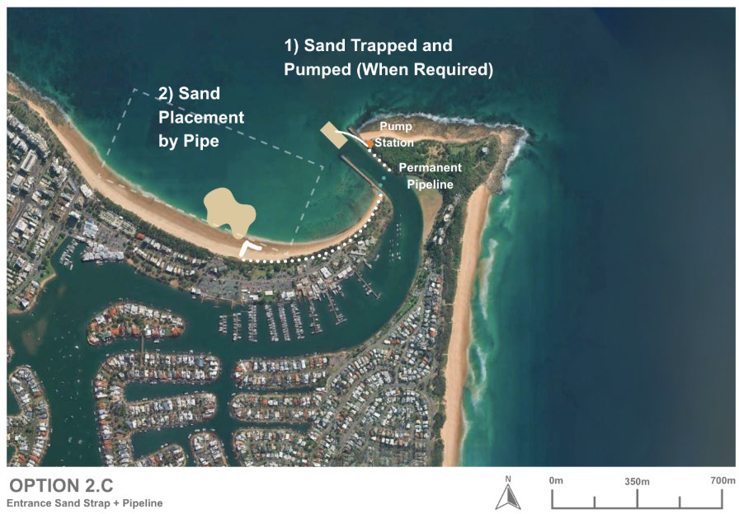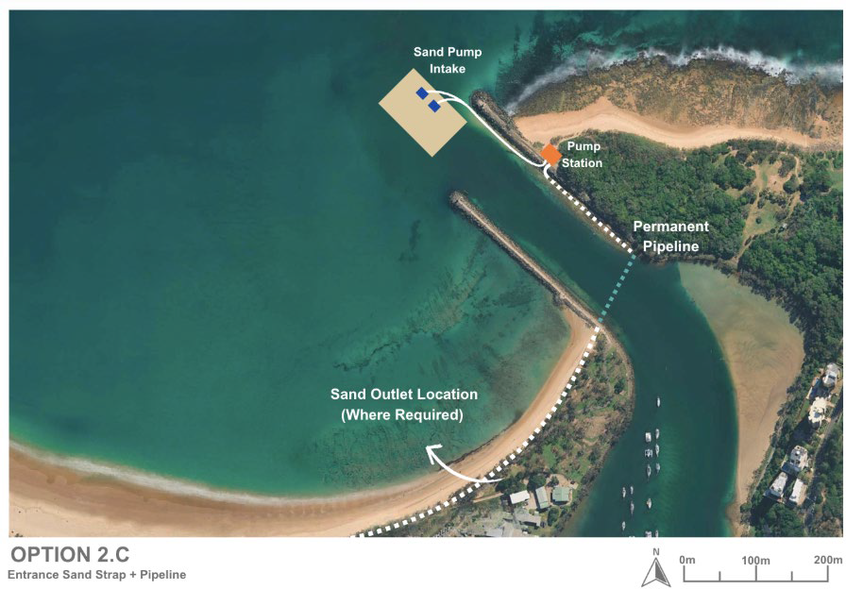
Figure 14-5: Option 2C schematic layout

Design and approvals
At this stage, the sand slurry pump system for Option 2C is conceptual only, based on preliminary input from potential suppliers. Further work is required to define the pump specifications, suction arrangements, intake configuration, pipe alignment, and control systems to ensure reliable operation and compatibility with site conditions. This includes confirming the exact location of the onshore pump station (approx. 30 m × 20 m behind the dunes near the breakwater), the layout of sand and water intake pipes within the entrance, and the connection into the existing pipeline network to Mooloolaba Beach.
Detailed design will also need to address public access and safety, particularly where pipelines interface with Point Cartwright and the breakwater. This may include walkways, cover slabs, or crossings to maintain safe pedestrian movement over or around pipes and associated infrastructure, and careful integration to limit impacts on visual amenity.
From an approval’s perspective, Option 2C would require a suite of statutory approvals and tenure arrangements, likely including:
- Coastal and tidal works approvals for the pump station, intakes, and pipelines.
- Environmental approvals relating to marine disturbance, noise, water quality, and operational discharges.
- Land tenure and access agreements for infrastructure within the Point Cartwright reserve and dune areas.
Hydrodynamic and numerical modelling, coupled with geotechnical and structural assessments, will be essential inputs to the approvals process to demonstrate that the system operates safely, reliably, and without unacceptable impacts on coastal processes, navigation, or public use.

Capital works
As per 2A for the channel excavation with additional capital requirement for the installation of the semi-permanent slurry pump system and associated infrastructure.
A key requirement is the excavation of a deeper zone within the trap area to ensure sufficient hydraulic head for effective pump operation and to create a conical depression to facilitate sand capture. This may involve cutting into the underlying rock seabed, adding complexity and cost to the works. Excavation and trenching would also be required to install suction lines and a pipeline connection to the discharge outlet on Mooloolaba Beach. These works are considered technically challenging due to the presence of shallow rock strata and the need for precision trenching in the marine environment.
Onshore, a small, fenced pump station compound (approximately 30m × 20m) would be established on the landward side of the eastern breakwater, requiring minor site preparation and levelling. The pump unit would be delivered via road or barge, subject to environmental and logistical constraints.
A pipeline network would then be installed to connect the pump station to the water intake and sand suction lines within the excavated trap, and to the existing discharge pipeline to Mooloolaba Beach. Protective walkways, cover slabs, or low-profile crossings may be required where pipelines intersect public access routes or recreational areas along the breakwater.
While the above-ground infrastructure is relatively modest, the requirement for rock excavation, underwater trenching, and buried pipeline installation makes the capital works more significant than initially suggested.
Given these constraints, the capital works associated with this option are considered significant, and the overall feasibility is likely to be lower than traditional methods such as Cutter Suction Dredging CSD o TSHD.

Operational works
Under Option 2C, the sand slurry pump system would operate intermittently, transferring sand from the excavated trap to Mooloolaba Beach as needed. Routine hydrographic surveys would monitor sand build-up in the trap, with the system activated when levels approach the target threshold. The sand and water intakes, positioned at the base of the eastern breakwater, would be designed to withstand typical wave conditions and allow pumping under a wider range of weather than dredging operations, providing greater control and reliability in managing shoaling.
While the intake pumps can draw sand from their immediate surroundings, they would not have the same reach or mobility as a dredge that moves around the trap. Therefore, an initial trial period would be required to determine the optimal number and layout of intake heads, balancing capture efficiency with cost. Once operational, ongoing monitoring would assess system performance, with adjustments made as needed to improve efficiency or address wear and tear.
Considerations of pump intake disturbance or blockages from debris is also needed for consideration as this may limit use and require more significant maintenance during time of high debris in the water (e.g. post storm events).
Operationally, the system would involve short-term onshore activity during pumping, with noise and vibration from the pump unit (approximately 10 ft container size) managed through acoustic shielding and limited operating hours. Routine maintenance would include inspecting and servicing the pump, intake heads, and pipeline connections, particularly after storm events.

Environmental constraints
A preliminary assessment of environmental constraints for the excavated sand trap with semi-permanent pump system (Option 2C), based on the constraints analysis criteria in Table 14-5, detailed in Table 14-6.
Table 14-5: Constraints analysis criteria
Constraint level | Description
No impact | There is no impact pathway for the sensitive receptor. No further assessment is required.
Low | There is low potential for impact to the sensitive receptor. No further assessment is required. No or standard management likely.
Moderate | There is a moderate potential for impact to the sensitive receptor which will require further assessment to determine the significance of impact. Likely to be manageable or engineered to minimise potential impacts on the receiving environment.
High | There is a high potential for impact to the sensitive receptor. Further assessment is required to determine the significance of impact and mitigation strategy. Consideration for regulatory approvals.

Table 14-6: Environmental constraints for excavated sand trap with semi-permanent pump system (Option 2C)
Category | Receptor | Impact pathway | Constraint level | Justification | Further assessment recommendations | Potential monitoring and management requirements
Marine environmental quality | Water quality | - Generation of turbidity | High (for rock cutting) | - An assessment of the predicted plume extent will inform the extent of turbidity related impacts however as this is a dynamic, open ocean environment, any plume will likely dissipate quickly  - Turbidity is likely to be more extensive and persistent during rock cutting works | - Turbidity modelling | - Turbidity monitoring during works  - Standard turbidity mitigation procedures e.g. silt curtains, staging of works
Marine environmental quality | Water quality | - Release of contaminants/hypoxia | Low | - Dredge sediments likely comprise clean marine sand free of contaminants with low organic matter content  - Rock is likely to be uncontaminated | - Assumption that suitable data exists to inform this risk | - None
Marine environmental quality | Water quality | - Hydrocarbon spills/waste | Low | - Compliance with standard procedures will minimise this risk | - None | - Standard oil spill and waste procedures
Marine environmental quality | Water quality | - Introduced marine species | Low | - Compliance with standard procedures will minimise this risk | - None | - Compliance with standard state and commonwealth procedures regarding IMS
Marine fauna | Turtles | - Behavioural response and interruption of nesting behaviour due to light  - Mortality/injury due to vessel collision, entanglement, entrainment  - Mortality/injury due to entrainment in bypassing equipment  - Mortality/injury due to onshore plant and vehicle movement during beach profiling  - Disturbance of habitat during sediment disposal and beach reprofiling  - Change of beach profile at Mooloolaba Main Beach due to sediment disposal direct to beach impacting nesting | Moderate | - Several turtle species listed as endangered or vulnerable under the EPBC were identified in the project area with Green (Vulnerable) and Loggerhead (Endangered) turtles known to nest on Buddina and Mooloolaba beaches. Therefore, potential impacts need to be managed accordingly. | - Assessment of shoreline response to works  - Light assessment if night works are proposed | - Timing of works outside of turtle nesting periods  - Limitation of works to daylight hours or if necessary, standard light mitigation procedures  - Design to minimise disturbance of turtle habitat and maintain the beach profile  - Standard marine fauna mitigation practices e.g. marine fauna observers and exclusion zones  - Turtle guards on dredger/bypassing equipment  - Appropriate management for onshore works e.g. onshore vehicles and plant to operate in designated tracks and areas  - Beach profile monitoring
Marine fauna | Marine mammals | - Mortality/injury/behavioural response due to noise of rock cutting and dredging  - Vessel collision, entanglement, entrainment | High (for rock cutting) | - Humpback whales may use the area for resting with calves during their migration period  - Species of dolphins listed as vulnerable may also occur in the area and while they tend to move away from noise sources and are at lower risk of injury, the greater level of noise generated from rock cutting requires further assessment | - Underwater noise assessment including modelling | - Timing of works outside of whale migration periods  - Standard marine fauna mitigation practices e.g. marine fauna observers and exclusion zone
Marine fauna | Roosting Seabirds | - Mortality/injury/behavioural response due to noise of rock cutting and dredging  - Behavioural response and interruption of nesting behaviour due to light  - Mortality/injury/behavioural response due to physical presence  - Disturbance/degradation of habitat during pump installation  - Mortality/injury due to onshore plant and vehicle movement during pump installation and beach reprofiling | Moderate | - Several species of migratory seabirds aggregate and may nest at Point Cartwright and could be impacted | - Noise assessment including modelling  - Light assessment if night works are proposed | - Timing of works outside of peak aggregation season (summer) for migratory terns  - Design to minimise clearing required and avoid key habitat areas  - Appropriate management for onshore works e.g. onshore vehicles and plant to operate in designated tracks and areas, design to avoid key habitat areas.
Marine fauna | Foraging Seabirds | - Generation of turbidity impacting foraging activities | Moderate | - Turbidity will impede the ability of aerial feeding birds to see prey underwater, which will impact the Little Terns aggregating in Point Cartwright reserve. Larger seabirds will travel outside of the turbid zone to forage.  - An assessment of the predicted plume extent will inform the extent of turbidity related impacts however as this is a dynamic, open ocean environment, any plume will likely dissipate quickly  - Turbidity is likely to be more extensive and persistent during rock cutting works | - Turbidity modelling | - Timing of works outside of peak aggregation season (summer) for migratory terns  - Turbidity monitoring during works  - Standard turbidity mitigation procedures e.g. silt curtains, staging of works
Marine fauna | Site attached species | - Direct mortality/injury due to dredging and disposal  - Mortality/injury/behavioural response due to physical effects of turbidity  - Mortality/injury/behavioural response due to smothering at disposal site | High (for rock cutting) | - These species are broadly distributed along the coastline  - The dredging area has a relatively small footprint and in an area of bare sand which is not the habitat for most of these species, including the endangered White’s Seahorse and sand yabby  - It is assumed that the disposal area is an already disturbed area from previous disposal works  - Dredging and disposal is in a dynamic, open ocean environment, any plume will likely dissipate quickly  - Turbidity is likely to be more extensive and persistent during rock cutting works and could impact endangered species habitat | - Turbidity modelling  - Fauna / benthic habitat assessment | - Turbidity monitoring during works  - Standard turbidity mitigation procedures e.g. silt curtains, staging of works
Marine fauna | Site attached species | - Mortality/injury/behavioural response due to toxic effects due to release of contaminants/hypoxia | Low | - Dredge sediments likely comprise clean marine sand free of contaminants with low organic matter content  - Rock is likely to be uncontaminated | - Assumption that suitable data exists to inform this risk | - None
Marine fauna | Mobile species | - Vessel collision  - Direct mortality/injury due to dredging  - Mortality/injury/behavioural response due to physical effects of turbidity | Low | - Mobile species including the critically endangered Grey Nurse Shark and conservation dependent scalloped hammerhead will actively avoid areas of activity | - None | - None
Marine fauna | Mobile species | - Mortality/injury/behavioural response due to toxic effects due to release of contaminants/hypoxia | Low | - Dredge sediments likely comprise clean marine sand free of contaminants with low organic matter content  - Rock is likely to be uncontaminated | - Assumption that suitable data exists to inform this risk | - None
Benthic habitats | Rocky reef habitat, seagrass and corals | - Direct removal due to dredging  - Generation of turbidity  - Smothering | High (for rock cutting) | - The dredge area has been previously dredged and comprises bare sand  - Further assessment is required to determine if the potential turbidity generated will impact sensitive marine habitats  - Dredging is in a dynamic, open ocean environment, any plume will likely dissipate quickly  - Turbidity is likely to be more extensive and persistent during rock cutting works | - Benthic habitat assessment in and surrounding dredging and disposal areas  - Turbidity modelling | - Turbidity monitoring during works  - Standard turbidity mitigation procedures e.g. silt curtains, staging of works  - Benthic habitat monitoring
Benthic habitats | Rocky reef habitat, seagrass and corals | - Release of contaminants/hypoxia | Low | - Dredge sediments likely comprise clean marine sand free of contaminants with low organic matter content  - Rock is likely to be uncontaminated | - Assumption that suitable data exists to inform this risk | - None
Terrestrial fauna including shorebirds and raptors |  | - Mortality/injury/behavioural response due to noise  - Mortality/injury/behavioural response due to dust from beach disposal and onshore works  - Behavioural response and interruption of nesting due to light  - Mortality/injury/behavioural response due physical presence  - Mortality/injury due to onshore plant and vehicle movement  - Loss/degradation/fragmentation of habitat due to onshore construction of pipeline and pumping station | High (for rock cutting and pump installation) | - Several species listed as vulnerable or endangered may occur in the project area  - Several species of shorebirds are listed as occurring at Point Cartwright and could be impacted; however, it is more likely they would occur at the lower Maroochy River | - Noise assessment including modelling  - Terrestrial fauna assessment | - Timing of works outside of peak aggregation periods for migratory shorebirds  - Standard noise management procedures  - Limitation of works to daylight hours or if necessary, standard light mitigation procedures  - Standard fauna mitigation practices including monitoring for conservation significant fauna, management of fauna entrapment in construction trenches, appropriate fencing of work area  - Fauna relocation procedures  - Waste management procedures  - Revegetation of cleared areas post-construction
Terrestrial flora |  | - Direct clearing of vegetation  - Smothering and degradation of habitat due to dust generation from works | High (for rock cutting and pump installation) | - Several MSES and TECs occur in the project area | - Terrestrial flora assessment  - Extended vegetation mapping | - Design to minimise clearing required and avoid key habitat areas  - Appropriate management for onshore works e.g. onshore vehicles and plant to operate in designated tracks and areas  - Dust management procedures  - Weed control management procedures  - Waste management procedures  - Monitor conservation significant flora  - Post construction survey  - Topsoil stockpiling and revegetation of cleared areas post-construction
Assumptions:
- Dredge area is an area of bare sand
- There is sediment contamination data to inform the risk of on release of contaminants via dredging and disposal
- Excavated rock will be disposed of offsite if not appropriate for offshore disposal

Similar to Option 2A, capital rock cutting will potentially result in a more extensive and persistent turbid plume and greater noise impacts potentially resulting in significant impacts to marine environmental quality, marine and terrestrial fauna and benthic habitats. This will require further assessment and monitoring/management during works, including timing the works to avoid key seasons for conservation significant fauna and minimising/avoiding disturbance to onshore habitats.
Once established, the pump would generate localized noise, vibration, and minor exhaust emissions during operation, though these can be mitigated through acoustic shielding, appropriate housing, and limited run times. Unlike dredging, the slurry system eliminates the need for frequent vessel operations, reducing turbidity, fuel use, and marine disturbance. The fixed intakes create only minor, localized seabed effects, and ongoing monitoring would confirm there are no unintended impacts on water quality or nearby habitats.
Overall, the system represents a lower-impact and more sustainable alternative for ongoing sediment transfer.

Social impacts
Option 2C is expected to generate social value with three positive impacts ranked as high in the SIE assessment, including: safer channel access through reduced shoaling, improved economic outcomes through more reliable channel access and increased frequency of sand placement for beach nourishment.
When compared to the baseline, there were 11 negative social impacts identified, however, after mitigation measures were considered, there were four which may be of high concern to the community and stakeholders, including: potential negative environmental impacts, potential visual impacts, risks to pump infrastructure from severe weather and potential noise during pump operation. Further mitigations must be undertaken to reduce potential negative social impacts including environmental assessments, visual impact assessments, management plans, silt curtains and broader community and stakeholder engagement.

Economic impacts
Option 2C is expected to have a low to moderate economic impact compared with the current approach. The project will reduce shoaling at the harbour entrance improving channel access and reliability for users in the long-term. This enhancement will allow both commercial and recreational vessels to navigate the channel without interruption, reducing delays and minimising reliance on emergency maintenance dredging. By ensuring consistent access, the project supports safer operations and greater confidence for businesses and the boating community.
The project involves installing a pump station and an onshore pipeline to transfer sand from the trap to Mooloolaba Beach for nourishment. While this sand nourishment will enhance beach amenity and provide long-term coastal protection, these benefits may be partially offset by operation and the ongoing presence of infrastructure. Potential concerns include noise from pump operations and reduced visual amenity, as well as the occupation of space adjacent to the national park.
During construction, temporary changes to channel access may occur, affecting recreational boaters and commercial operators who use the harbour entrance. Onshore rock fishing at the breakwater and Point Cartwright may also be impacted due to reduced fishing locations and safety requirements during works. These disruptions could lead to fewer visitors during the construction period, with some choosing alternative destinations on the Sunshine Coast or other coastal areas. This may result in short-term reductions in local spending, affecting nearby businesses; however, these impacts are expected to be temporary and managed to minimise disruption.
In the longer term, Option 2C may result in changes to tidal patterns that influence wave conditions at Mooloolaba Beach. These changes could lead to a decline in surf quality, particularly to the north of the harbour, where wave energy may be reduced. A reduction in surf conditions could affect the area’s reputation as a popular surfing destination, potentially decreasing visitation over time. This decline in visitor numbers may have flow-on effects for local businesses that rely on tourism and recreational activity, including accommodation providers, cafes, and surf-related enterprises. While these impacts are uncertain and dependent on the extent of tidal changes, they represent a potential long-term consideration for the local economy and community.

Future adaption
The combination of an excavated sand trap and semi-permanent pump system allows for flexible and scalable management that can evolve as sedimentation rates, storm patterns, or sea levels change.
As sea-level rise and more frequent storm events increase sediment movement around Point Cartwright, the rate of infill within the trap is likely to accelerate. In response, the system could be upgraded with additional sand intake heads or higher-capacity pumps to maintain the required bypassing rate and prevent excessive shoaling. The modular nature of the system means these upgrades can be implemented progressively with minimal disruption to existing infrastructure.
The pump and intake setup is also highly adaptable operationally, pumping frequency, duration, and placement strategies can be adjusted based on real-time monitoring of sediment accumulation and coastal behaviour. Over time, the system could even be automated or integrated into a broader active sediment management program that responds dynamically to changing coastal conditions.
Structurally, the system is expected to remain resilient under future sea-level rise, with intake heads and pipe alignments able to be modified or extended to suit new seabed and shoreline profiles. This adaptability ensures that the infrastructure remains functional and effective as environmental conditions evolve, providing a sustainable long-term approach to maintaining safe navigation and balanced coastal sediment transport

Safety of Option 2C
Option 2C provides the highest safety benefit of the three variations due to its ability to transfer sand across the entrance more regularly and responsively. This enhances the reliability of all-tide access by maintaining shallower shoal growth, reducing the likelihood of unexpected depth constraints. The semi-permanent pump system also improves clarity of navigation, as sediment transfer can occur before depths become critically low, ensuring channel markers and charted depths remain relevant for longer periods.
In terms of mariner safety, Option 2C excels because it minimises the need for large dredging vessels to operate near the entrance. The reduction in mobilisation events eliminates vessel–recreational craft conflicts, bar-crossing risks, and dredge-related navigation hazards. This option also allows for more proactive safety management by activating the bypass system in response to short-term shoaling pulses, which reduces hazardous wave steepening and breaking conditions at the entrance.
There is limited design or modelling for all option 2 scenarios. It’s noted that there may be potential risk during larger wave events that the sudden drop in the seabed at the entrance hole may trigger some wave shoaling.

Cost
Capital Works Costs
Capital costs for Option 2C are expected to be significantly higher than Options 2A and 2B. In addition to the full rock excavation required to form the sand trap, this option includes installation of a semi-permanent sand pumping system, intake structures, electrical supply, control systems, and a dedicated discharge pipeline to Mooloolaba Beach. These additional mechanical and electrical components, together with the required structural and civil works, place Option 2C in the upper cost range of the rock-trap options.
Operational Costs
Although this option avoids repeated mobilisation of dredging plant, ongoing costs include energy consumption, maintenance of pumps and control systems, periodic inspection of the pipeline, and replacement of mechanical components. When averaged annually, overall operational expenditure is expected to be similar to (or slightly higher than) the maintenance costs of Option 2A/2B, acknowledging that:
- the trap still infills at variable, storm-driven rates
- the pump system must be maintained in a high-energy marine environment
- periodic supplementary dredging may still be required following large events
Because the initial rock excavation removes the major cost burden, operational works involve only the handling of clean sand, but the semi-permanent pumping infrastructure introduces a steady annual running cost profile rather than episodic campaign-based expenditure.

Option 2 sub-options compared
Table 14-7: Comparing of Option 2 variations
Criteria | Option 2A – Deepened entrance trap (CSD maintenance) | Option 2B – Deepened entrance trap (TSHD campaigns) | Option 2C – Deepened entrance trap with semi-permanent pump system
Description | Excavate a rock-based sand trap in the entrance; maintain via periodic Cutter Suction Dredge (CSD) operations. | Excavate a rock-based sand trap; remove accumulated sand with periodic Trailer Suction Hopper Dredge (TSHD) campaigns and nearshore placement. | Excavate a rock-based sand trap; install an onshore pump system and fixed intakes to transfer sand slurry across the entrance on demand.
Capital works | Moderate– rock excavation only; minimal surface works. | Moderate – same excavation as 2A | Major– additional excavation for pump head and pipeline.
Operational works | Small-scale dredging (CSD); placement to Mooloolaba Beach. | Larger dredging campaigns (TSHD); nearshore placement in Area B. | Intermittent pumping as required; on-demand sediment transfer across entrance using slurry system.
Physical processes | Functions as a sediment sink; reduces shoaling frequency but relies on dredging access. | Functions as a sediment sink; reduces shoaling frequency but relies on dredging access. | Continuous or responsive sediment management; high control over shoaling and near-natural bypass replication.
Environmental impacts | Turbidity and noise rock cutting during capital works will potentially result in significant impacts to marine environmental quality, marine and terrestrial fauna and benthic habitats of conservation significance.  Ongoing works broadly consistent with existing maintenance dredging operations and have low risk of significant impacts. | Turbidity and noise rock cutting during capital works will potentially result in significant impacts to marine environmental quality, marine and terrestrial fauna and benthic habitats of conservation significance.  Ongoing works will result in temporary turbidity generation greater than Option 2A during dredging/placement, however, there will be low risk of significant impacts. | Turbidity and noise rock cutting during capital works will potentially result in significant impacts to marine environmental quality, marine and terrestrial fauna and benthic habitats of conservation significance.  Ongoing works will result in low overall impact; some pump noise and minor emissions; there will be reduced turbidity and vessel disturbance compared with dredging.
Social impacts | Low visual impact but consideration needed around environment | Low visual impact but consideration needed around environment | Increased visual impact with consideration needed around environment, and pump resilience and operations.
Cost profile | Moderate CAPEX; ongoing OPEX for periodic dredging. | Moderate CAPEX; higher OPEX per campaign but less frequent. | Higher initial CAPEX for pump system; lower ongoing OPEX; adaptable to demand.
Technical feasibility | High – straight forward dredging in known conditions. | High – proven TSHD capability; requires scheduling and vessel access. | Moderate–high – established technology; requires design refinement and approvals for onshore  installation.
Advantages | Simple, proven, easily reversible; low environmental risk. | Efficient sediment transfer; reduced dredge frequency; supports regional nourishment. | Continuous control; less weather-dependent; adaptable and scalable; lower long-term environmental footprint.
Disadvantages | Reliant on dredge availability; frequent maintenance. | Dependent on TSHD availability; higher mobilisation cost. | Higher setup cost; some visual/aesthetic change; mechanical maintenance required.
Overall assessment | Low-risk, conservative improvement to current management. | Effective medium-term strategy with strong bypass performance and moderate intervention. | Proactive long-term solution offering best operational control and adaptability to climate and  sea-level change.

Table 14-8: Comparison of CAPEX vs OPEX for Option 2 variations
 | Capital works |  |  | Operational works
Category | Option 2A | Option 2B | Option 2C | Option 2A | Option 2B | Option 2C
General | Excavate a rock-based sand trap in the entrance to form a controlled sink for sand. | Same excavation as 2A; configure access for larger dredge operations (TSHD). | Same excavation plus install semi-permanent pump station (≈ 30  × 20 m),  short pipelines, and walkway covers. | Periodic small-scale CSD  dredging to remove sand from trap and place at Mooloolaba Beach. | Larger-volume TSHD  campaigns; placement in nearshore Area B for natural dispersion. | Pump system operated on demand; sand and water intakes remove accumulated sand from trap and transfer across entrance via existing pipe network.
Pros | Straightforward, low impact works; minimal infrastructure; easily implemented with existing plant. | Proven construction method; allows efficient large-volume dredging; compatible with regional nourishment programs. | Compact, low-impact setup; flexible operation; limited excavation; can integrate with future automated systems. | Simple and proven method; regular small dredging maintains entrance depth; minimal onshore activity. | Efficient, predictable removal in good weather windows; fewer, safer campaigns; supports natural nearshore nourishment. | Precise, responsive control of sand movement; less weather-dependent; lower long-term environmental disturbance.
Cons | Ongoing reliance on dredge access; minor temporary turbidity during excavation. | Requires TSHD  access and mobilisation costs, limited flexibility between campaigns. | Requires approvals for onshore pump site and dune access; minor vegetation disturbance; visual change along  breakwater. | Continual dependence on dredge availability; short operational windows under calm conditions. | Dependent on vessel scheduling and sea state; temporary turbidity and noise during operations. | Pump noise during operation; localised vibration; limited reach of intake heads may require multiple units and periodic maintenance.

Multi-criteria analysis for Options 2A, 2B & 2C
The MCA scoring legend follows:
Score | Description of scores
1 | Worst performance or Significant impacts
2 | Poor performance or Major impacts
3 | Average performance or Moderate impacts Average performance or Moderate impacts
4 | Good performance or Minor impacts
5 | Excellent performance or Insignificant impacts

Table 14-9: Option 2A MCA scoring
MCA Category | MCA criteria | Score
Coastal engineering | Effectiveness: Likely ability to shift enough sand past the entrance (bypassing efficiency, trap capture rate, reduction in shoal frequency/magnitude, entrance depth reliability). | 4
Coastal engineering | Impacts on coastal processes: the level in which it changes or has negative impacts on existing coastal processes | 3
Coastal engineering | Design and approvals: how far is the option progressed with design and approvals and how much would be required | 1
Coastal engineering | Capital works: how significant the capital works would be and their impacts during the process | 2
Coastal engineering | Operational works: how significant the operational works would be and their impacts during the process | 3
Coastal engineering | Future adaption: how well the option be adapted to future conditions | 4
Coastal engineering | Sub-total | 17
Safety | Reliability of all-tide access | 4
Safety | Clarity of navigation | 4
Safety | Mariner safety | 3
Safety | Sub-total | 11
Social and economic | Consistency with SRG preference for lower impact, “softer” measures where practicable. | 5
Social and economic | Traditional Owners do not experience disturbance to cultural values | 3
Social and economic | Visual amenity | 4
Social and economic | Community amenity (inc. noise from pumps) | 3
Social and economic | Beach users experience | 4
Social and economic | Safe access for business and recreational users | 3
Social and economic | Reliable access for business and recreational users | 4
Social and economic | Broader economic considerations during construction and operation | 3
Social and economic | Environmental impact perceptions | 1
Social and economic | Sub-total | 30
Environmental | Marine water quality impacts | 2
Environmental | Marine habitats & protected species impacts | 1
Environmental | Terrestrial habitats & protected species impacts | 2
Environmental | Sub-total | 5
Financial | Capital (CAPEX), | 2
Financial | Operations and maintenance (OPEX), contingency, monitoring. | 5
Financial | Sub-total | 7
Total Score |  | 70

Table 14-10: Option 2B MCA scoring
MCA Category | MCA criteria | Score
Coastal engineering | Effectiveness: Likely ability to shift enough sand past the entrance (bypassing efficiency, trap capture rate, reduction in shoal frequency/magnitude, entrance depth reliability). | 4
Coastal engineering | Impacts on coastal processes: the level in which it changes or has negative impacts on existing coastal processes | 3
Coastal engineering | Design and approvals: how far is the option progressed with design and approvals and how much would be required | 1
Coastal engineering | Capital works: how significant the capital works would be and their impacts during the process | 2
Coastal engineering | Operational works: how significant the operational works would be and their impacts during the process | 2
Coastal engineering | Future adaption: how well the option be adapted to future conditions | 5
Coastal engineering | Sub-total | 17
Safety | Reliability of all-tide access | 4
Safety | Clarity of navigation | 3
Safety | Mariner safety | 4
Safety | Sub-total | 11
Social and economic | Consistency with SRG preference for lower impact, “softer” measures where practicable. | 5
Social and economic | Traditional Owners do not experience disturbance to cultural values | 3
Social and economic | Visual amenity | 4
Social and economic | Community amenity (inc. noise from pumps) | 4
Social and economic | Beach users experience | 4
Social and economic | Safe access for business and recreational users | 3
Social and economic | Reliable access for business and recreational users | 4
Social and economic | Broader economic considerations during construction and operation | 3
Social and economic | Environmental impact perceptions | 1
Social and economic | Sub-total | 31
Environmental | Marine water quality impacts | 2
Environmental | Marine habitats & protected species impacts | 1
Environmental | Terrestrial habitats & protected species impacts | 2
Environmental | Sub-total | 5
Financial | Capital (CAPEX), | 2
Financial | Operations and maintenance (OPEX), contingency, monitoring. | 3
Financial | Sub-total | 5
Total Score |  | 69

Table 14-11: Option 2C MCA scoring
MCA Category | MCA criteria | Score
Coastal engineering | Effectiveness: Likely ability to shift enough sand past the entrance (bypassing efficiency, trap capture rate, reduction in shoal frequency/magnitude, entrance depth reliability). | 4
Coastal engineering | Impacts on coastal processes: the level in which it changes or has negative impacts on existing coastal processes | 3
Coastal engineering | Design and approvals: how far is the option progressed with design and approvals and how much would be required | 1
Coastal engineering | Capital works: how significant the capital works would be and their impacts during the process | 1
Coastal engineering | Operational works: how significant the operational works would be and their impacts during the process | 4
Coastal engineering | Future adaption: how well the option be adapted to future conditions | 4
Coastal engineering | Sub-total | 17
Safety | Reliability of all-tide access | 4
Safety | Clarity of navigation | 4
Safety | Mariner safety | 3
Safety | Sub-total | 11
Social and economic | Consistency with SRG preference for lower impact, “softer” measures where practicable. | 3
Social and economic | Traditional Owners do not experience disturbance to cultural values | 3
Social and economic | Visual amenity | 2
Social and economic | Community amenity (inc. noise from pumps) | 2
Social and economic | Beach users experience | 4
Social and economic | Safe access for business and recreational users | 3
Social and economic | Reliable access for business and recreational users | 4
Social and economic | Broader economic considerations during construction and operation | 3
Social and economic | Environmental impact perceptions | 1
Social and economic | Sub-total | 25
Environmental | Marine water quality impacts | 2
Environmental | Marine habitats & protected species impacts | 1
Environmental | Terrestrial habitats & protected species impacts | 2
Environmental | Sub-total | 5
Financial | Capital (CAPEX), | 1
Financial | Operations and maintenance (OPEX), contingency, monitoring. | 3
Financial | Sub-total | 4
Total Score |  | 62

OPTION 3 – EASTERN BREAKWATER EXTENSION

Option description
This option involves extending the existing eastern breakwater by approximately 60 m to intercept and control sediment transport at the Mooloolah River entrance. The extension functions as a groyne-like structure designed to capture northward-moving sand along the shoreline, thereby forming a controlled sand accumulation zone on the updrift (Point Cartwright) side.
By creating a predictable sediment trap (Area A), the structure reduces the volume of sand that naturally bypasses into the entrance channel, thereby mitigating shoaling and improving navigability. Accumulated sand can then be mechanically bypassed to the downdrift shoreline (Mooloolaba Beach, Area B) through one of several proposed transfer methods.
- Cutter suction dredge and pipeline transfer (Option 3A)
- Buried slurry pump (Sand Shifter) system (Option 3B)
- Crane-operated jet pump (Option 3C)
Once the updrift compartment reaches capacity, natural bypassing resumes, and without timely intervention, shoaling may again occur. As such, this option requires ongoing but predictable management through planned bypassing campaigns.

Impact on Coastal Processes
The 60 m extension of the eastern breakwater alters the entrance's sediment dynamics by functioning as a groyne, capturing sand transported northward along the shoreline. This intervention promotes the formation of an updrift sediment compartment, modifying the natural littoral transport regime and reducing sand influx into the navigation channel. By concentrating sediment deposition in a defined area, the structure reduces irregular shoaling and enables proactive sand extraction.
The breakwater also modifies wave transformation across the entrance by altering nearshore bathymetry. This results in improved wave attenuation and more stable entrance conditions. However, reduced natural bypassing will necessitate managed sediment transfer to maintain downdrift supply to Mooloolaba Beach.
These changes are consistent with coastal management objectives but require complementary operational strategies to sustain system balance and minimise erosion risks.

Effectiveness of option
The 2014 BMT WBM study and the subsequent 2018 extended modelling collectively demonstrate that the eastern breakwater 60m extension is highly effective in mitigating entrance shoaling at Mooloolaba.
Key findings include:
- Entrance wave heights reduced by up to 80%, with typical entrance wave heights < 0.5 m
- Reduces natural sand bypassing to less than ~10% of baseline volumes natural sand bypassing (including depths beyond channel) reduced from ~96,500 m³ to approximately 8,600 m³.
- Maintains reliable navigation depths, with the entrance channel consistently modelled to remain deeper than -3 m LAT.
- Formation of a distinct updrift sand compartment (up to ~5 m thick) that could be periodically extracted and bypassed mechanically
The 2018 modelling extended the analysis to assess longer-term performance under sequential storm and shoaling events, particularly in scenarios where the updrift compartment is not maintained below its design capacity. Results showed that once the compartment reaches full capacity, natural bypassing resumes, allowing sediment to enter the navigation channel and offshore areas.
- During the first design shoaling event (based on 2011–2012 data), channel infill was limited to approximately 300 m³, indicating strong initial protection.
- In the subsequent event, infill increased by a further ~6,900 m³, while bypassing volumes offshore of the breakwater (between -3 m and -9 m LAT) rose to approximately 77,600 m³, confirming the onset of overflow once storage is exceeded.
These outcomes reinforce the importance of periodic sediment removal to maintain system performance. Modelling indicates an optimal dredging cycle of approximately every two years, with each campaign targeting removal of around 30,000 m³ from the updrift sand trap for placement on Mooloolaba Beach.

Variations of Option 3
Three variations of the breakwater extension option are proposed, which differ primarily in how accumulated sand is intercepted at the updrift (eastern) breakwater and transferred to Mooloolaba Bay. All three are examined in the following subsections in terms of capital and operational works, physical processes, environmental and social implications, cost, and overall feasibility.
- Option 3A – Breakwater extension with dredging and placement: Continuation and adaptation of TMR’s existing maintenance strategy, using a Cutter Suction Dredge (CSD) to remove accumulated sand from the updrift side of the extended breakwater and pump it via pipeline for placement on Mooloolaba Beach.
- Option 3B – Breakwater extension with sand shifter bypass system: Installation of a buried sand shifter system adjacent to the eastern breakwater, designed to intermittently pump sand across the entrance to Mooloolaba Bay in a semi-automated manner, similar to the Noosa Main Beach facility.
- Option 3C – Breakwater extension with crane-operated mobile jet pump system: Deployment of a crane-mounted jet pump (“eductor”) to fluidise and pump sand from the entrance shoal to the downdrift shoreline, using 50t or 90t crawler cranes operating from the breakwater crest and/or a dedicated crane platform.

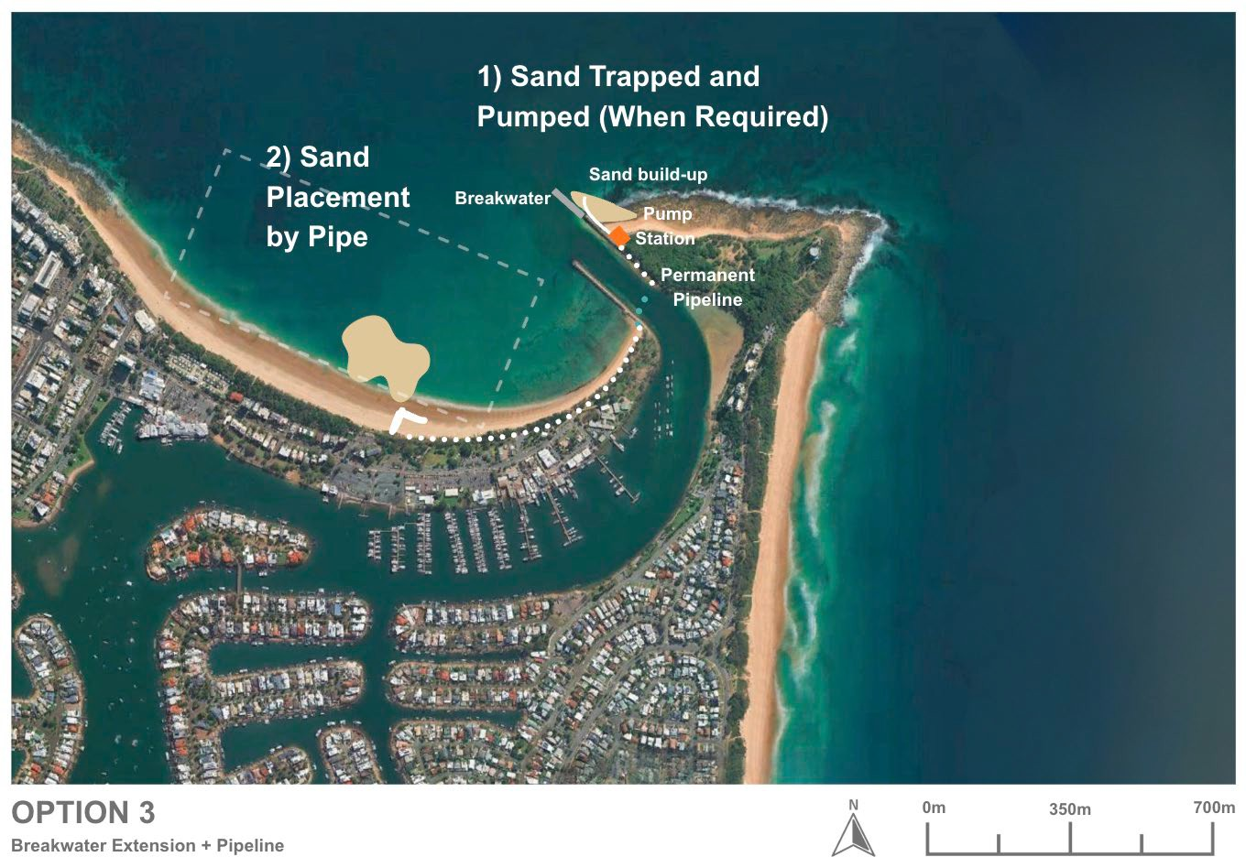
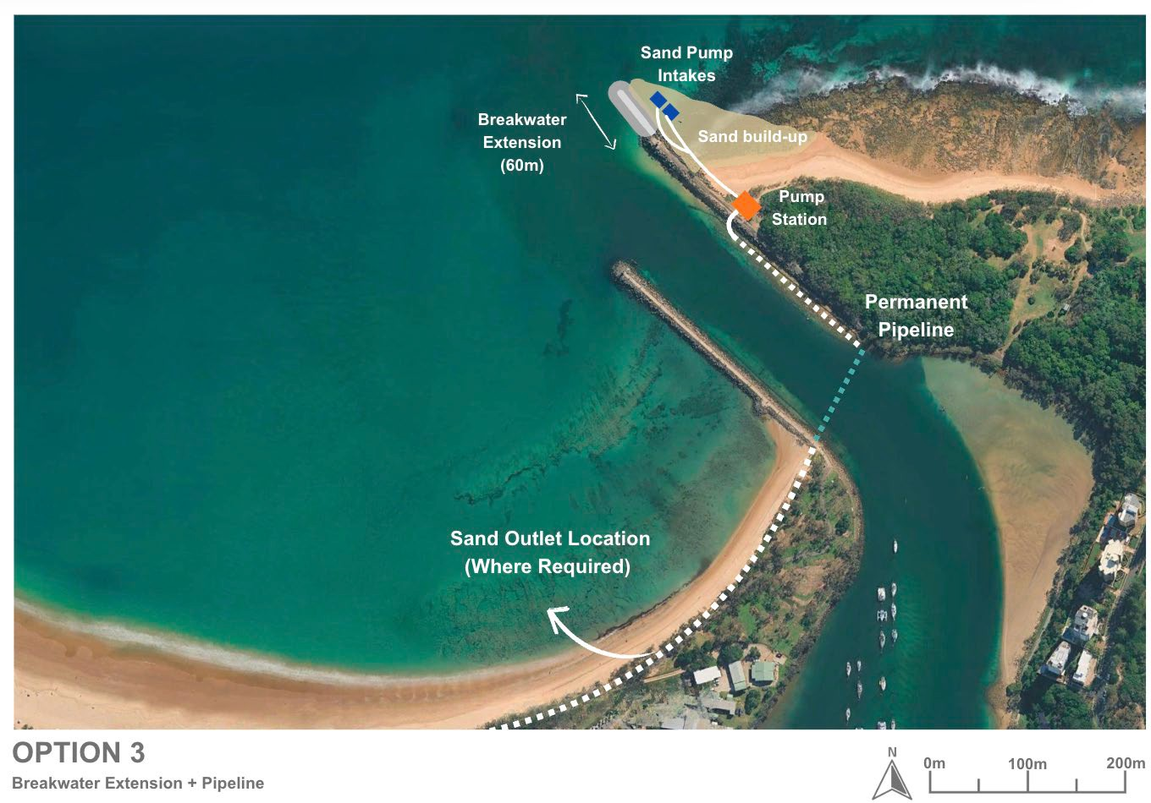
Figure 15-1: Option 3 schematics

Option 3A – Breakwater extensions with dredging and placement

Option descriptions
Option 3A builds on the long-standing dredging approach already used to manage shoaling at the Mooloolah River entrance. Under this variation, the extended eastern breakwater is allowed to function as a controlled sand trap, intercepting sand that would otherwise bypass naturally into Mooloolaba Bay. At intervals of approximately 2 years, accumulated sand is mechanically relocated from the updrift side of the breakwater to the downdrift beach system using a CSD and pipeline placement.

Design and approvals
The proposed 60 m breakwater extension has been extensively modelled and engineered as a conventional rock structure, directly tied into the existing breakwater and topped with a reinforced concrete crest pathway to provide durable maintenance access. The structure is designed to withstand a 200-year ARI wave conditions and incorporates a crest height allowance for future sea-level rise, ensuring long-term stability under extreme conditions.
The updrift sand trap formed by the extension will lie within an exposed nearshore environment, requiring the associated dredging system to be resilient to energetic wave conditions and variable seabed characteristics, including shallow rock substrata. The CSD currently used for maintenance dredging within the entrance channel is considered suitable for this task; however, its operational capacity may be constrained during adverse sea states. The existing pipeline infrastructure located along the breakwater can be reused for sediment outflow and transport to the designated placement area at Mooloolaba Beach (Area B).
The breakwater extension and associated dredging activities constitute Prescribed Tidal Works and will trigger relevant statutory approval processes, including:
- Owner’s consent for use of State land and seabed.
- A Prescribed Tidal Works application under the Planning Act 2016.
- Dredging permits under the Coastal Protection and Management Act 1995.
Given the potential disturbance to marine habitats and alteration of coastal processes, an Environmental Impact Assessment / Dredge Management Plan is likely to be required.
Early engagement with regulatory authorities is strongly recommended to guide the approval pathway. Pre-lodgement meetings will assist in aligning the design with statutory requirements, identifying information needs, and streamlining the assessment process.

Capital works
Capital works for Option 3A primarily involve the construction of the 60 m eastern breakwater extension and enabling infrastructure for periodic dredging operations. The breakwater extension represents the most significant capital component, requiring approximately 30,000 tonnes of core and armour rock, with individual armour units weighing up to 12 tonnes. Material will be sourced from approved quarries, transported by road or sea, and placed using a combination of land-based equipment and marine plant (e.g. barges or cranes), depending on access conditions.
Construction staging will be carefully sequenced to maintain safe navigation access throughout the works. Where possible, construction activities will be scheduled outside of the peak swell season to reduce weather-related risks and minimise disruption to marine operations.
Beyond the breakwater itself, only minimal permanent infrastructure is required to support dredging operations. The CSD and associated floating pipeline are mobilised on an as-needed basis and do not require fixed installations.
Any shore-based booster pumps or temporary beach works (e.g. spreaders, discharge diffusers) would be assembled and operated during dredging campaigns and then demobilised. These facilities are considered operational rather than capital assets and would not require permanent installation.
Standard environmental and construction controls would be applied throughout the works, including sediment containment, access management, and buffer zones to reduce impacts on marine fauna, water quality, and adjacent recreational areas.

Operational works
Operationally, Option 3A relies on regular dredging campaigns to transfer sand across the entrance. Based on numerical modelling and past experience, a dredging campaign is anticipated approximately every two years, targeting up to ~30,000 m³ of sand per campaign. A CSD would be mobilised for each campaign and positioned in the sand trap area on the updrift side of the extended breakwater. The dredge uses a swinging cutter head to agitate and suction up sand that has accumulated in the trap, and a pump system to send the sand-water slurry through a floating or submerged pipeline. The pipeline would likely be routed around or through a dedicated conduit on the breakwater to reach the beach discharge location on Mooloolaba Beach.
During pumping, sand slurry is discharged either directly on the beach or in the nearshore zone, where it is re-profiled to renourish, the beach as needed. Each dredging campaign would likely span a few weeks, including setup, dredging, and demobilisation, though timing can vary with weather. Because the dredging site is relatively exposed, operations need to be carefully timed to suitable wave conditions – calm weather windows are utilised to maximise productivity and safety.
Although there is precedent at the site for CSD working on the outer edge of the existing channel, the number of workable days per campaign east of the breakwater will be constrained by sea state and wave reflection, with associated risks of productivity loss and cost escalation. These constraints are recognised in the MCA by scoring operational works average performance / moderate impact. A detailed metocean and downtime analysis would be required at the next design stage to refine assumptions on workable days and confirm unit rates.
During dredging, Notices to Mariners and exclusion zones would ensure navigational safety around the dredge and pipeline. The dredging contractor or third-party contractor would likely be required to implement water quality monitoring (to manage turbidity) and beach management (to spread out the placed sand and remove pipeline sections promptly after completion).
The operational works consist of periodic, adaptive dredging campaigns that relocate sand from the breakwater’s trap to downdrift beaches, thereby maintaining the desired sediment balance and navigation depth.

Environmental constraints
A preliminary assessment of environmental constraints for the breakwater extensions with dredging and placement (Option 3A), based on the constraints analysis criteria in Table 15-1, detailed in Table 15-2.
Table 15-1: Constraints analysis criteria
Constraint level | Description
No impact | There is no impact pathway for the sensitive receptor. No further assessment is required.
Low | There is low potential for impact to the sensitive receptor. No further assessment is required. No or standard management likely.
Moderate | There is a moderate potential for impact to the sensitive receptor which will require further assessment to determine the significance of impact. Likely to be manageable or engineered to minimise potential impacts on the receiving environment.
High | There is a high potential for impact to the sensitive receptor. Further assessment is required to determine the significance of impact and mitigation strategy. Consideration for regulatory approvals.

Table 15-2: Environmental constraints for breakwater extensions with dredging and placement (Option 3A)
Category | Receptor | Impact pathway | Constraint level | Justification | Further assessment recommendations | Potential monitoring and management requirements
Marine environmental quality | Water quality | - Generation of turbidity during construction and dredging | Moderate | - An assessment of the predicted plume extent will inform the extent of turbidity related impacts however as this is a dynamic, open ocean environment, any plume will likely dissipate quickly  - Turbidity is likely to be more extensive during breakwater extension | - Turbidity modelling | - Turbidity monitoring during works  - Standard turbidity mitigation procedures  - e.g. silt curtains, staging of works
Marine environmental quality | Water quality | - Release of contaminants/hypoxia | Low | - Dredge sediments likely comprise clean marine sand free of contaminants with low organic matter content  - Breakwater construction materials assumed to be free of contamination | - Assumption that suitable data exists to inform this risk | - None
Marine environmental quality | Water quality | - Hydrocarbon spills/waste | Low | - Compliance with standard procedures will minimise this risk | - None | - Standard oil spill and waste procedures
Marine environmental quality | Water quality | - Introduced marine species | Low | - Compliance with standard procedures will minimise this risk | - None | - Compliance with standard state and commonwealth procedures regarding IMS
Marine fauna | Turtles | - Behavioural response and interruption of nesting behaviour due to light  - Mortality/injury due to vessel collision, entanglement, entrainment  - Mortality/injury due to onshore plant and vehicle movement during beach profiling  - Disturbance of habitat during sediment disposal and beach reprofiling  - Change of beach profile at Mooloolaba Main Beach due to sediment disposal direct to beach impacting nesting | Moderate | - Several turtle species listed as endangered or vulnerable under the EPBC were identified in the project area with Green (Vulnerable) and Loggerhead (Endangered) turtles known to nest on Buddina and Mooloolaba beaches. Therefore, potential impacts need to be managed accordingly. | - Assessment of shoreline response to works  - Light assessment if night works are proposed | - Timing of works outside of turtle nesting periods  - Limitation of works to daylight hours or if necessary, standard light mitigation procedures  - Design to minimise disturbance of turtle habitat and maintain the beach profile  - Standard marine fauna mitigation practices e.g. marine fauna observers and exclusion zones  - Turtle guards on dredger  - Appropriate management for onshore works e.g. onshore vehicles and plant to operate in designated tracks and areas  - Beach profile monitoring
Marine fauna | Marine mammals | - Mortality/injury/behavioural response due to noise of dredging and construction  - Vessel collision, entanglement, entrainment | Moderate | - Humpback whales may use the area for resting with calves during their migration period  - While species of dolphins listed as vulnerable may also occur in the area, they tend to move away from noise sources and are at lower risk of injury  - While species of dolphin have breeding BIA in area, there is a lower risk to breeding because of the wide distribution of the BIAs | - Underwater noise assessment | - Timing of works outside of whale migration periods  - Standard marine fauna mitigation practices e.g. marine fauna observers and exclusion zone
Marine fauna | Roosting Seabirds | - Mortality/injury/behavioural response due to noise of dredging and construction  - Behavioural response and interruption of nesting behaviour due to light  - Mortality/injury/behavioural response due physical presence  - Mortality/injury due to onshore plant and vehicle movement during beach reprofiling | Moderate | - Several species of migratory seabird aggregate and may nest at Point Cartwright and could be impacted | - Noise assessment  - Light assessment if night works are proposed | - Timing of works outside of peak aggregation season (summer) for migratory terns  - Appropriate management for onshore works e.g. onshore vehicles and plant to operate in designated tracks and areas, design to avoid key habitat areas.
Marine fauna | Foraging Seabirds | - Generation of turbidity impacting foraging activities | Moderate | - Turbidity will impede the ability of aerial feeding birds to see prey underwater, which will impact the Little Terns aggregating in Point Cartwright reserve. Larger seabirds will travel outside of the turbid zone to forage.  - An assessment of the predicted plume extent will inform the extent of turbidity related impacts however as this is a dynamic, open ocean environment, any plume will likely dissipate quickly  - Turbidity is likely to be more extensive during breakwater extension | - Turbidity modelling | - Timing of works outside of peak aggregation season (summer) for migratory terns  - Turbidity monitoring during works  - Standard turbidity mitigation procedures  - e.g. silt curtains, staging of works
Marine fauna | Site attached species | - Direct mortality/injury due to dredging and construction  - Mortality/injury/behavioural response due to physical effects of turbidity | High (for breakwater extension) | - These species are broadly distributed along the coastline  - The dredging and construction footprint area has a relatively small footprint but further assessment is required to determine the impact to habitat for species of high conservation e.g. the endangered White’s Seahorse and sand yabby  - Dredging is in a dynamic, open ocean environment, any plume will likely dissipate quickly  - Turbidity is likely to be more extensive during breakwater extension | - Fauna / benthic habitat assessment | - Construction and dredging designed to avoid protected marine fauna habitats
Marine fauna | Site attached species | - Mortality/injury/behavioural response due to toxic effects due to release of contaminants/hypoxia | Low | - Dredge sediments likely comprise clean marine sand free of contaminants with low organic matter content  - Breakwater construction materials assumed to be free of contamination | - Assumption that suitable data exists to inform this risk | - None
Marine fauna | Mobile species | - Vessel collision  - Direct mortality/injury due to dredging and construction  - Mortality/injury/behavioural response due to physical effects of turbidity | Low | - Mobile species including the critically endangered Grey Nurse Shark and conservation dependant scalloped hammerhead will actively avoid areas of activity | - None | - None
Marine fauna | Mobile species | - Mortality/injury/behavioural response due to toxic effects due to release of contaminants/hypoxia | Low | - Dredge sediments likely comprise clean marine sand free of contaminants with low organic matter content  - Breakwater construction materials assumed to be free of contamination | - Assumption that suitable data exists to inform this risk | - None
Benthic habitats | Rocky reef habitat, seagrass and corals | - Direct removal due to dredging and construction  - Generation of turbidity  - Smothering | High (for breakwater construction) | - The dredge area likely comprises bare sand, further assessment is required for the breakwater extension footprint  - Further assessment is required to determine if the potential turbidity generated will impact sensitive marine habitats  - Dredging and construction is in a dynamic, open ocean environment, any plume will likely dissipate quickly  - Turbidity is likely to be more extensive during breakwater extension | - Benthic habitat assessment in and surrounding disturbance area  - Turbidity modelling | - Turbidity monitoring during works  - Standard turbidity mitigation procedures  - e.g. silt curtains, staging of works  - Benthic habitat monitoring
Benthic habitats | Rocky reef habitat, seagrass and corals | - Release of contaminants/hypoxia | Low | - Dredge sediments likely comprise clean marine sand free of contaminants with low organic matter content  - Breakwater construction materials assumed to be free of contamination | - Assumption that suitable data exists to inform this risk | - None
Terrestrial fauna including shorebirds and raptors |  | - Mortality/injury/behavioural response due to noise  - Mortality/injury/behavioural response due to dust from breakwater construction and beach disposal  - Behavioural response due to light  - Mortality/injury/behavioural response due physical presence  - Mortality/injury due to onshore plant and vehicle movement | High (for breakwater construction) | - Several species listed as vulnerable or endangered may occur in the project area  - Several species of shorebirds are listed as occurring at Point Cartwright and could be impacted; however, it is more likely they would occur at the lower Maroochy River | - Noise assessment  - Terrestrial fauna assessment | - Timing of works outside of peak aggregation periods for migratory shorebirds  - Standard noise management procedures  - Limitation of works to daylight hours or if necessary, standard light mitigation procedures  - Standard fauna mitigation practices including monitoring for conservation significant fauna, appropriate fencing of work area  - Dust management procedures  - Waste management procedures
Terrestrial flora |  | - Smothering of vegetation due to dust generated by breakwater construction  - Disturbance or degradation of dune vegetation behind Mooloolaba Main Beach during reprofiling | Moderate | - Several MSES and TECs occur in the project area | - None | - No vegetation clearing  - Appropriate management for onshore works e.g. onshore vehicles and plant to operate in designated tracks and areas  - Dust management procedures  - Weed control management procedures  - Waste management procedures
Assumptions:
- Dredge area is an area of bare sand
- There is sediment contamination data to inform the risk of on release of contaminants via dredging and disposal
- No vegetation clearing is required for this option
- All materials used for breakwater extension are free of contaminants

The breakwater extension will potentially result in a more extensive turbid plume and greater underwater noise impacts; benthic and terrestrial habitat impacts that will require further assessment and monitoring/management during works. Overall, the breakwater extension works could potentially result in significant impacts to marine and terrestrial fauna of high conservation value.
Once established, the ongoing environmental impact would be less with potential impacts to benthic habitats, marine fauna and beach habitat that can be managed during works. The beneficial reuse of dredged sand at Mooloolaba Beach would support natural coastal nourishment and maintain sediment balance along the shoreline.

Social impacts
Option 3A is expected to generate social value with three positive impacts ranked as high in the SIE assessment, including: safer channel access through reduced shoaling, improved economic outcomes through more reliable channel access and increase nearshore sand placement improving beach nourishment.
When compared to the baseline, there were eight negative social impacts identified, however, after mitigation measures were considered, there were three which may be of high concern to the community and stakeholders, including: potential negative environmental impacts, potential visual impacts and construction impacts. Further mitigations must be undertaken to reduce potential negative social impacts including environmental assessments, visual impact assessments, environment and construction management plans, silt curtains and broader community and stakeholder engagement.

Economic impacts
Option 3A is expected to have a low to moderate economic impact compared with the current approach. The project will significantly reduce shoaling at the harbour entrance, improving channel access and long-term reliability for both commercial and recreational users. This will minimise delays, reduce reliance on emergency maintenance dredging, and provide greater confidence for businesses and the boating community. While maintenance dredging will continue in line with current practices, the frequency is expected to decrease over time as shoaling at the entrance is reduced.
Lengthening the breakwater will create additional space for recreational fishing, enhancing opportunities for anglers. The project will also involve redistributing larger volumes of sand to nearshore areas, allowing natural processes to transport material to beaches further north, supporting coastal resilience and amenity.
During construction, temporary changes to channel access may occur, affecting recreational boaters and commercial operators who use the harbour entrance. Onshore rock fishing at the breakwater and Point Cartwright will be impacted due to reduced fishing locations and safety requirements during works. These disruptions could lead to fewer visitors during the construction period, with some choosing alternative destinations on the Sunshine Coast or other coastal areas. This may result in short-term reductions in local spending, affecting nearby businesses; however, these impacts are expected to be temporary and managed to minimise disruption.
In the longer term, Option 3A may result in changes to tidal patterns that influence wave conditions at Mooloolaba Beach. These changes could lead to a decline in surf quality, particularly to the north of the harbour, where wave energy may be reduced. A reduction in surf conditions could affect the area’s reputation as a popular surfing destination, potentially decreasing visitation over time. This decline in visitor numbers may have flow-on effects for local businesses that rely on tourism and recreational activity, including accommodation providers, cafes, and surf-related enterprises. While these impacts are uncertain and dependent on the extent of tidal changes, they represent a potential long-term consideration for the local economy and community.

Future adaptation
This combined structural and operational solution provides a high degree of future adaptability. The breakwater extension is a permanent structure with a long design life (50+ years) and is expected to remain stable and effective under rising sea levels and evolving wave climates. Its primary function, reducing channel shoaling, is anticipated to remain effective over time, supported by extensive design modelling.
Training walls paired with managed sand bypassing are a well-established approach along Australia’s east coast, such as the Noosa River, Gold Coast Seaway and Tweed River.
If future coastal processes shift more significantly, due to changes in sediment supply, wave direction, or storm intensity, the breakwater geometry could be modified or extended, albeit with considerable additional capital works. The Kirra Groyne on the Gold Coast provides a relevant precedent, having been shortened and later re-extended since its original construction in the 1980s in response to changing coastal dynamics.
The dredging component offers considerable flexibility and responsiveness. Importantly, sediment transport in this region is episodic, with high peaks during major storm events and lower background transport during calmer periods. This variability in transport means that sand volumes reaching the trap area can fluctuate significantly year to year. Given this, periodic dredging is not bound to a fixed schedule, campaigns can be scaled up, down, or paused entirely based on actual need, as determined through monitoring.
Each dredging campaign can be tailored in frequency, duration, and volume, depending on infill rates, weather windows, and shoreline response. Sand placement is similarly adaptable: if conditions or priorities shift, material can be redirected to alternative nourishment sites such as Alexandra Headland or Maroochydore Beach via extended pipelines or hopper barge, rather than exclusively to Mooloolaba Beach. This approach supports broader regional sediment management goals.
Option 3A is also compatible with future system upgrades. Should a permanent sand bypass system, such as a sand shifter or fixed pump system, become preferred, it could be implemented alongside or in place of the CSD operations. It is noted that nearby Gold Coast Seaway and Tweed River have a Sand Pumping Stations that are regularly supplemented by Dredging.
Option 3A combines a durable structural intervention (breakwater) with a scalable and responsive management practice (dredging), allowing the system to be tuned over time in response to observed coastal behaviour and evolving needs.

Safety of Option 3A
Option 3A provides a moderate improvement in safety by combining structural interception (breakwater extension) with familiar CSD-based dredging operations. The extended breakwater would help stabilise the entrance bar and marginally improve reliability of all-tide access, though shoaling would still occur and require ongoing dredging. The clarity of navigation improves once dredging is undertaken, but depths may continue to fluctuate between campaigns.
In terms of mariner safety, CSD dredging introduces temporary operational hazards, including floating pipelines, restricted zones, and vessel interactions near the entrance. These risks are well understood and manageable but require ongoing navigation warnings and exclusion areas. Overall, Option 3A delivers safety gains similar to current practice, with significant improvements provided by the breakwater extension.

Cost
Capital Works Costs
Capital costs for Option 3A are dominated by the construction of the 60 m eastern breakwater extension, including supply and placement of armour rock, core material, and construction of the concrete crest and access infrastructure. The KBR (2021) design report provides an indicative capital cost estimate for the breakwater extension works. This aligns with expectations for a project of this scale and reflects a conventional but substantial rock structure build.
Beyond the breakwater itself, only minor enabling infrastructure is required, as dredging equipment is mobilised as needed. Adjustments to this estimate will depend on updated design refinements, material availability, and market conditions at the time of delivery.
Operational Costs
Operational costs are tied to the periodic dredging campaigns required to remove sand accumulating within the updrift trap. Based on modelling and historical behaviour, campaigns would occur roughly every two years, typically removing up to ~30,000 m³ per event. Costs include mobilisation of the Cutter Suction Dredger (CSD), pipeline setup, pumping, and demobilisation.
Unit rates are expected to be broadly comparable to current maintenance dredging at Mooloolaba, noting that the material dredged will be clean sand, which is generally more cost-effective to handle than mixed or consolidated sediments. Overall operational expenditure remains moderate, with total annualised costs dependent on campaign frequency and weather-related productivity constraints.

Option 3B – Breakwater extension with sand shifter bypass system

Option description
Option 3B involves the same 60 m extension of the existing eastern breakwater described in Section 15.4. However, instead of relying on mobile dredging for sediment transfer, this variation proposes installation of a Sand Shifter sediment bypass system to transport sand from the updrift accumulation zone (Area A) to Mooloolaba Beach on the downdrift side.
The Sand Shifter is a proprietary, fixed-bed pump system buried within the seabed. It draws in sand and seawater as a slurry and transfers it through a pipeline across the entrance channel. This provides a semi-continuous bypass mechanism, replicating natural littoral drift while aiming to prevent the sand trap from reaching full capacity and reducing the risk of entrance shoaling.

Design and approvals
Option 3B involves the same 60 m extension of the eastern breakwater described in Section 15.4 but replaces mobile dredging with a Sand Shifter system. This setup allows semi-continuous sediment bypassing, helping to maintain the entrance channel and downdrift supply without relying on periodic dredging campaigns.
While the Sand Shifter concept has demonstrated success at Noosa Main Beach, where a system has operated since 2012, its feasibility at Mooloolaba is more constrained. A trial of a similar slurry pump system was undertaken at the Mooloolah River entrance in 2012 by Maritime Safety Queensland (MSQ). The trial indicated that, without substantial excavation of a sand trap into the underlying rock, the pump system was ineffective as it had the inability to form a conical depression in the seabed limited sediment capture, and sand was not reliably entrained into the pump intake. As a result, a large mobile crane with a jet pump or mechanical removal was considered the only practical bypass method at the time.
It is noted, however, that the 2012 trial was conducted prior to any breakwater extension, meaning no defined sand trap was present. Under Option 3B, the breakwater extension would create a 5 m deep updrift compartment, which is likely to enhance sediment accumulation and may improve pumping effectiveness compared to the initial trial. Nonetheless, key constraints remain - particularly the presence of shallow rock - which would pose significant challenges for installing a buried intake system and may limit the ability to effectively remove deeper sand within the trap. The system is therefore expected to require significant capital works to ensure performance.
As with Option 3A, the works would trigger relevant statutory approvals as Prescribed Tidal Works, including:
- Owner’s consent for use of State land and seabed.
- A Prescribed Tidal Works application under the Planning Act 2016.
- Dredging permits under the Coastal Protection and Management Act 1995.
Given the potential disturbance to marine habitats and alteration of coastal processes, an Environmental Impact Assessment / Dredge Management Plan is likely to be required.
Early engagement with regulatory authorities is strongly recommended to guide the approval pathway. Pre-lodgement meetings will assist in aligning the design with statutory requirements, identifying information needs, and streamlining the assessment process.

Capital works
Implementing a Sand Shifter system requires significant capital works. Unlike dredging (which uses mobile equipment), the Sand Shifter is a permanent installation. Capital components include one or more submersible pump units to be buried in the seabed at the selected trap site, a pipeline running from the pump to existing pipeline connection, or the discharge outlet on Mooloolaba Beach, a shore-based pump station (to house booster pumps, electrical controls, etc.), and connection to a reliable power supply.
Construction would require both land-based civil works (for the pump station and electrical connection) and significant marine construction to trench and bury the intake system and pipeline. Of particular concern is the presence of shallow rock substrata, which would complicate excavation and increase the complexity, cost, and feasibility risks of installing the intake structure and pipeline beneath the seabed.
While the Sand Shifter offers long-term sediment management benefits and reduced reliance on mobilisation logistics, its viability is heavily dependent on constructability and geological conditions. The high upfront investment must be weighed against operational savings over time; and compared against other alternatives (i.e. Sub option 3A and 3C).

Operational works
Once installed, the Sand Shifter operates continuously or at least regularly (e.g. during high-sediment transport months) to pump sand. Operationally, this means running the electric pumps that drive the eductor and booster, monitoring the pipeline pressure and slurry flow, and managing the discharge on the beach.
According to Slurry Systems Marine’s input, a Mooloolah Sand Shifter was assumed to have a capacity similar to Noosa’s system, on the order of tens of thousands of cubic metres per year.
The system would need regular inspections (diver checks of the intake, etc.), and maintenance of pumps and pipelines (e.g. clearing any blockages, servicing motors). Notably, the Sand Shifter can be largely automated but requires contingency plans for downtime.
Operational works for 3B involve continuous management operational program, rather than individual campaigns.

Environmental constraints
A preliminary assessment of environmental constraints for breakwater extension with sand shifter bypass system (Option 3B), based on the constraints analysis criteria in Table 15-3, detailed in Table 15-4.
Table 15-3: Constraints analysis criteria
Constraint level | Description
No impact | There is no impact pathway for the sensitive receptor. No further assessment is required.
Low | There is low potential for impact to the sensitive receptor. No further assessment is required. No or standard management likely.
Moderate | There is a moderate potential for impact to the sensitive receptor which will require further assessment to determine the significance of impact. Likely to be manageable or engineered to minimise potential impacts on the receiving environment.
High | There is a high potential for impact to the sensitive receptor. Further assessment is required to determine the significance of impact and mitigation strategy. Consideration for regulatory approvals.

Table 15-4: Environmental constraints for breakwater extension with sand shifter bypass system (Option 3B)
Category | Receptor | Impact pathway | Constraint level | Justification | Further assessment recommendations | Potential monitoring and management requirements
Marine environmental quality | Water quality | - Generation of turbidity during construction and rock cutting | High (for breakwater extension and rock cutting) | - An assessment of the predicted plume extent will inform the extent of turbidity related impacts however as this is a dynamic, open ocean environment, any plume will likely dissipate quickly  - Turbidity is likely to be more extensive and persistent during breakwater extension and rock cutting works | - Turbidity modelling | - Turbidity monitoring during works  - Standard turbidity mitigation procedures  - e.g. silt curtains, staging of works
Marine environmental quality | Water quality | - Release of contaminants/hypoxia | Low | - Bypass sediments likely comprise clean marine sand free of contaminants with low organic matter content  - Breakwater construction materials assumed to be free of contamination  - Rock is likely to be uncontaminated | - Assumption that suitable data exists to inform this risk | - None
Marine environmental quality | Water quality | - Hydrocarbon spills/waste | Low | - Compliance with standard procedures will minimise this risk | - None | - Standard oil spill and waste procedures
Marine environmental quality | Water quality | - Introduced marine species | Low | - Compliance with standard procedures will minimise this risk | - None | - Compliance with standard state and commonwealth procedures regarding IMS
Marine fauna | Turtles | - Behavioural response and interruption of nesting behaviour due to light  - Mortality/injury due to vessel collision, entanglement, entrainment  - Mortality/injury due to onshore plant and vehicle movement during beach profiling  - Disturbance of habitat during sediment disposal and beach reprofiling  - Change of beach profile at Mooloolaba Main Beach due to sediment disposal direct to beach impacting nesting | Moderate | - Several turtle species listed as endangered or vulnerable under the EPBC were identified in the project area with Green (Vulnerable) and Loggerhead (Endangered) turtles known to nest on Buddina and Mooloolaba beaches. Therefore, potential impacts need to be managed accordingly. | - Assessment of shoreline response to works  - Light assessment if night works are proposed | - Timing of works outside of turtle nesting periods  - Limitation of works to daylight hours or if necessary, standard light mitigation procedures  - Design to minimise disturbance of turtle habitat and maintain the beach profile  - Standard marine fauna mitigation practices e.g. marine fauna observers and exclusion zones  - Turtle guards on bypassing equipment  - Appropriate management for onshore works e.g. onshore vehicles and plant to operate in designated tracks and areas  - Beach profile monitoring
Marine fauna | Marine mammals | - Mortality/injury/behavioural response due to noise of construction, rock cutting and bypassing  - Vessel collision, entanglement, entrainment | High (for breakwater extension and rock cutting) | - Humpback whales may use the area for resting with calves during their migration period  - Species of dolphins listed as vulnerable may also occur in the area and while they tend to move away from noise sources and are at lower risk of injury, the greater level of noise generated from rock cutting requires further assessment | - Underwater noise assessment including modelling | - Timing of works outside of whale migration periods  - Standard marine fauna mitigation practices e.g. marine fauna observers and exclusion zone
Marine fauna | Roosting Seabirds | - Mortality/injury/behavioural response due to construction, rock cutting and bypassing  - Behavioural response and interruption of nesting behaviour due to light  - Mortality/injury/behavioural response due to physical presence onshore  - Disturbance/degradation of habitat during pump installation  - Mortality/injury due to onshore plant and vehicle movement during beach reprofiling | Moderate | - Several species of migratory seabird aggregate and may nest at Point Cartwright and could be impacted | - Noise assessment  - Light assessment if night works are proposed | - Timing of works outside of peak aggregation season (summer) for migratory terms  - Appropriate management for onshore works e.g. onshore vehicles and plant to operate in designated tracks and areas, design to avoid key habitat areas.
Marine fauna | Foraging Seabirds | - Generation of turbidity impacting foraging activities | Moderate | - Turbidity will impede the ability of aerial feeding birds to see prey underwater, which will impact the Little Terns aggregating in Point Cartwright reserve. Larger seabirds will travel outside of the turbid zone to forage.  - An assessment of the predicted plume extent will inform the extent of turbidity related impacts however as this is a dynamic, open ocean environment, any plume will likely dissipate quickly  - Turbidity is likely to be more extensive and persistent during breakwater extension and rock cutting | - Turbidity modelling | - Timing of works outside of peak aggregation season (summer) for migratory terms  - Turbidity monitoring during works  - Standard turbidity mitigation procedures  - e.g. silt curtains, staging of works
Marine fauna | Site attached species | - Direct mortality/injury due to construction, rock cutting and bypassing  - Mortality/injury/behavioural response due to physical effects of turbidity | High (for breakwater extension and rock cutting) | - These species are broadly distributed along the coastline  - The dredging and construction footprint area has a relatively small footprint but further assessment is required to determine the impact to habitat for species of high conservation value e.g. the endangered White’s Seahorse and sand yabby  - Dredging is in a dynamic, open ocean environment, any plume will likely dissipate quickly  - Turbidity is likely to be more extensive and persistent during breakwater extension and rock cutting | - Fauna / benthic habitat assessment | - Construction and dredging designed to avoid protected marine fauna habitats
Marine fauna | Site attached species | - Mortality/injury/behavioural response due to toxic effects due to release of contaminants/hypoxia | Low | - Bypass sediments likely comprise clean marine sand free of contaminants with low organic matter content  - Breakwater construction materials and rock assumed to be free of contamination | - Assumption that suitable data exists to inform this risk | - None
Marine fauna | Mobile species | - Vessel collision  - Direct mortality/injury due to construction, rock cutting and bypassing  - Mortality/injury/behavioural response due to physical effects of turbidity | Low | - Mobile species including the critically endangered Grey Nurse Shark and conservation dependant scalloped hammerhead will actively avoid areas of activity | - None | - None
Marine fauna | Mobile species | - Mortality/injury/behavioural response due to toxic effects due to release of contaminants/hypoxia | Low | - Bypass sediments likely comprise clean marine sand free of contaminants with low organic matter content  - Breakwater construction materials and rock assumed to be free of contamination | - Assumption that suitable data exists to inform this risk | - None
Benthic habitats | Rocky reef habitat, seagrass and corals | - Direct removal due to construction, rock cutting and bypassing  - Generation of turbidity  - Smothering | High (for breakwater extension and rock cutting) | - The bypass area likely comprises bare sand, further assessment is required for the breakwater extension footprint  - Further assessment is required to determine if the potential turbidity generated will impact sensitive marine habitats  - Dredging and construction is in a dynamic, open ocean environment, any plume will likely dissipate quickly  - Turbidity is likely to be more extensive and persistent during breakwater extension and rock cutting | - Benthic habitat assessment in and surrounding disturbance area  - Turbidity modelling | - Turbidity monitoring during works  - Standard turbidity mitigation procedures  - e.g. silt curtains, staging of works  - Benthic habitat monitoring
Benthic habitats | Rocky reef habitat, seagrass and corals | - Release of contaminants/hypoxia | Low | - Bypass sediments likely comprise clean marine sand free of contaminants with low organic matter content  - Breakwater construction materials assumed to be free of contamination | - Assumption that suitable data exists to inform this risk | - None
Terrestrial fauna including shorebirds and raptors |  | - Mortality/injury/behavioural response due to noise from breakwater extension, rock cutting and the bypass pump  - Mortality/injury/behavioural response due to dust from breakwater construction and beach disposal  - Behavioural response due to light  - Mortality/injury/behavioural response due physical presence  - Mortality/injury due to onshore plant and vehicle movement  - Disturbance/degradation of habitat during pump installation | High (for breakwater construction and rock cutting) | - Several species listed as vulnerable or endangered may occur in the project area  - Several species of shorebirds are listed as occurring at Point Cartwright and could be impacted; however, it is more likely they would occur at the lower Maroochy River | - Noise assessment  - Terrestrial fauna assessment | - Timing of works outside of peak aggregation periods for migratory shorebirds  - Standard noise management procedures  - Limitation of works to daylight hours or if necessary, standard light mitigation procedures  - Standard fauna mitigation practices including monitoring for conservation significant fauna, appropriate fencing of work area  - Dust management procedures  - Waste management procedures
Terrestrial flora |  | - Direct clearing of vegetation  - Smothering of vegetation due to dust generated by breakwater construction  - Disturbance or degradation of dune vegetation behind Mooloolaba Main Beach during reprofiling | High (for pump installation) | - Several MSES and TECs occur in the project area | - Terrestrial flora assessment | - Design to minimise clearing required and avoid key habitat areas  - Appropriate management for onshore works e.g. onshore vehicles and plant to operate in designated tracks and areas  - Dust management procedures  - Weed control management procedures  - Waste management procedures  - Monitor conservation significant flora  - Post construction survey  - Topsoil stockpiling and revegetation of cleared areas post-construction
Assumptions:
- Bypass area is an area of bare sand
- There is sediment contamination data to inform the risk of on release of contaminants via dredging and disposal
- All materials used for breakwater extension are free of contaminants
- Excavated rock will be disposed of offsite if not appropriate for offshore disposal

Similar to Option 3A, the breakwater extension and rock cutting will potentially result in a more extensive and persistent turbid plume and greater underwater noise impacts, benthic and terrestrial habitat impacts that will require further assessment and monitoring/management during works. Overall, the capital works could potentially result in significant impacts to marine mammals and terrestrial fauna of high conservation value.
Once established, the ongoing environmental impact would be less with potential impacts to benthic habitats, marine fauna and beach habitat that can be managed during works. The beneficial reuse of dredged sand at Mooloolaba Beach would support natural coastal nourishment and maintain sediment balance along the shoreline.

Social impacts
Option 3B is expected to generate social value with three positive impacts ranked as high in the SIE assessment, including: safer channel access through reduced shoaling, improved economic outcomes through more reliable channel access and increased frequency of sand placement for beach nourishment.
When compared to the baseline, there were 12 negative social impacts identified, however, after mitigation measures were considered, there were four which may be of high concern to the community and stakeholders, including: potential negative environmental impacts, potential visual impacts, potential noise from pump operations and construction impacts. Further mitigations must be undertaken to reduce potential negative social impacts including environmental assessments, visual impact assessments, environment and construction management plans, noise monitoring, silt curtains and broader community and stakeholder engagement and communications.

Economic impacts
Option 3B is expected to have a low to moderate economic impact compared with the current approach. The project will significantly reduce shoaling at the harbour entrance, improving channel access and long-term reliability for both commercial and recreational users. This will minimise delays, reduce reliance on emergency maintenance dredging, and provide greater confidence for businesses and the boating community. This option does not require maintenance dredging as the pump acts as a semi-continuous bypass mechanism.
Lengthening the breakwater will create additional space for recreational fishing, enhancing opportunities for anglers in the long term.
During construction, temporary changes to channel access may occur, affecting recreational boaters and commercial operators who use the harbour entrance. Onshore rock fishing at the breakwater and Point Cartwright will be impacted due to reduced fishing locations and safety requirements during works. These disruptions could lead to fewer visitors during the construction period, with some choosing alternative destinations on the Sunshine Coast or other coastal areas. This may result in short-term reductions in local spending, affecting nearby businesses; however, these impacts are expected to be temporary and managed to minimise disruption.
In the longer term, Option 3B may result in changes to tidal patterns that influence wave conditions at Mooloolaba Beach. These changes could lead to a decline in surf quality, particularly to the north of the harbour, where wave energy may be reduced. A reduction in surf conditions could affect the area’s reputation as a popular surfing destination, potentially decreasing visitation over time. This decline in visitor numbers may have flow-on effects for local businesses that rely on tourism and recreational activity, including accommodation providers, cafes, and surf-related enterprises. While these impacts are uncertain and dependent on the extent of tidal changes, they represent a potential long-term consideration for the local economy and community.

Future adaptation
Option 3B provides a semi-automated sediment bypass solution with limited operational input once installed; however, its long-term adaptability is more constrained than mobile-based systems. The fixed Sand Shifter infrastructure offers consistent performance if infill volumes and trap behaviour remain within expected parameters, but its flexibility in adjusting to evolving coastal dynamics is reduced compared to dredging-based solutions.
Sediment transport at the Mooloolah River entrance is episodic and influenced by storm-driven events and seasonal variability. If longshore transport volumes increase over time - due to climate change or other catchment changes - the fixed intake location and pumping capacity may prove insufficient to manage sand accumulation effectively. Unlike dredging, which can target specific shoals or hotspots as they develop, the Sand Shifter operates in a fixed zone and may not fully intercept mobile shoals forming further offshore or along shifting alignment pathways.
System performance could potentially be enhanced by adding a second intake or upgrading pump capacity, but these upgrades would involve additional engineering work and capital costs. Major relocations or geometric adjustments would be technically challenging once infrastructure is embedded.
A Sand Shifter could be integrated into a broader sediment management system – supplemented by periodic dredging during extreme events, or by crane-operated jet pumping if shoals form outside its influence zone.
While the Sand Shifter offers reduced operational effort and potentially more consistent bypassing (if designed and constructed with enough embedment into rock), its ability to scale, adapt, or respond to unanticipated sediment patterns is limited. Its future success is therefore highly dependent on accurate prediction of sediment volumes and trap behaviour.

Safety of Option 3B
Option 3B provides a greater safety improvement than Option 3A due to the semi-automated nature of the sand shifter system. Because sand can be intermittently pumped across the entrance without needing dredge mobilisation, the entrance channel remains clearer for longer, improving reliability of all-tide access. The system reduces the occurrence of unexpected shoaling, thereby improving the clarity of navigation and maintaining more predictable depth profiles.
For mariner safety, the sand shifter offers lower operational risk because it removes the need for large dredging plant near the entrance. With pumping equipment buried or contained within a narrow footprint along the breakwater, the system minimises conflicts with recreational boaters, surfers, and swimmers. Storm exposure remains a consideration, but overall, Option 3B presents a safer and more stable sediment-management approach than dredging-only options.

Cost
Capital Works Costs
Capital costs for Option 3B are expected to be significantly higher than Option 3A due to the installation of the Sand Shifter semi-permanent bypassing system. While Option 3A requires only the breakwater extension plus periodic mobilisation of a CSD, Option 3B introduces additional fixed infrastructure, including buried intake pumps, a seabed trench and pipeline network, electrical supply, telemetry, and a shore-based pump station.
The presence of shallow rock beneath the trap area presents a major constructability challenge. Trenching through indurated rock to install the buried intake and pipeline will increase cost, duration, and risk relative to a mobile dredging solution. These additional requirements place Option 3B at the upper end of capital expenditure for the breakwater-based options.
Capital works remain anchored by the estimate for the breakwater extension (KBR, 2021), with the Sand Shifter system representing a substantial additional cost overlay—likely several million dollars depending on excavation needs, pump station configuration, power connection distance, and seabed trenching feasibility.
Operational Costs
Operational costs for Option 3B differ fundamentally from Option 3A. Instead of periodic dredging campaigns, Option 3B incurs continuous or near-continuous operating costs associated with pump operation, energy consumption, mechanical wear, and routine inspections.
Key considerations include:
- Continuous pump operation during transport-active periods leads to steady annual running costs, rather than episodic expenditure.
- Pumps, eductors, valves, and electrical systems require regular servicing, particularly given the energetic marine environment and abrasive nature of sediment-laden flows.
- Diver inspections and maintenance of the buried intake system will be required to ensure reliable sediment entrainment.
- Although mobilisation costs are avoided, overall annual OPEX may be comparable to or higher than the average annualised cost of 3A’s biennial dredging regime, particularly when accounting for power use, pump maintenance, and periodic component replacement.
The Sand Shifter offers potential long-term efficiency benefits if continuous sediment supply is confirmed; however, performance is highly dependent on trap geometry, sediment availability, and the ability of the intake to reliably capture sand within a partially rock-bound environment. Operational costs must therefore be balanced against uncertainties in system effectiveness and the risk of requiring supplementary dredging following large storm-driven deposition events.

Option 3C – Breakwater extension with crane-operated mobile jet pump system

Option description
Option 3C involves the same 60 m extension of the existing eastern breakwater in 3A and 3B; however, the sediment transport system involves the use of a mobile jet pump system deployed via crane to mechanically bypass sand from the entrance shoal to the downdrift beach system. In this approach, a crawler crane (typically 50t or 90t) is positioned on the crest of the eastern breakwater or a nearby platform and lowers a submersible jet pump into the designated sand trap area (Area A).
Once deployed, the eductor uses high-pressure water jets to fluidise sand, which is then pumped as a slurry via pipeline to the downdrift Mooloolaba Beach. The system mimics the core function of traditional dredging (as in Option 3A) but replaces the dredge vessel with a land-based crane for increased flexibility and reduced mobilisation complexity.
Unlike the continuous or semi-automated operation of a fixed Sand Shifter system (Option 3B), this option is operated intermittently. The crane and pump are mobilised on demand (anticipated every two years), when monitoring shows that the entrance trap has reached a trigger sand volume requiring bypassing.
The system has international precedent: a similar crane-operated eductor has been in use at Indian River Inlet (Delaware, USA) since 1990 and has demonstrated effective shoal management with minimal infrastructure. A comparable trial at Lakes Entrance, Victoria further supports the concept’s feasibility in Australian coastal settings.
Option 3C provides a targeted, flexible bypass solution that avoids the need for a full dredge mobilisation while allowing sediment to be relocated efficiently to maintain entrance depth and downdrift nourishment.

Design and approvals
The structural component of Option 3C; the 60 m breakwater extension, is the same as described in Options 3A and 3B (refer Section 15.4), with design already completed for a conventional rock structure incorporating a reinforced concrete crest pathway for maintenance and crane access.
The jet pump system is considered an operational attachment rather than a fixed facility. While detailed design of the jet pump unit and crane interface would be required, the system largely consists of off-the-shelf or proven components. Equipment selection (e.g. pump size, crane rating) would be based on local bathymetry, sediment characteristics, and target bypassing volumes.
This sub-option avoids many of the fixed infrastructure challenges of Option 3B (e.g. seabed trenching or pump station installation), simplifying approvals. However, the crane pad or platform may need structural design and certification depending on location and loading. Temporary pipelines for sand placement would be laid during each campaign and removed after completion.
As with other options, the works would constitute Prescribed Tidal Works and trigger approvals under the Planning Act 2016 and Coastal Protection and Management Act 1995. Owner’s consent for use of State land and seabed would be required. A Dredge Management Plan would likely be needed to address water quality, environmental safeguards, and operational protocols.
Due to the reduced seabed disturbance compared to a buried pipeline, this option may face fewer constructability and environmental approval hurdles, though pre-lodgement consultation with agencies is still recommended.

Capital works
The crane-operated jet pump system is largely modular, so capital works are modest. If using an existing crane, there is little permanent infrastructure to build. If a larger crane (such as 90 tonne) is preferred to extend reach, the tip of the eastern breakwater would need to be widened to create a stable crane pad.
Preliminary feasibility and crest width requirements for crane-based jet pump deployment were assessed in the BMT WBM 2014. It is likely that the existing ~4 m crest width is sufficient for a 50t crawler crane, while accommodating a 90t crane would require widening the breakwater by to 7 m for the last 10 m of extension (~2,575 m³ of rock)
For a smaller crane (50 t), the existing breakwater (~4 m crest width) was deemed sufficient with no modification. Other capital elements include the jet pump equipment itself (hoses, power unit, booster pump) – however, these are mobile assets usually rented or owned by the contractor, not fixed installations.
Option 3C’s capital works mostly involve planning for crane access: ensuring the breakwater can support the crane (which may involve reinforcing certain sections) and possibly constructing convenient access points or laydown areas for the crane and pumps. Compared to Option 3B, the upfront construction is minimal; the main costs are in procurement of equipment when needed, which is accounted for in operational costs rather than capital.

Operational works
The operation of Option 3C occurs in campaigns. Based on the high-level bypass strategy, the idea is to run a sand bypass campaign approximately every two years. Each campaign would involve mobilising a crawler crane to the site via the breakwater access, along with the jet pump assembly, hoses, booster pump, and fuel/power units. A 50t crane can be driven out along the breakwater and set up at the end; the pump is then lowered into the water on the channel side where the sand shoal is sitting. A campaign is likely to last a few weeks where the pump would extract ~30,000 m³ of sand, sending it through the pipeline to the discharge. During pumping, operators must monitor slurry flow to avoid clogging and reposition the pump as needed to cover the target area.
After the campaign, all equipment is demobilised and the site returns to normal use. This cycle repeats when monitoring shows the shoal volume nearing a threshold. Because operations are intermittent, coordination with weather is crucial – calm sea states are needed for crane stability (especially if working at the breakwater’s end). The flexibility of this method is evident: if shoaling is slower than expected, the next campaign can be delayed; in larger shoaling events, extra campaign can be scheduled.
The crawler-based jet pump system is nevertheless weather-window dependent. Safe crane operation on the breakwater crest requires low wave conditions and controlled overtopping, and wave climate remains the primary constraint on productivity. While Option 3C scores higher than Options 3A and 3B in the MCA for operational works - reflecting its modularity, lower mobilisation complexity, and ability to operate from alternative locations - its overall efficiency is still governed by the same metocean limitations that influence CSD performance.

Environmental constraints
A preliminary assessment of environmental constraints for breakwater extension with crane-operated mobile jet (Option 3B), based on the constraints analysis criteria in Table 15-5, detailed in Table 15-6.
Table 15-5: Constraints analysis criteria
Constraint level | Description
No impact | There is no impact pathway for the sensitive receptor. No further assessment is required.
Low | There is low potential for impact to the sensitive receptor. No further assessment is required. No or standard management likely.
Moderate | There is a moderate potential for impact to the sensitive receptor which will require further assessment to determine the significance of impact. Likely to be manageable or engineered to minimise potential impacts on the receiving environment.
High | There is a high potential for impact to the sensitive receptor. Further assessment is required to determine the significance of impact and mitigation strategy. Consideration for regulatory approvals.

Table 15-6: Environmental constraints for breakwater extension with crane-operated mobile jet (Option 3C)
Category | Receptor | Impact pathway | Constraint level | Justification | Further assessment recommendations | Potential monitoring and management requirements
Marine environmental quality | Water quality | - Generation of turbidity during construction and bypassing | Moderate | - An assessment of the predicted plume extent will inform the extent of turbidity related impacts however as this is a dynamic, open ocean environment, any plume will likely dissipate quickly  - Turbidity is likely to be more extensive during breakwater extension | - Turbidity modelling | - Turbidity monitoring during works  - Standard turbidity mitigation procedures  - e.g. silt curtains, staging of works
Marine environmental quality | Water quality | - Release of contaminants/hypoxia | Low | - Dredge sediments likely comprise clean marine sand free of contaminants with low organic matter content  - Breakwater construction materials assumed to be free of contamination | - Assumption that suitable data exists to inform this risk | - None
Marine environmental quality | Water quality | - Hydrocarbon spills/waste | Low | - Compliance with standard procedures will minimise this risk | - None | - Standard oil spill and waste procedures
Marine environmental quality | Water quality | - Introduced marine species | Low | - Compliance with standard procedures will minimise this risk | - None | - Compliance with standard state and commonwealth procedures regarding IMS
Marine fauna | Turtles | - Behavioural response and interruption of nesting behaviour due to light  - Mortality/injury due to vessel collision, entanglement, entrainment  - Mortality/injury due to onshore plant and vehicle movement during beach profiling  - Disturbance of habitat during sediment disposal and beach reprofiling  - Change of beach profile at Mooloolaba Main Beach due to sediment disposal direct to beach impacting nesting | Moderate | - Several turtle species listed as endangered or vulnerable under the EPBC were identified in the project area with Green (Vulnerable) and Loggerhead (Endangered) turtles known to nest on Buddina and Mooloolaba beaches. Therefore, potential impacts need to be managed accordingly. | - Assessment of shoreline response to works  - Light assessment if night works are proposed | - Timing of works outside of turtle nesting periods  - Limitation of works to daylight hours or if necessary, standard light mitigation procedures  - Design to minimise disturbance of turtle habitat and maintain the beach profile  - Standard marine fauna mitigation practices e.g. marine fauna observers and exclusion zones  - Turtle guards on bypassing equipment  - Appropriate management for onshore works e.g. onshore vehicles and plant to operate in designated tracks and areas  - Beach profile monitoring
Marine fauna | Marine mammals | - Mortality/injury/behavioural response due to noise of construction and bypassing  - Vessel collision, entanglement, entrainment | Moderate | - Humpback whales may use the area for resting with calves during their migration period  - While species of dolphins listed as vulnerable may also occur in the area, they tend to move away from noise sources and are at lower risk of injury  - While species of dolphin have breeding BIA in area, there is a lower risk to breeding because of the wide distribution of the BIAs | - Underwater noise assessment including modelling | - Timing of works outside of whale migration periods  - Standard marine fauna mitigation practices e.g. marine fauna observers and exclusion zone
Marine fauna | Roosting Seabirds | - Mortality/injury/behavioural response due to noise of construction and bypassing  - Behavioural response and interruption of nesting behaviour due to light  - Mortality/injury/behavioural response due to physical presence onshore  - Disturbance/degradation of habitat due to laydown area and booster pump installation  - Mortality/injury or due to onshore plant and vehicle movement if beach reprofiling required | Moderate | - Several species of migratory seabird aggregate and may nest at Point Cartwright and could be impacted | - Noise assessment  - Light assessment if night works are proposed | - Timing of works outside of peak aggregation season (summer) for migratory terns  - Appropriate management for onshore works e.g. onshore vehicles and plant to operate in designated tracks and areas, design to avoid key habitat areas.
Marine fauna | Foraging Seabirds | - Generation of turbidity impacting foraging activities | Moderate | - Turbidity will impede the ability of aerial feeding birds to see prey underwater, which will impact the Little Terns aggregating in Point Cartwright reserve. Larger seabirds will travel outside of the turbid zone to forage.  - An assessment of the predicted plume extent will inform the extent of turbidity related impacts however as this is a dynamic, open ocean environment, any plume will likely dissipate quickly  - Turbidity is likely to be more extensive during breakwater extension | - Turbidity modelling | - Timing of works outside of peak aggregation season (summer) for migratory terns  - Turbidity monitoring during works  - Standard turbidity mitigation procedures  - e.g. silt curtains, staging of works
Marine fauna | Site attached species | - Direct mortality/injury due to construction and bypassing  - Mortality/injury/behavioural response due to physical effects of turbidity | High (for breakwater extension) | - These species are broadly distributed along the coastline  - The dredging and construction footprint area has a relatively small footprint but further assessment is required to determine the impact to habitat for species of high conservation value e.g. the endangered White’s Seahorse and sand yabby  - Dredging is in a dynamic, open ocean environment, any plume will likely dissipate quickly  - Turbidity is likely to be more extensive and persistent during breakwater extension | - Fauna / benthic habitat assessment | - Construction and dredging designed to avoid protected marine fauna habitats
Marine fauna | Site attached species | - Mortality/injury/behavioural response due to toxic effects due to release of contaminants/hypoxia | Low | - Bypass sediments likely comprise clean marine sand free of contaminants with low organic matter content  - Breakwater construction materials and rock assumed to be free of contamination | - Assumption that suitable data exists to inform this risk | - None
Marine fauna | Mobile species | - Vessel collision  - Direct mortality/injury due to dredging and construction  - Mortality/injury/behavioural response due to physical effects of turbidity | Low | - Mobile species including the critically endangered Grey Nurse Shark and conservation dependant scalloped hammerhead will actively avoid areas of activity | - None | - None
Marine fauna | Mobile species | - Mortality/injury/behavioural response due to toxic effects due to release of contaminants/hypoxia | Low | - Dredge sediments likely comprise clean marine sand free of contaminants with low organic matter content  - Breakwater construction materials and rock assumed to be free of contamination | - Assumption that suitable data exists to inform this risk | - None
Benthic habitats | Rocky reef habitat, seagrass and corals | - Direct removal due to construction and bypassing  - Generation of turbidity  - Smothering | High (for breakwater construction) | - The dredge area likely comprises bare sand, further assessment is required for the breakwater extension footprint  - Further assessment is required to determine if the potential turbidity generated will impact sensitive marine habitats  - Dredging and construction is in a dynamic, open ocean environment, any plume will likely dissipate quickly  - Turbidity is likely to be more extensive during breakwater extension | - Benthic habitat assessment in and surrounding disturbance area  - Turbidity modelling | - Turbidity monitoring during works  - Standard turbidity mitigation procedures  - e.g. silt curtains, staging of works  - Benthic habitat monitoring
Benthic habitats | Rocky reef habitat, seagrass and corals | - Release of contaminants/hypoxia | Low | - Bypass sediments likely comprise clean marine sand free of contaminants with low organic matter content  - Breakwater construction materials assumed to be free of contamination | - Assumption that suitable data exists to inform this risk | - None
Terrestrial fauna including shorebirds and raptors |  | - Mortality/injury/behavioural response due to noise from breakwater extension and bypassing  - Mortality/injury/behavioural response due to dust from breakwater construction and beach disposal  - Behavioural response due to light  - Mortality/injury/behavioural response due physical presence  - Mortality/injury due to onshore plant and vehicle movement  - Disturbance/degradation of habitat during laydown area and booster pump installation | High (for breakwater construction | - Several species listed as vulnerable or endangered may occur in the project area  - Several species of shorebirds are listed as occurring at Point Cartwright and could be impacted; however, it is more likely they would occur at the lower Maroochy River | - Noise assessment  - Terrestrial fauna assessment | - Timing of works outside of peak aggregation periods for migratory shorebirds  - Standard noise management procedures  - Limitation of works to daylight hours or if necessary, standard light mitigation procedures  - Standard fauna mitigation practices including monitoring for conservation significant fauna, appropriate fencing of work area  - Dust management procedures  - Waste management procedures
Terrestrial flora |  | - Smothering of vegetation due to dust generated by breakwater construction  - Disturbance/degradation of habitat during laydown area and booster pump installation  - Disturbance or degradation of dune vegetation behind Mooloolaba Main Beach during reprofiling | Moderate | - Several MSES and TECs occur in the project area | - None | - No vegetation clearing  - Appropriate management for onshore works e.g. onshore vehicles and plant to operate in designated tracks and areas  - Dust management procedures  - Weed control management procedures  - Waste management procedures
Assumptions:
- Bypass area is an area of bare sand
- There is sediment contamination data to inform the risk of on release of contaminants via dredging and disposal
- No vegetation clearing is required for this option
- All materials used for breakwater extension are free of contaminants

Similar to Option 3A, the breakwater extension and installation of laydown area and booster pumps will potentially result in a more extensive turbid plume and greater underwater noise impacts, benthic and terrestrial habitat impacts that will require further assessment and monitoring/management during works. Overall, the capital works could potentially result in significant impacts to marine mammals and terrestrial fauna of high conservation value.
Once established, the ongoing environmental impact would be less with potential impacts to benthic habitats, marine fauna and beach habitat that can be managed during works. The beneficial reuse of dredged sand at Mooloolaba Beach would support natural coastal nourishment and maintain sediment balance along the shoreline.

Social impacts
Option 3C is expected to generate social value with two positive impacts ranked as high in the SIE assessment, including: safer channel access through reduced shoaling and improved economic outcomes through more reliable channel access.
When compared to the baseline, there were 10 negative social impacts identified, however, after mitigation measures were considered, there were four which may be of high concern to the community and stakeholders, including: potential negative environmental impacts, potential visual impacts, potential noise from pump operations and construction impacts. Further mitigations must be undertaken to reduce potential negative social impacts including environmental assessments, visual impact assessments, environment and construction management plans, noise monitoring, silt curtains and broader community and stakeholder engagement and communications.

Economic impacts
Option 3C is expected to have a low to moderate economic impact compared with the current approach. The project will significantly reduce shoaling at the harbour entrance, improving channel access and long-term reliability for both commercial and recreational users. This will minimise delays, reduce reliance on emergency maintenance dredging, and provide greater confidence for businesses and the boating community.
Unlike the current baseline, this option does not depend on regular dredging to remove sand, offering a more sustainable solution. Option 3C provides a targeted, flexible bypass solution that avoids the need for a full dredge mobilisation while allowing sediment to be relocated efficiently to maintain entrance depth and downdrift nourishment.
Lengthening the breakwater will create additional space for recreational fishing, enhancing opportunities for anglers in the long term.
During construction, temporary changes to channel access may occur, affecting recreational boaters and commercial operators who use the harbour entrance. Onshore rock fishing at the breakwater and Point Cartwright will be impacted due to reduced fishing locations and safety requirements during works. These disruptions could lead to fewer visitors during the construction period, with some choosing alternative destinations on the Sunshine Coast or other coastal areas. This may result in short-term reductions in local spending, affecting nearby businesses; however, these impacts are expected to be temporary and managed to minimise disruption.
In the longer term, Option 3C may result in changes to tidal patterns that influence wave conditions at Mooloolaba Beach. These changes could lead to a decline in surf quality, particularly to the north of the harbour, where wave energy may be reduced. A reduction in surf conditions could affect the area’s reputation as a popular surfing destination, potentially decreasing visitation over time. This decline in visitor numbers may have flow-on effects for local businesses that rely on tourism and recreational activity, including accommodation providers, cafes, and surf-related enterprises. While these impacts are uncertain and dependent on the extent of tidal changes, they represent a potential long-term consideration for the local economy and community.

Future adaptation
Option 3C provides a highly adaptable sediment management approach that combines the function of the breakwater extension with the mobility and modularity of a crane-operated jet pump system. The breakwater itself is a long-lived structural asset (50+ year design life), engineered to accommodate sea-level rise and increasing storm intensity. As with Options 3A and 3B, it can be further modified or extended in the long term if required.
The jet pump system introduces greater flexibility than fixed installations. Its mobility allows responsive, targeted sand bypassing based on actual shoaling conditions, sediment availability, or operational constraints. Because no components are permanently installed on the seabed, the system can be easily upgraded or replaced as equipment technologies evolve or site needs change.
If sediment accumulation patterns shift beyond the reach of the breakwater or crane access area, the system could be adapted. The crane can operate from different locations on the breakwater, or from the beach, enabling access to various parts of the shoal trap.
Higher capacity jet pumps or booster systems could be introduced to increase pumping efficiency or reach more distant discharge areas.
Option 3C can function in parallel with other systems. A Sand Shifter or other fixed bypass solution could be installed in the future, while retaining the crane-operated jet pump as a contingency or supplementary tool during peak events or maintenance downtime.
The system’s scalability and low fixed footprint also make it suitable for future reconfiguration. If sediment transport volumes increase or nourishment priorities shift, the discharge line can be adapted by extending the pipeline or coordinating with a hopper barge to place sand at alternative sites.
Option 3C’s has excellent operational agility. It has a low infrastructure commitment, responsiveness to conditions, and compatibility with evolving strategies.

Safety of Option 3C
Option 3C offers variable safety performance, with both strengths and notable risks. The ability to rapidly remove sand from the shoal improves reliability of all-tide access, especially after storm events, and supports clearer navigation when the crane system is deployed. However, because pumping occurs only intermittently, depth stability between operations is less predictable than under Option 3B.

Mariner safety is significantly influenced by crane operations on the breakwater crest. Working adjacent to breaking waves introduces operational hazards for crane operators, support crew, and nearby water users, and requires strict safety controls and favourable environmental conditions. Equipment mobilisation may temporarily affect breakwater access and increase on-site risk exposure. While Option 3C reduces marine-traffic hazards by avoiding dredge mobilisation, it introduces substantial land-based operational risks, making its overall safety rating dependent on operational management and site conditions.

Cost
Capital Works Costs
Capital costs for Option 3C are relatively modest compared to Options 3A and 3B, as the only permanent structural element is the 60 m eastern breakwater extension.
The jet-pump system itself is mobile equipment, not fixed infrastructure, and therefore does not add substantial capital expenditure. Minor modifications to the breakwater crest may be required depending on crane size:
- A 50 t crawler crane can typically operate on the existing ~4 m crest width with minimal upgrades.
- A 90 t crane may require widening the final 10 m of the breakwater to ~7 m, adding approximately 2,575 m³ of rock.
Such reinforcement remains small compared to the breakwater extension cost, keeping Option 3C at the lower end of capital expenditure among the breakwater options.
Operational Costs
Operational costs arise from intermittent bypass campaigns, similar in frequency to Option 3A but using a crane-deployed jet pump rather than a cutter suction dredger (CSD). Campaigns are expected approximately every two years, targeting up to ~30,000 m³ per operation.
Costs include:
- mobilisation of the crane and jet pump
- fuel/power for pumping
- hire or operation of booster pumps, hoses, and pipeline
- labour, monitoring, and demobilisation
While mobilisation costs are lower than a full dredge campaign, jet-pump productivity can be sensitive to sea state and pump positioning. Unit rates are generally comparable to or slightly lower than CSD-based dredging, depending on weather conditions and shoal characteristics. The system remains flexible and scalable, and additional campaigns can be initiated in response to larger storm-driven shoaling pulses.
Option 3C offers a lower-capital, moderate-operational-cost bypassing approach with operational expenditure governed by campaign frequency and productivity rather than continuous machinery running costs.

Option 3 sub-options compared
Table 15-7: Comparison of Option 3 variations
Criteria | Option 3A – Breakwater extensions with dredging and placement | Option 3B – Breakwater extension with sand shifter bypass system | Option 3C – Breakwater Extension with Crane-Operated Mobile Jet Pump System
Description | Extend the eastern breakwater by 60m to form a controlled sand trap; maintain through periodic dredging using a CSD. | Extend the eastern breakwater by 60m to form a controlled sand trap; install fixed Sand Shifter to semi-continuously pump sand across entrance to Mooloolaba Beach. | Extend the eastern breakwater by 60m to form a controlled sand trap; use mobile crane to deploy jet pump periodically to transfer sand to downdrift side
Capital works | Moderate: breakwater extension (~30,000 tonnes of rock); | Major – breakwater extension (~30,000 tonnes of rock); seabed excavation (including rock), buried pumps, shore-based station and pipeline. | Moderate – breakwater extension plus optional crane pad (2,575 m³ of rock for 90t crane);
Operational works | Dredging every ~2 years; transfer ~30,000m³ of sand via pipeline to Mooloolaba Beach. | Semi-continuous pumping of sand via fixed intake and pipeline system; automated or scheduled to avoid trap overfill. | Intermittent campaigns (~2 yearly); crane lowers jet pump into shoal, pumps ~30,000m³ to beach via temporary pipeline.
Physical processes | Functions as a sediment sink; intercepts natural sediment transport; maintains entrance depth and reduces bypassing frequency with ongoing dredging. | Functions as a sediment sink; intercepts natural sediment transport; maintains entrance depth and reduces bypassing frequency with ongoing dredging | Functions as a sediment sink; intercepts natural sediment transport; maintains entrance depth and reduces bypassing frequency with ongoing dredging
Environmental impacts | The breakwater extension works could potentially result in significant impacts to marine and terrestrial fauna of high conservation value.  Ongoing environmental impacts to benthic habitats, marine fauna and beach habitat that can be managed during works. | The breakwater extension and rock cutting works would be greater than 3A and 3C and potentially result in significant impacts to marine and terrestrial fauna of high conservation value.  Ongoing environmental impacts will be reduced and can be managed during works. | The breakwater extension works could potentially result in significant impacts to marine and terrestrial fauna of high conservation value.  Ongoing environmental impacts to terrestrial fauna can be managed during works.
Social impacts | High visual and construction impacts with consideration needed for environment | High visual and construction impacts with consideration needed for environment and pump operations | High visual and construction impacts with consideration needed for environment and pump operations
Cost profile
Technical feasibility | Excellent – proven coastal structure and dredging methodology. | Poor – Early 2012 trial demonstrated poor performance due to inability to form an effective trap in the rock seabed. Although some constraints may be mitigated through deeper excavation and the presence of a breakwater-formed compartment, site conditions remain challenging and effectiveness uncertain. | Very Good – proven pump tech, adaptable crane access; less fixed risk.
Advantages | Durable structure, flexible dredging strategy, scalable and responsive. | Durable structure, Low daily input; semi-automated; minimal disruption post-build | Durable structure, Flexible deployment, quick mobilisation, adaptable targeting of infill zones.
Disadvantages | Requires weather windows; dependent on dredge availability; maintenance cycles. | Requires seabed trenching; fixed intake limits flexibility; costly to upgrade. | Requires weather windows; limited to crane access zone; temporary set-up and removal each time.
Overall assessment | Highly effective at managing entrance shoaling with a robust breakwater structure and proven dredging approach. Offers strong long-term adaptability, operational flexibility, and is already aligned with existing strategies. | Significant constructability issues and poor past trial performance due to rock seabed. While effectiveness may improve with breakwater-formed trap, performance remains uncertain and high capital cost not justified given better alternatives. | Similar to 3A; potentially better operational performance.  Balances effective sediment bypassing with operational responsiveness. Suitable as a stand-alone or supplementary method to Sub-Option 3A.

Table 15-8: Comparison of CAPEX vs OPEX for Option 3 variations
 | Capital works |  |  |  |  | Operational works
Category | Option 3A |  | Option 3B | Option 3C |  | Option 3A | Option 3B |  | Option 3C
General | - Breakwater extension only; no fixed bypass plant. |  | - Breakwater extension plus significant permanent pumping infrastructure  . | - Breakwater extension plus minor crest widening (if needed for 90t crane). |  | - Periodic dredging campaigns (~2-year cycle) using CSD to remove  ~30,000 m³ per event; clean sand pumped to Mooloolaba Beach via pipeline. | - Semi-continuous bypass system running during transport-active periods; intake buried in seabed draws sand into pumping system for transfer to beach. |  | - Intermittent jet-pump campaigns (~2-year cycle). Crane lowers pump into trap; sand pumped through temporary pipeline to downdrift beach.
Pros | - Proven, conventional approach.  - Lower  technical risk.  - Capital cost known |  | - Reduces reliance on dredge mobilisation.  - Semi-continuous bypass replicates natural drift. | - Lowest capital overhead of the three.  - Flexible, scalable, and deployable on demand.  - No permanent seabed disturbance. |  | - High dredge productivity.  - Predictable  campaign structure.  - Equipment well understood and readily available.  - Suitable for large volumes including storm-driven pulses. | - Avoids dredge mobilisation.  - Provides continuous bypass when  sand is available.  - Helps keep trap shallow and reduces buildup between events.  - Lower visual disturbance during operation. |  | - Flexible and scalable—mobilise only when needed.  - Lower  mobilisation cost than dredging.  - Can match timing to shoaling events.  - No permanent mechanical systems to maintain.
Cons | - Requires dredge weather windows.  - Ongoing mobilisation costs.  - Unit rates sensitive to weather delays. | - Very high capital due to seabed trenching and buried pumps.  - Installation complicated by shallow rock.  - Higher technical risk. |  |  | - May require crest widening (~2,575 m³ of rock).  - Crane operations limited by wave conditions.  - Lower productivity than CSD. | - Requires weather windows for dredge stability.  - Mobilisation/ demobilisation cost each campaign.  - Reactive shoal may get large before campaign occurs.  - Dependent on dredge availability. |  | - High operating cost from continuous pump energy consumption.  - Performance uncertain due to shallow rock and intake burial challenges.  - Intake prone to clogging; diver inspections required.  - May still need supplemental dredging after major storm pulses. | - Requires calm-weather windows for crane stability.  - Lower productivity than CSD—campaign duration may be longer.  - Temporary pipeline setup/pack-down each time.  - Dependent on crane availability and site access.

Multi-criteria analysis for Options 3A, 3B & 3C
The MCA scoring legend follows:
Score | Description of scores
1 | Worst performance or Significant impacts
2 | Poor performance or Major impacts
3 | Average performance or Moderate impacts Average performance or Moderate impacts
4 | Good performance or Minor impacts
5 | Excellent performance or Insignificant impacts

Table 15-9: Option 3A MCA scoring
MCA Category | MCA criteria | Score
Coastal engineering | Effectiveness: Likely ability to shift enough sand past the entrance (bypassing efficiency, trap capture rate, reduction in shoal frequency/magnitude, entrance depth reliability). | 5
Coastal engineering | Impacts on coastal processes: the level in which it changes or has negative impacts on existing coastal processes | 4
Coastal engineering | Design and approvals: how far is the option progressed with design and approvals and how much would be required | 5
Coastal engineering | Capital works: how significant the capital works would be and their impacts during the process | 3
Coastal engineering | Operational works: how significant the operational works would be and their impacts during the process | 3
Coastal engineering | Future adaption: how well the option be adapted to future conditions | 5
Coastal engineering | Sub-total | 25
Safety | Reliability of all-tide access | 5
Safety | Clarity of navigation | 5
Safety | Mariner safety | 4
Safety | Sub-total | 14
Social and economic | Consistency with SRG preference for lower impact, “softer” measures where practicable. | 1
Social and economic | Traditional Owners do not experience disturbance to cultural values | 3
Social and economic | Visual amenity | 2
Social and economic | Community amenity (inc. noise from pumps) | 3
Social and economic | Beach users experience | 3
Social and economic | Safe access for business and recreational users | 4
Social and economic | Reliable access for business and recreational users | 5
Social and economic | Broader economic considerations during construction and operation | 4
Social and economic | Environmental impact perceptions | 2
Social and economic | Sub-total | 27
Environmental | Marine water quality impacts | 3
Environmental | Marine habitats & protected species impacts | 2
Environmental | Terrestrial habitats & protected species impacts | 2
Environmental | Sub-total | 7
Financial | Capital (CAPEX), | 2
Financial | Operations and maintenance (OPEX), contingency, monitoring. | 3
Financial | Sub-total | 5
Total Score |  | 78

Table 15-10: Option 3B MCA scoring
MCA Category | MCA criteria | Score
Coastal engineering | Effectiveness: Likely ability to shift enough sand past the entrance (bypassing efficiency, trap capture rate, reduction in shoal frequency/magnitude, entrance depth reliability). | 2
Coastal engineering | Impacts on coastal processes: the level in which it changes or has negative impacts on existing coastal processes | 5
Coastal engineering | Design and approvals: how far is the option progressed with design and approvals and how much would be required | 2
Coastal engineering | Capital works: how significant the capital works would be and their impacts during the process | 1
Coastal engineering | Operational works: how significant the operational works would be and their impacts during the process | 3
Coastal engineering | Future adaption: how well the option be adapted to future conditions | 3
Coastal engineering | Sub-total | 16
Safety | Reliability of all-tide access | 5
Safety | Clarity of navigation | 5
Safety | Mariner safety | 4
Safety | Sub-total | 14
Social and economic | Consistency with SRG preference for lower impact, “softer” measures where practicable. | 1
Social and economic | Traditional Owners do not experience disturbance to cultural values | 3
Social and economic | Visual amenity | 1
Social and economic | Community amenity (inc. noise from pumps) | 2
Social and economic | Beach users experience | 3
Social and economic | Safe access for business and recreational users | 4
Social and economic | Reliable access for business and recreational users | 5
Social and economic | Broader economic considerations during construction and operation | 4
Social and economic | Environmental impact perceptions | 1
Social and economic | Sub-total | 24
Environmental | Marine water quality impacts | 2
Environmental | Marine habitats & protected species impacts | 1
Environmental | Terrestrial habitats & protected species impacts | 1
Environmental | Sub-total | 4
Financial | Capital (CAPEX), | 2
Financial | Operations and maintenance (OPEX), contingency, monitoring. | 4
Financial | Sub-total | 6
Total Score |  | 64

Table 15-11: Option 3C MCA scoring
MCA Category | MCA criteria | Score
Coastal engineering | Effectiveness: Likely ability to shift enough sand past the entrance (bypassing efficiency, trap capture rate, reduction in shoal frequency/magnitude, entrance depth reliability). | 5
Coastal engineering | Impacts on coastal processes: the level in which it changes or has negative impacts on existing coastal processes | 4
Coastal engineering | Design and approvals: how far is the option progressed with design and approvals and how much would be required | 3
Coastal engineering | Capital works: how significant the capital works would be and their impacts during the process | 3
Coastal engineering | Operational works: how significant the operational works would be and their impacts during the process | 4
Coastal engineering | Future adaption: how well the option be adapted to future conditions | 4
Coastal engineering | Sub-total | 23
Safety | Reliability of all-tide access | 5
Safety | Clarity of navigation | 5
Safety | Mariner safety | 4
Safety | Sub-total | 14
Social and economic | Consistency with SRG preference for lower impact, “softer” measures where practicable. | 1
Social and economic | Traditional Owners do not experience disturbance to cultural values | 3
Social and economic | Visual amenity | 1
Social and economic | Community amenity (inc. noise from pumps) | 3
Social and economic | Beach users experience | 3
Social and economic | Safe access for business and recreational users | 4
Social and economic | Reliable access for business and recreational users | 5
Social and economic | Broader economic considerations during construction and operation | 5
Social and economic | Environmental impact perceptions | 1
Social and economic | Sub-total | 26
Environmental | Marine water quality impacts | 3
Environmental | Marine habitats & protected species impacts | 2
Environmental | Terrestrial habitats & protected species impacts | 2
Environmental | Sub-total | 7
Financial | Capital (CAPEX), | 1
Financial | Operations and maintenance (OPEX), contingency, monitoring. | 3
Financial | Sub-total | 4
Total Score |  | 74

OPTION 4 – PERMANENT AUTOMATED SAND BYPASSING SYSTEM AT HEADLAND SAND TRAP

Option description
Option 4 proposes the installation of a permanent, fully automated sand-bypassing system at Point Cartwright headland located adjacent to the northern breakwater of the Mooloolah River entrance. The concept involves excavating sections of the existing rock shelf on the seaward side of the headland to form a purpose-built sand trap (Area A) that captures sand transported northward along Buddina Beach before it enters the entrance channel. Sand accumulated within this trap would then be automatically pumped via a permanent pipeline system beneath the river entrance to designated discharge outlets along Mooloolaba Main Beach (Area B).
This system would provide a continuous and self-regulating sediment transfer mechanism, effectively replicating the natural littoral drift that currently delivers sand into the entrance and causes shoaling. By mechanically diverting the sand around the entrance in real time, the bypass system would disrupt the sand supply to the shoal, maintaining navigable depths and significantly reducing the frequency and volume of maintenance dredging. The design incorporates a shore-based pump station located near the northern breakwater, connected to a fixed jetty over the sand-trap zone for maintenance access and intake operations, and a submerged discharge pipeline terminating at multiple outlets along Mooloolaba Beach. This configuration offers a long-term, high-reliability solution that provides continuous sand management and improved navigational safety, while maintaining sediment balance within the broader coastal system.

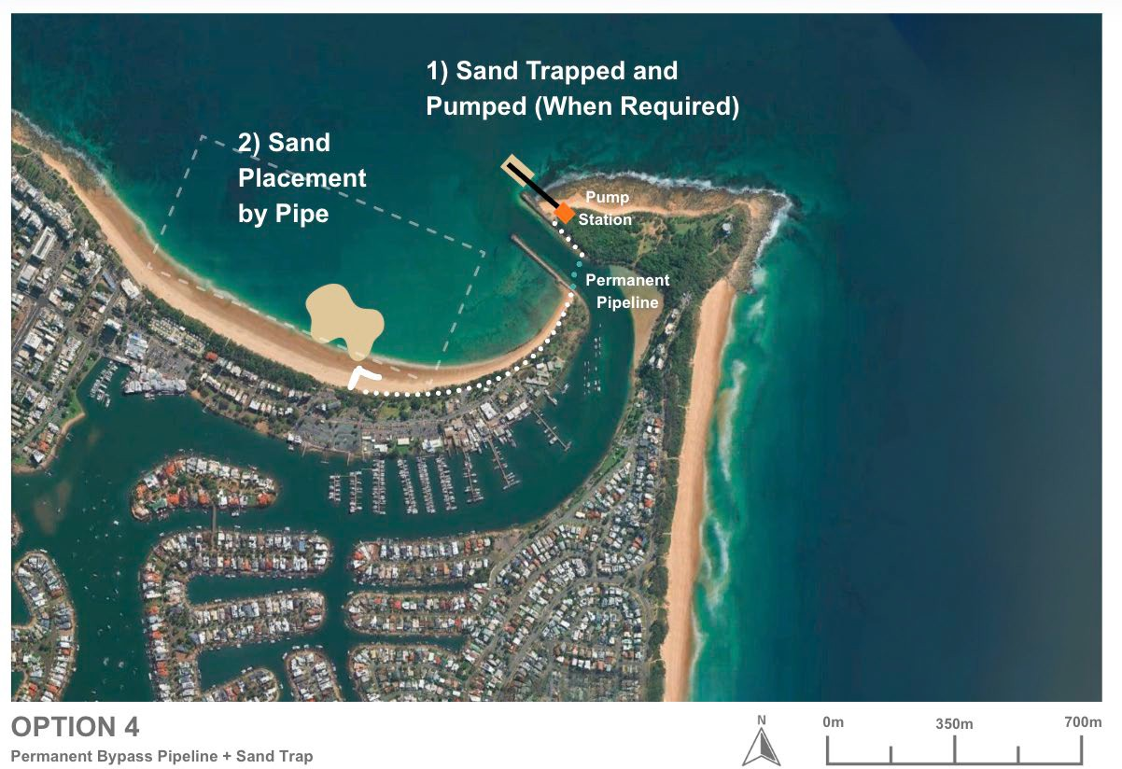
Figure 16-1: Option 4 – Permanent Automated Sand Bypassing System at Headland Sand Trap Conceptual Plan View (ICM, 2025)

Effectiveness of option
The effectiveness of Option 4 is fundamentally governed by its interaction with the longshore sediment transport system, which is the primary driver of shoaling at the Mooloolaba River entrance. As established in BMT (2024), the Mooloolaba–Buddina coastal cell experiences a net northward transport of approximately 75,000 m³/year, with gross transport exceeding 485,000 m³/year. This mobile sediment flux is the source of sand accumulation within the entrance channel.
Option 4 proposes to intercept this sand at the headland using an excavated rock sand trap in combination with a jetty-mounted dredge and pump system. The engineered trap increases retention within the shallow compartment and improves the likelihood of sand being available at the dredge head relative to the natural bedrock platform. In principle, intercepting sediment at the natural bypassing point provides a more direct mechanism for reducing entrance shoaling than campaign dredging.
However, local wave climate and sediment mobilisation patterns limit system reliability. The Buddina headland is a moderate-energy environment, meaning trap infill depends on episodic wave events rather than continuous transport. During low-energy periods, sand supply to the dredge head is reduced and the system may operate inefficiently or remain idle. Conversely, during storm-driven conditions, which deliver a significant proportion of shoaling material, sand is mobilised across the full profile, including seaward of the trap, enabling natural bypassing to occur beyond the jetty’s capture zone.
Because the excavated trap does not extend to the depth of closure, a portion of the longshore transport will always bypass offshore and remain exposed to cross-shore processes. Without structural confinement, this bypassing sand retains a direct pathway into the entrance channel. The absence of long training walls - commonly used in successful bypassing systems such as the Gold Coast Seaway - further reduces control over sediment delivery into the trap and diminishes overall system efficiency.
These constraints are similar to those identified for the Sand Slurry Bypass option (2B), which also relied on a rock-excavated trap but was shown to have limited effectiveness due to excavation complexity and inability to capture the full transport stream. While system performance could improve with a breakwater extension to increase containment and direct more sand into the trap, this would significantly increase capital cost, environmental impact, and design complexity.
Overall, the bypassing jetty system would remain inherently limited without some form of containment backstop, as its efficiency shortfalls would allow un-intercepted sand to eventually shoal the channel. Given the expected shallow-compartment bypassing volume of approximately 10,000 m³/year (compared with
~75,000 m³/year across the full active profile), a crawler crane system is likely to have adequate capacity to manage the site’s actual bypassing demand. Jetty-style continuous pumping systems are typically suited to far more active sediment environments – such as the Tweed River and Gold Coast Seaway – where annual transport exceeds 500,000 m³/year. If future monitoring demonstrates that a crawler crane combined with a breakwater cannot maintain the required bypass capacity, a jetty system could be implemented as a later-stage augmentation; however, its installation is not justified as an initial solution.

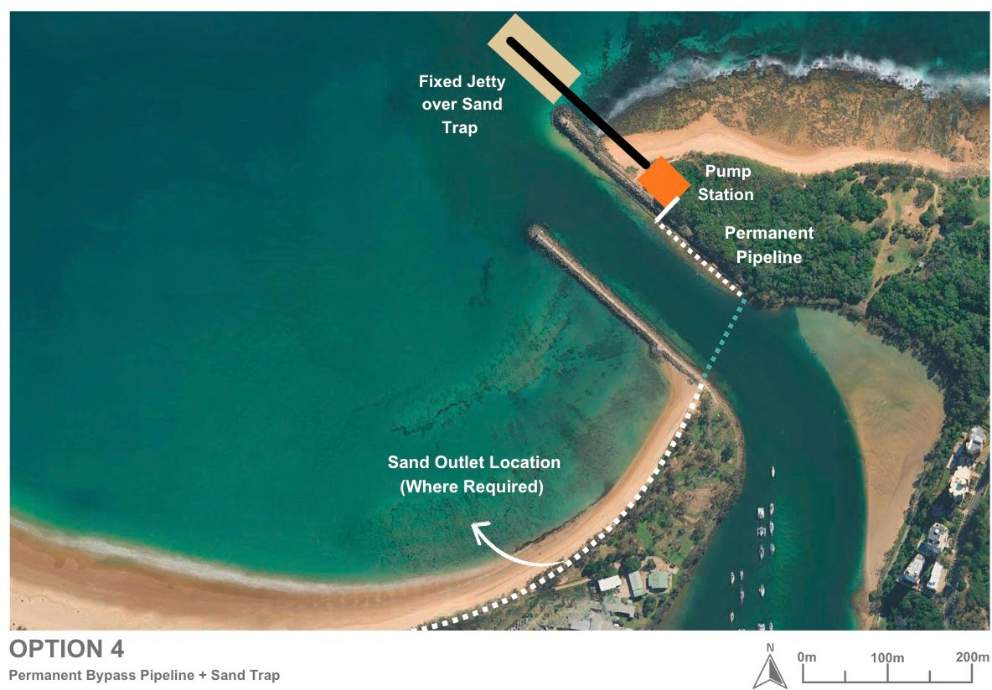
Figure 16-2: Option 4 – Permanent Automated Sand Bypassing System at Headland Sand Trap Conceptual Plan View (ICM, 2025)

Coastal processes impacts
Option 4 would alter local coastal processes primarily within the shallow headland zone south of Point Cartwright. Excavation of a sand trap into the rock platform would increase sediment retention in this compartment, but trap infilling would remain strongly dependent on episodic wave events. Because the trap does not extend to the depth of closure, a substantial portion of longshore transport would continue to bypass seaward of the system, maintaining a natural pathway for sediment to enter the entrance channel.
Interception of sand in the shallow zone may slightly reduce the volume of material available for nearshore and upper-beach recovery along southern Buddina Beach. Any such effects are expected to be localised and minor relative to the gross transport system.
Cross-shore dynamics during storm events would continue to shift sand offshore beyond the trap footprint, reducing trap infill during and immediately after major events. Mooloolaba Beach would receive bypassed sand via controlled discharge, supporting regional sediment continuity, although nourishment rates would still reflect the variable infill behaviour of the trap.

Design and approvals
Option 4 remains at an early feasibility stage, with no detailed engineering design completed for the jetty-based bypassing system or the excavated sand trap. Previous 2012 geotechnical investigations provide only a preliminary indication of bedrock depth; however, key parameters such as rock composition, strength, ease of excavation, and local variability are not yet defined. These uncertainties mean that constructability, excavation methods, system performance, and cost reliability cannot be confirmed at this stage.
Progression of this option would require a coordinated package of coastal process modelling, geotechnical investigation, and preliminary structural/mechanical design to test whether the concept is technically viable. This includes validating how the excavated trap and jetty would interact with local waves, currents, and sediment pathways, assessing excavation feasibility in shallow rock, and defining the operational requirements of the pumping system.
In parallel, the project would require early environmental and regulatory engagement, as the works involve seabed excavation, new coastal infrastructure, and ongoing sediment discharge. The scale and nature of disturbance mean that detailed environmental assessment and multiple statutory approvals would be expected as part of any progression toward detailed design.

Capital works
Implementation of Option 4 would require a substantial capital works, reflecting the scale and permanence of the proposed infrastructure. This option involves forming a purpose-built sand trap directly adjacent to the northern breakwater by excavating the existing nearshore rock shelf, combined with constructing a fixed pump station, jetty, and permanent pipeline network to transfer sand from the trap (Area A) to Mooloolaba Beach (Area B).
- Excavation of the headland sand trap
  - Creation of a functioning sand trap by mechanically excavating the shallow rock platform to achieve sufficient depth and holding capacity.
  - Management of excavated rock, with disposal or potential reuse subject to geotechnical suitability.
  - Stabilisation of excavated slopes and treatment of exposed rock surfaces to ensure long-term structural integrity and minimise scour.
- Pump Station Construction
  - Development of a permanent shore-based pumping facility incorporating intake screening, grit management, automated controls, electrical systems, and monitoring instrumentation.
  - Inclusion of pump redundancy to maintain system operability under variable sand loads and storm conditions.
  - Design considerations for noise, ventilation, and visual integration within a coastal setting.
- Jetty or Access Structure
  - Construction of a fixed jetty or access bridge over the trap to support intake pipelines and allow safe access for inspection and maintenance.
  - Structural design to withstand wave loading, storm conditions, and long-term marine corrosion.
- Pipeline Network
  - Installation of a permanent buried pipeline beneath the entrance to transfer sand from the trap to the beach.
  - Provision of beach-side discharge infrastructure (e.g., outlets or diffusers) to enable controlled nourishment along Mooloolaba Beach.
- Electrical and Control Systems
  - High-capacity electrical supply, switchgear, and backup systems to support continuous operations.
  - Integration of telemetry, SCADA, and real-time monitoring for flows, pressures, and operational performance.
- Construction Access and Site Establishment
  - Establishment of temporary compounds, access routes, crane pads, and marine plant mobilisation areas necessary for installation of the jetty and pump infrastructure.
Option 4 represents a large and intensive capital works investment, comparable to other automated sand bypassing systems implemented in high-energy coastal environments. While it provides a permanent and continuous bypassing mechanism, its overall performance and long-term value would depend on the efficiency of the sand trap, the local wave climate, and the system’s ability to reliably intercept sand before it contributes to shoaling.

Operational works
Operation of Option 4 would involve the periodic or semi-continuous transfer of sand from the excavated headland trap (Area A) to Mooloolaba Beach (Area B) via fixed pumping infrastructure. Unlike dredging-based options, the system operates in response to actual trap infill, with pumping occurring only when sufficient sand is available. The effectiveness of operations therefore remains closely tied to how reliably the trap receives sand under local wave and sediment-transport conditions.
- Sand Collection and Trap Behaviour
  - Sand would accumulate within the excavated trap during moderate–high energy wave events capable of mobilising sediment across the nearshore rock platform.
  - As the trap occupies only the shallow portion of the active profile, infilling would be episodic, with reduced capture during low-energy periods and continued bypassing seaward of the trap.
  - Intake screens and suction lines within the compartment would remove sand as it becomes available, helping maintain storage capacity and reducing overflow into the natural bypass pathway.
- Pumping System Operation
  - Pumping would occur intermittently or in short cycles, depending on trap infill rates, wave climate, and operational constraints.
  - Sand slurry would be pumped through the permanent submerged pipeline to designated discharge points along Mooloolaba Beach.
- Sand Placement on Mooloolaba Beach
  - Discharged sand would be placed on the dry beach, providing direct ongoing nourishment.
  - Multiple outlet points would allow targeted placement in priority shoreline sections.
  - This maintains regional sediment continuity by returning intercepted material to the downdrift system.
- Maintenance Requirements
  - Routine servicing of pumps, intake screens, valves, and electrical components would be required to ensure reliability.
  - The submerged pipeline would require periodic inspection and potential flushing to prevent internal build-up.
  - Jetty structures, supports, and mechanical components would require regular structural inspection for corrosion and storm exposure.
- Operational Management
  - Operational frequency would vary with seasonal wave energy, increasing after energetic events and decreasing during extended low-energy periods when trap infill is limited.

Environmental constraints
A preliminary assessment of environmental constraints for the permanent automated sand bypassing system at headland sand trap (Option 4), based on the constraints analysis criteria in Table 16-1, detailed in Table 16-2.
Table 16-1: Constraints analysis criteria
Constraint level | Description
No impact | There is no impact pathway for the sensitive receptor. No further assessment is required.
Low | There is low potential for impact to the sensitive receptor. No further assessment is required. No or standard management likely.
Moderate | There is a moderate potential for impact to the sensitive receptor which will require further assessment to determine the significance of impact. Likely to be manageable or engineered to minimise potential impacts on the receiving environment.
High | There is a high potential for impact to the sensitive receptor. Further assessment is required to determine the significance of impact and mitigation strategy. Consideration for regulatory approvals.

Table 16-2: Environmental constraints for permanent automated sand bypassing system at headland sand trap (Option 4)
Category | Receptor | Impact pathway | Constraint level | Justification | Further assessment recommendations | Potential monitoring and management requirements
Marine environmental quality | Water quality | - Generation of turbidity during construction and bypassing | High (for rock excavation) | - An assessment of the predicted plume extent will inform the extent of turbidity related impacts however as this is a dynamic, open ocean environment, any plume will likely dissipate quickly  - Turbidity is likely to be more extensive and persistent during rock cutting works | - Turbidity modelling | - Turbidity monitoring during works
Marine environmental quality | Water quality | - Release of contaminants/hypoxia | Low | - Bypass sediments likely comprise clean marine sand free of contaminants with low organic matter content  - Rock is likely to be uncontaminated | - Assumption that suitable data exists to inform this risk | - None
Marine environmental quality | Water quality | - Hydrocarbon spills/waste | Low | - Compliance with standard procedures will minimise this risk | - None | - Standard oil spill and waste procedures
Marine environmental quality | Water quality | - Introduced marine species | Low | - Compliance with standard procedures will minimise this risk | - None | - Compliance with standard state and commonwealth procedures regarding IMS
Marine fauna | Turtles | - Behavioural response and interruption of nesting behaviour due to light  - Mortality/injury due to plant and vehicle movement during construction and maintenance  - Mortality/injury due to entrainment in bypassing equipment  - Disturbance of habitat during sediment disposal and beach reprofiling | Moderate | - Several turtle species listed as endangered or vulnerable under the EPBC were identified in the project area with Green (Vulnerable) and Loggerhead (Endangered) turtles known to nest on Buddina and Mooloolaba beaches. Therefore, potential impacts need to be managed accordingly. | - Assessment of shoreline response to works  - Light assessment if night works are proposed | - Timing of works outside of turtle nesting periods  - Limitation of works to daylight hours or if necessary, standard light mitigation procedures  - Design to minimise disturbance of turtle habitat and to maintain the beach profile  - Standard marine fauna mitigation practices e.g. marine fauna observers and exclusion zones  - Turtle guards on bypassing equipment  - Appropriate management for onshore works e.g. onshore vehicles and plant to operate in designated tracks and areas  - Beach profile monitoring
Marine fauna | Marine mammals | - Mortality/injury/behavioural response due to noise construction and bypassing | High (for construction and rock excavation) | - Humpback whales may use the area for resting with calves during their migration period  - Species of dolphins listed as vulnerable may also occur in the area and while they tend to move away from noise sources and are at lower risk of injury, the greater level of noise generated from rock cutting requires further assessment  - Piling for jetty construction will potentially cause significant impacts, further assessment is required | - Underwater noise assessment including modelling | - Timing of works outside of whale migration periods  - Standard marine fauna mitigation practices e.g. marine fauna observers and exclusion zone
Marine fauna | Roosting Seabirds | - Mortality/injury/behavioural response due to noise of construction and bypassing  - Behavioural response and interruption of nesting behaviour due to light  - Mortality/injury/behavioural response due physical presence  - Mortality/injury due to onshore plant and vehicle movement  - Loss of habitat due to onshore construction of pumping station | Moderate | - Several species of migratory seabirds aggregate and may nest at Point Cartwright and could be impacted  - Potential for loss/degradation of habitat needs to be assessed  - Piling for jetty construction will potentially cause significant impacts, however this can be managed by timing/ staging of works | - Noise assessment  - Light assessment if night works are proposed  - Assessment of bird habitat with reference to proposed clearing and works areas | - Timing of works outside of peak aggregation season (summer) for migratory terns  - Design to minimise clearing required and avoid key habitat areas  - Appropriate management for onshore works e.g. onshore vehicles and plant to operate in designated tracks and areas, design to avoid key habitat areas.
Marine fauna | Foraging Seabirds | - Generation of turbidity impacting foraging activities | Moderate | - Turbidity will impede the ability of aerial feeding birds to see prey underwater, which will impact the Little Terns aggregating in Point Cartwright reserve. Larger seabirds will travel outside of the turbid zone to forage.  - An assessment of the predicted plume extent will inform the extent of turbidity related impacts however as this is a dynamic, open ocean environment, any plume will likely dissipate quickly | - Turbidity modelling | - Timing of works outside of peak aggregation season (summer) for migratory terns
Marine fauna | Site attached species | - Direct mortality/injury due to construction and bypassing  - Mortality/injury/behavioural response due to physical effects of turbidity | High (for construction) | - These species are broadly distributed along the coastline  - The bypassing area has a relatively small footprint and in an area of bare sand but further assessment of the construction footprint is required to determine the impact to habitat for species of high conservation value e.g. the endangered White’s Seahorse and sand yabby  - Construction may impact  - Bypassing is in a dynamic, open ocean environment, any plume will likely dissipate quickly. | - Fauna / benthic habitat assessment | - Construction and dredging designed to avoid protected marine fauna habitats
Marine fauna | Site attached species | - Mortality/injury/behavioural response due to toxic effects due to release of contaminants/hypoxia | Low | - Dredge sediments likely comprise clean marine sand free of contaminants with low organic matter content  - Rock is likely to be uncontaminated | - Assumption that suitable data exists to inform this risk | - None
Marine fauna | Mobile species | - Direct mortality/injury due to bypassing  - Mortality/injury/behavioural response due to physical effects of turbidity | Low | - Mobile species including the critically endangered Grey Nurse Shark and conservation dependant scalloped hammerhead will actively avoid areas of activity | - None | - None
Marine fauna | Mobile species | - Mortality/injury/behavioural response due to toxic effects due to release of contaminants/hypoxia | Low | - Bypass sediments likely comprise clean marine sand free of contaminants with low organic matter content | - Assumption that suitable data exists to inform this risk | - None
Benthic habitats | Rocky reef habitat, seagrass and corals | - Direct removal due to bypassing  - Generation of turbidity  - Smothering | Moderate | - The bypass area comprises bare sand  - Further assessment is required to determine if the potential turbidity generated will impact sensitive marine habitats.  - Bypassing is in a dynamic, open ocean environment, any plume will likely dissipate quickly. | - Benthic habitat assessment in and surrounding bypassing area  - Turbidity modelling | - Turbidity monitoring during works
Benthic habitats | Rocky reef habitat, seagrass and corals | - Release of contaminants/hypoxia | Low | - Dredge sediments likely comprise clean marine sand free of contaminants with low organic matter content  - Rock is likely to be uncontaminated | - Assumption that suitable data exists to inform this risk | - None
Terrestrial fauna including shorebirds and raptors |  | - Mortality/injury/behavioural response due to noise during construction and bypassing  - Mortality/injury/behavioural response due to dust at Mooloolaba Main Beach  - Behavioural response due to light during construction and maintenance  - Mortality/injury/behavioural response due physical presence of bypassing equipment  - Mortality/injury due to onshore plant and vehicle movement  - Loss of habitat due to onshore construction of pumping station | High (for construction) | - Several species listed as vulnerable or endangered may occur in the project area  - Timing of works outside of peak aggregation periods for migratory shorebirds | - A terrestrial fauna assessment | - Timing of works outside of peak aggregation periods for migratory shorebirds  - Limitation of works to daylight hours or if necessary, standard light mitigation procedures  - Standard fauna mitigation practices including monitoring for conservation significant fauna, management of fauna entrapment in construction trenches, appropriate fencing of work area  - Fauna relocation procedures  - Waste management procedures  - Revegetation of cleared areas post-construction
Terrestrial flora |  | - Direct clearing of vegetation  - Smothering and degradation of habitat due to dust generation from bypassing at Mooloolaba Main Beach | High (for construction) | - Several MSES and TECs occur in the project area | - Terrestrial flora assessment  - Extended vegetation mapping | - Design to minimise clearing required and avoid key habitat areas  - Appropriate management for onshore works e.g. onshore vehicles and plant to operate in designated tracks and areas  - Dust management procedures  - Weed control management procedures  - Waste management procedures  - Monitor conservation significant flora  - Post construction survey  - Topsoil stockpiling and revegetation of cleared areas post-construction
Assumptions:
- Bypassing area is an area of bare sand
- There is sediment contamination data to inform the risk of on release of contaminants via dredging and disposal
- Excavated rock will be disposed of offsite if not appropriate for offshore disposal

For Option 4, there are some key aspects that require further assessment regarding localised vegetation clearing/disturbance and impacts to marine and terrestrial fauna and flora. Specifically, there is the potential for significant impacts to conservation significant marine and terrestrial species depending on the disturbance footprint and construction methods.
Impacts from bypassing operations would be reduced and manageable; however, ongoing noise from the bypass equipment will require further assessment and potential mitigation.
It is likely that environmental monitoring and management during works, above the standard dredging management procedures, would be required to manage risks to terrestrial fauna and habitats and marine fauna and shoreline habitats. Additionally monitoring and management for turbidity related impacts and impacts to benthic habitats.

Social impacts
Option 4 is expected to generate social value with three positive impacts ranked as high in the SIE assessment, including: safer channel access through reduced shoaling, improved economic outcomes through more reliable channel access and increased frequency of sand placement for beach nourishment.
When compared to the baseline, there were 10 negative social impacts identified, however, after mitigation measures were considered, there were five which may be of high concern to the community and stakeholders, including: potential negative environmental impacts, potential visual impacts, perceived property value decrease from visual changes, construction impacts and the pump may be at risk of impacts from severe weather. Further mitigations must be undertaken to reduce potential negative social impacts including environmental assessments, visual impact assessments, environment and construction management plans and broader community and stakeholder engagement and communications.

Economic impacts
Option 4 is expected to have a low to moderate economic impact compared with the current approach. The project will reduce shoaling at the harbour entrance improving channel access and reliability for users in the long-term. This enhancement will allow both commercial and recreational vessels to navigate the channel without interruption, reducing delays and minimising reliance on emergency maintenance dredging. By ensuring consistent access, the project supports safer operations and greater confidence for businesses and the boating community. Unlike the current baseline, this option does not depend on regular dredging to remove sand, offering a more sustainable solution.
During construction, temporary changes to channel access may occur, affecting recreational boaters and commercial operators who use the harbour entrance. Onshore rock fishing at the breakwater and Point Cartwright will be impacted due to reduced fishing locations and safety requirements during works. These disruptions could lead to fewer visitors during the construction period, with some choosing alternative destinations on the Sunshine Coast or other coastal areas. This may result in short-term reductions in local spending, affecting nearby businesses; however, these impacts are expected to be temporary and managed to minimise disruption.

Future adaption
Option 4 offers limited flexibility for future adaptation due to its reliance on fixed, permanent infrastructure. The jetty, pump station, and buried pipeline are relatively inflexible once constructed, and their performance is strongly tied to the long-term behaviour of the excavated sand trap and the surrounding wave and sediment-transport environment. As such, the system cannot readily be relocated, expanded offshore, or adjusted to accommodate major changes in sediment pathways without significant additional capital works.
The system could, however, be integrated with other coastal-management measures to improve performance over time. In particular, Option 4 is likely to be most effective when paired with a breakwater extension, which would provide the structural containment required to direct more sand into the trap and reduce the inefficiencies associated with seaward bypassing. If monitoring indicates that the excavated trap does not reliably intercept sufficient sand, a breakwater could be added at a later stage to enhance capture efficiency.
Some operational parameters (such as pumping frequency, activation thresholds, and discharge distribution) could be adjusted over time as sediment behaviour or nourishment needs change. Additional beach outlets could also be installed if future shoreline conditions require more targeted placement
However, changes to the core system - such as enlarging the trap, relocating infrastructure, or modifying jetty alignment - would require substantial new construction and may be constrained by underlying rock and environmental approvals.
While Option 4 allows some operational refinement, its long-term adaptability is considered limited, and its effectiveness is most likely to be realised when combined with complementary structural works such as a breakwater extension.

Safety of Option 4
Option 4 offers strong safety benefits by continuously intercepting sand before it enters the Mooloolaba entrance, resulting in more stable channel depths and improved reliability of all-tide access. The consistent bypassing of sand reduces the formation of shallow bars and minimises rapid depth changes, which in turn improves the clarity of navigation and reduces the need for frequent updates to aids to navigation.
Mariner safety is enhanced through fewer instances of wave breaking and steepening across the entrance bar, conditions that have historically contributed to hazardous vessel transits. Importantly, the system removes the need for large dredging vessels to operate near the entrance, eliminating associated risks such as bar crossing, restricted manoeuvring space, and vessel–recreational craft conflicts. Construction-phase risks exist but are temporary and manageable through standard controls.
Overall, Option 4 provides a high and consistent safety improvement, delivering the most reliable navigational conditions among the options considered.

Cost
Capital Works Cost
Option 4 is expected to have the highest capital cost of all options, reflecting the scale and permanence of the infrastructure required. Major cost drivers include:
- Rock excavation to form the headland sand trap, which is technically challenging and likely to require specialised marine plant.
- Construction of a fixed jetty or access structure, designed for wave loading, inspection access, and long-term durability.
- A permanent pump station, mechanical systems, electrical supply, and control infrastructure.
- Installation of a buried pipeline beneath the entrance, including beach-side discharge structures.
- Site establishment, temporary works, and marine access.
Given the extent of excavation and the substantial structural and mechanical components involved, the capital cost is expected to be very high, comparable to large-scale automated bypass systems such as the Tweed River or Gold Coast Seaway.
At this stage of concept development, costs carry a high level of uncertainty due to the lack of detailed geotechnical information and unresolved constructability constraints.
A more reliable estimate would require targeted site investigations and preliminary engineering design.
Operational Costs
Operational costs would primarily consist of:
- Power demand for near-continuous pumping (depending on trap infill behaviour).
- Routine servicing and maintenance of pumps, intake screens, valves, and electrical/control systems.
- Periodic inspection and maintenance of the jetty and pipeline, including corrosion protection, structural checks, and line flushing.
- Monitoring of trap infill, intake performance, and beach discharge areas.
While Option 4 avoids dredge mobilisation costs, its mechanical and electrical operating costs are expected to be substantially higher than intermittent dredging-based approaches due to continuous energy consumption and a larger, more complex plant to maintain.
Costs may vary considerably year-to-year depending on trap infill rates, which are strongly episodic and governed by storm-driven sediment pulses.
This introduces operational uncertainty and the potential for periods where the system incurs fixed costs while pumping little sand.

Option summary
Option 4 involves constructing a fixed jetty-based sand bypassing system supported by an excavated headland sand trap, permanent pump station, and buried pipeline to Mooloolaba Beach. While this option provides a permanent mechanism for transferring sand from the southern headland compartment to the downdrift beach, its effectiveness is fundamentally constrained by the local wave climate, the shallow extent of the trap, and the absence of structural containment (e.g., a breakwater).
The system can only intercept sand that enters the excavated trap; however, a portion of longshore transport will continue to bypass seaward of the trap and remain capable of contributing to entrance shoaling. As a result, Option 4 offers partial, rather than complete, reduction in shoaling risk. Its performance is expected to improve if coupled with a breakwater extension, which would increase sand retention and reduce bypass leakage, but this would introduce substantial additional capital cost and environmental impacts.
This option represents a major, high-capital coastal infrastructure investment that reduces dependence on mobile dredging but remains inherently limited by local sediment dynamics. While it provides long-term, predictable nourishment to Mooloolaba Beach, its operational efficiency and value-for-money depend heavily on how reliably the trap infills under varying coastal conditions (Table 16-3).
Table 16-3: Overview of Option 4 – Advantages and Disadvantages
Advantages | Disadvantages
- Provides a permanent mechanism for transferring sand from the headland compartment to Mooloolaba Beach.  - Reduces reliance on periodic maintenance dredging compared with fully campaign-based options.  - Supports consistent nourishment of Mooloolaba Beach and maintains regional sediment continuity.  - Automated pumping allows operation to occur during suitable wave conditions without mobilisation of mobile plant.  - Fixed infrastructure may offer long service life with predictable maintenance cycles.  - Potential to integrate with a future breakwater extension if greater sand-trap efficiency is required. | - Very high capital cost due to rock excavation  - High capital cost due to rock excavation, jetty construction, pump station works, and pipeline installation.  - System performance is inherently limited by trap infill, which is episodic and wave-dependent, reducing ability to intercept the full longshore transport.  - Sediment will continue to bypass the trap (both seaward and across through the jetty efficiency) allowing shoaling to persist.  - Lack of structural containment (e.g., long training wall) limits overall capture efficiency.  - Rock excavation poses constructability challenges and requires detailed geotechnical assessment.  - Permanent infrastructure introduces visual impacts and ongoing maintenance obligations.  - Pipeline and mechanical systems require long-term operational commitment and periodic inspection.  - Higher environmental footprint during construction, including seabed disturbance and potential marine-plant impacts.

Multi-criteria analysis for Option 4
The MCA scoring legend follows:
Score | Description of scores
1 | Worst performance or Significant impacts
2 | Poor performance or Major impacts
3 | Average performance or Moderate impacts Average performance or Moderate impacts
4 | Good performance or Minor impacts
5 | Excellent performance or Insignificant impacts

Table 16-4: Option 4 MCA Scoring
MCA Category | MCA criteria | Score
Coastal engineering | Effectiveness: Likely ability to shift enough sand past the entrance (bypassing efficiency, trap capture rate, reduction in shoal frequency/magnitude, entrance depth reliability). | 3
Coastal engineering | Impacts on coastal processes: the level in which it changes or has negative impacts on existing coastal processes | 4
Coastal engineering | Design and approvals: how far is the option progressed with design and approvals and how much would be required | 1
Coastal engineering | Capital works: how significant the capital works would be and their impacts during the process | 2
Coastal engineering | Operational works: how significant the operational works would be and their impacts during the process | 4
Coastal engineering | Future adaption: how well the option be adapted to future conditions | 2
Coastal engineering | Sub-total | 16
Safety | Reliability of all-tide access | 3
Safety | Clarity of navigation | 3
Safety | Mariner safety | 3
Safety | Sub-total | 9
Social and economic | Consistency with SRG preference for lower impact, “softer” measures where practicable. | 1
Social and economic | Traditional Owners do not experience disturbance to cultural values | 3
Social and economic | Visual amenity | 1
Social and economic | Community amenity (inc. noise from pumps) | 2
Social and economic | Beach users experience | 4
Social and economic | Safe access for business and recreational users | 3
Social and economic | Reliable access for business and recreational users | 3
Social and economic | Broader economic considerations during construction and operation | 4
Social and economic | Environmental impact perceptions | 1
Social and economic | Sub-total | 22
Environmental | Marine water quality impacts | 2
Environmental | Marine habitats & protected species impacts | 1
Environmental | Terrestrial habitats & protected species impacts | 1
Environmental | Sub-total | 4
Financial | Capital (CAPEX), | 2
Financial | Operations and maintenance (OPEX), contingency, monitoring. | 3
Financial | Sub-total | 5
Total Score |  | 56

OPTION 5 – WESTERN CHANNEL CONCEPT PLAN

Option description
The Western Channel Concept Plan builds on the existing Western Channel dredging trial and considers measures from purely operational enhancements through to structural modification of the western breakwater to formalise an alternative access route during shoaling events.

How Does It Work to Address Shoaling?
This option does not directly prevent or reduce shoaling, as it does not alter the underlying coastal sediment dynamics driving sand accumulation at the entrance. Instead, it works indirectly by relocating the navigation pathway to a position less affected by the most active shoaling areas, allowing improved access under more conditions. In essence, it seeks to bypass the problem rather than eliminate it, providing a navigable alternative when shoaling obstructs the existing entrance.

What Does This Option Involve?
Depending on the selected variation, the Western Channel Concept Plan may include one or more of the following components:
- Retaining and formalising the existing Western Channel dredging trial, including installation or enhancement of aids to navigation.
- Routine hydrographic monitoring to detect rapid shoal formation within the western channel corridor.
- Targeted maintenance dredging to maintain navigable depth.
- (For structural variations) Partial removal/shortening of the western breakwater to open a more landward channel alignment.
- (For operational-only variations) No structural modification, relying solely on navigational aids and ongoing maintenance dredging. Retaining the existing western channel trial dredging approach.
While the option may enhance short-term usability and safety, it does not modify the sediment supply from Area A to Area B or prevent sand accumulation at the main entrance. Instead, it shifts operational focus to maintaining an alternate access point that remains navigable for periods between dredging events.

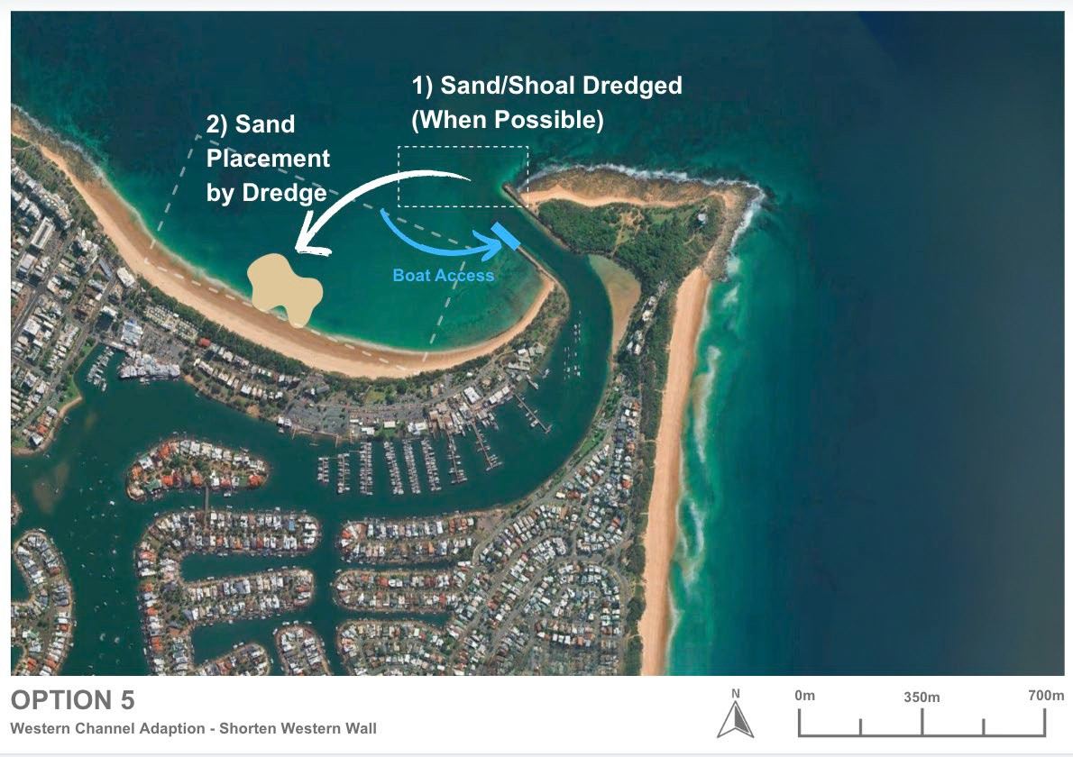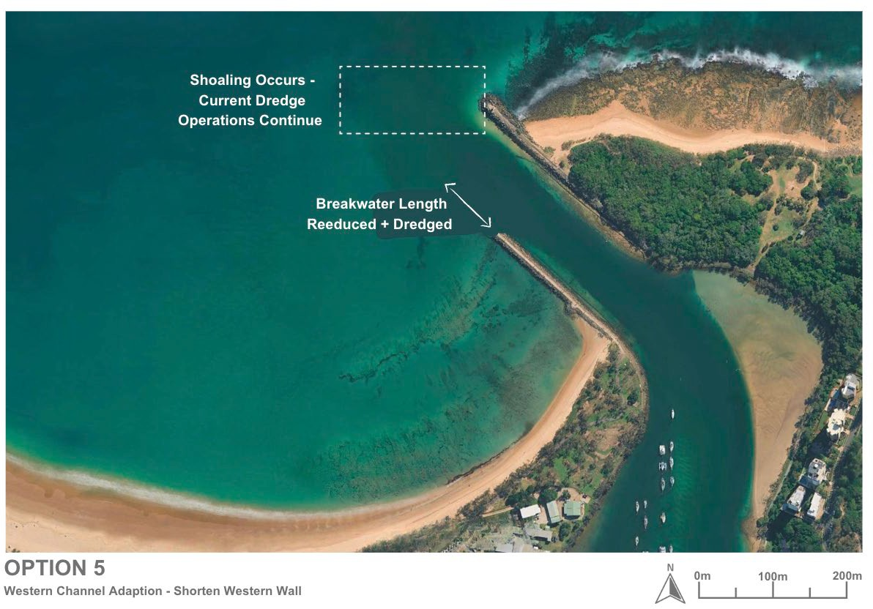
Figure 17-1: Option 5 – Shorten Western Entrance wall and Western Channel

Coastal processes impacts
As Option 5 remains conceptual, the assessment of coastal process impacts can only be undertaken at a high level. The original Mooloolaba entrance training walls were designed to balance tidal exchange, wave climate, and sediment transport, and any modification or reconfiguration of the system has the potential to influence this equilibrium.
For operational-only variations (e.g. formalising the Western Channel):
The coastal process implications are expected to be minimal, as no changes are made to the entrance structures or the underlying hydrodynamic drivers. Shoaling processes, sediment supply from Area A, and nearshore circulation patterns would continue unaffected. Under these variations, the western channel will still experience rapid and frequent sand accumulation, consistent with current trial observations.
For structural variations (e.g. shortening the western breakwater):
Changes to the geometry of the training walls could alter tidal and ebb-flow patterns, current velocities, and wave refraction both inside the entrance and along adjacent beaches. In particular, reducing the length of the western wall may draw the active shoal zone landward, potentially shifting or intensifying shoaling closer to the entrance. These effects may undermine anticipated access improvements and could influence sediment distribution around Mooloolaba Beach, with outcomes dependent on seasonal and wave-climate variability.
Because both variations leave the dominant sediment supply unchanged, neither is expected to significantly reduce shoaling frequency or improve natural bypassing efficiency. However, formalising an alternative access path may improve practical usability of the entrance during shoaling events and reduce unintended or unsafe channel crossings by boaters who may be unaware of Notice to Mariners warnings regarding the primary alignment.
For any structural modification, however, detailed hydrodynamic and sediment transport modelling would be required to quantify potential impacts, assess stability, and determine whether unintended coastal changes (beneficial or erosive) may arise.

Effectiveness of Option 5
In terms of effectiveness, while the shifted channel may allow more consistent access during moderate conditions, it would not significantly improve bypassing efficiency or reduce shoal frequency. The volume and rate of sand accumulation in the broader entrance system would remain similar to current conditions, meaning ongoing maintenance dredging would still be required.
From a navigation and safety perspective, this option presents potential concerns. The new alignment would require vessels to approach or exit the harbour at an angle (“beam-on”) to incoming waves, creating a more hazardous manoeuvre, especially for inexperienced or small-boat operators. Although accessibility might improve in calm weather, the approach could become riskier during higher wave energy events, undermining the safety gains sought through the channel modification.
Overall, while the concept offers short-term usability improvements, it provides limited long-term effectiveness in managing shoaling or ensuring safer navigation, and it does not enhance natural sediment bypassing between Area A and Area B.
However, given the precedent of extended operational use of the Western Channel during periods when the main entrance has shoaled, both variations may still provide value as a supplementary measure. In practice, Option 5 could extend operational access during peak shoaling events, support navigation during construction or transition phases of larger interventions, or function as a contingency route if other options reach capacity or require maintenance. In this context, Option 5 may complement - not replace - more substantial sediment management solutions.

Variations of Option 5
Two variations of the Western Channel concept are proposed. They differ primarily in the degree of structural intervention, navigation risk profile, and ability to influence long-term sediment dynamics at the harbour entrance. Both are examined in the following subsections in terms of capital and operational works, physical processes, environmental and social implications, cost, and overall feasibility.
- Option 5A Formalise Western Channel (No Structural Modification): This variation formalises the existing Western Channel as a recognised navigation route by installing clear aids to navigation, maintaining regular hydrographic surveys, and continuing the current targeted maintenance dredging regime. No structural works or changes to the breakwater are proposed.
This variation provides incremental operational benefit by offering a clearly defined alternative channel path (or a replacement for the primary alignment) during the early stages of shoal formation. However, it does not influence sediment supply, coastal processes, or the rate of shoaling within the entrance. As such, Option 5A is best regarded as a supplementary navigation and operational enhancement rather than a standalone sediment management solution.
- Option 5B – Shorten Western Channel Entrance Wall + Formalise Western Channel (Structural Modification): This variation involves the partial removal of the western breakwater and formal establishment of a new navigation channel farther landward.
This option seeks to improve access by shifting vessel movements away from the most active shoaling zone; however, it does not reduce sand supply and introduces potential safety challenges due to altered wave approach angles.
Compared with Option 5A, this variation requires significant capital works, detailed hydrodynamic and sediment transport modelling, and a more extensive approvals pathway. While it may offer short-term improvements in navigability, its long-term effectiveness remains limited without complementary sediment management infrastructure.

Option 5A – Formalise Western Channel (No Structural Modification)
This variation establishes the existing Western Channel as a formal navigation route through upgraded aids to navigation, ongoing hydrographic monitoring, and continuation of targeted maintenance dredging. No structural works or breakwater modifications are included. The variation provides a modest operational benefit by offering a clearly defined alternative access path during early shoaling phases but does not alter sediment supply or reduce shoaling frequency, and therefore functions primarily as a supplementary navigation measure.

Design and approvals
Option 5A involves no structural modification to the entrance training walls; therefore, the design and approvals requirements are comparatively limited. As this variation focuses on formalising the existing Western Channel through operational measures, the primary design tasks relate to navigational safety, survey planning, and channel management rather than reconfiguration of coastal infrastructure.
Design considerations would include:
- Determining the required aids to navigation, including type, placement, lighting, and visibility, to formalise the route in accordance with appropriate guidelines.
- Establishing an appropriate hydrographic survey frequency and monitoring framework to track rapid shoal development and inform Notice to Mariners updates.
- Confirming the dredged channel alignment and target depths based on experience from the existing Western Channel trial.
- Developing operational protocols for declaring the western channel “open” or “closed,” and whether it is defined as an alternative or primary navigation path.
Because no changes to the breakwater or entrance geometry are proposed, detailed hydrodynamic or sediment transport modelling is not required for this variation. However, some modelling or scenario testing could be beneficial to validate operational effectiveness, refine alignment decisions, and support proof-of-concept evaluation.
From an approvals perspective, Option 5A would fall largely under existing maintenance dredging approvals, with only minor additional requirements related to the installation or upgrading of navigation aids. Any new or relocated aids would require approval from MSQ under standard navigational safety processes. No capital works, rock removal, or structural modifications are triggered under this option.
Overall, Option 5A carries a low design and approvals burden and could be implemented within the current regulatory framework, provided that navigation safety assessments and operational management plans are clearly defined.

Capital works
Option 5A involves no structural modification to the western breakwater and no new channel excavation, as the variation relies entirely on the existing Western Channel alignment and continuation of targeted maintenance dredging. As such, capital works requirements are minimal and limited to operational enhancements that support formalisation of the route.
The only capital works required would be the installation or upgrading of aids to navigation, including marks, lighting, and signage to clearly define and formalise the channel alignment.
Option 5A is comparatively straightforward to implement. Navigation aids can be installed using standard marine plant such as small barges or workboats, with minimal disruption to existing public access or harbour operations.
Option 5A represents a low-impact, low-cost capital works option, with the primary investment focused on navigation safety infrastructure rather than any physical alteration of the entrance.

Operational works
The operational component of Option 5A closely aligns with the existing Western Channel dredging trial, as this variation relies entirely on ongoing maintenance activities to maintain navigable depth. No structural works or entrance modifications are proposed; therefore, operational works focus on monitoring, dredging, and navigation management. The ongoing works would involve:
- Hydrographic surveys to monitor shoal development and channel depth.
- Targeted maintenance dredging, likely using a CSD, to maintain a safe navigable corridor.
Sand placement and management within designated nearshore or onshore areas, coordinated with council for beneficial reuse.
Operationally, this option would continue to face similar constraints and challenges as the current Western Channel trial. Dredging windows would remain limited by weather, wave conditions, and vessel availability, restricting the timing and efficiency of maintenance efforts.
While technically feasible to operate, the new configuration may not yield any long-term improvement in sediment bypassing or shoal management. The overall effectiveness in maintaining clear access would depend heavily on how the modified entrance influences sand inflow rates and deposition zones.
From a technical standpoint, the operational works are feasible, using standard dredging methods and established management practices. However, because sediment supply and coastal processes remain unaltered, Option 5A is not expected to significantly improve sediment bypassing efficiency or reduce shoaling frequency. Instead, it would maintain a regime of reactive dredging, with navigability dependent on the timing, frequency, and effectiveness of maintenance campaigns.
Overall, Option 5A provides a familiar and manageable operational framework but does not reduce long-term dredging demand or improve geomorphic stability at the entrance. It functions as an operational enhancement rather than a transformative sediment management measure.

Environmental constraints
A preliminary assessment of environmental constraints for the Formalise Western Channel (No Structural Modification) (Option 5A), based on the constraints analysis criteria in Table 17-1, detailed in Table 17-2.
Table 17-1: Constraints analysis criteria
Constraint level | Description
No impact | There is no impact pathway for the sensitive receptor. No further assessment is required.
Low | There is low potential for impact to the sensitive receptor. No further assessment is required. No or standard management likely.
Moderate | There is a moderate potential for impact to the sensitive receptor which will require further assessment to determine the significance of impact. Likely to be manageable or engineered to minimise potential impacts on the receiving environment.
High | There is a high potential for impact to the sensitive receptor. Further assessment is required to determine the significance of impact and mitigation strategy. Consideration for regulatory approvals.

Table 17-2: Environmental constraints for Formalise Western Channel (No Structural Modification) (Option 5A)
Category |  | Receptor | Impact pathway |  |  | Constraint level | Justification |  |  |  | Further assessment recommendations |  |  |  |  | Potential monitoring and management requirements
Marine environmental quality |  | Water quality | - Generation of turbidity |  |  | Low | - This is a dynamic, open ocean environment, any plume will likely dissipate quickly and data from the dredge area indicate fast sediment settling rates |  |  |  | - None |  |  |  |  | - Turbidity monitoring during works
Marine environmental quality |  | Water quality | - Release of contaminants/hypoxia |  |  | Low | - Dredge sediments likely comprise clean marine sand free of contaminants with low organic matter content |  |  | - None |  |  |  | - None
Marine environmental quality |  | Water quality | - Hydrocarbon spills/waste |  |  | Low | - Compliance with standard procedures will minimise this risk |  |  | - None |  |  |  | - Standard oil spill and waste procedures
Marine environmental quality |  | Water quality | - Introduced marine species |  |  | Low | - Compliance with standard procedures will minimise this risk |  |  | - None |  |  |  | - Compliance with standard state and commonwealth procedures regarding IMS
Marine fauna | Turtles |  | - Behavioural response and interruption of nesting behaviour due to light  - Mortality/injury due to vessel collision, entanglement, entrainment  - Change of beach profile at Mooloolaba Main Beach due to sediment disposal offshore of beach impacting nesting  - Mortality/injury due to onshore plant and vehicle movement |  |  | Moderate | - Several turtle species listed as endangered or vulnerable under the EPBC were identified in the project area with Green (Vulnerable) and Loggerhead (Endangered) turtles known to nest on Buddina and Mooloolaba beaches. Therefore, potential impacts need to be managed accordingly. |  |  |  |  | - Assessment of shoreline response to works  - Light assessment if night works are proposed |  |  |  | - Timing of works outside of turtle nesting periods  - Limitation of works to daylight hours or if necessary, standard light mitigation procedures  - Design to minimise disturbance of turtle habitat and maintain the beach profile  - Standard marine fauna mitigation practices e.g. marine fauna observers and exclusion zones  - Turtle guards on dredger  - Appropriate management for onshore works e.g. onshore vehicles and plant to operate in designated tracks and areas  - Beach profile monitoring
Marine fauna | Marine mammals |  | - Mortality/injury/ behavioural response due to noise  - Vessel collision, entanglement, entrainment |  |  | Moderate | - Humpback whales may use the area for resting with calves during their migration period.  - While species of dolphins listed as vulnerable may also occur in the area, they tend to move away from noise sources and are at lower risk of injury.  - While species of dolphin have breeding BIA in area, there is a lower risk to breeding because of the wide distribution of the BIA |  | - Underwater noise assessment |  |  |  |  | - Timing of works outside of whale migration periods  - Standard marine fauna mitigation practices e.g. marine fauna observers and exclusion zones
Marine fauna | Roosting Seabirds |  | - Mortality/injury/ behavioural response due to noise  - Behavioural response and interruption of nesting behaviour due to light  - Mortality/injury/behavioural response due physical presence |  |  | Moderate | - Several species of migratory seabirds aggregate and may nest at Point Cartwright and could be impacted |  | - Noise assessment  - Light assessment if night works are proposed |  |  |  |  | - Timing of works outside of peak aggregation season (summer) for migratory terns
Marine fauna | Foraging Seabirds |  | - Generation of turbidity impacting foraging activities |  |  | Moderate | - Turbidity will impede the ability of aerial feeding birds to see prey underwater, which will impact the Little Terns aggregating in Point Cartwright reserve. Larger seabirds will travel outside of the turbid zone to forage.  - An assessment of the predicted plume extent will inform the extent of turbidity related impacts however as this is a dynamic, open ocean environment, any plume will likely dissipate quickly. |  |  |  |  | - Turbidity modelling |  |  |  | - Timing of works outside of peak aggregation season (summer) for migratory terns
Marine fauna | Site attached species |  | - Direct mortality/injury due to dredging  - Mortality/injury/ behavioural response due to physical effects of turbidity  - Mortality/injury/ behavioural response due to smothering at disposal site |  |  | Low | - These species are broadly distributed along the coastline  - The dredging area has a relatively small footprint and in an area of bare sand which is not the habitat for most of these species, including the endangered White’s Seahorse and sand yabby  - It is assumed that the disposal area is an already disturbed area from previous disposal  - works  - Dredging and disposal is in a dynamic, open ocean environment, any plume will likely dissipate quickly |  |  |  |  | - None |  | - None
Marine fauna | Site attached species |  | - Mortality/injury/behavioural response due to toxic effects due to release of contaminants/hypoxia |  |  | Low | - Dredge sediments likely comprise clean marine sand free of contaminants with low organic matter content |  |  |  |  | - Assumption that suitable data exists to inform this risk |  | - None
Marine fauna | Mobile species |  | - Vessel collision  - Direct mortality/injury due to dredging  - Mortality/injury/ behavioural response due to physical effects of turbidity  - Mortality/injury/ behavioural response due to smothering at disposal site |  |  | Low | - Mobile species including the critically endangered Grey Nurse Shark and conservation dependant scalloped hammerhead will actively avoid areas of activity |  |  |  |  | - None |  | - None
Marine fauna | Mobile species |  |  |  | - Mortality/injury/behavioural response due to toxic effects due to release of contaminants/hypoxia | Low | - Dredge sediments likely comprise clean marine sand free of contaminants with low organic matter content |  |  |  | - Assumption that suitable data exists to inform this risk |  |  |  | - None
Benthic habitats | Rocky reef habitat, seagrass and corals |  |  |  | - Direct removal due to dredging  - Generation of turbidity  - Smothering | Low | - The dredge and disposal area comprise bare sand  - Dredging and disposal is in a dynamic, open ocean environment, any plume will likely dissipate quickly and data from the dredge area indicate fast sediment settling rates |  |  |  | - None |  |  |  | - None
Benthic habitats | Rocky reef habitat, seagrass and corals |  |  |  | - Release of contaminants/hypoxia | Low | - Dredge sediments likely comprise clean marine sand free of contaminants with low organic matter content |  |  |  | - Assumption that suitable data exists to inform this risk |  |  |  | - None
Terrestrial fauna including shorebirds and raptors |  |  | - Mortality/injury/behavioural response due to noise  - Behavioural response and interruption of nesting behaviour due to light  - Mortality/injury/behavioural response due physical presence |  |  | Moderate | - Several species listed as vulnerable or endangered may occur in the project area  - Several species of shorebirds are listed as occurring at Point Cartwright and could be impacted; however, it is more likely they would occur at the lower Maroochy River |  |  |  |  | - Assessment of species occurrence at Point Cartwright  - Noise assessment  - Light assessment if night works are proposed |  | - Timing of works outside of peak aggregation periods for migratory shorebirds
Terrestrial flora |  |  |  | No impact pathway to terrestrial environment |  | No impact | - NA | - None |  |  |  |  | - None
Assumptions:
- Dredge area is an area of bare sand
- Disposal area assumed to be within the nearshore area offshore of southern end of Mooloolaba Main Beach where sediment has been placed previously
- There is sediment contamination data to inform the risk of on release of contaminants via dredging and disposal

The formalisation of the Wester Channel with no structural changes to the entrance will have no additional disturbance footprint compared the Western Channel Trial. As such, there would be temporary impacts during maintenance dredging campaigns similar to existing maintenance dredging operations and can be managed during works to minimise turbidity related impacts and impacts to marine fauna, shorebirds, benthic habitats and beach habitats.

Social impacts
Option 5A is expected to generate social value with two positive impacts ranked as high in the SIE assessment, including: safer channel access through reduced shoaling and improved economic outcomes through more reliable channel access.
When compared to the baseline, there were two negative social impacts identified, which after mitigations, both may be of high concern to the community and stakeholders, including: potential for increased safety risks due to the need to navigate “beam-on” to incoming waves and the perception that the option does not achieve improved safety or access as it does not prevent shoaling. Further mitigations must be undertaken to reduce potential negative social impacts including real-time navigation aids and continuing to issue Notice to Mariners on conditions.

Economic impacts
Option 5A is expected to have a low to moderate economic impact compared to the current approach. The project would improve access to the western channel by creating a wider route and managing shoaling through dredging operations. However, it does not eliminate shoaling at the harbour entrance, meaning ongoing dredging will still be required, similar to current practices. This option shifts operational focus toward maintaining an alternate access point that remains navigable between dredging events.
Despite these improvements, businesses and recreational users may face increased safety risks. Navigating “beam-on” to incoming waves when entering or exiting the harbour significantly raises the risk of capsizing or loss of control. These safety concerns could discourage some visitors, potentially reducing boating activity and associated tourism. A decline in boating activity may lead to fewer visitors, impacting tourism-related businesses such as accommodation providers, restaurants, and marine service operators. Commercial operators could also experience higher insurance costs and operational delays, adding to the overall economic burden.

Future adaption
In the context of sea-level rise and increasing storm frequency, Option 5A offers limited effectiveness as a long-term sediment management solution. Because it does not alter entrance structures or the coastal processes driving sand movement around Point Cartwright, the frequency and magnitude of shoaling events are expected to persist, and may intensify, as coastal conditions evolve.
However, Option 5A does offer operational adaptability. As it does not involve capital works or permanent structural change, the channel alignment remains flexible and can be modified, refined, or integrated with more advanced systems in the future. While its effectiveness is limited in isolation, Option 5A can be combined with other sediment management measures to provide a more responsive and adaptable operational framework.
Despite this flexibility, Option 5A would still need to be supported by more substantial long-term interventions - such as a sand trap, permanent bypassing system, or slurry pump arrangement - to achieve sustainable navigation outcomes. Option 5A is best viewed as a supplementary or transitional measure that forms part of, rather than replaces, a broader integrated sediment management strategy.

Safety of Option 5A
Option 5A provides moderate safety benefits by formalising the Western Channel as a navigation route during periods of shoaling in the primary entrance (or replacing the primary entrance). By directing vessels into a more sheltered area and away from the most active shoaling and breaking-wave zone, the option may improve access reliability immediately following maintenance dredging.
Formalising the channel with improved aids to navigation can enhance clarity for mariners, reducing the likelihood of vessels inadvertently crossing hazardous shoals or misinterpreting the intended alignment, particularly for visiting or inexperienced operators. Clear marking and consistent updates to Notices to Mariners would be essential to support safe use of the route.
However, the safety gains under Option 5A remain limited by the western channel’s susceptibility to rapid shoaling. Depths may reduce quickly between dredging campaigns, potentially creating shallow or uneven areas that increase navigational risk if not closely monitored. Because no physical changes are made to modify wave or current conditions, the route may still be exposed to turbulent or beam-on wave angles during moderate to high energy events.
Option 5A offers modest, operational-level safety improvements, but does not provide the long-term reliability afforded by options that directly manage sediment supply or stabilise entrance morphology. Its safety benefits are therefore conditional on ongoing monitoring, frequent dredging, and clear communication with mariners.

Cost
Capital Works Cost
Option 5A carries a low capital cost, as no structural modification, excavation, or breakwater works are proposed. Capital expenditure is limited to installation or upgrading of aids to navigation (marks, lighting, signage).
No rock removal, bedrock excavation, dredged corridor establishment, or temporary breakwater closures are required. Accordingly, capital cost uncertainty is low compared with structural options.
Operational Costs
Operational costs for Option 5A would be broadly similar to those associated with the current Western Channel dredging trial, as the variation does not reduce sediment supply or alter the shoaling behaviour of the entrance system.
Operational costs include:
- Hydrographic monitoring to track shoal movement and channel depth.
- Periodic maintenance dredging to maintain navigable depth, likely at frequencies comparable to existing practice.
- Sand placement and environmental management, coordinated with council for beneficial reuse.
- Navigation management activities, including maintaining aids to navigation and issuing Notice to Mariners updates.
Option 5A does not influence the volume of sand entering the entrance system, operational costs remain highly dependent on storm-driven shoaling events and seasonal sediment mobility. The western channel may still shoal rapidly, meaning dredging demand is not reduced and long-term operational cost efficiencies are limited.
Option 5A represents a low-capital, ongoing-operational cost profile, with expenditure dominated by dredging and monitoring requirements rather than infrastructure development.

Option 5B – Shorten Western Entrance Wall + Formalise Western Channel (Structural Modification):
This variation involves the partial removal of the western breakwater and formal establishment of a new navigation channel farther landward. The intent is to shift vessel movements away from the most active shoaling zone; however, the option does not alter sediment supply and may introduce safety challenges due to more oblique wave-approach angles.
Compared with Option 5A, this variation requires significant capital works, detailed hydrodynamic and sediment transport modelling, and a more intensive approvals process. While it may deliver short-term improvements in navigability, its long-term effectiveness remains limited unless supported by broader sediment management interventions.

Design and approvals
Option 5B remains at a conceptual stage, with no detailed design or numerical analysis completed to date. To advance this option, significant additional design and investigation work would be required to understand its feasibility, safety implications, and coastal process effects.
The entrance system at Mooloolaba is strongly influenced by both tidal exchange and ebb-flow dynamics, meaning any alteration to the western breakwater length would have a direct impact on hydrodynamic behaviour. Shortening the wall could change current patterns, wave refraction, and sediment transport around the entrance.
To properly assess these outcomes, comprehensive hydrodynamic and morphological modelling would be essential. This would likely require a combination of numerical modelling and physical scale testing, given the complex interactions between tidal flows, waves, and sediment transport in this area. Physical modelling, while resource-intensive, would be critical to evaluate the stability and performance of the modified entrance structure under varying conditions.
From an approvals standpoint, the proposal would also involve capital dredging and removal of rock material from the existing breakwater. These works would trigger the need for environmental and coastal management approvals, including assessment of potential impacts on marine habitats, water quality, and shoreline stability.
This option would demand a high level of design refinement and environmental assessment before progressing. The investigations required, particularly hydrodynamic and sediment transport studies, represent a significant commitment of time and cost to validate whether the modification could achieve safe and sustainable outcomes.

Capital works
The capital works for Option 5B would involve a combination of structural modification and channel excavation activities to establish the new entrance alignment. The key components include:
- Partial demolition of the existing western breakwater, removing a defined section to open the new channel alignment.
- Dredging and excavation of a new access channel, likely requiring removal of material down to the bedrock level to achieve navigable depths.
- Handling and management of excavated rock and sediment, with suitable onshore storage, sorting, and offsite transport or reuse.
- Potential reinforcement of new channel margins, depending on stability and wave exposure post-construction.
From a technical and constructability standpoint, this option is feasible but complex. The works would require careful sequencing to manage safety, navigation, and public access, as the western breakwater is a popular pedestrian route and vantage point. Temporary closures or diversions would likely be necessary during demolition and excavation.
Rock removal could be conducted using land based or marine-based plant such as a barge-mounted excavator, similar to methods proposed for other bedrock excavation options. Depending on the quantity and quality of rock material, direct loading onto barges for offshore disposal or temporary stockpiling near the beach or parkland could be considered. However, stockpiling would require dedicated space and environmental management to control dust, noise, and runoff.
Excavation into bedrock introduces significant uncertainty and risk, particularly regarding the depth, strength, and variability of the substrate. Without further site-specific data, it is unclear how extensive rock cutting would be required to achieve sufficient navigable depth. As such, detailed geotechnical and hydrographic investigations would be a prerequisite to defining scope, cost, and feasibility.

Operational works
The operational component of Option 5B would closely align with the existing Western Channel dredging trial. The approach would rely on periodic dredging campaigns to maintain navigable depths along the newly created channel alignment following the removal or shortening of the western breakwater. The ongoing works would involve:
- Hydrographic surveys to monitor shoal development and channel depth.
- Targeted maintenance dredging, likely using a CSD, to maintain a safe navigable corridor.
Sand placement and management within designated nearshore or onshore areas, coordinated with council for beneficial reuse.
Operationally, this option would continue to face similar constraints and challenges as the current Western Channel trial. Dredging windows would remain limited by weather, wave conditions, and vessel availability, restricting the timing and efficiency of maintenance efforts.
The shortened western wall introduces further uncertainty to operational performance. By changing local hydrodynamics, the modification could alter current circulation and sediment transport patterns, potentially shifting the main shoal further landward into the newly excavated channel area. This may reduce the duration of navigable depth gains achieved through each dredging campaign and increase maintenance frequency.
While technically feasible to operate, the new configuration may not yield any long-term improvement in sediment bypassing or shoal management. The overall effectiveness in maintaining clear access would depend heavily on how the modified entrance influences sand inflow rates and deposition zones, which
From a technical standpoint, the operational works are feasible, using standard dredging methods and existing equipment. However, efficiency and reliability would remain limited by environmental conditions and the unchanged sediment supply from Area A. The likely redistribution of the shoal zone closer to the entrance could reduce operational flexibility and increase maintenance demand over time.
While the operational regime under this option is manageable and familiar, it is not likely to significantly enhance sediment bypassing efficiency or reduce shoaling frequency. Instead, it would perpetuate a cycle of reactive dredging with potentially higher effort due to altered entrance hydrodynamics.

Environmental constraints
A preliminary assessment of environmental constraints for the Shorten Western Entrance Wall + Formalise Western Channel (Structural Modification) (Option 5B), based on the constraints analysis criteria in Table 17-3, detailed in Table 17-4.
Table 17-3: Constraints analysis criteria
Constraint level | Description
No impact | There is no impact pathway for the sensitive receptor. No further assessment is required.
Low | There is low potential for impact to the sensitive receptor. No further assessment is required. No or standard management likely.
Moderate | There is a moderate potential for impact to the sensitive receptor which will require further assessment to determine the significance of impact. Likely to be manageable or engineered to minimise potential impacts on the receiving environment.
High | There is a high potential for impact to the sensitive receptor. Further assessment is required to determine the significance of impact and mitigation strategy. Consideration for regulatory approvals.

Table 17-4: Environmental constraints for Shorten Western Entrance Wall + Formalise Western Channel (Structural Modification) (Option 5B)
Category | Receptor | Impact pathway | Constraint level | Justification | Further assessment recommendations | Potential monitoring and management requirements
Marine environmental quality | Water quality | - Generation of turbidity | High (for rock cutting and breakwater removal) | - An assessment of the predicted plume extent will inform the extent of turbidity related impacts however as this is a dynamic, open ocean environment, any plume will likely dissipate quickly  - Turbidity is likely to be more extensive and persistent during breakwater removal and rock cutting works | - Turbidity modelling | - Turbidity monitoring during works  - Standard turbidity mitigation procedures e.g. silt curtains, staging of works
Marine environmental quality | Water quality | - Release of contaminants/hypoxia | Low | - Dredge sediments likely comprise clean marine sand free of contaminants with low organic matter content  - Breakwater materials assumed to be free of contamination  - Rock is likely to be uncontaminated | - Assumption that suitable data exists to inform this risk | - None
Marine environmental quality | Water quality | - Hydrocarbon spills/waste | Low | - Compliance with standard procedures will minimise this risk | - None | - Standard oil spill and waste procedures
Marine environmental quality | Water quality | - Introduced marine species | Low | - Compliance with standard procedures will minimise this risk | - None | - Compliance with standard state and commonwealth procedures regarding IMS
Marine fauna | Turtles | - Behavioural response and interruption of nesting behaviour due to light  - Mortality/injury due to vessel collision, entanglement, entrainment  - Change of beach profile at Mooloolaba Main Beach due to sediment disposal offshore of beach impacting nesting  - Mortality/injury due to onshore plant and vehicle movement | Moderate | - Several turtle species listed as endangered or vulnerable under the EPBC were identified in the project area with Green (Vulnerable) and Loggerhead (Endangered) turtles known to nest on Buddina and Mooloolaba beaches. Therefore, potential impacts need to be managed accordingly. | - Assessment of shoreline response to works  - Light assessment if night works are proposed | - Timing of works outside of turtle nesting periods  - Limitation of works to daylight hours or if necessary, standard light mitigation procedures  - Design to minimise disturbance of turtle habitat and maintain the beach profile  - Standard marine fauna mitigation practices e.g. marine fauna observers and exclusion zones  - Turtle guards on dredger  - Appropriate management for onshore works e.g. onshore vehicles and plant to operate in designated tracks and areas  - Beach profile monitoring
Marine fauna | Marine mammals | - Mortality/injury/behavioural response due to noise of breakwater removal, rock cutting and dredging  - Vessel collision, entanglement, entrainment | High (for rock cutting and breakwater removal) | - Humpback whales may use the area for resting with calves during their migration period  - Species of dolphins listed as vulnerable may also occur in the area and while they tend to move away from noise sources and are at lower risk of injury, the greater level of noise generated from rock cutting requires further assessment | - Underwater noise assessment including modelling | - Timing of works outside of whale migration periods  - Standard marine fauna mitigation practices e.g. marine fauna observers and exclusion zone
Marine fauna | Roosting Seabirds | - Mortality/injury/behavioural response due to noise of breakwater removal, rock cutting and dredging  - Behavioural response and interruption of nesting behaviour due to light  - Mortality/injury/behavioural response due physical presence  - Mortality/injury due to onshore plant and vehicle movement  - Mortality/injury/behavioural response/habitat loss due to noise of breakwater removal, rock cutting and dredging | Moderate | - Several species of migratory seabirds aggregate and may nest at Point Cartwright and could be impacted | - Noise assessment  - Light assessment if night works are proposed  - Assessment of breakwater habitat use | - Timing of works outside of peak aggregation season (summer) for migratory terns  - Appropriate management for onshore works e.g. onshore vehicles and plant to operate in designated tracks and areas, design to avoid key habitat areas.
Marine fauna | Foraging Seabirds | - Generation of turbidity impacting foraging activities | Moderate | - Turbidity will impede the ability of aerial feeding birds to see prey underwater, which will impact the Little Terns aggregating in Point Cartwright reserve. Larger seabirds will travel outside of the turbid zone to forage.  - An assessment of the predicted plume extent will inform the extent of turbidity related impacts however as this is a dynamic, open ocean environment, any plume will likely dissipate quickly  - Turbidity is likely to be more extensive and persistent during rock cutting and breakwater removal | - Turbidity modelling | - Timing of works outside of peak aggregation season (summer) for migratory terns  - Turbidity monitoring during works  - Standard turbidity mitigation procedures e.g. silt curtains, staging of works
Marine fauna | Site attached species | - Direct mortality/injury due to breakwater removal, rock cutting and dredging  - Mortality/injury/behavioural response due to physical effects of turbidity | High (for breakwater removal) | - These species are broadly distributed along the coastline  - The dredging and construction footprint area has a relatively small footprint and already disturbed but further assessment is required to determine if breakwater removal will remove habitat for species of high conservation e.g. the endangered White’s Seahorse and sand yabby  - Dredging is in a dynamic, open ocean environment, any plume will likely dissipate quickly  - Turbidity is likely to be more extensive and persistent during rock cutting and breakwater removal | - Fauna / benthic habitat assessment  - Assessment of breakwater habitat use | - Construction and dredging designed to avoid protected marine fauna habitats
Marine fauna | Site attached species | - Mortality/injury/behavioural response due to toxic effects due to release of contaminants/hypoxia | Low | - Dredge sediments likely comprise clean marine sand free of contaminants with low organic matter content  - Breakwater materials assumed to be free of contamination  - Rock is likely to be uncontaminated | - Assumption that suitable data exists to inform this risk | - None
Marine fauna | Mobile species | - Vessel collision  - Direct mortality/injury due to breakwater removal, rock cutting and dredging  - Mortality/injury/behavioural response due to physical effects of turbidity | Low | - Mobile species including the critically endangered Grey Nurse Shark and conservation dependant scalloped hammerhead will actively avoid areas of activity | - None | - None
Marine fauna | Mobile species | - Mortality/injury/behavioural response due to toxic effects due to release of contaminants/hypoxia | Low | - Dredge sediments likely comprise clean marine sand free of contaminants with low organic matter content  - Breakwater materials assumed to be free of contamination  - Rock is likely to be uncontaminated | - Assumption that suitable data exists to inform this risk | - None
Benthic habitats | Rocky reef habitat, seagrass and corals | - Direct removal due to breakwater removal, rock cutting and dredging  - Generation of turbidity  - Smothering | High (for rock cutting and breakwater removal) | - The dredge area likely comprises bare sand, further assessment is required to confirm this  - Further assessment is required to determine if the potential turbidity generated will impact sensitive marine habitats  - Dredging and breakwater removal is in a dynamic, open ocean environment, any plume will likely dissipate quickly  - Turbidity is likely to be more extensive and persistent during breakwater removal and rock cutting | - Benthic habitat assessment in and surrounding disturbance area  - Turbidity modelling | - Turbidity monitoring during works  - Standard turbidity mitigation procedures e.g. silt curtains, staging of works  - Benthic habitat monitoring
Benthic habitats | Rocky reef habitat, seagrass and corals | - Release of contaminants/hypoxia | Low | - Dredge sediments likely comprise clean marine sand free of contaminants with low organic matter content  - Breakwater materials assumed to be free of contamination  - Rock is likely to be uncontaminated | - Assumption that suitable data exists to inform this risk | - None
Terrestrial fauna including shorebirds and raptors |  | - Mortality/injury/behavioural response due to noise from breakwater removal, rock cutting and dredging  - Mortality/injury/behavioural response due to dust from breakwater removal and onshore stockpiling  - Behavioural response due to light  - Mortality/injury/behavioural response due physical presence  - Mortality/injury due to onshore plant and vehicle movement | High (for rock cutting) | - Several species listed as vulnerable or endangered may occur in the project area, however sources of impact are further from Point Cartwright Reserve  - Several species of shorebirds are listed as occurring at Point Cartwright and could be impacted; however, it is more likely they would occur at the lower Maroochy River | - Noise assessment  - Terrestrial fauna assessment | - Timing of works outside of peak aggregation periods for migratory shorebirds  - Standard noise management procedures  - Limitation of works to daylight hours or if necessary, standard light mitigation procedures  - Standard fauna mitigation practices including monitoring for conservation significant fauna, appropriate fencing of work area  - Dust management procedures  - Waste management procedures
Terrestrial flora |  | - Smothering of vegetation due to dust generated by breakwater removal and onshore stockpiling  - Disturbance or degradation of dune vegetation behind Mooloolaba Main Beach during reprofiling | Moderate | - Several MSES and TECs occur in the project area | - None | - No vegetation clearing  - Appropriate management for onshore works e.g. onshore vehicles and plant to operate in designated tracks and areas  - Dust management procedures  - Weed control management procedures  - Waste management procedures
Assumptions:
- Dredge area is an area of bare sand
- There is sediment contamination data to inform the risk of on release of contaminants via dredging and disposal
- No vegetation clearing is required for this option
- All materials from the breakwater are free of contaminants and will be disposed of offsite
- Excavated rock will be disposed of offsite if not appropriate for offshore disposal

The breakwater removal and Wester Channel dredging will potentially result in a more extensive and persistent turbid plume and greater noise impacts; benthic habitat impacts that will require further assessment and monitoring/management during works. Overall, the breakwater extension works could potentially result in significant impacts to marine and terrestrial fauna of high conservation value.
Once operational, the environmental impacts would be broadly similar to the existing status quo, involving periodic dredging to maintain navigable depth. This would continue to generate temporary turbidity and seabed disturbance; however, these impacts can be managed and there are no new long-term or large-scale environmental pressure expected beyond those already associated with current maintenance activities.

Social impacts
Option 5B is expected to generate social value with three positive impacts ranked as high in the SIE assessment, including: safer channel access through reduced shoaling, improved economic outcomes through more reliable channel access and improved beach nourishment through nearshore sand placement.
When compared to the baseline, there were eight negative social impacts identified, however, after mitigation measures were considered there were four which may be of high concern to the community and stakeholders, including: potential for increased safety risks due to the need to navigate “beam-on” to incoming waves, perception that the option does not achieve improved safety or access as it does not prevent shoaling, potential negative environmental impacts and construction impacts. Further mitigations must be undertaken to reduce potential negative social impacts including real-time navigation aids, continuing to issue Notice to Mariners on conditions, environmental impact assessment, environment and construction management plans and stakeholder and community engagement.

Economic impacts
Option 5B is expected to have a moderate to major economic impact compared with the current approach.
The project would provide improved access to the western channel, particularly if the Western Channel Trial continues. However, it does not eliminate shoaling at the harbour entrance and will still require ongoing dredging similar to current practices. This option shifts operational focus to maintaining an alternate access point that remains navigable between dredging events.
Businesses and recreational users may face increased safety risks due to the need to navigate “beam-on” to incoming waves when entering or exiting the harbour—a manoeuvre that significantly raises the risk of capsizing or loss of control. These safety concerns could discourage some visitors, potentially reducing boating activity and associated tourism. A decline in boating activity could result in fewer visitors, impacting tourism-related businesses such as accommodation providers, restaurants, and marine service operators.
Commercial operators may also face higher insurance costs and operational delays, adding to the economic burden.
Broader impacts on Mooloolaba Beach remain uncertain but may include changes in nearshore circulation and sediment distribution, particularly around the beach corner near the breakwater. Depending on seasonal and prevailing conditions, these effects could be either beneficial or erosive. In the longer term, Option 5 may also alter tidal patterns, influencing wave conditions at Mooloolaba Beach. A decline in surf quality, especially north of the harbour, could affect the area’s reputation as a surfing destination, reducing visitation over time. This reduction may have flow-on effects for local businesses reliant on tourism and recreational activity. While these impacts are uncertain and depend on the extent of tidal changes, they represent a potential long-term consideration for the local economy and community.

Future adaption
In the context of sea-level rise and increasing storm frequency, Option 5B offers limited adaptability as a long-term sediment management solution. While the shortened western wall may provide a temporary alteration to entrance dynamics, it does not fundamentally change the ongoing shoaling processes driven by sand movement around Point Cartwright. As such, the frequency and magnitude of shoaling events are expected to persist or potentially worsen over time as coastal conditions evolve.
From a scaling perspective, this option does not readily lend itself to staged upgrades or integration of more adaptive systems on its own. Over time, the altered entrance configuration may even require more frequent maintenance dredging if sediment deposition increases with rising sea levels and enhanced storm-driven transport.
In terms of resilience, the modified channel and shortened structure may become increasingly exposed to wave energy under higher sea levels, potentially reducing navigational safety and accelerating structural wear. Unlike softer or hybrid interventions, this option offers little flexibility to adjust or evolve with changing conditions.
For these reasons, this concept would likely need to be combined or succeeded by other long-term options - such as a sand trap, permanent bypass system, or slurry pump arrangement - to achieve sustainable navigation and sediment management outcomes. While the Western Channel modification could serve as a short-term experiment or transitional measure, it would need to form part of a broader integrated sediment management strategy to remain viable in the long term.

Safety of Option 5B
Option 5B provides some moderate safety benefit by shifting vessel access into the more sheltered Western Channel, away from the highest shoaling and breaking-wave zone at the existing entrance. This relocation can improve reliability of all-tide access immediately following dredging, although ongoing depth stability still depends on frequent maintenance because the option does not reduce overall shoaling.
The new channel alignment may improve clarity of navigation by avoiding rapidly changing shoals, but it also introduces an unfamiliar route that would require clear marking and updates to navigational aids.
For mariner safety, moving vessels away from the entrance bar reduces exposure to breaking waves and turbulent conditions. However, safety gains are limited by the need for continuous dredging to maintain adequate depths, and the removal or modification of the western breakwater introduces temporary construction risks.
Option 5B offers incremental safety improvements, but does not provide the long-term navigation reliability achieved by options that directly address sediment supply.

Cost
Capital Works Cost
Option 5B is expected to carry a moderate to high capital cost, driven primarily by:
- Partial demolition of the existing western breakwater, including rock removal, handling, and disposal or reuse.
- Excavation of a new channel alignment, including potential bedrock cutting to achieve navigable depth.
- Establishment of a new dredged corridor, with possible side-slope stabilisation or bank protection depending on post-construction hydrodynamics.
- Temporary works, including pedestrian detours, marine plant mobilisation, and safety exclusion zones.
Because the option has not progressed beyond concept level, cost estimates carry very high uncertainty.
The extent of required rock excavation, in particular, is unknown and could significantly escalate capital cost once geotechnical conditions are confirmed.
No new pumps, pipelines, or mechanical systems are required, meaning capital investment is largely confined to breakwater modification and new channel excavation.
However, compared with other options, the cost relies heavily on rock depth, breakwater removal quantities, and entrance stability modelling, none of which are presently defined.

Operational Costs
Operational costs for Option 5B would be similar to or potentially higher than current Western Channel maintenance dredging, as the option does not reduce sand supply to the entrance system.
Key operational cost components include:
- Hydrographic monitoring to track shoal movement and depth.
- Periodic maintenance dredging of the new channel, expected at frequencies comparable to the current western channel trial.
- Sand placement and associated environmental management.
- Potentially increased dredging demand if hydrodynamic changes associated with shortening the western wall accelerate shoaling within the new alignment.
Because the option does not control or reduce the volume of sand entering the entrance system, operational costs remain highly dependent on storm-driven shoaling events.
Shortening the western wall may further increase uncertainty, as the modified hydrodynamics could draw the main shoal zone closer to the new channel, reducing the period between maintenance campaigns.
Operational works remain fully reliant on dredging, with little to no efficiency gain compared with the current status quo.

Multi-criteria analysis for Option 5
The MCA scoring legend follows:
Score | Description of scores
1 | Worst performance or Significant impacts
2 | Poor performance or Major impacts
3 | Average performance or Moderate impacts Average performance or Moderate impacts
4 | Good performance or Minor impacts
5 | Excellent performance or Insignificant impacts

Table 17-5: Option 5A MCA Scoring
MCA Category | MCA criteria | Score
Coastal engineering | Effectiveness: Likely ability to shift enough sand past the entrance (bypassing efficiency, trap capture rate, reduction in shoal frequency/magnitude, entrance depth reliability). | 1
Coastal engineering | Impacts on coastal processes: the level in which it changes or has negative impacts on existing coastal processes | 5
Coastal engineering | Design and approvals: how far is the option progressed with design and approvals and how much would be required | 4
Coastal engineering | Capital works: how significant the capital works would be and their impacts during the process | 5
Coastal engineering | Operational works: how significant the operational works would be and their impacts during the process | 4
Coastal engineering | Future adaption: how well the option be adapted to future conditions | 3
Coastal engineering | Sub-total | 22
Safety | Reliability of all-tide access | 1
Safety | Clarity of navigation | 1
Safety | Mariner safety | 2
Safety | Sub-total | 4
Social and economic | Consistency with SRG preference for lower impact, “softer” measures where practicable. | 5
Social and economic | Traditional Owners do not experience disturbance to cultural values | 5
Social and economic | Visual amenity | 4
Social and economic | Community amenity (inc. noise from pumps) | 5
Social and economic | Beach users experience | 4
Social and economic | Safe access for business and recreational users | 2
Social and economic | Reliable access for business and recreational users | 1
Social and economic | Broader economic considerations during construction and operation | 4
Social and economic | Environmental impact perceptions | 3
Social and economic | Sub-total | 33
Environmental | Marine water quality impacts | 4
Environmental | Marine habitats & protected species impacts | 3
Environmental | Terrestrial habitats & protected species impacts | 3
Environmental | Sub-total | 10
Financial | Capital (CAPEX), | 5
Financial | Operations and maintenance (OPEX), contingency, monitoring. | 3
Financial | Sub-total | 8
Total Score |  | 77

Table 17-6: Option 5B MCA Scoring
MCA Category | MCA criteria | Score
Coastal engineering | Effectiveness: Likely ability to shift enough sand past the entrance (bypassing efficiency, trap capture rate, reduction in shoal frequency/magnitude, entrance depth reliability). | 1
Coastal engineering | Impacts on coastal processes: the level in which it changes or has negative impacts on existing coastal processes | 3
Coastal engineering | Design and approvals: how far is the option progressed with design and approvals and how much would be required | 1
Coastal engineering | Capital works: how significant the capital works would be and their impacts during the process | 2
Coastal engineering | Operational works: how significant the operational works would be and their impacts during the process | 4
Coastal engineering | Future adaption: how well the option be adapted to future conditions | 2
Coastal engineering | Sub-total | 13
Safety | Reliability of all-tide access | 1
Safety | Clarity of navigation | 1
Safety | Mariner safety | 2
Safety | Sub-total | 4
Social and economic | Consistency with SRG preference for lower impact, “softer” measures where practicable. | 1
Social and economic | Traditional Owners do not experience disturbance to cultural values | 3
Social and economic | Visual amenity | 3
Social and economic | Community amenity (inc. noise from pumps) | 4
Social and economic | Beach users experience | 3
Social and economic | Safe access for business and recreational users | 2
Social and economic | Reliable access for business and recreational users | 1
Social and economic | Broader economic considerations during construction and operation | 2
Social and economic | Environmental impact perceptions | 2
Social and economic | Sub-total | 21
Environmental | Marine water quality impacts | 2
Environmental | Marine habitats & protected species impacts | 2
Environmental | Terrestrial habitats & protected species impacts | 2
Environmental | Sub-total | 6
Financial | Capital (CAPEX), | 2
Financial | Operations and maintenance (OPEX), contingency, monitoring. | 3
Financial | Sub-total | 5
Total Score |  | 49

OPTIONS EVALUATION COMPARISON
The following Table 181 is a summary of the MCA scoring of the Long-term options:
- Option 1A; Buddina Sand Trap via a Hopper Dredge
- Option 1A; Buddina Sand Trap with pump station and permanent pipeline
- Option 2A; Increased Dredge Channel Depth with Rock Excavation – Excavated sand trap with existing CSD operations
- Option 2B; Increased Dredge Channel Depth with Rock Excavation - Excavated sand trap with TSHD campaigns
- Option 2C; Increased Dredge Channel Depth with Rock Excavation - Excavated sand trap with semi-permanent pump system
- Option 3A; Eastern Breakwater Extension - Cutter suction dredge and pipeline transfer
- Option 3B; Eastern Breakwater Extension - Buried slurry pump (Sand Shifter) system
- Option 3C; Eastern Breakwater Extension - Crane-operated jet pump
- Option 4; Permanent Automated Sand Bypassing System
- Option 5A; Formalise Western Channel (No Structural Modification):
- Option 5B; Shorten Western Entrance Wall + Formalise Western Channel (Structural Modification):

Table 18-1: MCA evaluation of long-term options
Options | Coastal Engineering | Safety | Social & Economic | Environmental | Financial | Total Score
1A | 19 | 9 | 32 | 9 | 6 | 75
1B | 16 | 9 | 21 | 6 | 5 | 57
2A | 17 | 11 | 30 | 5 | 7 | 70
2B | 17 | 11 | 31 | 5 | 5 | 69
2C | 17 | 11 | 25 | 5 | 4 | 62
3A | 25 | 14 | 27 | 7 | 5 | 78
3B | 16 | 14 | 24 | 4 | 6 | 64
3C | 23 | 14 | 26 | 7 | 4 | 74
4 | 16 | 9 | 22 | 4 | 5 | 56
5A | 22 | 4 | 33 | 10 | 8 | 77
5B | 13 | 4 | 21 | 6 | 5 | 49

Evaluation Summary
The evaluation of long-term management options for the Mooloolah River entrance shows a clear distinction between options that provide meaningful improvements to sediment management and navigation safety, and those that offer only incremental operational benefit. The scoring results reflect a combination of coastal engineering capability, safety performance, community and environmental considerations, and financial implications.
Across all options assessed, Option 3A (Breakwater Extension - Rock Armour) achieved the highest overall score. This option performed well because it offer improved control over sediment transport, reduced frequency of shoaling, and enhanced reliability of entrance access. It also demonstrates stronger alignment with long-term management goals, particularly those aiming to improve navigability at all times.
Option 5A, which formalises the existing Western Channel without structural change, ranked well due to its extremely low environmental and social impact and modest cost. However, its high score reflects its suitability as an operational enhancement, not as a comprehensive sediment management solution. It does not reduce shoaling frequency, improve bypassing efficiency, or address the root causes of entrance instability. Its value lies in improving clarity, user confidence, and safety messaging during early shoal formation, rather than resolving the underlying problem.
Overall, the evaluation confirms that options that directly influence sediment pathways and improve entrance stability (e.g., engineered extensions or well-designed trap systems) are most effective from a long-term operational and navigational standpoint. Operational improvements (such as Option 5A) remain valuable but cannot replace the need for a long-term intervention that manages sediment consistently and safely. The results highlight the importance of selecting a solution that is both technically feasible and resilient while maintaining community expectations and environmental performance.

Evaluation Discussion
Option 3A ranked highest because it provides the strongest alignment with the core objectives of safe and reliable access, while also being the most progressed option in terms of design maturity. Its detailed engineering design and physical model testing mean the likely performance, safety outcomes, and sediment behaviour are well understood. This significantly reduces uncertainty and provides confidence that it can deliver consistent, predictable navigation access.
We recognise that from the SRG perspective, emerged structures are not preferred, particularly where visual impacts or perceived changes to beach character arise. This sentiment is fully acknowledged by the review team. However, when assessed strictly against the unweighted criteria, Option 3A offers the most dependable path toward achieving long-term access, based on what is currently known.
Option 2 shows promise as a softer alternative and is expected to improve entrance conditions in many scenarios by providing a sand trap and creating more operational flexibility around when material is removed. However, it also carries potential negative effects, including local changes in wave transformation and the risk of creating new or modified shoaling patterns. Because Option 2 remains at a conceptual stage, with no detailed design or numerical modelling completed, it is difficult to quantify these effects or directly compare its reliability against Option 3A. There is merit in progressing Option 2 into more detailed design and modelling, but in its current early form it cannot be ranked higher than an option with fully established performance.
Option 3A also scored higher than other Option 3 variations because it remains compatible with the existing CSD and pipeline network to manage sand that builds up against the structure. Alternative systems (such as a crawler crane and pump) introduce new machinery requirements, greater setup complexity, and added impacts on beach users. While these alternatives may provide slightly more flexibility in operating conditions, the balance of operational effort, cost, and community impact favours Option 3A.
Importantly, the review places strong emphasis on the community and social dimensions, not solely the technical outcomes. For this reason, even though Option 3A ranks highest, it is recommended that it be considered as a later-stage intervention, following the trial and evaluation of softer measures. This supports ongoing progress while respecting community preferences and enables a staged pathway toward a long-term, stable entrance solution if future monitoring shows that softer approaches alone cannot achieve the required level of safety and reliability.

LONG TERM RECOMMENDATIONS
The objective of this Long-Term review was to assess the available options and determine which solutions best address the navigational and coastal management challenges at the entrance. Based on the current level of development across the options, Option 3A ranked the highest due to its established design work and proven performance at comparable sites. At the same time, we recognise that there has been community hesitation toward more structural approaches, with a preference expressed for softer measures where feasible.
Our team aligns with this preference and supports the principle of applying the least intrusive option that can still deliver meaningful improvement. This is why we recommend starting off ‘softer’ to develop more detailed understanding and design development.
After considering technical performance, constructability, and community impacts, it is recommended that Option 1A be progressed as the next stage of works.
Option 1A presents a low-impact and low-risk opportunity to address entrance shoaling. It is expected to provide measurable improvements while introducing limited disturbance to existing beach conditions. Given that nature of the works is removal of sand only from an agile environment, it is likely to proceed more efficiently through environmental and approval pathways. For these reasons, Option 1A is suited to early implementation as a trial.
We recommend that Option 1A be implemented with ongoing monitoring. This would allow performance to be assessed under a range of conditions and provide valuable data on changes to the entrance, sediment behaviour, and any associated impacts.
The trial does not need to be a stand-alone effort. While Option 1A is being trialled, further development of Option 2 can continue, noting that Option 2 scored well but remains at an early, concept stage. Advancing its design in parallel would ensure that a more refined version is ready should the trial indicate the need for additional measures.
It is also important to acknowledge that the options in this report were assessed individually. There is opportunity to refine or combine measures as more information becomes available. Trial monitoring results from Option 1A could directly inform updates to subsequent designs, improving confidence in performance and helping determine the appropriate level of intervention.
In summary, the recommended pathway is:
- Proceed with Buddina Beach Sand Trap (Option 1A) with ongoing monitoring as the next step.
- Further develop and detail the Rock excavation of the entrance (Option 2) then re-assess against Option 3.
- Use 1A monitoring results to validate performance and inform future refinement, including potential combinations of measures if required.
- Continue the use of the Western Channel during the 2-year trial period. This will give additional safety measures by providing a known navigational route and reduce the time constraint of addressing the entrance shoal during limited working weather windows.
- Re-evaluate options 3 vs. 2 once further detailed.
This staged approach enables early action through a soft solution, supports data-driven decision making, and maintains flexibility for future upgrades if needed.
It is recommended that broader stakeholder and community engagement is undertaken for any option that significantly alters the current state, such as infrastructure changes, amenity or access impacts, cultural significance and environmental impacts or coastal changes.

SUGGESTED NEXT STEPS
The short-term actions identified in this review provide immediate pathways to maintain navigable conditions and improve monitoring capability. To progress toward a longer-term solution while keeping flexibility for community input and regulatory requirements, the following next steps are recommended.

1. Implement Short Term Recommendations
The improvements identified in the short-term recommendations should continue to be implemented to strengthen the monitoring system that supports both dredging and evaluation of future works. Key steps include:
- Further upgrading/automating the existing modelling tools.
- Incorporating forecasted conditions into predictive assessments.
- Using upgraded camera technology to maintain up-to-date information on channel behaviour.
- Continuing the Western Channel Trial and integrating any new data into the long-term assessment process.
- Review currents on western side of entrance and existing breakwaters condition

2. Regulatory and Approvals Engagement
Early engagement will be essential to confirm the requirements for implementing the Option 1A trial, as well as any future measures. A preliminary meeting with the relevant State and Federal regulators should be arranged to outline the intent of the trial, likely construction footprint, monitoring approach, and approval pathway. Early dialogue will also help clarify whether additional assessments (e.g., environmental review, cultural heritage checks, or coastal hazard considerations) are required before works commence.

3. Planning the Trial for Option 1A
To move toward implementation of Option 1A, the following tasks are recommended:
- Develop a plan outlining the footprint, expected performance indicators, site access arrangements, safety considerations, and monitoring program.
- Prepare supporting technical documentation for approvals, including concept drawings, anticipated volumes, and any localised management measures.
- Establish a monitoring framework that aligns with the ongoing improvements in site data collection, including drone surveys, numerical modelling inputs, and camera technology.
- Coordinate with stakeholders, including Council, MSQ, local users, and community groups, to ensure clear communication around the intent and scale of the trial.
Ongoing monitoring should be adopted to capture a representative range of conditions and provide evidence for assessing the performance and future suitability of this measure.

4. Parallel Development of Option 2
While Option 1A is being trialled (or even prior – as soon as possible), further design development of Option 2 should progress. This includes:
  - Advancing the technical design beyond the current schematic stage – refining the size, shape and depth of the sand trap, geotechnical investigation, etc.
  - Undertaking numerical modelling to test expected changes to sediment and wave behaviour.
  - Identifying the likely construction methods, staging, and access needs.
This parallel development ensures that an alternative pathway is ready should the Option 1A trial indicate that a higher level of intervention is required.

5. Prepare a cost benefit/detailed plan for formalising the Western Channel (5A) for the 2-year trial period
While Option 1A is being trialled (or even prior – as soon as possible), further design development of Option 5A should progress. This includes:
  - Developing a plan for the navigational markers and associated capital and maintenance costs
This parallel development ensures that an alternative pathway is ready should the Option 1A trial indicate that a higher level of intervention is required.

REFERENCES
Atlas of Living Australia. (ALA). (2025). List. Accessed 11/11/2025. Species list items | Atlas of Living Australia
Birdlife Australia. (2025). List. Accessed 17/11/2025. Explore | Birdata
BMT. (2013). Sunshine Coast Regional Council. Coastal Processes Study for the Sunshine Coast.
Reference: R.B17314.004.04.Coastal_Process es.doc
BMT (2018). Mooloolaba Harbour Sediment Sampling and Analysis Plan Implementation Report – Final.
Reference: R.B23317.001.01 SAP.docx
BMT. (2023). Queensland Recreational Boating Facilities Demand Forecasting Study 2022. Available from https://www.publications.qld.gov.au/dataset/recreational-boating-facilities-demand-forecasting-study-2022/resource/157db8f3-ecdc-4c37-9eba-da809e9fe6cc
Bureau of Meteorology (BOM). (2025). Sunshine Coast Airport. Climate statistics for Australian locations Cobb, G. (2025). Nudibranchs of the Sunshine Coast Queensland Australia and Indo-Pacific. Species Lists.
Nudibranchs of the Sunshine Coast Australia and Indo-Pacific - Nudibranch Blog - Peak Baggers Guide - Gary Cobb
Department of Climate Change, Energy, the Environment and Water (DCCEEW). (2025). EPBC Protected Matters Search Tool. Commonwealth of Australia. Accessed on 8/10/2025. https://www.dcceew.gov.au/environment/epbc/protectedmatters-search-tool
Department of Environment, Science and Innovation. (DESI). (2022). Maroochy River Environmental Values and Water Quality Objectives, accessed on 9 October 2025 from
https://environment.des.qld.gov.au/ data/assets/pdf_file/0024/273633/maroochy-river-ev-wqo.pdf
Department of the Environment, Tourism, Science and Innovation (DETSI). (2025). WildNet Search.
Queensland Government. Accessed 11/11/2025. https://wildnet.science-data.qld.gov.au/
Department of the Environment, Water, Heritage and the Arts (DEWHA). (2009). 'National Assessment Guidelines for Dredging.' Australian Government, Canberra
Department of the Environment (DoE). (2025a). Tursiops aduncus in Species Profile and Threats Database, Department of the Environment, Canberra. Available from: https://www.environment.gov.au/sprat.
Accessed Wed, 19 Nov 2025 20:16:47 +1100.
Department of the Environment (DoE). (2025b). Sousa sahulensis in Species Profile and Threats Database, Department of the Environment, Canberra. Available from: https://www.environment.gov.au/sprat.
Accessed Wed, 19 Nov 2025 20:16:47 +1100.
Department of the Environment (DoE). (2025c). Sternula albifron in Species Profile and Threats Database, Department of the Environment, Canberra. Available from: https://www.environment.gov.au/sprat.
Accessed Wed, 19 Nov 2025 20:16:47 +1100.
Department of Primary Industries (DPI). (20Statewide recreational fishing survey 2019-20 Department of Primary Industries, Accessed October 10 2025 from https://www.dpi.qld.gov.au/business-priorities/fisheries/monitor/rec/statewide-survey
Discover Mooloolaba. (n.d.). Discover Mooloolaba – Official Tourism Website. Retrieved October 3, 2025, from https://discovermooloolaba.com.au
Frc environmental. (2009). Mooloolah River Entrance. Sediment Sampling and Analysis. Reference: 090408Rii. Unpublished report.
Future-Plus Environmental (FPE). (2022). Environmental Values Report. Point Cartwright Reserve and La Balsa Park Master Plan Project. Unpublished report.
Healthy Land and Water (HLW). (2021). Report Card Catchment Summaries. HLW Report Card | HLW Report Card

Hofmeister, K., Twaddle, H., O’Conner, J. and Limpus, C. J. (2019). Marine Turtle Nesting Population: Sunshine Coast Region 2005 – 2016. Bribie Island Turtle Trackers, TurtleCare Sunshine Coast Volunteers and Coolum and North Shore Coast Care Volunteers
Kellogg Brown and Root Pty Ltd (KBR). (2023). Mooloolaba Breakwater. Marine Benthic Habitat Survey and Terrestrial Vegetation Report. Unpublished report.
Maritime Safety Queensland. (2025). Boating facilities – Sunshine Coast, accessed, 3 Oct 2025, from https://www.msq.qld.gov.au/Boating-facilities
Moore, A, Schirmer, J, Magnusson, A, Keller, K, Hinten, G, Galeano, D, Woodhams, J, Wright, D, Maloney, L, FRDC, ABARES, UC. (2023). National Social and Economic Survey of Recreational Fishers 2018-2021, February. CC BY 3.0.
National Environment Protection Council (NEPC). (1999). National Environment Protection (Assessment of Site Contamination) Measure – Schedule B(1) Guideline on Investigation. Levels for Soil and Groundwater.
National Institute of Economic and Industry Research (NIEIR). (2025). Compiled and presented in economy.id by .id (informed decisions), accessed 3 Oct 2025 from https://economy.id.com.au/sunshine-coast/tourism-value
Pascoe, S. (2019). Recreational beach use values with multiple activities. Ecological Economics, 137-144. Queensland Herbarium. (2024). Regional Ecosystem Description Database (REDD). Version 13.1 (October
2025) (DESI: Brisbane).
Sunshine Coast Council. (n.d). Mooloolaba Harbour and Boat Ramp Information, accessed 3 Oct 2025, from https://www.sunshinecoast.qld.gov.au
Sunshine Coast Council. (2020). Shorebird Conservation Action Plan. www.\sunshinecoast.qld.gov.au Sunshine Coast Council. (2023a). Point Cartwright Reserve and La Balsa Park Masterplan. Point Cartwright
Reserve La Balsa Park master plan | Sunshine Coast Council
Sunshine Coast Council. (2023b). Environment and Liveability Strategy Part A 2023, accessed 9 October 2025 from https://assets-au-scc.kc-usercontent.com/330b87ea-148b-3ecf-9857-698f2086fe8d/33a9c74f-1311-4d76-bc9a-0f0e6e379640/Environment%20and%20Liveability%20Strategy%20PART%20A%202023.pdf
Sunshine Coast Council. (2024). Vision of beauty: See into foreshore’s fabulous future, accessed on 3 Oct 2025 from https://www.sunshinecoast.qld.gov.au/news/vision-of-beauty-see-into-foreshore-s-fabulous-future
Sunshine Coast News (2025). Master plan to chart harbour’s future. accessed 3 Oct 2025 from https://www.sunshinecoastnews.com.au/2025/08/11/master-plan-to-chart-harbours-future/
The Wharf Mooloolaba. (2025). Explore the Wharf, accessed 3 Oct 2025 from https://www.wharfmooloolaba.com.au
Tourism Research Australia. (2024). Local Government Area profiles – Sunshine Coast. Retrieved October 9, 2025 from https://www.tra.gov.au/en/regional/local-government-area-profiles
Visit Sunshine Coast. (n.d.). Mooloolaba – Places to Visit. Retrieved October 3, 2025, from https://www.visitsunshinecoast.com/place/mooloolaba
WildNet. (2025). WildNet wildlife records. Queensland Government. WildNet wildlife records - published - Queensland - Dataset - Open Data Portal | Queensland Government

In-text citations:
BMT, 2014
BMT, 2018
BMT, 2024
BMT Pty Ltd, 19/2/2024
Castelle et al., 2009 Cowper & Nankervis, 1997
Department of Harbours and Marine, 1987
Ex-Tropical Cyclone Oswald (2013)
GHD,2021
Hall, 2025
ICM, 2017
ICM, 2024
ICM, 2025
Jackson, 2023
Lazarow, 2007
Legislative Framework and Generic Shoreline Management Options (2013) Placemaking Mooloolaba master plan
Shoreline erosion management plan SSPL, 1994
Sand Slurry Systems, 2025
Tweed Sand Bypassing, 2025
WBM, 2004
WBM, 2005

EPBC Act Protected Matters Search Tool, WildNet search results and ATLAS of Living Australia search results

Social Impact Evaluation

Other relevant project examples

Sunshine Coast Council, Mooloolaba Harbour and Boat Ramp Information, accessed 3 Oct 2025, from https://www.sunshinecoast.qld.gov.au
Queensland Recreational Boating Facilities Demand Forecasting Study 2022 (2023), BMT, available from https://www.publications.qld.gov.au/dataset/recreational-boating-facilities-demand-forecasting-study-2022/resource/157db8f3-ecdc-4c37-9eba-da809e9fe6cc
Moore, A, Schirmer, J, Magnusson, A, Keller, K, Hinten, G, Galeano, D, Woodhams, J, Wright, D, Maloney, L, FRDC, ABARES, UC, 2023, National Social and Economic Survey of Recreational Fishers 2018-2021, February. CC BY 3.0
Local Government Area profiles – Sunshine Coast (2024) Tourism Research Australia. Retrieved October 9, 2025 from https://www.tra.gov.au/en/regional/local-government-area-profiles
Ibid
Discover Mooloolaba – Official Tourism Website. Retrieved October 3, 2025, from https://discovermooloolaba.com.au
Visit Sunshine Coast, Mooloolaba – Places to Visit. Retrieved October 3, 2025, from https://www.visitsunshinecoast.com/place/mooloolaba
Visit Sunshine Coast, Mooloolaba – Places to Visit. Retrieved October 3, 2025, from https://www.visitsunshinecoast.com/place/mooloolaba

