Port of Brisbane
First-strike Oil Spill Response Plan
A supplement to the Queensland Coastal Contingency Action Plan

Document control sheet

Prepared by Maritime Services Branch
Division Maritime Safety Queensland
Location Floor 6, 230 Brunswick Street, Fortitude Valley, Brisbane 4006
Version no. 4.1
Revision date February 2014
Status Final
File Number 225/00028

Document sign-off
Version 1 of this document was approved by the Chair of the Queensland National Plan State Committee in July 2006. Subsequent amendments have been of an administrative nature only and have not changed the intent of the document.
Contact for enquiries and proposed changes
If you have any questions or suggested improvements please phone the Manager, Pollution Response on 07 3066 3911 or email pollution@msq.qld.gov.au

Contents
1. Scope 3
2. Objective 3
3. Roles and responsibilities 3
4. Direction of Maritime Safety Queensland 4
5. Threat assessment 4
6. RAMSAR sites 5
7. Possible spill scenarios 5
8. Small craft refuelling facilities 6
9. Response options 7
10. Callout and response 8
11. Incident Control Centre 9
12. Response team structure 9
13. First-strike equipment 10
14. Tidal compensator piles 10
15. Incident investigation 10
16. Oil sampling 10
17. Waste management 10
Appendix A - First-strike contact list 12
Appendix B – Map of Port of Brisbane Limits 13
Appendix C – Maritime Safety Queensland Brisbane region 14
Appendix D – Local government area maps 15
Appendix E – Marine Environmental High Risk Areas 17
Appendix F – RAMSAR sites 18
Appendix G – Incident Control Centre layout 19
Appendix H – Oil spill response incident control system 20
Appendix I – OSRICS definitions 21
Appendix J – Oil Sampling Procedure 22
Appendix K – Waste management service providers 23
Appendix M – Captain Bishop Bridge, boom configurations 25

Introduction
This plan has been prepared by the Department of Transport and Main Roads in accordance with the agreed arrangements of Australia's National Plan for Maritime Environmental Emergencies (National Plan) and the requirements of the Transport Operations (Marine Pollution) Act 1995. It is a supplement to the Queensland Coastal Contingency Action Plan.

1. Scope
This plan outlines the arrangements for response to marine pollution events that impact on, or likely to have an impact on, the Port of Brisbane Port Limits and Maritime Safety Queensland’s (MSQ) Brisbane region.
See Appendix B for map of MSQ’s Brisbane region.

2. Objective
The primary objectives of the Port of Brisbane First-strike Oil Spill Response Plan are to:
- Protect the Port of Brisbane and Moreton Bay marine and coastal environment from the effects of oil spills from ships by outlining operational plans, policies and procedures that enable an effective and timely response to incidents within the scope of this plan.
- Provide an adequate level of preparedness for incidents within the scope of the plan by promoting teamwork and cooperation between Department of Transport and Main Roads, Local Governments, the Port of Brisbane Pty Ltd, the oil industry and other agencies.
The plan is not a stand alone document and should be read in conjunction with:
- Queensland Coastal Contingency Action Plan
- MSQ’s Standard Operating Procedures for oil spill response
- the Oil Pollution First-strike Response Deed between Port of Brisbane Pty Ltd and the State of Queensland, acting through Maritime Safety Queensland.

3. Roles and responsibilities
The roles and responsibilities for first-strike response to oil spills within the Port of Brisbane are defined as follows:
- MSQ is both Statutory and Combat Agency for ship sourced oil spills and is the pre-designated Incident Controller for all incidents within the scope of this plan.
- The Port of Brisbane Pty Ltd is responsible for first-strike response for all oil spills within the Port of Brisbane as described in the Oil Pollution First-strike Deed and this response plan (Appendix A).
- For oil spills which occur outside of these defined port limits, MSQ will initiate a response in conjunction with those agencies which are identified within this document (Appendix C).
- The Department of Environment and Heritage Protection (DEHP) is the statutory agency for all land-sourced oil spills and is responsible for providing environmental and scientific advice to the Incident Controller for all spills within the area.
- MSQ is the combat agency for land sourced oil spills through a memorandum of understanding with DEHP.
- The relevant oil company is the combat agency for oils spills from terminals and from oil spills that occur during transfer operations. Maritime Safety Queensland and the Port of Brisbane Pty Ltd will provide trained personnel to assist with spills on the water if requested by the oil company, or if determined by the Incident Controller.
- Sunshine Coast Regional Council, Moreton Bay Regional Council, Brisbane City Council, Redland City Council are responsible for shoreline cleanup in their respective areas and have agreed to provide trained personnel for first-strike response to all incidents within the scope of this plan. See Appendix C for maps of Local Government areas.
Details of the roles and responsibilities relating to oil spill response in Australia may be found in Schedule 1 to the Inter-Governmental Agreement on Australia's National Plan for Maritime Environmental Emergencies.

4. Direction of Maritime Safety Queensland
Maritime Safety Queensland directs the Port of Brisbane Pty Ltd to initiate and carry out first-strike response operations within the Port of Brisbane. Response operations should be in accordance with Section 14 of this plan.

5. Threat assessment
In 2000, Maritime Safety Queensland completed an assessment of the risk of an oil spill for Queensland Coastal Waters. The focus of this assessment was coastal waters and did not include Ports. A key outcome of the assessment was the promulgation of marine environment high risk areas (MEHRAs), Moreton Bay was identified as a MEHRA. See Appendix D for map of MEHRAs.
In 2010 a further risk assessment was commissioned to assess the risk of oil spills in Queensland Ports. The Port of Brisbane and Moreton Bay were assessed as the highest risk port in Queensland with an overall risk score of 4130. The second highest risk port in Queensland is Gladstone with a risk score of 643 with all other ports well below this by at least a factor of 10.
The Port of Brisbane includes a large part of Moreton Bay Marine Park. Moreton Bay Marine Park protects a vast array of marine habitats, plants and animals. The park includes some of Australia's premier wetlands. Extensive mangroves and tidal flats support and shelter fish, birds and other wildlife. Sand flats provide roosting sites for migratory birds and sea-grass beds nurture fish, shellfish, dugong and turtles.
As well as large commercial fisheries in the marine park, the port has a significant recreational usage that includes fishing, boating, water sports and swimming at many of the sandy beach surrounding the area.
As accessed in the report commissioned in 2010 the risk of a major oil spill in the port is high and could potentially originate from any of the following:
- A marine incident involving a tanker or other ship entering or leaving the port. Crude oil shipments are generally in ships in the 70 000 to 150 000 dwt range while refined products are transported in vessels up to 60 000 dwt.
- A spillage of bunker fuel from a ship in port.
- Accidents involving fishing or recreational ships which may result in the spillage of diesel or lubricating oils.
- Bunkering operations from fixed shore installations or bunker barges.
There is also a potential of land based oil spills that may originate from:
- an accident during a discharge operation at a product berth
- loss of containment from a shore based storage terminal
- a road bunkering operation within the port
- a ruptured pipeline
- refuelling operations at marinas.

6. RAMSAR sites
The Ramsar Convention, to which Australia is a signatory, is an international convention that aims to halt the worldwide loss of wetlands and to conserve, through wise use and management, those that remain.
The convention seeks to conserve wetland habitat of international importance, but especially that which is of importance to waterbirds. Many parts of Moreton Bay, including the vegetated intertidal flats immediately adjacent to Fisherman Islands, are internationally recognised as significant wetlands.
These areas are vital resources for many species of waterbird, including migratory birds which stay in the southern hemisphere over winter before returning to the northern hemisphere (as far as Siberia and the Arctic Circle) to breed.
The wetlands adjacent to Fisherman Islands are vital feeding areas for wader species and enable them to obtain enough food resources to build up energy reserves for the 3,000km migration in our winter months.
Additionally, the Moreton Bay Ramsar Wetlands provide an essential habitat for a huge array of marine species (many of which are endangered), and support large commercial and recreational fisheries. See Appendix E for map of Ramsar sites.

7. Possible spill scenarios
The following types of spills could occur within the port:
- Three hundred tonnes of heavy fuel oil from a trading ship occurring from collisions and serious contact with other objects.
- Ten tonnes of petroleum products, including heavy fuel oil, during bunkering operations at berths.
- Five tonnes of petroleum products, including heavy fuel oil, during bunkering operations associated with the bunker barges.
- The types of incidents most likely to occur within the port are small spills of petrol, diesel fuel or bilge oil from commercial, fishing and recreational ships operating or refuelling in the port area.
However up to 20 000 litres of diesel fuel could spill from damaged or submerged vessels, ruptured shore refuelling installations or 40 000 litres of light oil products (petrol or diesel fuel) from road tanker accidents could enter the waterways via the areas storm water networks.

8. Small craft refuelling facilities
It has been identified that marine sourced oil spill incidents from commercial, fishing and recreational ships could occur at refuelling locations in numerous marinas such as:
- Spinnaker Sound
- Newport Waterways
- Scarborough Boat Harbour
- Cabbage Tree Creek
- Brisbane Water Police Depot (Whyte Island)
- Rivergate Marina
- Manly Boat Harbour
- Raby Bay Marina
- Toondah Harbour
- Wynnum Creek Marina.

9. Response options
The following guidelines apply to first-strike response within the Port of Brisbane area.

Area | Monitor | Contain recover | Protect resources | Shoreline cleanup | Apply dispersant
Fisherman Islands Wharves | Yes | If viable | If viable | If viable | No
BP Crude Oil Wharf | Yes | If viable | If viable | If viable | No
Caltex Products Wharf | Yes | If viable | If viable | If viable | No
Cement Australia Wharf | Yes | If viable | If viable | If viable | No
BP Products Wharf | Yes | If viable | If viable | If viable | No
Shell Oil Wharf | Yes | If viable | If viable | If viable | No
Pacific Terminals | Yes | If viable | If viable | If viable | No
Incitec North Wharf | Yes | If viable | If viable | If viable | No
Incitec South Wharf | Yes | If viable | If viable | If viable | No
Pinkenba Wharves | Yes | If viable | If viable | If viable | No
Bulk Sugar Terminal | Yes | If viable | If viable | If viable | No
Forgacs/Cairncross Wharf | Yes | If viable | If viable | If viable | No
Hamilton Wharfs | Yes | If viable | If viable | If viable | No
Brisbane Cruise Terminal | Yes | If viable | If viable | If viable | No
Queensland Water Police Depot | Yes | Yes | If viable | If viable | No
Rivergate Marina | Yes | If viable | If viable | If viable | No
Caloundra Bar | Yes | No | No | If viable | No
Areas to seaward of Bribie Island. | Yes | If viable | If viable | If viable | If viable
Moreton Bay Marine Park | Yes | If viable | If viable | If viable | No
Creeks and Drains entering Brisbane River | Yes | Yes | If viable | If viable | No
RAMSAR Sites | Yes | If viable | If viable | If viable | No

Note : - Dispersants should not normally be used within the port but their use could be considered in certain circumstances for example, to reduce the risk of fire and/or explosion from a petroleum products spill. Before using dispersants, the Incident Controller should consult with Environment and Scientific Coordinator any decision to do so should be consensual and in accordance with the Dispersant Use Guidelines outlined in the Queensland Coastal Contingency Action Plan.

10. Callout and response
The Port of Brisbane Pty Ltd (PBPL) Duty Officer is the first point of contact in respect to a marine sourced oil spill within the Port of Brisbane Limits. The Duty Officer must in all circumstances immediately inform Maritime Safety Queensland (MSQ) Brisbane VTS by phoning (07) 3305 1700. Brisbane VTS will report directly to the regional harbour master (RHM) or his delegate.
PBPL Duty Officer will investigate the report and determine the extent of the spill and the appropriate response action. The Duty Officer will arrange for the initial deployment of personnel and equipment. Based on the report from this officer through MSQ VTS, the RHM will determine and appoint the appropriate Incident Controller (IC). MSQ VTS will prepare and distribute a POLREP followed by a SITREP as appropriate. In the event of a large spill, the Duty Officer will coordinate spill response on the scene until the appropriate IC takes control.
See Appendix G for the Oil Spill Response Incident Control System (OSRICS).
OSRICS definitions are available at Appendix H.

11. Incident Control Centre
Depending upon the severity of the incident the Incident Controller may establish an Incident Control Centre at Maritime Safety Queensland's Marine Operations Base, Pinkenba. If the Oil Spill Response escalates to a multi-agency response it may be necessary for sections of the OSRICS structure to move to other offices within the Administration Building. See Appendix F for Incident Control Centre layout.

12. Response team structure

Incident Controller
Regional Harbour Master
Brisbane
Advisors
Port of Brisbane Pty Ltd
Finance and Administration Officer
Manager Corporate Support
Maritime Safety Queensland
Brisbane
Administration Unit
Administration Officers
Maritime Safety Queensland
Brisbane
Planning and Operations Officer
Area Manager
Maritime Safety Queensland
Brisbane

Marine Unit Coordinator
Port of Brisbane Pty Ltd
First-strike team
Port of Brisbane Pty Ltd with assistance from
Maritime Safety Queensland as required.

13. First-strike equipment
First-strike oil spill response equipment is located at the Port of Brisbane Operations Base Howard Smith Drive Whyte Island.
Additional oil spill response equipment is located at:
- Maritime Safety Queensland Marine Operations Base, MacArthur Avenue East, Pinkenba
- OPEC Systems Pty Ltd at Hemmat

14. Tidal compensator piles
The Port of Brisbane Pty Ltd has fitted a system of two piles and tidal compensators near the Captain Bishop Bridge in the Boat Passage at Whyte Island. The configuration of the piles allows pollution containment boom to be fitted to the piles to halt the egress of oil through the passage. The boom is fitted to the piles using standard ATSM fittings. See Appendix M for drawings of the layout.

15. Incident investigation
Maritime Safety Queensland with assistance from the Port of Brisbane Pty Ltd will investigate all instances of ship-sourced marine pollution.
The investigation process should begin as soon as possible following the occurrence of the incident. The investigation is to be undertaken by authorised officers under the Transport Operations (Marine Pollution) Act 1995 (TOMPA). Appropriate evidence is to be collected to support any potential prosecution.
Investigation of land-sourced incidents is the responsibility of the Department of Environment and Resource Management.

16. Oil sampling
The recommended procedures for collecting and forwarding oil samples for analysis are contained in Appendix J.

17. Waste management
Early consideration must be given to the task of removal and disposal of recovered material. This requires liaison between the Operations Officer, the Environment Coordinator, the Waste Management Coordinator and relevant local governments.
Where the method of permanent disposal is unable to be determined in the short term, arrangements for temporary disposal must be made.
Temporary disposal options that may be considered include:
- portable purpose built tanks available under National Plan arrangements;
- oil terminal tanks, both portable and in situ
- road tankers or rail tank wagons
- refuse tips
- lined and bunded earth or sand pits.
Potential permanent landfill sites, including municipal tips and disused quarries, may be suitable disposal sites, but these sites must be agreed on by the local government and the Department of Environment and Heritage Protection. Use of these sites will depend largely on the amount of oil and oiled debris recovered during a spill response. Potential disposal sites need to be identified early in a major clean up operation.
The Brisbane Region has identified a number of service providers that provide pickup, disposal and remediation of oil and oily waste. These services providers are listed at Appendix J.

Appendix A - First-strike contact list

Role | Agency | Phone | Mobile/AH
Process Spill Report  Send POLREP | Brisbane VTS Centre  Fax | (07) 3305 1700  (07) 33051708 | (07) 3305 1700
First-strike Responder | Port of Brisbane Duty Officer  Port Security | (07) 3258 4609  (07) 3258 4601 | 24 hours  0410 506 279
Shoreline Coordinator | Brisbane City Council  Fax | (07) 3403 8888  (07) 3403 8439 | 24 hours
Shoreline Coordinator | Moreton Bay Regional Council  Fax | (07) 5420 0609 | 0438173552
Shoreline Coordinator  Sunshine Coast Regional Council | Caloundra  Maroochy  Noosa | (07) 5420 7443  (07) 5475 8501  (07) 5449 5200 | 24 hours
Shoreline Coordinator | Redland City Council | (07) 3829 8262 | (07) 3829 8633
Incident Controller  (Local) | Area Manager (Brisbane)  Area Manager (Sunshine Coast) | (07) 3632 7538  (07) 5452 1808 | 0418883110  0419 742 592
Incident Controller  (Overall) | Regional Harbour Master (Brisbane) | (07) 3632 7500 | 0419 600 261
Deputy Incident Controller  (Overall) | Assistant Harbour Master (Brisbane) | (07) 36327549 | 0417 606 152
Finance and Administration | Manager Corporate Support, MSQ Brisbane | (07) 3632 7508 | 0437 549 410
Environment and Scientific Support for Spills | Duty Officer,  Department of Environment and Heritage Protection | 1300 130 372 | 24 hours
Police | Brisbane communications  Redcliffe communications  Maroochydore communications | (07) 3364 6464  (07) 3283 0555  (07) 5475 2444 | 24 hours
Brisbane Water Police | Whyte Island | (07) 3258 4609 | 24 hours
Queensland Fire and Rescue Service | Hendra area office  Cleveland area office | (07) 3866 6511  (07) 3383 1144 | 24 hours
Emergency services | Police  Fire  Ambulance | 000  Mobile 112 | 24 hours

Appendix B – Map of Port of Brisbane Limits
Appendix C – Maritime Safety Queensland Brisbane region
Appendix D – Local government area maps
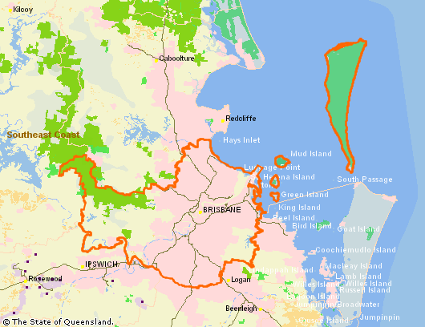

Brisbane City Council

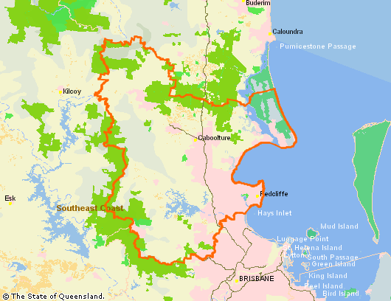
Moreton Bay Regional Council
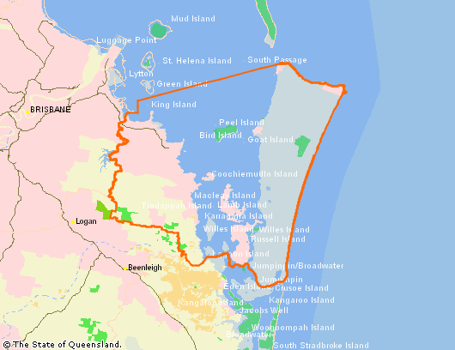
Redland City Council

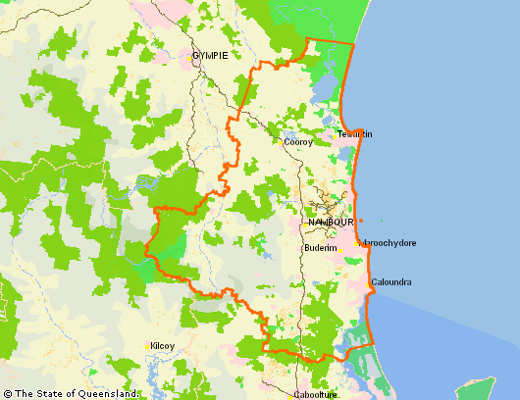
Sunshine Coast Regional Council
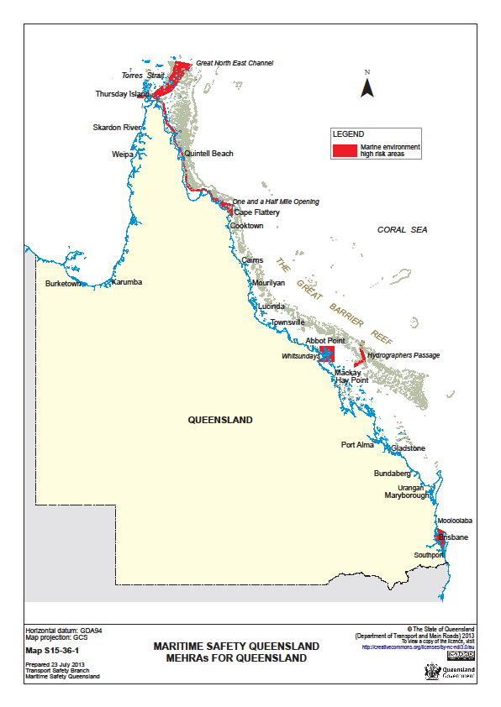Appendix E – Marine Environmental High Risk Areas
Appendix F – RAMSAR sites
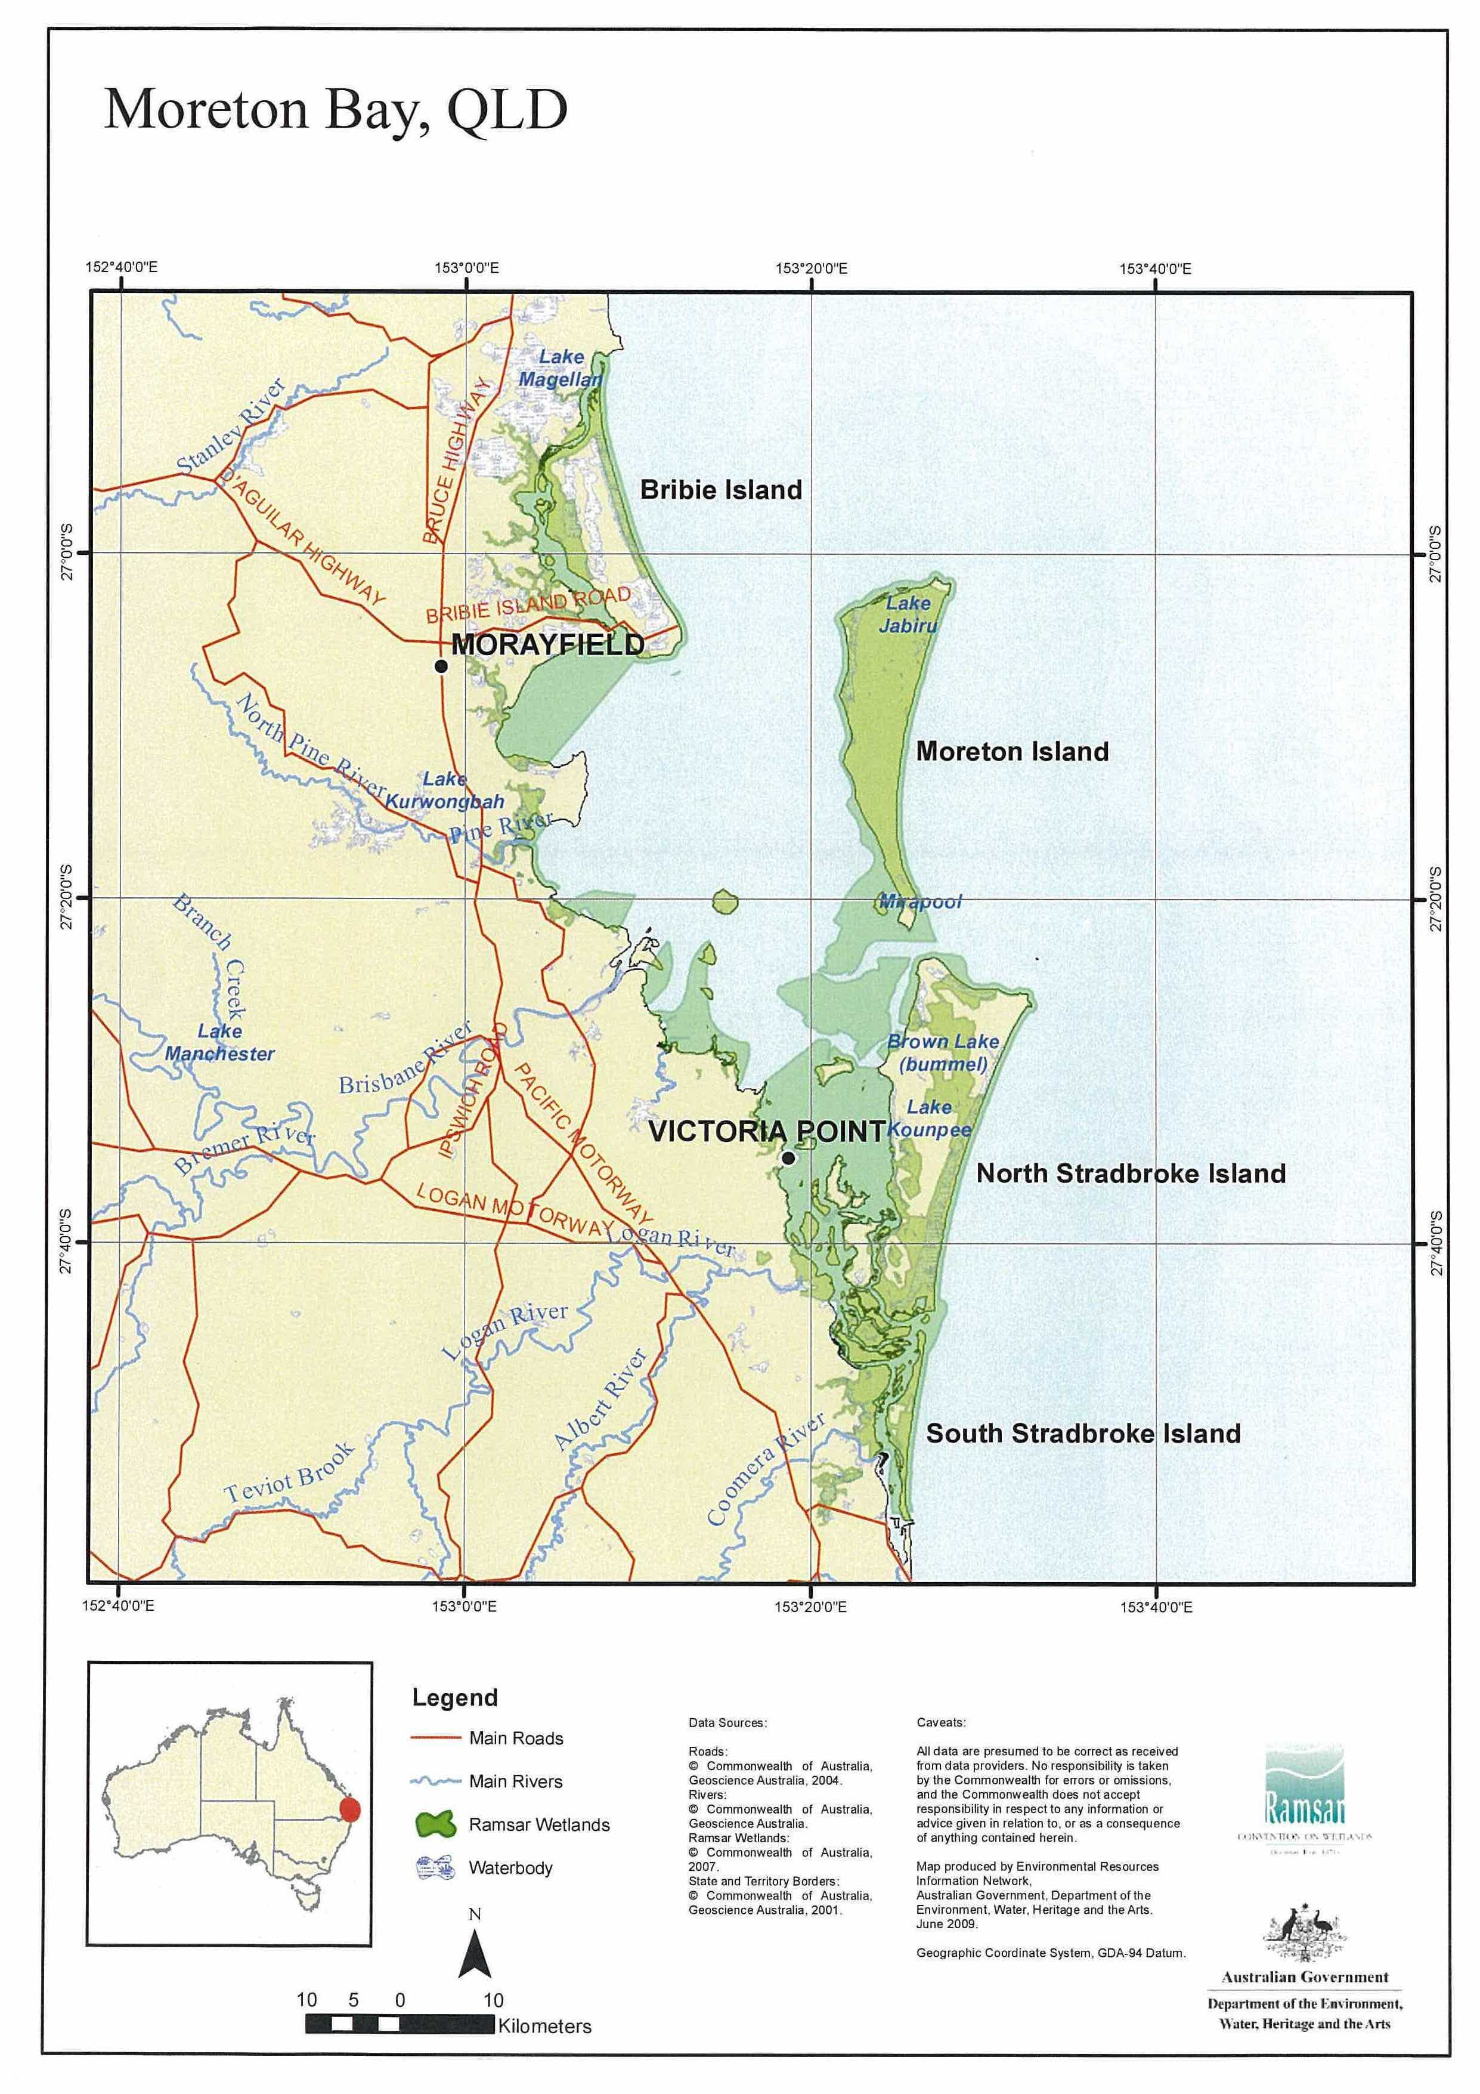

Appendix G – Incident Control Centre layout

Maritime Safety Queensland Pinkenba Incident Control Centre
Photocopier
Media Liaison Officer

 3860 3583
Operations Officer

 3860 3566
Finance & Administration Officer

 3860 3585

Logistics Officer

 3860 3567
Planning Officer

 3860 3565
Environment Coordinator

 3860 3568
Incident Safety Officer

 3860 3582
Shoreline Coordinator

 3860 3584
Incident Control Centre Manager

 3860 3555
 38603578
 38603577
Incoming Fax
 3860 3588
TV Cabinet
Bookcase
Media Display Screen
White Board
White Board
 Connected through ceiling
Balcony Doors
Media Projector

Appendix H – Oil spill response incident control system
Marine Pollution Controller
Incident Controller
Planning Officer
Finance & Administration Officer
Logistics Officer
Operations Officer
Advisors
Media Liaison Officer

Safety Officer
Situation Unit
Marine Unit
Procurement Unit
Response Planning Unit
Consultation Unit

Environment Unit
Resource Unit
Waste Management Unit
OH&S Unit
Wildlife Unit
Shoreline Unit
Aviation Unit
Staging Area Manager
Medical Unit
Communications Unit
Transport Unit
Services Unit
Incident Control Centre Manager
Records Unit
Administration Unit
Finance Unit

Appendix I – OSRICS definitions
For a complete list of OSRICS Definitions see Appendix 2 of QCCAP.

Appendix J – Oil Sampling Procedure

For a copy of the current oil sampling procedure please consult the MSQ Documents Database, document number MAR1136sh7.

Appendix K – Waste management service providers

Service provider | Services | Location | Contacts
Veolia Environmental Services | Contaminated waste disposal and remediation | Disposal and Soil Treatment Facility Willowbank, Qld | Phone: 07 3275 0111  E: qld@veolia.com.au  W: www.veoliaes.com.au
Wainless Enviro Services | Transport services | Brisbane Metro | Phone: 07 3875 9000  Fax: 07 3875 9001  W: www.wainless.com.au
Thiess Services | Contaminated waste disposal and remediation | Swanbank Landfill Site, Ipswich, Qld | Phone: 07 3288 7344  Fax: 07 3288 6795  E: info@thiess-services.com.au  W: www.theiess-services.com.au
JJ Richards and Sons | Contaminated waste disposal and remediation | Disposal and Soil Treatment Facility Willowbank, Qld | Phone: 07 3488 9600  Fax: 07 3488 9699  E: enquires@jjrichards.com.au  W: www.jjrichards.com.au
SITA Environmental Solutions | Liquid waste removal | 28 Weyba Street  Lower Nudgee Qld 4014 | Phone: 07 3212 8000  Fax: 07 3267 8264  W: www.sita.com.au
Austrans Haulage | Liquid waste removal | 980 Lytton Road  Murarrie Qld 4174 | Phone: 07 3890 7210  Fax: 07 3390 6110  W: www.austranshaulage.com.au
Zappaway | Liquid waste removal | 10 Platinum St, Crestmead Qld 4132 | Phone: 07 3489 5600‎

Appendix L – Equipment list

A kit of first strike oil spill response equipment is located at Port of Brisbane Corporation operations base, Howard Smith Drive, Whyte Island. This should be adequate for most small spills within the port.

If more equipment is required it can be obtained from the Tier 2 stockpile at Maritime Safety Queensland’s marine operations base, MacArthur Avenue East, Pinkenba or from the National Plan stockpile at Hemmant. a procedure for release of National Plan equipment from the stockpile from Hemmant and other areas around Australia can be found on the MSQ Documents Database – Document MAR1743.

Appendix M – Captain Bishop Bridge, boom configurations

